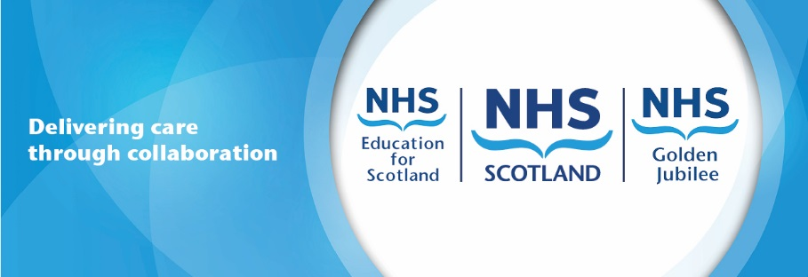
Proposal for the NHS Scotland Academy based at the Golden Jubilee

- Overview
The purpose of this paper is to outline the proposed NHS Scotland Academy developed through a partnership between NES and GJF. The NHSS Academy will be based at the NHS Golden Jubilee (GJ) as part of a hub and spoke national academy model for NHS Scotland. Critically it will offer accelerated training for a wide range of subjects and professions through residential and simulated virtual reality learning to support a resilient and skilled workforce for NHS health and care in Scotland.
While academy training is currently being delivered in a number of Boards, a National NHS Scotland Academy will provide a co-ordinated approach delivering training linked to workforce and skills gaps, recruitment and NHS needs. In addition, a second phase of the NHSS Academy will aim to develop a consistency across all NHS Scotland Academy programmes through uniform course content and training creating a common currency in training skills and standards. In addition, it is planned to develop a sense of NHSS Academy value and belonging with Alumni status for all who pass through and come back either for further training or to support others.
Unique Opportunity: Delivering the NHS Academy through a partnership between the GJF and NES offers the unique opportunity to base the NHSS Academy within a National NHS facility which is a recognised centre of clinical excellence with outstanding clinical, learning and hotel facilities to immediately support a new approach for workforce development and sustainability. Critically these facilities and clinical expertise will be harnessed to the educational excellence of our National education board who bring workforce and education expertise as well as a digital learning platform to ensure a world class educational provision.
Values Based & Person Centred Approach: In addition to the quality facilities and education an essential part of the NHS Scotland Academy will be its recognisable brand which provides a positive, values based experience for all. The course design and delivery will be built on the positive NHS Scotland values with each and every student being given values and human factors training irrespective of the course that they are completing. The experience will be one of quality with a client management approach being implemented from application to course delivery and onward to graduation and alumni status. The proposed NHS Scotland Academy is built around engaging our students in a positive career experience with established career long alumni relationship for future training and delivery.
Strategic Partnerships: In addition to the partnership between National Education Scotland (NES) and the Golden Jubilee Foundation (JGF). The NHSS Academy will establish and nurture key strategic partnerships with the Royal Colleges and key industry and academic partners to develop the best and most innovative training facilities including virtual reality, simulation and high quality video and webex links. In addition, through these partners, scholarships/fellowships will be created to extend the opportunities and pace of training with academic links providing further opportunities for honorary lecturer positions.

Drivers for Change
The changing population demographics means our NHS is caring for an ageing population with increasing needs. Recruitment challenges already exist in a number of areas and workforce planning predicts that greater challenges lie ahead unless we can develop innovative ways to improve our skills growth. There are also specific developments including the Elective Centres, Major Trauma Centres which have new requirements alongside shortages in estates and facilities, CSPD and school leaver opportunities. Any initiative must seek to address these emerging issues.

Proposal for the New NHS Scotland Academy
The aim of the NHS Scotland Academy is to provide needs driven accelerated, residential (optional) high quality, training delivered in state of the art facilities within a centre of excellence. Programme design will be aligned to need and will be linked with recruitment to attract and develop the right numbers of people at the right time, with the right skills and values to deliver high quality healthcare. The specific objectives of the NHS Scotland Academy will be to:
- Develop training courses linked to national recruitment and workforce needs
- Deliver accelerated training within state of the art training facilities within a centre of excellence linked to hotel facilities
- Provide exciting and attractive training programmes and scholarships linked to recruitment and career progression
- Design training and education based on upper quartile models of care such as the Golden Jubilee model of elective care to support national spread of best practice.
Achieving these objectives will enable a more effective, efficient and resilient workforce offering quality training, skills development and career satisfaction. The continued development and expansion of the academy model is vital to our ability in NHS Scotland to continue to grow and develop our workforce.

Key Elements of the Proposed NHS Scotland Academy
The 6 main elements of the development of NHS Training academy model at NHS Golden Jubilee:

Element 1: Leadership & Oversight
An NHS Scotland Academy Board will be established and co-chaired by the Chief Executives of NHS GJ and NHS Education for Scotland (NES) with membership consisting of key members of Scottish Government including the Chief Medical Officer, Chief Nursing Officer, Chief People Officer & Director of Health Workforce, Clinical Director for Healthcare Quality and Safety, and key Executives from the teams of NHS GJ and NES. The accountability for delivery will sit with the Chief Executives of GJ and NES within an SLA framework. Governance will be provided via a bespoke Commissioning and Academy Committee embedded within the Board Governance of NHS Golden Jubilee. An operational Delivery Group will be based within the GJ with each course having a Course Module Project Design and Implementation Group.
Element 2: Accelerated Training delivered to match Need
New courses will be designed to optimise delivery in a modular way through compressed, accelerated training which fully utilise the state of the art facilities and residential aspects, where appropriate, to offer evening human factors and simulation training wherever possible. There will be a focus on developing a sense of value for each student of the NHSS Academy and belonging as part of a recognised and respected entity which they will have lifelong involvement with as a student and Alumni.
Element 3: State of the Art Facilities – Innovative, High Quality, Residential
Working in collaboration with our strategic partners we will design and install new innovative training facilities providing virtual reality (VR) and simulation training suites in addition to further electronic enabled links with our advanced clinical facilities. These will be embedded within the existing hotel and conference facilities and will be supported by unique attributes NHS Golden Jubilee already has to offer including:
- Golden Jubilee Conference Hotel enabling residential training courses with direct access to hospital services
- Clinical skills centre with live links to operating suites/catheterisation labs and auditorium. Hospital services with nationally and internationally renowned best in class models of care
Element 4: Strategic Partnerships & Funding Flows
The NHS Scotland Academy will seek to attract funding commitments and support from a range of partners including professional bodies, academic institutes and commercial partners.
These strategic partnerships will support the development of the NHS Scotland workforce and healthcare delivery while also offering synergistic opportunities for both parties. Specifically, we will invite our partners to:
- Invest in provision of physical infrastructure and technology to enable highly advanced training and development including VR, simulation and use of advanced healthcare technology including robotics
- Contribute to grants and scholarships
- Establish specialist fellowships for extended placements within clinical services and affiliation with academic institutions
We will also look to market courses and facilities nationally and internationally to further income generate which will subsidise the NHSS Academy delivery.
Element 5: Educational Programme
NHS GJ and NHS Education for Scotland (NES) will develop a comprehensive educational programme in partnership with academic institutes and professional bodies which will include:
- An extended range of vocational courses for clinical and non-clinical roles in the NHS prioritised to match workforce needs across NHS Scotland
- Clinical skills courses for medical, nursing and other clinical staff which will train people in clinical skills and procedures that are nationally and internationally recognised as high quality and best in class
- Training and development modules in a range of other areas such as CSPD, Estates and Facilities, Leadership, Radiology, Advanced Practice and all will have values and human factors embedded within the course
- Fellowships to provide extended duration training for highly specialist roles within specialty areas such as innovative orthopaedics, ophthalmology, cardiothoracic and intensive care.
The educational programme will be flexible and delivered using a variety of teaching methods including distance learning and residential courses. All courses will be digitally enabled with e-learning integral to our approach.
Element 6: Workforce Planning, Recruitment & Scholarships
The critical purpose of the NHS Scotland Academy is to ensure that the workforce development needs of NHS Scotland are met in a timely, effective and efficient way. We will work with NES to:
- Understand NHS Scotland workforce needs in relation to specialist and advanced roles including numbers of staff required by when
- Prioritise the roles to be supported by the Academy and plan for recruitment to appropriate courses and ensure this aligned with recruitment to vacancies and new posts across NHS Scotland
- Agree funding of training posts where required to enable course attendance and vocational placements
The Academy will require funding of courses and training posts and this will include NHS board funded places at the Academy as well as scholarships, fellowships and self- funded options.

Next Steps
The NHS Scotland Academy is an exciting and ambitious programme that will require effective programme management and governance which will be hosted by NHS Golden Jubilee.
Step 1: Establish Programme Governance: Governance structures for The NHS Scotland Academy will be developed and agreed between Scottish Government, NHS Golden Jubilee and NES by January 2020 and will include leadership from the NHS Scotland Academy Board.
Step 2: Establish the NHS Scotland Academy Programme Team: The programme team for delivery will be developed between November 2019 and January 2020. In addition to Executive Leadership from the Chief Executives and their teams from NHS Golden Jubilee and NES there will also be:
- Director of Operations for the NHS Scotland Academy
- Associate Medical Director for NHSSA Medical Training
- Associate Nurse & AHP Director for NHSSA Nurse & AHP Training
- Senior Planning, Project, Digital and Administration support
Step 3: NHS Scotland Academy Programme Launch: The NHS Scotland Academy will be developed for launch by August 2020 offering a full programme of education for employees of NHS Scotland with associated scholarships which will enable accelerated delivery of postgraduate, vocational and continuing professional development training.

