Board Meeting: |  | 21 November 2019
 | Subject: | NHS Scotland Training Academy
 | Recommendation: | Members are asked to:
  Discuss and Note | ✓
  Discuss and Approve
  Note for Information only

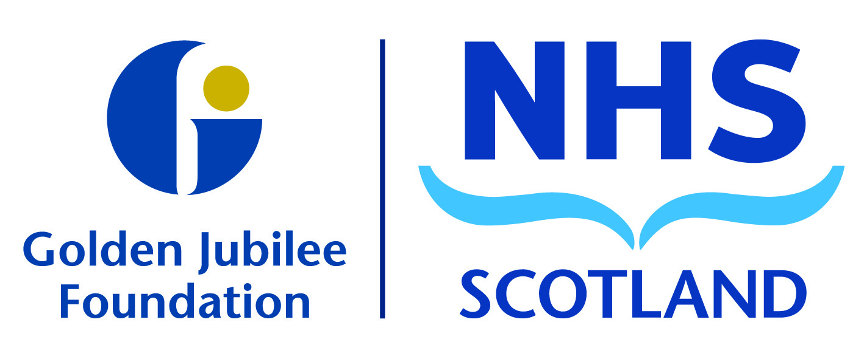
Background
Item 8.3

There has been work underway within the Board to progress the development of the NHS Scotland Training Academy (NHS STA). The Academy will be based here at the NHS Golden Jubilee (GJ) as part of a hub and spoke national academy model for NHS Scotland, providing a co-ordinated approach delivering training linked to workforce and skills gaps, recruitment and NHS needs.

The second phase will aim to develop a consistency across all NHS Scotland Academy programmes as a centre of excellence.

Programme governance will be established in agreement with Scottish Government and an NHS Scotland Academy Programme Team will be developed by January 2020, supported by Executive Leadership from GJ and NES. The expectation is to launch this by August 2020 with a full programme of education for employees of NHS Scotland with associated scholarships.

- Discussion

The paper describes the six key elements of the proposed NHS STA model at NHS Golden Jubilee. These elements are being explored and developed:
- Leadership & Oversight
- Accelerated Training delivered to match Need
- State of the Art Facilities – Innovative, High Quality, Residential
- Strategic Partnerships & Funding Flows
- Educational Programme
- Workforce Planning, Recruitment & Scholarships

- Recommendation

The committee are asked to note the exciting progress of the NHS Scotland Training Academy within the attached report and the next steps as described above.

Anne Marie Cavanagh
Executive Nurse Director
October 2019

