Board Meeting: | 21 November 2019 | 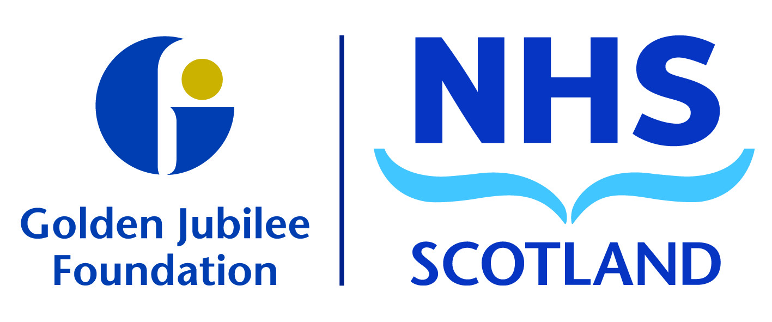
Subject: | NHS in Scotland 2019  Audit Scotland Report

Recommendation | Board members are asked to:
 | Discuss and Note
 | Discuss and Approve
 | Note for Information only

- Background

The Audit Scotland NHS in Scotland 2019 Report was published in October 2019 and provides an overview of the NHS and the realities of delivering healthcare in Scotland.

The report draws on a wide range of intelligence, interviews and data, to help understand context, challenges and performance. It sets out the financial performance of the NHS in 2018/19, and the financial outlook for 2019/20 and beyond.

This includes the new approach to longer-term financial planning, the new Medium Term Financial Framework (MTFF), and progress towards achieving the objectives of the Health and Social Care Delivery Plan (HSCDP).

The report includes data on workforce, leadership and culture, governance and performance against national targets.

Recommendation

Board Members are asked to review and note the content of the report.

Colin Neil
Executive Director of Finance
13 November 2019

