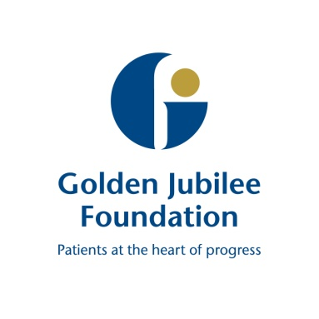
Ref: 5.3

Board Meeting: 21 November 2019

Subject: Clinical Governance Committee Update

Recommendation: Board members are asked to note discussions

___________________________________________________

1 Background

The following key points were agreed at the meeting and have been split into the three high level quality ambitions of person centred, safe, and effective.

Item | Details
Person Centred | The feedback report was presented and well received by the committee. A request was made to also feature “good news stories” and compliments.
Safe | The committee discussed significant pressure areas in microbiology, radiology and SACCS.  - Microbiology  Discussions continue with NHS GGC, with short term solutions in place. However, a longer term solution is being worked towards and GJNH is in the process of recruiting to a permanent microbiology service. The committee will continue to receive updates.  - Radiology  PR updated the committee on recent radiology incidents noting good learning from SAE embedded and developed.  This is also a service with an area of vulnerability around the reading and reporting of images. Work is in place to secure locum cover and further consideration could be given to looking further afield. Need to reflect further on phasing approach currently in place to balance scans and reports.  - SACCS  The committee noted the SACCS service is left vulnerable due to consultant absences. Support from non-ACHD GJNH cardiologists, increased input from territorial ACHD leads and support from the ACHD unit in Guy’s Hospital is mitigating the risk. Additional solutions are being vigorously pursued. By December 2020 the service will have a full complement of staff.  The Healthcare Improvement Scotland Adverse Event Management Board self-evaluation report was discussed; the committee welcomed the work underway to support national learning and will await further details of the system to support this.
Effective | The Healthcare Improvement Scotland Quality of Care Review report was discussed. Members noted that all recommendations are already being acted upon.  The committee were presented with the Prevention and Control of Infection annual report. However, as the meeting was not quorate full approval was not made. Members attending the meeting supported the report, and agreed that approval from another Non-Executive Director would be sought out with the meeting. *  *Approval was subsequently attained and the report will be published

The next meeting is scheduled for Tuesday 14 January 2020, 2pm, Level 5 Boardroom

Morag Brown
Chair, Clinical Governance Committee
(Mark MacGregor, Medical Director)
7 November 2019

