Board Meeting: | 21 November 2019 | 
Subject: | Integrated Performance Report  Board Summary Report
Recommendation: | Members are asked to:
  Discuss and Note
  Discuss and Approve | ✓
  Note for Information only

Background
Item 5.1

Following a review of corporate governance at the NHS Golden Jubilee, which aligned to the Blueprint for Governance developed by Scottish Government, the performance reporting cycle has been realigned.

New Governance Committee structures commenced in September 2019 and each committee is supported with accurate and current information to support scrutiny and enable assurance of their compliance with the statutory obligations.

This will enable Board members to be confident that the desired level of quality is being delivered in the development and delivery of Golden Jubilee services and objectives are being met.

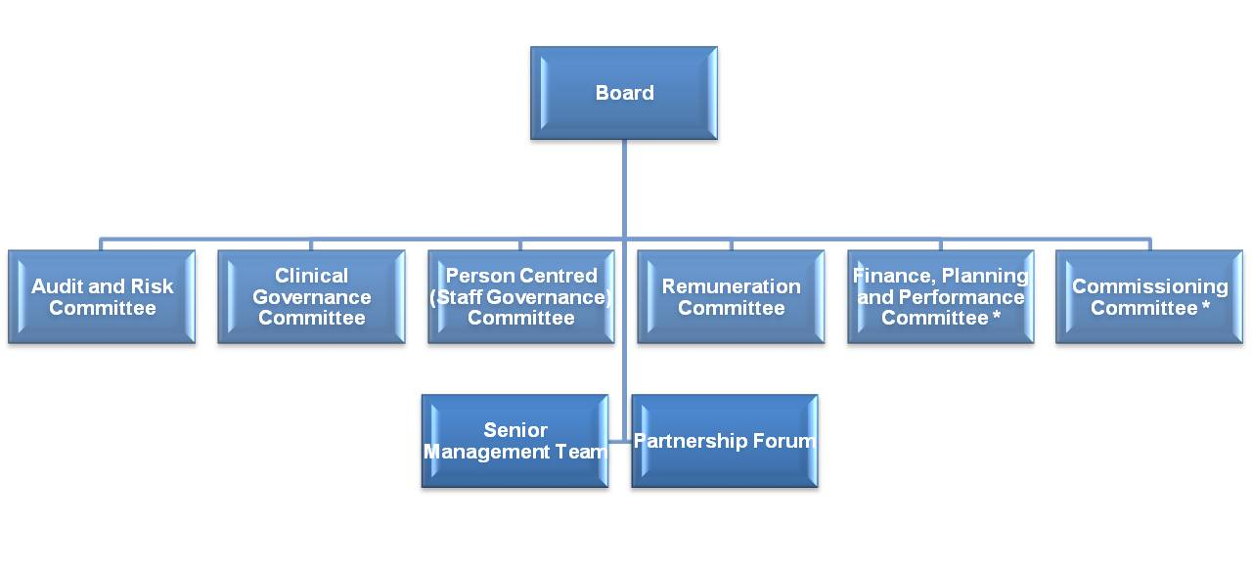

Figure 1: Board Governance Committee structure commencing from Sept 2019
* Indicates New Committees
Commissioning Committee is under review

- Function

In order to support the functions of the Clinical Governance, Person-Centred (Staff Governance) and Finance, Performance and Planning Committees an Integrated Performance Report (IPR) has been developed. Development of the report has been led by the Performance and Planning team in collaboration with other departments.

The data included forms the basis of the information that is issued to ISD and also includes the Hospital Associated Infection Report, Business Update Report and local performance information.

- Report Cycle

This report is produced monthly as part of a two monthly performance cycle. The key elements are:
- IPR produced and shared with Board members monthly.
- IPR on second month considered by three Committees.
- Board Summary Report produced including Chairs comments for Board consideration.

- Report Content

The current iteration of the IPR comprises four main sections:

- An overall summary section;
- A section to support and inform the Clinical Governance Committee;
- A section to support and inform the Staff Governance Committee; and
- A section to support and inform the Finance, Performance and Planning Committee.

The attached IPR Board Summary Report highlights the key priority areas identified in the IPR and outlines an Executive Summary of the three governance sections; Clinical Governance, Staff Governance and Finance & Performance.

Further refinement of the IPR and Board Summary Report will be an iterative process based on feedback and usage by the Committees and the Board.

- Recommendation

Members are asked to discuss and approve the content of the IPR Board Summary Report.

Jann Gardner
Chief Executive
12 November 2019

