Board Meeting: | 20 June 2019 | 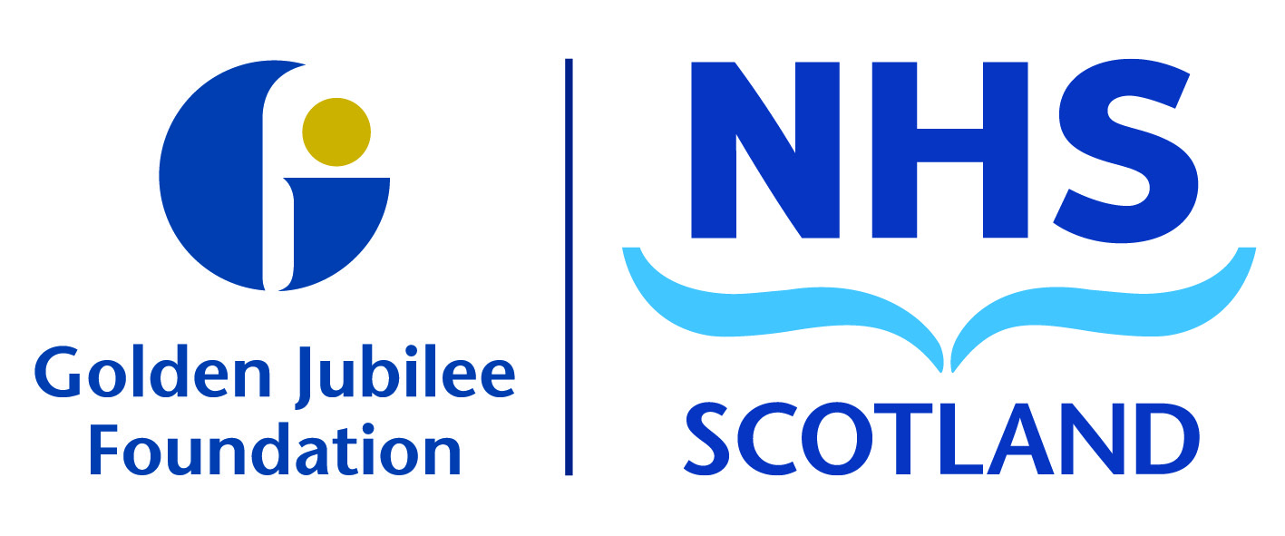
Subject: | Audit and Risk Committee update – 11 June 2019
Recommendation: | Board members are asked to:  Discuss and Note X  Discuss and Approve  Note for Information only

_______________________________________________________________________

1 Background

The following key points were agreed at the meeting and have been split into the three high level quality ambitions of person centred, safe, and effective.

Person Centred
Mutually beneficial partnerships between patients, their families and those delivering healthcare services which respect individual needs and values and which demonstrate compassion, continuity, clear communication and shared decision-making.
- The committee heard a useful presentation from Alex McGuire, Clinical Specialities Manager on Treatment Time Guarantees. This was requested as a result of a deep dive into waiting times risk and helped members to understand the factors behind some complex issues involved. Members were assured that the risk is being managed and recovery solutions are in place.
- There were no significant Audit Scotland reports applicable to the Board.
- An update on Prevention of Fraud was noted and the committee noted the activity undertaken throughout the year.
- The National Single Instance Service Audit Report was presented with assurance received from service audits for the National Finance System and the National IT System. This provides the committee with positive assurance over the controls in place. No actions were noted.
- The 2019/20 committee work plan was reviewed and approved. It was agreed that the risk deep dive areas will be discussed at the next meeting.
- Updated Terms of Reference for the committee were reviewed and approved with agreement going forward that, rather than naming individuals, job titles will be included and start and leaving dates would be inserted. These are due to be presented at the August Board.

Safe
There will be no avoidable injury or harm to people from healthcare they receive, and an appropriate, clean and safe environment will be provided for the delivery of healthcare services at all times.
- A review of the Board Risk Register highlighted proposed changes. Members were satisfied with recommendations to the following risks:
- EU Withdrawal risk reduced to medium level but members received assurance that this will continue to be closely monitored.
- Workforce Capacity risk increased to high level given workforce pressures linked to the expansion.
- Waiting Times risk is under review.
- The Assurance Mapping overview was presented. Members agreed that, overall, this was a positive and robust approach to strengthen assurance and agreed to continue this for the other areas identified. Members agreed with the improvement areas.
- The Procurement Annual Report was presented, highlighting work undertaken in the past year and future procurement requirements over the next two years. The report is submitted to Scottish Government and will be published on the Board’s website.

Effective
The most appropriate treatments, interventions, support and services will be provided at the right time to everyone who will benefit, and wasteful or harmful variation will be eradicated.
- The Internal Audit Consultant Job Planning Review was presented with an overall rating of ‘Partial Assurance with Improvement Required’. There were three recommendations which management have accepted and a recovery plan has been established. It was agreed this report would be shared with the other Committees.
- The Internal Audit Annual Report was presented. This summarises internal audit work undertaken throughout the year; the audit opinion based on reviews undertaken was that reasonable assurance can be given on overall adequacy and effectiveness of the framework of governance risk management and controls in place.
- The Internal Audit Annual Plan was presented and approved. The plan reflects discussion held at the committee meeting in April.
- The Internal Audit Recommendations Follow up Report was noted. The report summarised good progress against outstanding actions from audit reviews and the current status.
- The Audit and Risk Committee Annual Report was approved.

- The 2018/19 External Annual Audit Report to the Board was presented in draft with an overall conclusion of unqualified opinion which includes consolidation of the Charity annual accounts. Auditors were pleased to advise that this was a very positive report with no major issues identified.
- The Draft Annual Report and Accounts were presented in a new user friendly format for discussion and approval. It was noted that, as the majority of members have now received annual accounts training, this has proven beneficial in understanding the detail within the accounts. The annual accounts have now been recommended to the Board for final approval.
- The Statement of Assurance from the Audit and Risk Committee to the Board was presented. Members were satisfied with the arrangements within the Board in regard to the internal control framework.

The next meeting is scheduled for: Tuesday 22 October 2019.

Karen Kelly
Chair, Audit and Risk Committee
11 June 2019

(Julie Carter, Director of Finance)

