Board Meeting: | 20 June 2019 | 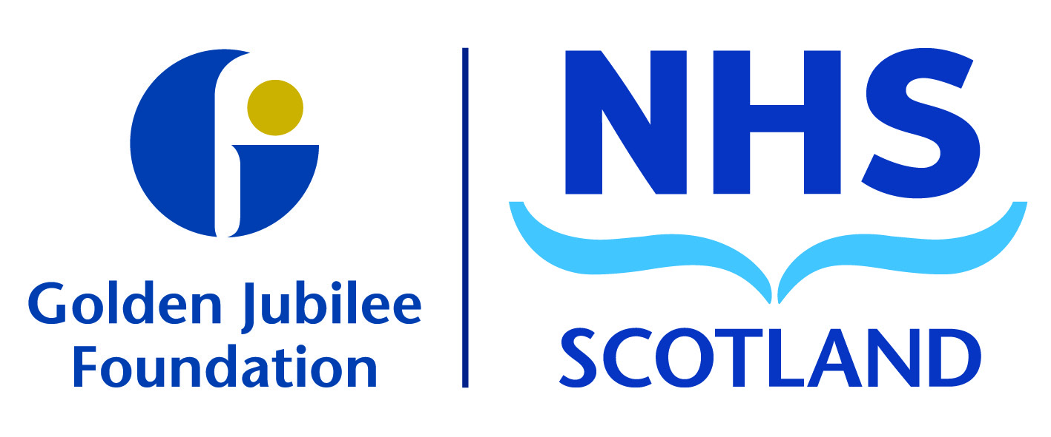
Subject: | Board Strategy
Recommendation: | Board members are asked to:  Discuss and Note  Discuss and Approve  Note for Information only

1 Background

The draft Board Strategy was presented to the Board on 4 April 2019. Since then there has been further refinement of the strategy.

It was agreed at the Board meeting on 9 May that further staff engagement, including with the Partnership Forum, would take place during May. The feedback from this period of engagement has been considered and addressed through changes and additions to the strategy. We have also updated staff, through a staff bulletin, on the feedback received and our response to the feedback.

An Equality Impact Assessment (EQIA) has been conducted on the Board Strategy and is attached for review and discussion. However, it is recognised that further EQIAs will be required for each of the key elements of the strategy and the strategic programmes that will support its delivery.

2 Next Steps

Delivery of the Board Strategy will be taken forward through the following:

- Annual Operational Plan,
- Corporate Objectives (which encompass the annual operational plan), and
- Strategic Programmes and Strategic Programme Board.

Executive Team objectives have also been developed that align with corporate objectives. A digital solution is also being explored to support the strategic programme management approach.

The Board Risk Register will be updated in line with the Board Strategy and associated delivery mechanisms.

3. Recommendation

The Board is asked to approve the Board Strategy and Equality Impact Assessment.

Gareth Adkins
Director of Quality, Innovation & People
7 June 2019

