

Standard Business Case

Expansion of Interventional Cardiology Services through an additional

Cath Lab (CL5)

Revision 7.1

CONTENTS

1. Executive summary 3

1.1 Background 4

1.1.1 Coronary Intervention 4

1.1.2 Electrophysiology 5

1.1.3 Device Service 6

1.1.4 National Services and Structural Heart Disease 6

1.2 Key points 7

1.3 Outcome from appraisal process 8

1.4 Statement of affordability 9

1.5 Implementation of project plan 9

2. Introduction/background 10

2.1 Coronary Intervention 12

2.2 Electrophysiology 14

2.3 Device Service 15

3. Description of existing service 17

3.1 Infrastructure 18

3.2 Coronary Intervention 18

3.3 Electrophysiology 19

3.4 Structural Heart Disease 20

3.4.1TAVI 20

3.4.2 Left Atrial Appendage Closure (LAAC) 20

3.4.3 Mitraclip 21

3.4.4 Patent Foramen Ovale Closure (PFO closure) 21

3.5 SACCs 21

3.6 SPVU 21

4. Summary of existing and projected capacity requirements 22

4.1 Current Capacity 22

4.1.1 Cardiology Day Unit capacity 22

4.1.2 Cath Lab capacity 22

4.1.3 Bed capacity 22

4.2 Capacity Gap 23

4.3 Future Projections 23

4.3.1 Coronary Intervention 23

4.3.2 Electrophysiology 23

4.3.3 Devices 24

4.3.4 Structural Heart Disease 24

4.3.5 NSD Specialties 24

5. Achieving full capacity 25

6. Objectives 27

7. List of business options 32

8. Benefits appraisal & assessment of risk 32

8.1 Stakeholders 32

8.2 Option appraisal process 32

8.3 Assessment of benefit criteria 33

8.4 Results of the benefits scoring exercise 34

8.5 Risk assessment 34

8.6 Conclusion from the assessment of benefits and risks 36

9. Financial appraisal 37

9.1 Overview 37

9.2 Key financial assumptions 37

9.3 The scope of financial analysis 37

9.4 Costing methodology 37

9.5 Capital costs 38

9.6 Depreciation 39

9.7 Recurring and Non-Recurring core revenue cost analysis 39

9.8 Expenditure profile 40

9.9 Affordability 41

10. Economic appraisal 43

10.1 Overview 43

10.2 Options appraisal 43

11. Implications of not procuring a fifth Cath Lab 44

12. Risk analysis 45

13. Preferred option 47

13.1 Benefits and realisation monitoring 47

13.1.1 Expected benefits 47

14. Implementing the preferred option 52

14.1 Project Control 52

14.2 Project organisation 52

14.3 Project stages 55

14.4 Project timetable 56

Appendix 1: Benefits scoring details 57

Appendix 2: Risk scoring details 58

## 1. Executive summary

This Standard Business Case (SBC) considers the provision of a fifth Cath Lab to address growing Coronary Intervention and Electrophysiology waiting times and operational pressures across a range of Interventional Cardiology clinical services.

The Business Case has been prepared as one of the recommendations from the Cardiology Strategy following significant capacity and demand analysis and benchmarking with other interventional cardiology centres. Visits to other sites have included Liverpool and Leeds which have both redesigned their patient pathways. In addition the Strategy work included horizon scanning, describing how the service needed to evolve in response to the predicted changes in the population need and treatment options.

The West of Scotland Interventional Cardiology Service has established a national reputation for excellence. This position has the potential to be further bolstered through expansion of the service and building on the well established high quality performance.

The three main quality objectives of the project are:

1. The project will deliver an increase in Cath Lab capacity supporting waiting times activity in coronary Intervention and electrophysiology, and providing sufficient capacity to meet projected future increases in demand and complexity
2. The project will deliver increased efficiency and flexibility across all cardiology admission pathways supporting timely treatment to urgent and elective patients.
3. The project will increase safety by enabling device activity to be moved to a dedicated imaging environment.

In addition to these core objectives, it is also anticipated that a fifth Cath Lab will improve service resilience and recruitment and retention opportunities, and importantly provide the capacity to meet future demands of the service.

The business case describes the drivers for the project and the reasons for the selected business option based on estimated costs, risks and expected benefits.

For the purpose of this business case, Cath Lab 5 (CL5) will be defined as consisting of the following:

* Cardiac angiography x-ray system
* Diagnostic review workstation or equivalent thin client solution
* Dose reduction system (as per revised IRMER regulations)
* Dose monitoring system
* UPS system for safe system backup
* Contrast injector
* Radiation shields
* Peripheral equipment used in Cath Lab to support all projected activities
* Equipment for associated clinical areas
* Radiological personal protection equipment
* Equipment for associated clinical areas

Additional option considered

* Electrophysiology equipment

Recurring revenue costs considered:

* Medical equipment maintenance
* Capital depreciation
* Consumables
* Laundry
* Catering
* Staffing

### 1.1 Background

Interventional cardiology includes coronary intervention including optimal reperfusion service (ORS) and the elective diagnostic and treatment service, structural heart interventions, electrophysiology and devices. Interventional cardiology also comprises the national services; SPVU admits patients for comprehensive assessment which includes right heart catheterisation carried out in the Cath Lab, and the adult congenital service carries out diagnostic and catheter based treatments within the Cath Lab.

The GJNH has provided the West of Scotland interventional cardiology service since 2008. Interventional cardiology deals specifically with the catheter based treatment of heart disease. The Interventional Cardiology Strategy was endorsed by the Board in October 2018 and its scope included the following services:

1. Coronary Intervention
2. Electrophysiology (EP)
3. Structural Heart Disease (non coronary interventions)
4. Scottish Adult Congenital Cardiac Service (SACCs)
5. Devices
6. Scottish Pulmonary Vascular Unit (SPVU)
7. Research including Scottish National Advanced Heart Failure Service (SNAHFS)

The strategy was developed with the three NHS Scotland quality ambitions at its core, planning to deliver safe and effective care designed around individual patients. This will be achieved by planning sufficient capacity to ensure patients are given the appropriate treatment timeously and are cared for in the appropriate care setting, by the appropriate team. Central to achieving these ambitions and one of the key recommendations of the strategy is an increase in the Cath Lab capacity to improve access for patients to timely and appropriate treatments, both in the short and long term.

There has been a significant amount of work undertaken since the Heart and Lung Service moved to GJNH in 2008, to increase capacity to meet the growing demand and to evolve the service in response to changes in the population and therapeutic landscape. The service consistently performs highly in terms of efficiency and Cath Lab utilisation when compared with similar large cardiology centres in the UK, however it is becoming increasingly challenging to sustain the delivery of high quality and timely interventional cardiology treatments for the planned and unplanned interventional cardiology service within the current footprint. This has resulted in increasing waiting times, particularly in the elective coronary intervention and EP services, and increasing challenges delivering a timely service to the NSTEMI population.

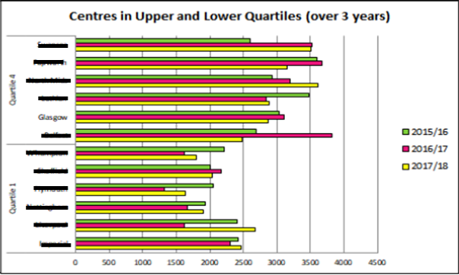

Figure 1: Number of cases per funded Cath Lab (NCBC data 2017/18)

#### 1.1.1 Coronary Intervention

Within coronary intervention, there has been an incremental shift from elective stable to urgent elective procedures, this has been experienced in GJNH, and reflects the UK trend. In addition the complexity of procedures is increasing.

Figure 2: Coronary Referrals 2013 - 19

Cath Lab capacity has been maximised through the extended day model of working which is not replicated to the same extent in the rest of the UK. In addition, GJNH has funded additional short term capacity to meet the demand and manage the waiting times through adhoc working at weekends and more recently through a mobile Cath Lab. The mobile lab had a significant impact on the waiting list – delivering an additional 400 procedures. However it also highlighted the challenges of delivering increases in capacity without the appropriate infrastructure increases. Of note the increased number of elective admissions reduced the bed availability for urgent patients and this did impact on our ability to treat the NSTEMI population within the recommended 72 hours.

The additional capacity ceased at the beginning of April 2019 and due to the capacity gap the waiting list is forecast to grow with patients breaching the 12 week TTG in Quarter 2 2019/20 if there is no additional capacity.

Figure 3: Waiting List Projection for Elective Coronary Intervention.

#### 1.1.2 Electrophysiology

The electrophysiology waiting list is currently sitting in excess of 300 patients, with capacity for 40 procedures per month. Patients are currently waiting in excess of 30 weeks from referral for their procedure, and the waiting list is growing with demand consistently exceeding referral. Figure 4 demonstrates the capacity pressures in EP.

Figure 4: EP Capacity Gap

The increase in the waiting times is the result of an increase in referrals since August 2016. This increase has been sustained with periodic peaks in referrals as a direct result of additional arrythymia clinics being held in Glasgow and Forth Valley.

Capacity is funded to deliver 40 procedures per month, however in 2017-18 the average number of monthly referrals was 62 per month. It is very challenging to increase the EP capacity on an adhoc basis due to the small teams of highly specialised staff and this has resulted in the significant increase in the waiting times.

A bid was submitted to Scottish Government for a second mobile Cath Lab with EP functionality to be located at GJNH June – November 2019. The plan would be to run EP lists three days per week and coronary two days per week. This would enable us to reduce the waiting list in EP by approximately 150 patients, and to address the capacity gap in coronary intervention; maintaining waiting times below the TTG. At time of writing is unlikely this bid will be funded and the EP list is projected to continue to grow at a rate dictated by referral rates.

#### 1.1.3 Device Service

The device implantation service at the Golden Jubilee National Hospital is primarily for complex devices such as implantable cardioverter-defibrillators (ICDs) biventricular pacemakers (or cardiac resynchronisation therapy pacemakers, (CRT-P) and biventricular defibrillators (CRT-D).

The service is currently delivered in the main theatre suite, 2 days per week. There is no flexibility during the week to accommodate urgent inpatients outwith the routine cardiology device lists and this results in patients waiting in GJNH or outlying hospitals to be treated. Transferring the service to the labs alongside the EP service would provide flexibility to device patients to the end of a Cath Lab list to delivery timely treatment, reduce prolonged hospital admissions, and avoid short notice cancellation of elective patients.

Concerns have been raised regarding the radiation exposure for staff carrying out these procedures in the theatre suite. The environment is sub-optimal and the risk remains on the risk register categorised as Major / Unlikely. It is proposed that the fifth Cath Lab is designed with sufficient air quality to accommodate the device implantation service.

#### 1.1.4 National Services and Structural Heart Disease

Structural heart interventions, especially non-surgical catheter-based treatment of heart valve disease are becoming more widespread. This reflects emerging evidence base of non-inferiority (or indeed superiority) to surgical valve interventions in selected patients and is underpinned by robust multi-disciplinary and shared decision-making. Currently the following structural heart interventions are delivered in the Cath Labs:

TAVI

Left Atrial Appendage Closure

Mitraclip

Patent Foramen Ovale Closure (PFO closure)

As the services become more established and the evidence base increases, it is anticipated that there will be growth in each of these services as has been the experience in the rest of the UK.

SACCs carries out interventional and diagnostic procedures in the Cath Lab – approximately 120-130 procedures in total. There has been a 10% increase in the adult congenital patients over the last 10 years and it is anticipated that this growth will be reflected in increased demand for catheter based procedures.

Similarly, there has been a growth in incidence of pulmonary hypertension in Scotland and it is projected that there will be a growing demand for right heart catheterisation as part of the assessment, mirroring the increase in survival, referral and incidence.

It is noted that the funding streams for national services and structural heart disease are currently separate and outwith the SLAs with the West of Scotland Boards. However it is important to note the general growth which is being experienced and the requirement to plan future capacity which takes into account the growing evidence base for structural heart interventions, and the increasing prevalence of ACHD and PH in Scotland.

In summary there is ongoing growth in demand for interventional cardiology procedures across the spectrum of services offered. This is due to the ageing population, new guidelines and increasing evidence and new treatment options. There has been successful redesign in the Cardiology Service to respond to the growth in demand and increasing complexity of the casemix of patients, however in response to the current pressures, and the activity projections discussed above, it is proposed that the Cardiology unit is expanded to develop a fifth Cath Lab initially providing additional capacity in EP and coronary intervention.

A fifth Cath Lab will provide sufficient increased capacity to –

1. Address the capacity gap in coronary intervention – delivering 646 additional procedures
2. Increase EP capacity by 37.5% equivalent to an increase of 190 procedures.
3. Facilitate transfer of device implantation out of theatre environment, reducing radiation exposure for staff and patients.
4. Deliver future sustainability

This business case recommends the following:

1. A fifth Cath Lab is purchased to deliver the quality objectives of this project.
2. In order to maximise capacity as soon as the lab is available for use, recruitment for the staffing of this new service must commence in advance of installation of the equipment to allow time for training.

The financial assessment describes the capital and revenue impact of the preferred option.

|  |  |  |
| --- | --- | --- |
|  | **Capital (£) Inc VAT** | **Recurring revenue (£)** |
| Purchase of additional Cath Lab | £826,000 | £ 1,941,000 |
| Depreciation |  | £89,000 |

Table 1

### 1.2 Key points

The scope of the project includes the purchase of a fifth Cath Lab and equipment for associated clinical areas. It also includes the associated running costs for the service.

The business case and project will consider the following:

* Procurement and lifecycle management of a fifth Cath Lab and associated peripherals
* Further expanding the interventional cardiology service
* Staffing (Cardiologists, Radiographers, Cardiac Physiologists Nursing, HCSW, Administration, Domestic Services) and associated lead times to achieve appropriate trained, competent staffing levels
* Service design
* Efficient patient workflow
* Up to date safety features
* Flexibility between the Cath Labs
* Future proofing the scanner capabilities
* Addressing the capacity gap in coronary intervention
* Relocation of device implantation service
* Resilience of the EP service

The business case describes the process that considers:

* Should the service be expanded and equipment purchased?
* The service and equipment required to support ‘waiting times’ demands and operational pressures
* The procurement process

The business case describes these points and recommends the purchase of a fifth Cath Lab. This supports significant patient benefits.

These benefits are summarised below:

* Deliver national waiting time guarantees and address regional waiting time pressures in coronary intervention and electrophysiology.
* Increased efficiency across all interventional cardiology pathways
* Meets service demands and future sustainability
* Enables the relocation of the Device Implantation Service to an appropriate dedicated imaging environment
* Increases the resilience of the EP service
* Reduces the impact of downtime, including planned replacement and maintenance
* Supports development of the Structural Heart Disease Programme
* Produces high quality imaging meeting the demands of the service
* Provides high quality training and opportunities for staff professional development

### 1.3 Outcome from appraisal process

The final options considered were as follows:

**Option 1: Do nothing**

Continue to deliver the interventional cardiology service with the existing 4 Cath Labs, 16 day unit chairs, and the 3 wards. This option includes a temporary mobile lab.

**Option 2: Increase capacity through existing infrastructure**

Increase capacity through the current 4 labs by increasing efficiency and extending days during Monday - Friday

**Option 3: Equip a fifth Cath Lab**

For the purposes of this business case, Option 3 has been split into options 3a and 3b. Option 3a is inclusive of EP activity and equipment and 3b is exclusive of EP. The splitting of this option allows the consideration of the impact operationally and financially of further development of the EP service. This may delay realisation of benefits around EP resilience and flexibility.

The outcome from the appraisal process for the business case has been summarised in the table below:

|  |  |  |  |  |
| --- | --- | --- | --- | --- |
|  | Option 1 | Option 2 | Option 3a | Option 3b |
| Benefits assessment | 257 (3) | 420 (2) | 767(1) | 767(1) |
| Financial assessment | (4) | (3) | (2) | (1) |
| Economic assessment | (4) | (3) | (2) | (1) |
| Risk assessment | 139 (3) | 128 (2) | 94 (1) | 94 (1) |
| Overall rank of options | 4 | 3 | 2 | 1 |

Table 2

Option 3b demonstrates significant benefits and delivers the key drivers for the project. This option provides the greatest scope for delivering additional capacity and progressing the Boards strategy as a leading centre for interventional cardiology.

It should be noted that the capital costs for the EP equipment will be reviewed separately in the next financial year

The whole life costs of the project demonstrate that option 1 is the most expensive. This is reflecting the increased costs of the private sector that provides a short term unsustainable solution. The risk scored above show that option 3b presents the least amount of risk. It is also the only option which enables the transfer of the regional device service out of theatres into an improved environment with reduced radiation exposure. Option 3b is the preferred option.

### 1.4 Statement of affordability

The financial impact is detailed within the business case.

The capital funding to support this project is contained within the Board’s capital plan.

The recurring revenue funding details three different options to support as reflected below;

1. Funding support from Scottish Government for all revenue costs of £2.094m recurrently
2. Funding support from West of Scotland Region for all revenue costs of £2.094m recurrently
3. Funding support on the basis of fixed cost funding support by Scottish Government of £0.734m and marginal cost support by the West of Scotland Regional of £1.128m and corporate cost supported by GJ of £0.232m.

Scottish Government has confirmed the opportunity to support £600k of non-recurring funding for 2019/20 at this stage while the discussions with the West of Scotland Boards continue.

### 1.5 Implementation of project plan

The Cross Sectional Imaging Group will function as the Project Board. The project will be managed using a methodology based on PRINCE 2. It will be split into a series of management stages, each requiring formal approval of the project board before initiation. All stages will be subject to adjustment in timescales and content resulting from continual project management, assessment of ongoing risks and reaction to incidents. This may provide additional scope for slippage or acceleration providing the risk assessment supports this. Financial approval will also be required by the Board’s Capital Group.

Figure 5: Project management stages

## 2. Introduction/background

This business case has been prepared in support of the development of a fifth catheterisation lab at the Golden Jubilee Foundation (GJF), an NHS Scotland Special Health Board. The Golden Jubilee Foundation comprises of the Golden Jubilee National Hospital (GJNH), the Golden Jubilee Research Institute, the Golden Jubilee Innovation Centre and the Golden Jubilee Conference Hotel.

The main clinical services provided are heart and lung, elective major orthopaedics, general surgery, plastic surgery, diagnostic imaging and endoscopy services.

The amalgamation of Heart and Lung services together in a multi-disciplinary centre, for the first time in the West of Scotland, brought together regional, national, and in some cases, international expertise under one roof and created one of Europe’s largest integrated Heart and lung Centres. Currently we are the second highest volume Interventional Cardiology centre in the UK. Interventional cardiology includes coronary intervention including optimal reperfusion service (ORS) and the elective diagnostic and treatment service, structural heart interventions, electrophysiology and devices. Interventional cardiology also comprises the national services; SPVU admits patients for comprehensive assessment which includes right heart catheterisation carried out in the Cath Lab, and the adult congenital service carries out diagnostic and catheter based treatments within the Cath Lab.

The delivery of comprehensive, high quality Regional and National Heart and Lung Services for Scotland remains a core objective for the Board. The Interventional Cardiology Strategy was endorsed by the Board in October 2018 and its scope included the following services:

1. Coronary Intervention
2. Electrophysiology (EP)
3. Structural Heart Disease (non coronary interventions)
4. Scottish Adult Congenital Cardiac Service (SACCs)
5. Devices
6. Scottish Pulmonary Vascular Unit (SPVU)
7. Research including Scottish National Advanced Heart Failure Service (SNAHFS)

The Strategy described the current service and the predicted requirements for change and expansion over the next five years.

The drivers for change are clear; there is a relentless burden of cardiovascular disease in Scotland, and in particular the West of Scotland; an aging population; and increasing technology and innovation. The strategy was developed with the three NHS Scotland quality ambitions at its core, planning to deliver safe and effective care designed around individual patients. This will be achieved by planning sufficient capacity to ensure patients are given the appropriate treatment timeously and are cared for in the appropriate care setting, by the appropriate team. There has been a significant amount of work undertaken since the Heart and Lung Service moved to GJNH in 2008, to increase capacity to meet the growing demand and to evolve the service in response to the changes in the population and therapeutic landscape

The service benchmarks well consistently performing in the upper quartile when compared with other centres. This is demonstrated in Figure 6 which shows that Glasgow delivers efficient utilisation of Cath Labs compared with other interventional cardiology centres in the UK.

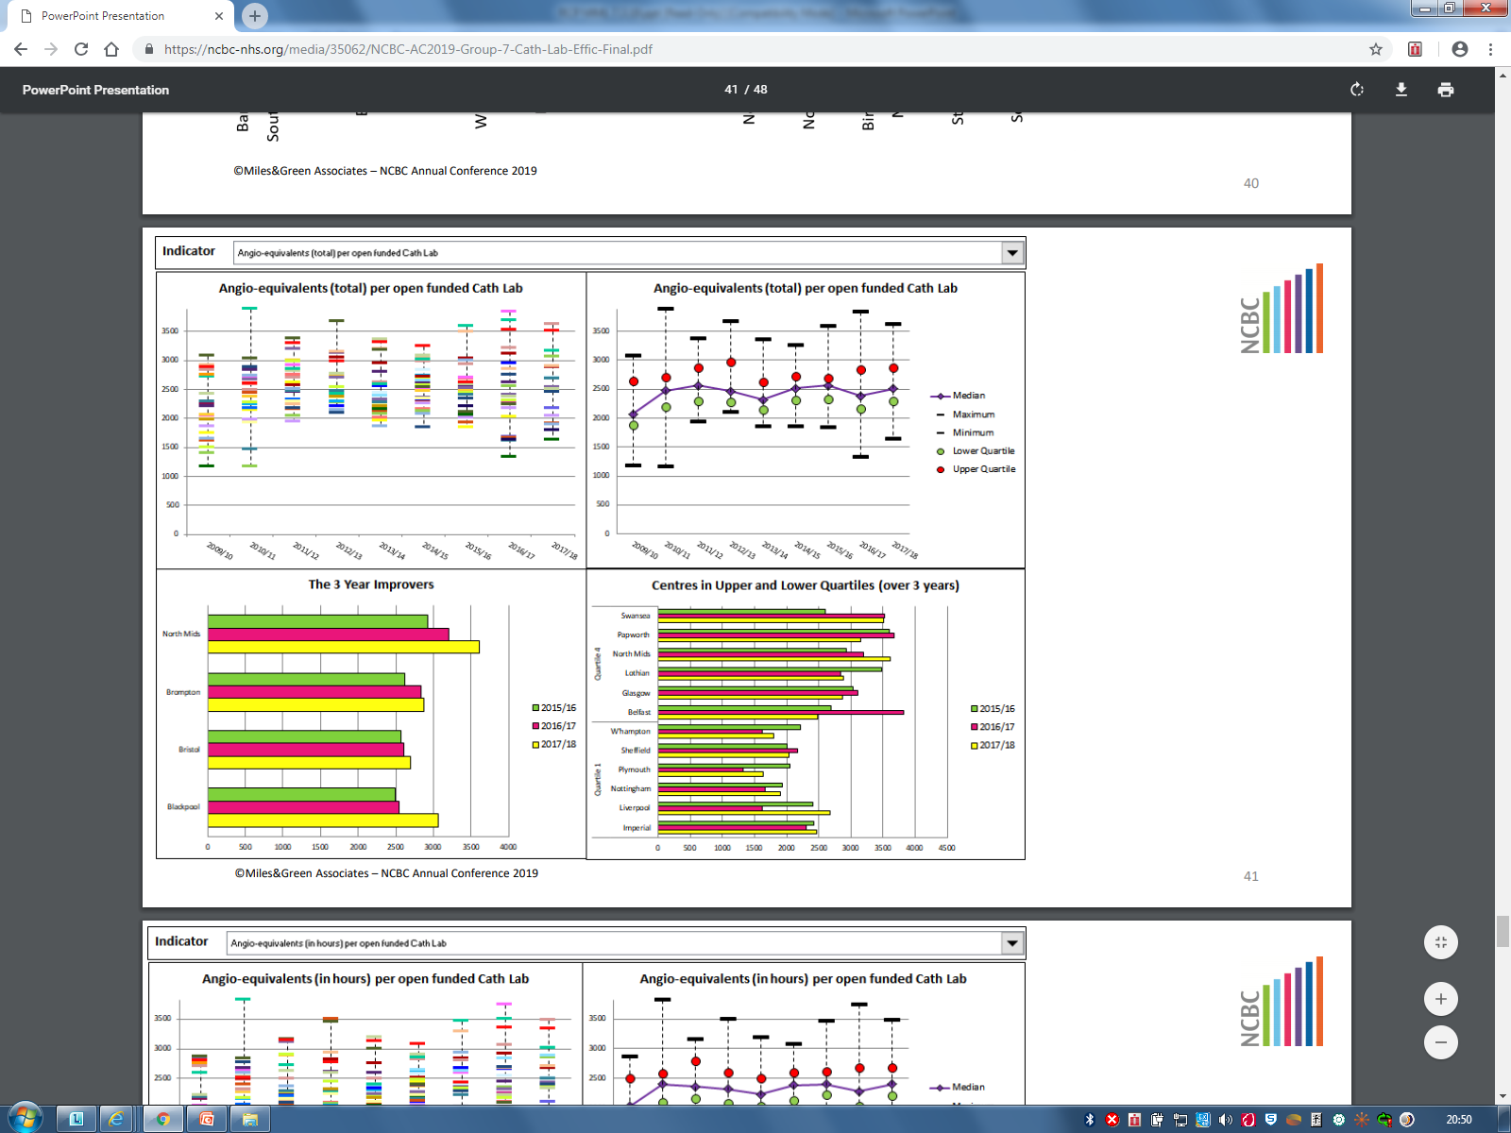

Figure 6: Number of cases per funded Cath Lab – (NCBC data 2017/18)

However the strategy concluded that the current service is no longer able to flex capacity to meet the increasing demand without expansion of the service and the recommendation to build a fifth Cath Lab including associated beds. There are significant capacity pressures within interventional cardiology resulting in long waiting times for the elective work, and sub-optimal waits for the urgent inpatient NSTEMI admissions. Figure 7 illustrates the numbers of patients on the elective waiting lists for interventional cardiology including devices, coronary intervention and EP, and the numbers waiting over 9 weeks. It is noted the waiting list peaked at the beginning of January, exceeding 1000 patients on the list. Investment in short term additional capacity, notably a mobile Cath Lab improved the position January – March 2019. The additional capacity ceased at the end of March 2019 and immediately the waiting list has started to grow due to demand consistently exceeding the core capacity.

|  |  |  |  |  |
| --- | --- | --- | --- | --- |
| **0 - 3 Weeks** | **3 - 6 Weeks** | **6 - 8 Weeks** | **9th Week** | **Over 9 Weeks** |
|

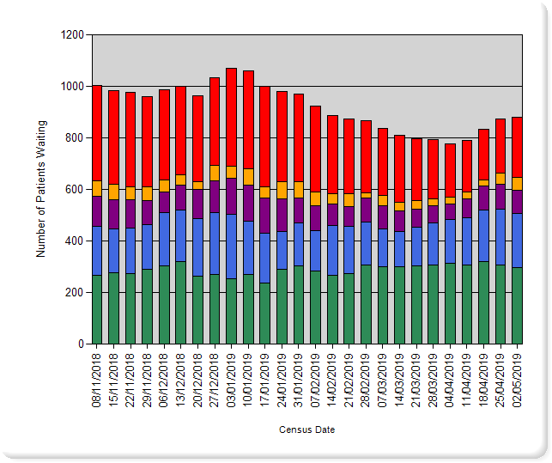

Figure 7: Elective interventional cardiology waiting list by length of time waiting

One of the key recommendations of the strategy is an increase in the Cath Lab capacity to improve access for patients to timely and appropriate treatments, both in the short and long term.

### 2.1 Coronary Intervention

Since the heart and lung service transferred to GJNH there has been a gradual increase in referrals as a result of the ageing population and changes in technology. This is further exacerbated by the inherent changes in the presentation and contemporary management of coronary disease with an incremental shift from elective stable to urgent elective procedures and volume of patients with traditional indications for cardiac surgical revascularisation being referred for consideration of high-risk and complex percutaneous revascularisation. Figure 8 illustrates the increase in total referrals to the service since 2013. It is noted that the number of elective referrals has remained constant during this period, and that the increase has been in the urgent elective demand.

Figure 8: Coronary referrals 2013 - 2019

The service has been modernised at the GJNH to meet the growing demand and delivers a high volume of activity through a relatively small footprint when compared with other centres. This has been achieved through streamlined working practices, and in particular Cath Lab capacity has been maximised through the extended day model of working which is not replicated to the same extent in the rest of the UK. In addition, GJNH has funded additional short term capacity to meet the demand and manage the waiting times through adhoc working at weekends and more recently through a mobile Cath Lab. However, it is increasingly challenging to manage the increasing demand without investment and this is demonstrated by the increasing waiting lists.

Table 3 below demonstrates the increase in coronary activity delivered through the Cath Labs over the last 10 years split by Health Board. A business case was approved by the regional boards to increase investment in the service in 2013 however there has been no further long term investment in the service despite a 9% increase in activity delivered. This has been achieved through internally funded waiting list sessions. It is noted from the table that Ayrshire and Arran, Dumfries and Galloway and GGC have driven the main increases in activity. There was a step increase in the Dumfries and Galloway activity following the closure of their Cath Lab in 2013 and demand from D&G has continued to increase year on year. Activity for Ayrshire and Arran has risen by 28.7% since 2013, and although Glasgow has seen a more gradual increase in activity, due to the large volume, this accounts for 150 additional procedures through the Cath Lab.

|  |  |  |  |  |  |  |  |  |  |  |  |
| --- | --- | --- | --- | --- | --- | --- | --- | --- | --- | --- | --- |
| Health Board | 2008-09 | 2009-10 | 2010-11 | 2011-12 | 2012-13 | 2013-14 | 2014-15 | 2015-16 | 2016-17 | 2017-18 | 2018-19 |
|  | 27 | 12 |  |  |  | 1 | 3 | 2 | 9 | 8 | 4 |
| [Foreign] | 4 | 8 | 19 | 9 | 10 | 4 | 8 | 2 | 11 | 11 | 12 |
| [UK] | 22 | 37 | 33 | 25 | 26 | 18 | 20 | 28 | 29 | 19 | 19 |
| Ayrshire and Arran | 539 | 458 | 558 | 482 | 610 | 584 | 569 | 611 | 715 | 697 | 752 |
| Borders | 3 | 5 | 1 | 8 | 4 | 2 | 4 | 6 | 4 | 1 |  |
| Dumfries and Galloway | 230 | 211 | 246 | 236 | 225 | 421 | 565 | 530 | 554 | 549 | 640 |
| Fife | 11 | 15 | 12 | 17 | 25 | 6 | 11 | 10 | 11 | 12 | 15 |
| Forth Valley | 315 | 384 | 370 | 396 | 370 | 255 | 352 | 312 | 268 | 288 | 278 |
| Grampian | 7 | 3 | 6 | 6 | 7 | 6 | 7 | 4 | 11 | 3 | 1 |
| Greater Glasgow and Clyde | 3536 | 3411 | 3617 | 3460 | 3604 | 3714 | 3583 | 3434 | 3710 | 3739 | 3757 |
| Highland | 338 | 310 | 331 | 352 | 384 | 379 | 361 | 376 | 379 | 385 | 316 |
| Lanarkshire | 416 | 400 | 349 | 341 | 346 | 309 | 299 | 292 | 324 | 295 | 328 |
| Lothian | 26 | 15 | 20 | 19 | 15 | 15 | 15 | 22 | 13 | 14 | 8 |
| Orkney | 1 | 1 |  |  |  |  | 2 | 1 | 1 |  |  |
| Shetland |  |  |  |  | 1 | 1 |  | 1 |  | 1 | 2 |
| Tayside | 19 | 18 | 8 | 16 | 14 | 11 | 7 | 16 | 7 | 9 | 7 |
| Western Isles | 92 | 76 | 86 | 79 | 96 | 85 | 112 | 119 | 72 | 91 | 103 |
| TOTAL | 5586 | 5364 | 5656 | 5446 | 5737 | 5811 | 5918 | 5766 | 6118 | 6122 | 6242 |

Table 3 – Coronary interventions performed in the GJNH by Health Board.

Based on the current demand trend, the waiting list for elective coronary intervention is projected to increase with patients exceeding 12 weeks in June if there is no additional capacity.

Figure 9: Waiting list projections for elective coronary intervention.

In line with clinical guidelines, we aim to treat the urgent NSTEMI patients within 72 hours of referral as there is substantial evidence to demonstrate that early intervention maximises clinical benefit. During the period the mobile lab was on site and we were delivering additional 35 – 40 procedures per week, it was reported that these patients were waiting longer, with only 17% being admitted within the 72 hours target in February. Performance against this target was worse than the same period in previous years, due to the impact of the additional activity on admissions and bed availability. This highlighted the importance of ensuring the appropriate infrastructure is in place to support additional elective capacity to ensure the urgent pathway is not compromised.

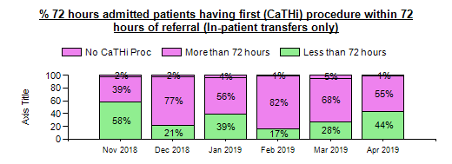

Figure 10: Performance against 72 hour target

### 2.2 Electrophysiology

The electrophysiology waiting list is currently sitting in excess of 300 patients, with capacity for 40 procedures per month. Patients are currently waiting in excess of 30 weeks from referral for their procedure, and the waiting list is growing with demand consistently exceeding referral. Figure 11 demonstrates the capacity pressures in EP.

Figure 11: EP Waiting List

The increase in the waiting list has been as a direct result of the increasing referrals received into the service since 2016. This increase has been sustained with periodic peaks in referrals as a direct result of additional arrhythmia clinics being held in Glasgow and Forth Valley.

Currently the service has capacity for 500 procedures per annum and it has proved very challenging to increase this on an adhoc basis due to the small teams of specialised staff. Capacity is funded to deliver 40 procedures per month, however in 2018-19 the average number of monthly referrals was 62 per month. It is very challenging to increase the EP capacity on an adhoc basis due to the small teams of highly specialised staff and this has resulted in the significant increase in the waiting times. Table 4 provides a break down of the increase in referrals over the last 3 years by health board demonstrating significant increases across each of the boards. Prior to 2016 the referral rates had remained relatively static, averaging 35 - 40 per month.

|  |  |  |  |  |  |  |  |  |
| --- | --- | --- | --- | --- | --- | --- | --- | --- |
| HealthBoard | Ayrshire and Arran | Dumfries and Galloway | Forth Valley | Greater Glasgow and Clyde | Highland | Lanarkshire | Other | Total Referrals |
| 16/17 | 77 | 41 | 62 | 208 | 25 | 101 | 8 | 522 |
| 17/18 | 62 | 36 | 79 | 209 | 31 | 112 | 17 | 546 |
| 18/19 | 89 | 53 | 111 | 282 | 33 | 161 | 10 | 739 |
|  |  |  |  |  |  |  |  |  |
| Percentage increase | 15.6% | 29.3% | 79.0% | 35.6% | 32.0% | 59.4% | 66.7% | 41.6% |

Table 4

A bid was submitted to Scottish Government for a second mobile Cath Lab with EP functionality to be located at GJNH June – November 2019. The plan would be to run EP lists three days per week and coronary two days per week. This would enable us to reduce the waiting list in EP by approximately 150 patients, and to address the capacity gap in coronary intervention; maintaining waiting times below the TTG.

The mobile vehicles offer short term solutions delivering additional capacity to manage the capacity gaps and the waiting times. However the mobile options do not provide a long term solution as they are expensive, dependent on the expansion programme regarding on site location, and they do not offer a solution for the complex procedures. At time of writing, it is unlikely that this bid will be approved.

### 2.3 Device Service

The device implantation service at the Golden Jubilee National Hospital is primarily for complex devices such as implantable cardioverter-defibrillators (ICDs) biventricular pacemakers (or cardiac resynchronisation therapy pacemakers, (CRT-P) and biventricular defibrillators (CRT-D). For the ICD and CRT services, implant numbers have grown gradually over the past decade. The ICD implant rate in the West of Scotland is currently around 100 implants per million population per year, the CRT implant rate is currently around 54 implants per million population. These implant rates are below the Scottish and UK implant rates. In England the CRT implant rate is closer to 200 per million population.

The device implantation service is delivered in the main theatre suite, 2 days per week. There is no flexibility during the week to accommodate urgent inpatients outwith the routine cardiology device lists and this results in patients waiting in GJNH or outlying hospitals to be treated. Transferring the service to the labs alongside the EP service would provide flexibility to device patients to the end of a Cath Lab list to delivery timely treatment, reduce prolonged hospital admissions, and avoid short notice cancellation of elective patients.

Concerns have been raised regarding the radiation exposure for staff carrying out these procedures in the theatre suite. Whilst controls have been put in place to minimise patient and staff radiation doses, the environment is sub-optimal and the risk remains on the risk register categorised as Major / Unlikely. It is proposed that the fifth Cath Lab is designed with sufficient air quality to accommodate the device implantation service. This would also provide increased flexibility to accommodate inpatient device patients at the end of EP lists.

Equipping a fifth Cath Lab and expanding Cath Lab capacity will address the capacity pressures outlined above and aligns completely with the Board’s strategy as follows:

**Patient safety** – Planning sufficient capacity to ensure patients are given the appropriate treatment timeously and are cared for in the appropriate care setting, by the appropriate team.

**Clinical outcomes and effectiveness** – There is a significant evidence base to demonstrate that improved outcomes in the high risk presentations are linked to early intervention. The GJNH has an excellent track record in delivering a high quality optimal perfusion service as evidenced through the key performance indicators, however additional capacity, including bed capacity is required to sustain this performance, and to continue to provide timely treatment to the Non STEMI population.

**Person centred experience** – One of the drivers for change is the advances in technology and treatment options available for patients. In particular, structural heart interventions, particularly non-surgical catheter based treatment of heart valve disease are becoming more widespread. This reflects emerging evidence base of non-inferiority (or indeed superiority) to surgical valve interventions in selected patients and is underpinned by robust multi-disciplinary and shared decision-making. The development of Transcatheter aortic valve implantation (TAVI) is now recognised evidence based treatment for inoperable patients or those at high surgical risk and the resultant individual patient benefits in terms of symptom control, quality (and duration) of life are exponential. The development of additional capacity will enable us to respond to the growing evidence base and advances in technology and to develop the structural heart programme to deliver appropriate treatment options to patients. It is noted that the Structural Heart programme is currently funded separately outwith the West of Scotland service level agreements, however additional physical capacity will be required to support the development of evidence based treatment options and new technologies in the future.

**Opportunities for Research** – Research has been well supported within the Interventional Cardiology services, attracting funding to GJF and university appointments, in addition to promoting staff retention. Moreover, the research potential and reputation of the Golden Jubilee Foundation is world class. It is important that research continues to be supported in the department and that sufficient capacity is available both in terms of physical and human resource to enable the research studies to run successfully. Leading quality, research, and innovation is integral to our Board’s vision. The service must capitalise on the track-record and continue to lead by example.

## 3. Description of existing service

The current Interventional Cardiology service comprises:

* Coronary Intervention
* Structural Heart Disease (Non Coronary Interventions)
* Scottish Adult Congenital Cardiac Service (SACCS)
* Electrophysiology (EP)
* Devices
* Scottish Pulmonary Vascular Unit (SPVU)
* Cardiac Imaging
* Research including Scottish National Advanced Heart Failure Service (SNAHFS)

The amalgamation of Heart and Lung services together in a multi-disciplinary centre, brought together regional, national, and in some cases, international expertise under one roof and created one of Europe’s largest integrated Heart and Lung Centres (currently we are the second highest volume Interventional Cardiology centre in the UK – Figure 12. The WoS Heart and Lung Centre has been front and centre of world-class innovation in heart and lung care. Moving forward there is an opportunity to consolidate and capitalise on this reputation as an international centre of excellence.

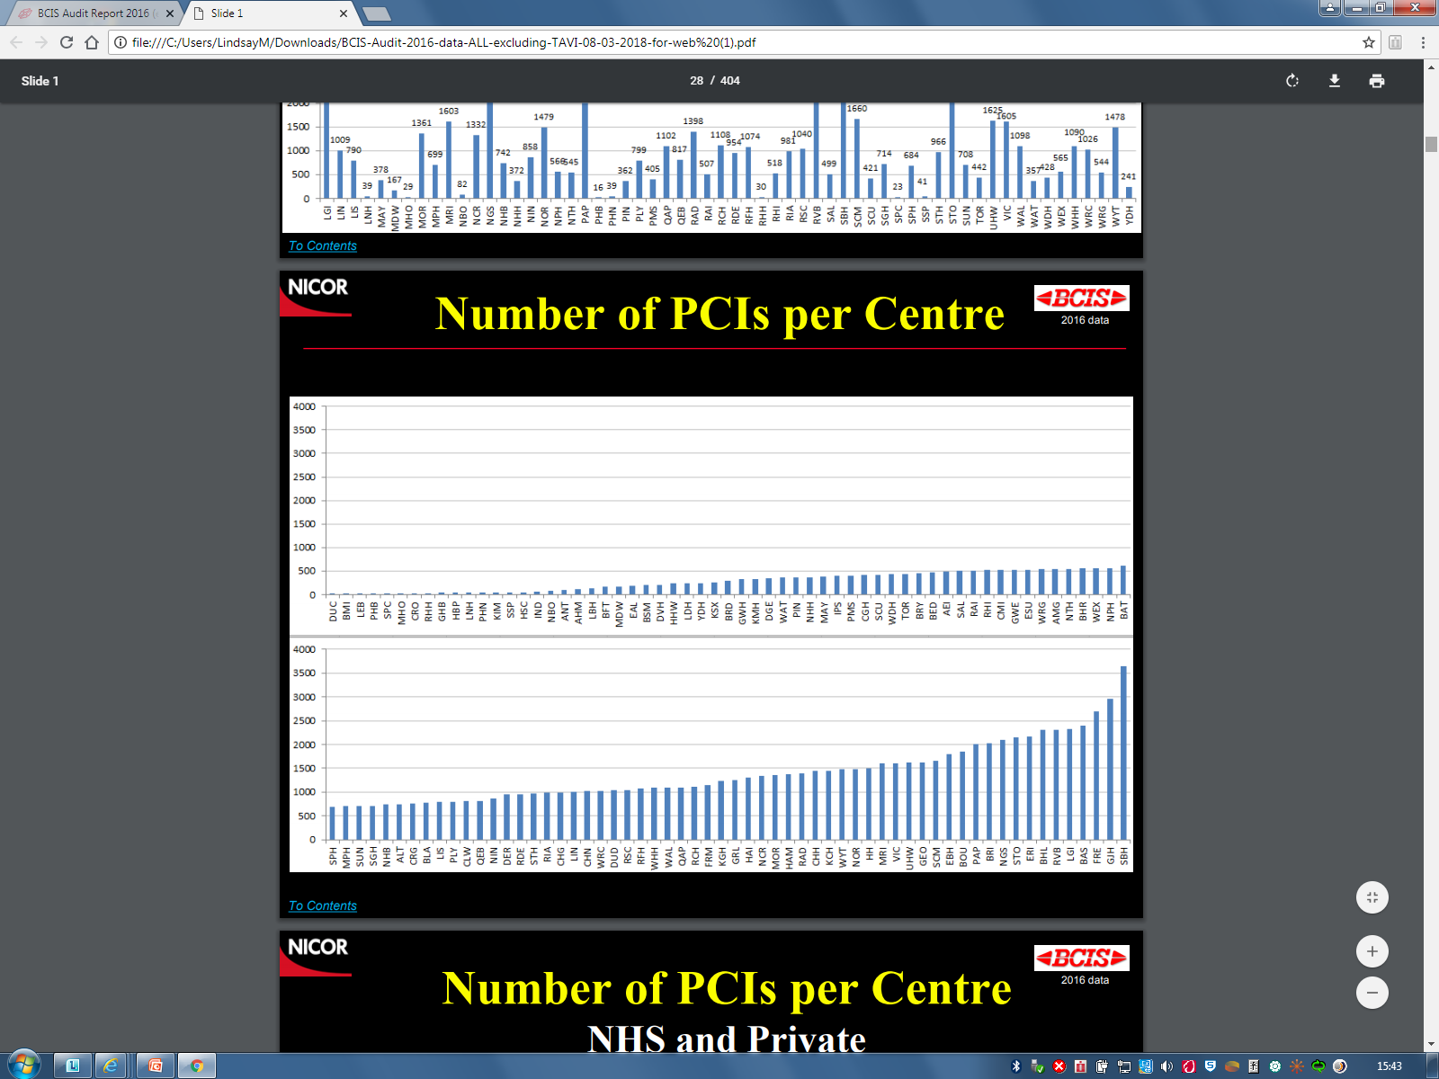

Figure 12: Annual PCI volume (BCIS audit 2016/17)

The Interventional Cardiology service is comprised of the national and regional cardiology components of the Heart and Lung Centre and is the focus for this business case. The service has redesigned over time to accommodate increasing referral activity and changes in complexity. However, the demand on the current service has continued to grow since migration, and the current capacity can no longer manage demand within recommended timelines. This growth is predicted to continue with an ageing population and changes in the management of cardiovascular disease.

The Interventional Cardiology Strategy detailed the current service and the predicted requirements for the service over the next five years, recommending a series of actions to support the risks and future proof the service for medium and long term development. Key to the strategy was recognition that the cardiology capacity needs to increase to meet the demand, and that this required an increase in the physical footprint of the cardiology unit. One of the key recommendations was the development of a fifth Cath Lab.

The development of a fifth Cath Lab will enable the service to address the capacity pressures in coronary intervention and EP, the relocation of device implantation service to the Cath Lab, and to respond to predicted growth in activity in the NSD specialties and the Structural Heart Programme. Each of these areas is discussed below.

### 3.1 Infrastructure

* Four Catheter Laboratories – (including 1 bi-plane system)
* CCU (level 2) – eight beds
* 2C – overnight ward – eight beds (closes Saturday 2pm and reopens Sunday pm)
* 2D – overnight ward – eight beds (Mon- Fri – closing Friday 20:00)
* CT scanner – two sessions / week
* Cardiac MRI – 10 sessions
* NSD ward (Level 2 ) – eight beds + lead lined procedure room
* ITU
* Out Patient clinics (NSD, RHF, TAVI)
* *Ad hoc* beds on L3 (CT Surgery) and L2 (only SPVU patients)
* Device theatre sessions x 4

### 3.2 Coronary Intervention

Despite non recurring funding from the Scottish Government, demand for coronary intervention continues to outstrip capacity. The non recurrent funding supported rental of a mobile Cath Lab on site for 12 weeks between January – March 2019. This delivered an additional 400 procedures which had a significant impact on the waiting times, reducing them from 12 weeks to 6 weeks. However, since the additional capacity ceased on 5 April 2019, the waiting list has started to grow and is projected to grow by approximately 12 patients per week, reflecting the current capacity gap.

This gap is evidenced by the current and incremental waiting list pressures and is further exacerbated by the inherent changes in the presentation and contemporary management of coronary disease with an incremental shift from elective stable to urgent elective procedures and volume of patients with traditional indications for cardiac surgical revascularisation being referred for consideration of high-risk and complex percutaneous revascularisation.

Figure 13 below illustrates the transition from a stable elective population to the management of acute coronary syndromes. This UK data is mirrored in our experience at the GJNH.

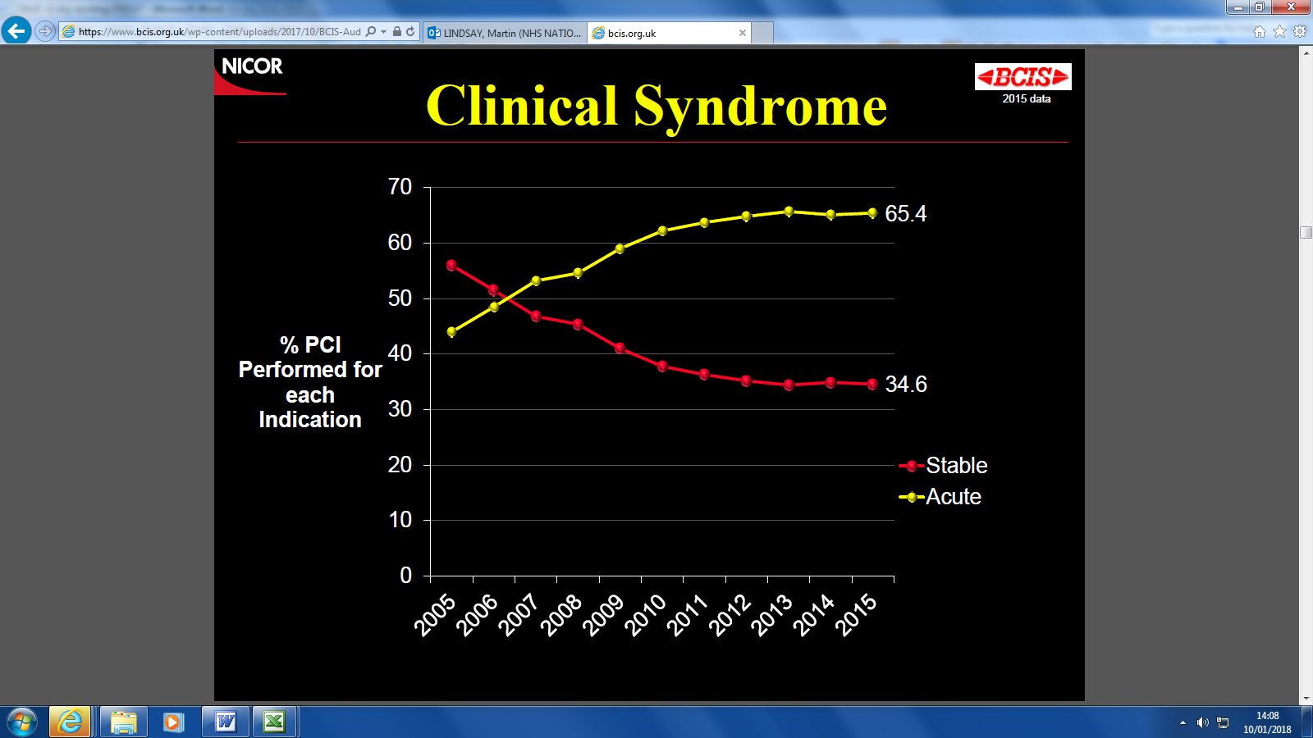

Figure 13: Indications for PCI grouped by presentation

Interventional cardiology is not immune to the pressures of an ageing and increasingly co-morbid population. This manifests itself in an increasing number of patients with conventional surgical anatomy being “turned down” for surgical revascularisation and being referred for complex PCI. This has been illustrated in the recent patient flow project which demonstrates that 1/3 of patients referred for in-patient cardiac surgery ultimately do not get CABG. The majority undergo high risk PCI. Additionally the evidence base shows that complex coronary disease can be effectively managed with complex PCI. Evolving techniques allow more patients to appropriately access revascularisation by PCI if equivalent benefit can be offered to (or they are unsuitable for) CABG.

### 3.3 Electrophysiology

Cardiac electrophysiology is the sub-speciality of cardiology that deals with the treatment of heart rhythm disorders.

The capacity gap and waiting times have increased steadily over the last 18 months predominantly due to the expanding range of treatment options available for patients with arrhythmias and the increasing evidence base for interventional EP procedures.

The rates of ablation per million population are relatively low in WoS compared to the rest of the UK and to Europe. Figure 14 below shows the average rate of ablation in 2013-14 (the most recently available data from NICOR). At that time, activity in WoS equated to approximately 200 per million population (pmp), making us comparable with Portugal and Croatia in the chart below (red arrow).

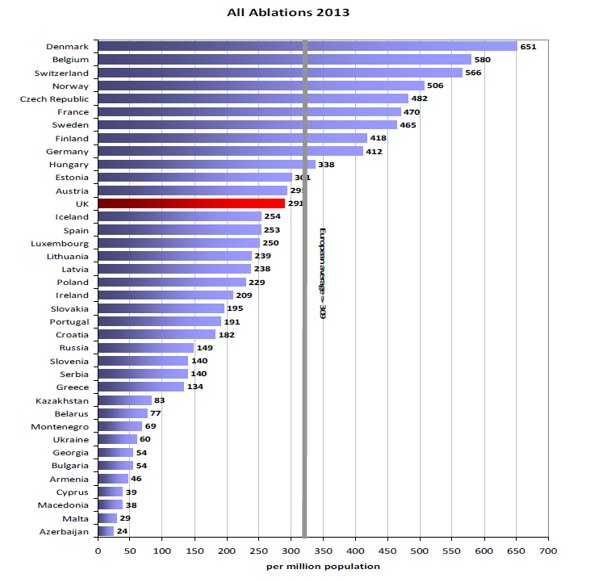

Figure 14: European Ablation Rates 2014 (NICOR National Audit of Cardiac Ablation 2013/14)

This relative low ablation rate in Scotland is recognised and is acknowledged to be a result of the limited capacity in the region as opposed to population differences. Based on contemporary evidence-based clinical guidelines and the ablation rates in the rest of the UK and Europe it is reasonable to acknowledge that there is currently an unmet need in West of Scotland and that demand will continue to grow. In order to balance our population need with capacity (measured against comparable ablation rates to the rest of the UK) our ablation numbers would need to increase to approximately 750 per annum, compared to current capacity of 500. Current WoS referrals to the service average 62 per month, equating to 744 per annum suggesting referral rates are appropriate.

The capacity gap and waiting times have increased steadily over the last 18 months, predominantly due to the expanding range of treatment options available for patients with arrhythmias and the increasing evidence base for interventional EP procedures. Patients are referred to the inpatient EP service via the regional arrythymia outpatient clinic. Prior to August 2016, all patients from West of Scotland were assessed in the arrythymia clinic in Glasgow. Following a joint appointment with Forth Valley, we are now accepting referrals direct from the consultant who assesses the patients at Forth Valley, negating the need for these patients to be reassessed in Glasgow. The Regional Planning Group is reviewing the whole pathway for these patients, recognising the current inequity of access and long waiting times prior to be added to the inpatient waiting list.

There are four x 2 session EP lists per week. 1 – 4 procedures are carried out on a full day list depending on the complexity of the procedure. On average 2-3 procedures are booked, however recently non complex lists have been organised with 4 procedures.

EP procedures are performed in a single dedicated Cath Lab, equipped with highly specialist equipment. This includes an EP recording system, radio frequency ablation system, cryo-ablation system and state-of-the-art cardiac mapping system. In most instances, only one of each equipment type exists, creating multiple ‘single point of failure’ risks for the service. The complexity of integration and embedded fibre optic communication infrastructure linking the devices also means that the equipment can not be easily re-located to another Cath Lab in the event of x-ray system failure. This has resulted in lists being cancelled due to equipment failure in the lab without the flexibility of moving cases into another functioning Cath Lab.

### 3.4 Structural Heart Disease

Structural heart disease is an umbrella term for issues which affect the valves and chambers of the heart and the blood vessels which supply and leave the heart, including the aorta. These issues may be present at birth (congenital) or develop later in life (acquired) and in some cases may have associated coronary heart disease (CHD).

Structural heart interventions, especially non-surgical catheter-based treatment of heart valve disease are becoming more widespread. This reflects emerging evidence base of non-inferiority (or indeed superiority) to surgical valve interventions in selected patients and is underpinned by robust multi-disciplinary and shared decision-making.

### 3.4.1TAVI

The development of Transcatheter aortic valve implantation (TAVI) is now recognised evidence based treatment for inoperable patients or those at high surgical risk

The TAVI rates per million populations in the rest of the UK are shown in Figure 15, illustrating the upward trend and growth of the service. In 2017 the UK TAVI rate pmp was 56.

In the same year the WoS rate per million was 28.9, whilst in the East this was 37.5.



Figure 15: TAVI rates per million population

The service in GJNH was established in April 2018 with a planned capacity of 84 TAVI procedures in the first year, increasing the pmp to 36.3. To increase access in WoS to the UK pmp average would require growth in capacity to deliver a minimum of 140 procedures per annum requiring 44 full days in the Cath Lab per annum. The Scottish Government Planning Forum is currently reviewing the TAVI service in Scotland and will publish its recommendations imminently. It is however anticipated that there will be a growth in the TAVI service across Scotland, in line with the trend in the rest of the UK, and reflecting the increasing evidence base for TAVI in patients at high risk of surgery.

### 3.4.2 Left Atrial Appendage Closure (LAAC)

NICE guidance for the technique of percutaneous transcatheter closure of the left atrial appendage in patients with non-valvular atrial fibrillation for the prevention of thromboembolism was issued in June 2010, and the procedure is now well established in multiple sites in the UK. In July 2018, NHS England issued its commissioning policy for the procedure after reviewing the evidence to treat non valvular atrial fibrillation and absolute and relative contraindications to oral anticoagulants with percutaneous left atrial appendage occlusion, concluding that there is enough evidence to consider making the treatment available. The procedure is carried out in the Cath Lab, under general anaesthetic with TOE guidance. The projected activity will depend on the NICE guidance and the recommendations, however in WoS this could be up to 20 patients per annum

### 3.4.3 Mitraclip

The establishment of a mitraclip service in WoS was approved in summer 2016 and has been supported by the WoS Boards. Given recent evidence (COAPT) it is predicted that there will be an expanded indication for Mitraclip in this selected patient group; offering a treatment option that both improves the quality and duration of life in some of the most symptomatic patients with MR associated with heart failure.

### 3.4.4 Patent Foramen Ovale Closure (PFO closure)

In 2017 a change in evidence suggested that, in selected patients who had been carefully assessed to confirm that a stroke had taken place and that it was felt to be a cryptogenic stroke related to a patent foramen ovale, device closure of the patent foramen ovale reduced the likelihood of recurrent stroke. The estimated volume from our stroke physicians is suggested to be approximately 100 cases per annum for Scotland. In terms of alternative West of Scotland models, the volume anticipated for Scotland would be best served with a two centre model.

### 3.5 SACCs

Currently SACCs delivers 120 – 130 diagnostic and interventional procedures in the Cath Lab per annum. There has been an approximate 10% increase in the adult congenital patients over the last 10 years and this increase is anticipated to continue combined with a need for repeat procedures of increasing complexity.

### 3.6 SPVU

There has been a growth in incidence of pulmonary hypertension in Scotland over the past 10 years which is predicted to continue. Patients referred to the service are admitted for comprehensive assessment which includes right heart catheterisation, carried out in the Cath Lab. It is anticipated that there will be a growing demand for this procedure mirroring the increase in survival, referral and incidence.

It is noted that the funding streams for national services and structural heart disease are currently separate and outwith the SLAs with the West of Scotland Boards. However it is important to note the general growth which is being experienced and the requirement to plan future capacity which takes into account the growing evidence base for structural heart interventions, and the increasing prevalence of ACHD and PH in Scotland.

In summary there is ongoing growth in demand for interventional cardiology procedures across the spectrum of services offered. This is due to the ageing population, new guidelines and increasing evidence and new treatment options. There has been successful redesign in the Cardiology Service to respond to the growth in demand and increasing complexity of the casemix of patients, however in response to the current pressures, and the activity projections discussed above, it is proposed that the Cardiology unit is expanded to develop a fifth Cath Lab initially providing additional capacity in EP and coronary intervention.

## 4. Summary of existing and projected capacity requirements

### 4.1 Current Capacity

### 4.1.1 Cardiology Day Unit capacity

There are up to 20 day case spaces within the Cardiology Day Unit (through 16 chairs) which is open from 07.30 until 20.00 for coronary, SACCS and SPVU patients as well as those patients requiring TOE procedure within the Cardiology Imaging department. All coronary and SACCS patients require to be observed for a minimum of 3 hours post procedure and therefore elective coronary cases planned for discharge need to have their procedure completed by 5pm to allow recovery and discharge from the day unit before 8pm. Increasing elective activity through the Cath Labs is limited by the number of spaces available in the day unit along with unit closure at 8pm. Without a redesign of the area there is no capacity for additional chairs.

### 4.1.2 Cath Lab capacity

The recently published BCIS data demonstrates that GJNH is the highest activity coronary lab in the UK, performing 2946 PCIs in 2016/17 through 2.5 labs (The remaining 1.5 lab capacity covers unfunded lab sessions x 2 (two labs Friday pm) and delivery of SACCS, SPVU, EP activity). Activity has remained high with 2949 PCIs in 2018/19 and a total of 6972 diagnostic and interventional procedures.

GJNH has redesigned the service significantly since transfer and subsequently achieved high activity levels through extended days, ongoing daily focus to ensure optimisation of bed utilisation, maximum use of Consultant flexible sessions and effective waiting list management. The GJNH remains the only lab in UK routinely working extended days for elective work and performs in the top quartile of high performing Cath Labs in the UK when comparing efficiency and throughput of coronary workload. Figure 16 compares the activity delivered per open funded Cath Lab demonstrating that Glasgow is one of the highest performing Cath Labs in the UK.

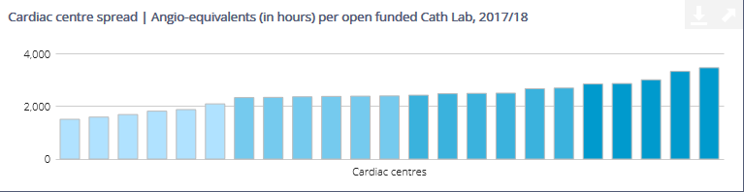

Figure 16: Comparison of In-hours Angio Equivalents per Cath Lab 2014/15 (NCBC dataset)

### 4.1.3 Bed capacity

* CCU (level 2) – eight beds
* 2C – overnight ward – eight beds (closes Saturday 2pm and reopens Sunday pm)
* 2D – overnight ward – eight beds (Mon- Fri – closing Friday 20:00)
* Ad hoc beds on L3 (CT surgery) and L2 – only SPVU patients

Table 5 provides further benchmarking information comparing the activity and infrastructure in GJNH with Liverpool Heart and Lung Hospital and Papworth which are comparable in that they are elective, stand alone heart and lung centres with similar activity levels.

|  |  |  |  |  |  |
| --- | --- | --- | --- | --- | --- |
|  | Card beds | CCU | Day Case Cap | No of Cath Labs | Total No of PCI |
| Liverpool | 41 | 10 | 18 | 5 | 2677 |
| Papworth | 27 |  | 21 | 5 | 2214 |
| Glasgow | 15 | 8 | 16 | 4 | 2949 |

Table 5: Comparison of infrastructure supporting Cath Lab activity

GJNH currently delivers high volume capacity through a comparably small footprint of Cath Labs, day unit and overnight beds. As discussed this has been achieved through continued improvement and modernisation, maximising the Cath Lab capacity via extended days and high utilisation. In addition GJNH has a high day case rate for coronary procedures and is improving the day case rates for EP and device procedures. The negative impact of the increased activity during January – March 2019 has demonstrated the importance of ensuring that the infrastructure is expanded to support any increases in Cath Lab capacity to ensure that there are sufficient day case areas and overnight beds to deliver the required increased volume of elective work whilst continuing to delivery high quality and timely care to the urgent patients.

### 4.2 Capacity Gap

Considering the current interventional cardiology footprint (Cath Labs, beds and day-case procedures) against benchmarking data from other high-volume tertiary referral centres several shortfalls are evident. With a projected increase in coronary, EP and non-coronary (structural) Cath Lab work together with increasing complexity of intervention and a shift from elective to urgent inpatient demand, the service will require expansion. Table 6describes a summary of the current demand against activity and highlights the minimum infrastructure required to deliver against the current demand.

|  |  |  |  |  |  |
| --- | --- | --- | --- | --- | --- |
| Current Service pressure | Demand | Capacity | Gap | sessions / week | Beds / chairs |
| Coronary Intervention (excl ORS) | 5835 | 5189 | 646 | 3.25 | 3 beds x 1 night, 6 chairs |
| Electrophysiology (inc SACCS) | 700 | 500 | 200 | 3.25 | 2 beds x 1 night , 2 chairs |
| Structural heart disease | 125 | 84 | 41 | 0.5 | 2 beds x 3 nights |
| Research | varies* | 0 |  | 1 session* |  |
|  |  |  |  | 8 | Min 3 beds and 6 chairs |

*Depending on trial numbers and recruitment Table 6: Summary Current Capacity gap

### 4.3 Future Projections

### 4.3.1 Coronary Intervention

The management of both acute and chronic CHD is likely to continue to dominate workload within interventional cardiology in the near and intermediate future. Though the incidence of new disease may be in part reduced by risk factor modification through public health measures, this is likely to take many years to manifest and will be offset by an aging population with considerable burden of additional long term conditions. Within the coronary interventional community there has been, and will continue to be, a shifting workload from the management of stable CHD (stable angina) to emergency or urgent presentations (following acute coronary syndrome). Increased flexibility is required to effectively meet the increase in unscheduled demand timeously.

It is important that Cath Lab capacity is increased to meet the current demand, and also builds in additional capacity to meet future increases in demand and the flexibility required to meet the growing demand for unscheduled care. It is noted that additional day case and bed capacity is required to support additional Cath Lab activity – a minimum of 6 recovery chairs and 3 overnight beds.

### 4.3.2 Electrophysiology

The demand for EP currently outstrips capacity. Capacity is restricted to approximately 500 procedures per annum based on four full day lists with an average of 2-3 procedures per list depending on complexity. The complexity of patients is increasing, and in particular for the ACHD population. These procedures tend to be very complex, often requiring dual operator and general anaesthesia Since January 2019 we have been running non complex lists with 4 cases per day and this has been implemented successfully, increasing productivity and activity through the Cath Lab. However, the numbers on the waiting list are in excess of 300 with 116 patients waiting over 12 weeks. Referrals are averaging 62 per month equating to 744 referrals per annum. In order to increase capacity to meet this demand, which would bring us in line with the UK ablation rates, we would need to deliver 14 -15 procedures per week, currently we provide an average of 10 procedures per week. Increasingly, patients are admitted for their ablation as a day case avoiding a hospital admission which will minimise the impact on bed capacity.

### 4.3.3 Devices

There is scope for redesign to redistribute some elements of the service across other Health Boards and this is currently being considered by the Regional Planning Group. However, WoS activity is behind the rest of Scotland and the UK and is therefore likely to expand. One of the disadvantages of the current service model is that the service is delivered in fixed sessions with no flexibility to meet urgent demand. Relocating the service to a Cath Lab where EP is delivered, would provide some flexibility as urgent cases could be added to the end of an EP list, thus minimising delays to treatment and unnecessary bed stays in hospital waiting for treatment.

### 4.3.4 Structural Heart Disease

The TAVI service is well established and patient outcomes after the first year have been excellent. The TAVI rates per million population remain low compared to the rest of the UK, and the service is expected to grow mirroring experience in the rest of the UK, and also reflecting current evidence. Additional Cath Lab and bed capacity will be required to support any growth in this service. This service is funded separately on an cost per case basis, however we require the physical infrastructure including Cath Lab and beds to deliver expansion.

### 4.3.5 NSD Specialties

It is noted that as treatments improve survival and disease prevalence is increasing for both SPVU and SACCs and this is therefore likely to increase the number of catheter based assessments and complex interventions. Currently both services run to capacity.

## 5. Achieving full capacity

The drivers for change are clear:

* The unyielding burden of cardiovascular disease (particularly in the West of Scotland).
* An aging and often poly-morbid (two or more chronic health conditions) population and a challenging fiscal landscape which must react to emerging evidence.
* The use of technology and innovation in a realistic and flexible manner.
* The requirement to relocate the device activity out of theatre and to reduce radiation exposure for patients and staff.

To achieve the Board ambition of international centre of excellence status and to respond to the increasing demands (population, innovation, emerging research and national / regional priorities), further capacity is needed. The current estimated capacity gap in the labs is 7 sessions per week – 4 coronary and 3 EP sessions with associated beds and expansion of the day unit. A minimum of 3 beds and 6 recovery spaces is required to support the additional activity planned.

The benefits gained from addressing these needs include:

* Reduced waiting times
* Future proof the service
* Flexibility to meet the increasing urgent demand, specifically developing the NSTEMI service
* Respond to new evidence / guidelines and changes in the therapeutic landscape
* Reduction in radiation exposure

The fifth lab will operate 5 days per week. A provisional schedule for the fifth lab is shown below. The additional 7 sessions are highlighted. The device activity is a relocation of service. The third coronary session on Thursday has been moved from a core session from the main labs to improve work flow.

|  |  |  |  |  |  |
| --- | --- | --- | --- | --- | --- |
|  | **Monday** | **Tuesday** | **Wednesday** | **Thursday** | **Friday** |
| Am | EP* | Device | Coronary | Coronary | Device |
| Pm | EP* | Device | Coronary | Coronary | Device |
| Eve | EP* |  |  | Coronary |  |

*Requires funding for EP equipment Table 7: Provisional schedule for CL 5

This will deliver an additional 190 EP cases and 646 additional coronary procedures per annum, fully addressing the current capacity gap in coronary, and significant increasing the EP capacity in line with UK ablation rates. Providing EP functionality in a second Cath Lab also provides more flexibility to this service, and resilience against equipment failures. In addition, it is anticipated that there will also be scope to carry out additional device procedures on reduced EP lists providing a more responsive urgent Device service and reducing unnecessary lengths of stay for these patients.

The proposed workforce to support the additional EP and coronary service model is as follows: This does not include the Device service which is expected to be cost neutral as the staff will transfer from Theatres with the service.

|  |  |  |
| --- | --- | --- |
| **Workforce** | **Number WTE** | **Recruitment lead-time including training** |
| EP Consultant | 1 | 24 wks |
| Cardiologist - Coronary | 0.5 | 24 wks |
| Band 6 Radiographer | 1.3 | approved WRG 25/03/19 |
| Band 5 Nurse | 2.17 | approved WRG 25/03/19 |
| B 6 Nurse | 2.11 | approved WRG 25/03/19 |
| Band 3 | 2.17 | approved WRG 25/03/19 |
| Band 7 ANP | 0.5 | approved WRG 25/03/19 |
| Band 7 Cardiac Physiology EP | 0.87 |  |
| B 6 Cardiac Physiology Coronary | 0.3 |  |
| B7 Cardiac Physiology Coronary | 0.3 |  |
| B7 Student Cardiac Physiology -EP | 1 | 2 year training programme |
| B6 Student Cardiac Physiology Coronary (B6) | 1 | 2 year training programme |
| Admin - various |  | 12 wks |

Table 8

Radiographer and nursing recruitment was approved in anticipation of the second mobile lab from 1 August 2019. Recruitment has been suspended until recurrent funding has been approved, however, whilst recruitment to these specialist posts is challenging we expect to appoint in time for the fifth lab. There is a lead in time for all staffing groups of minimum 3 months to recruit and train new staff.

Timing of recruitment will be critical to successful appointment. There are opportunities to advertise joint posts in EP and this is a strategy supported by the WoS Health Boards as part of the review of equity of access. There are a limited number of suitable candidates however advertising prior to September will increase the likelihood of recruitment. Appointment to the consultant coronary sessions is expected to be successful; however there will be a lead in time of 3 months to facilitate required changes to job plans. It is noted that the lead in time can be up to 24 weeks between offer and start date for permanent consultant posts.

Cardiac Physiology recruitment is recognised as being a challenge and a risk, due to the national shortage and current unfilled vacancies. Using vacancy money, we have successfully appointed student physiologists, initiating an ‘Academy’ in this area, however due to the length of the training, these staff will not be fully trained until February 2021 and there will therefore be a gap of approximately 12 months. This training programme is established and the plan is to continue this Academy beyond the first intake of trainees, taking into account the national shortages and recruitment challenges, staff turnover and projected growth in demand for cardiac physiology in the Cath Labs. In addition to the trainee programme, we will continue to try and recruit to the permanent posts and will use temporary staffing solutions where required and available to address any gaps.

Within EP, we are reviewing working practices to increase the number of procedures which can be delivered independently by one physiologist with support from the team. This will release resource to support additional lists. There is also a succession plan in place to start training existing members of staff.

## 6. Objectives

Purpose of the project – Benefits of development

* Deliver national waiting time guarantees and address regional waiting time pressures in coronary intervention and electrophysiogy.
* Increased efficiency across all interventional cardiology pathways
* Meets service demands and future sustainability
* Enables the relocation of the Device Implantation Service to an appropriate dedicated imaging environment
* Increases the resilience of the EP service
* Reduces the impact of downtime, including planned replacement and maintenance
* Supports development of the Structural Heart Disease Programme
* Produces high quality imaging meeting the demands of the service
* Provides high quality training and opportunities for staff professional development

**Service Objectives**

| **Objectives (In no particular order)**  ***Quality Criteria*** | **Related Success Criteria**  ***Acceptance Criteria*** |
| --- | --- |
| **Addresses regional waiting times pressures in Coronary Intervention and EP**   * Supports the Scottish Government in addressing regional pressures in Coronary Intervention * Supports projected increase in activity | * Increased in-house activity will be demonstrated in GJNH activity statistics for the Regional Coronary Intervention and EP waiting times patient cohorts |
| **Supports increased efficiency across all Interventional cardiology pathways of admission**   * Increases capacity to accommodate *emergency admission from SAS and local A&E* in a timely manner * The increased capacity will allow a greater volume of *elective admissions* to be processed * Urgent inpatient pathway – *Inter hospital transfers and direct NSTEMI admissions*, will be better served by a larger number of labs. This would also support the proposed expansion of Direct NSTEMI service | * Door to balloon times will remain at least on a par with our current UK leading average. Table below demonstrates we have the shortest median door to balloon time (2017/18)      * The increased lab capacity will better support definitive treatment for the average 250 elective coronary referrals and 62 EP referrals per month. * Waiting times statistics will demonstrate a reduction in patients waiting for treatment and a reduction in the period of time they are waiting. * Increase in the number of urgent inpatient transfers having their procedure within 72 hours of referral.   25iS0T1 |
| **Meets current and future service demands across Interventional Cardiology**   * Supports the expansion of the *Electrophysiology* service to meet growing demand by providing increased Cath Lab capacity. * Supports *SACCS* in the delivery of an increasing number of complex interventions * Supports the predicted slow, steady growth in *SPVU* by accommodating expansion beyond the already fully utilised allocated session | * Waiting times statistics will demonstrate a reduction in patients waiting for treatment and a reduction in the period of time they are waiting. * Statistics will demonstrate an increase in SACCS patient throughput and complexity of caseloads. * Capacity will be available to flex up SPVU throughput to match increase in demand |
| **Enables the relocation of the Device Implantation Service to an appropriate dedicated imaging environment**   * Provides high quality imaging to support implantation * Delivers the service in an environment with appropriate dose management to protect patients and staff * Addresses a long standing organisational risk centred around delivering this service with a C-arm in a Theatre environment | * Imaging will be provided on high quality digital angiography system * Established radiation protection controls found in dedicated imaging Cath Labs will be applied to this service * The organisational risk will be nullified |
| **Increases the resilience of the EP service**   * EP functionality in 2 labs * Flexibility to run 2 parallel EP lists * Increased resilience if equipment failure to relocate to 2nd lab * Address single point of failure risk associated with delivering the service with multiple examples of one-off items of equipment. * Addresses lack of EP cabling infrastructure outwith CL2 | * Reduced cancellations due to equipment failure * Increased activity |
| **Reduces the impact of downtime, including planned replacement and maintenance**   * Current waiting times pressures have effectively rendered the planned equipment replacement of the Cath Lab imaging systems unattainable. We have now reverted to a ‘replace on failure’ mode which will see increasing levels of breakdowns and unplanned downtime as the system continues to age. Over time, the technology will continue to be surpassed by newer systems delivering better diagnostic visualisation and improved workflow at lower doses. Eventually the system will develop a significant failure that will force replacement at a time not of our choosing. The resulting unplanned replacement will have a significantly increased period of downtime when compared to a planned replacement. Digital angiography systems are not purchased off the shelf, but are instead manufactured to order with lead-times measured in months. This will critically impact on the delivery of services. Mitigation will be mainly restricted to the hire of a mobile Cath Lab. This is a highly specialised and limited market where availability can not be guaranteed. | * The remaining Cath Labs will be replaced within a controlled project structure at a time suitable to the service |
| **Supports development of the Structural Heart Disease Programme**   * Provides the GJNH TAVI service introduced in April 2018 with physical space to grow in line with predicted demand * Provides scope to deliver the TAVI service in an environment with theatre quality air filtration and a high volume of air changes. * Supports delivery of additional services such as:   + Left Atrial Appendage Closure (LAAC)   + Percutaneous Transcatheter mitral valve repair (mitraclip)   + Patent Foramen Ovale Closure In Cryptogenic Stroke (PFO) | * An increase in TAVI throughput will be demonstrated in GJNH statistics. |
| **Provides high quality training and opportunities for staff professional development**  Improved environment  Increase in cases  Appropriately staffed lists  Increased complexity of cases and research opportunities  Development of training academy | * Recruitment and retention statistics – review unfilled vacancies in key staff groups * Recruitment to and from the Cardiac Physiology training academy * Reduction in sickness absence rates |

Table 9: Service Objectives

**Equipment Objectives**

| Objectives (In no particular order)  *Quality Criteria* | Related Success Criteria  *Acceptance Criteria* |
| --- | --- |
| **Up to date technology**   * Stakeholders will benefit from the use of recent technology advances | * Patients will receive minimised radiation doses in line with our most recent equipment * Users will receive minimised radiation doses in line with our most recent equipment * Image quality will be on a par with our most recent equipment, providing excellent diagnostic visualisation * There is increased scope for multi modality integration |
| **Value for money**   * The decision process will consider cost as a primary factor | * Value for money will be demonstrated and measurable through the procurement process |
| **Delivered in a timely manner**   * The project is delivered in the specified timescale | * Project timescale will be monitored by the project board with appropriate tolerances applied with respect to dependencies on related build projects |
| **Optimise workflow**   * The unit will be compatible with the national Carestream PACS and RIS system * The new unit will be compatible with and integrate with existing GE archive/workstations * Will accommodate standardised working between labs * Disruption and down time due to installation of the new system will be minimised | * Full connectivity with RIS, PACS and Centricity Archive will be achieved * Full connectivity with the GE workstations will be achieved * Room will be usable for advanced cardiac intervention * The project plan will detail installation downtime and methods to reduce disruption. This will be reviewed by operational and clinical leads to ensure acceptability |
| **Management of Radiation exposure**   * Minimises patient and staff radiation exposure * Provides appropriate dose monitoring | * Patient exposure will be on a par with or better than diagnostic reference levels set by Clinical Physics * A system will be in place to real-time monitor staff exposure * Monitoring of patient doses will be performed automatically |
| **Image quality**   * Produces high quality imaging meeting the demands of Interventional Cardiology | * Image quality will, as a minimum, be on a par with recently purchased systems * The system will incorporate advanced imaging enhancement software * Clinical Physics will carry out acceptance testing and routine QA * Radiographers will carry out routine QA |
| **Future sustainability**   * Provides scope for development of the Interventional Cardiology service * Supports innovation | * There will be increased scope for multi modality integration * The system will be state of the art * The system will be a platform designed to accept new innovations and upgrades |
| **Safe**   * UPS backup for greater safety during power failure * Comply with relevant British and European standards and legislation * Fully compliant with MEIGaN Regulations | * UPS will be available for backup fluoroscopy * Acceptance testing will be carried out * Will meet MEIGaN requirements |

Table 10: Equipment Objectives

## 

## 7. List of business options

The final options for review by Benefits Appraisal were :

* **Option 1: Do nothing**

Continue to deliver the interventional cardiology service with the existing 4 Cath Labs, 16 day unit chairs, and the 3 wards. This option includes a temporary mobile lab.

* **Option 2: Increase capacity through existing infrastructure**

Increase capacity through the current 4 labs by increasing efficiency and extending days during Monday - Friday

* **Option 3: Equip a fifth Cath Lab**

For the purposes of this business case, Option 3 has been split into options 3a and 3b. Option 3a is inclusive of EP activity and equipment and 3b is exclusive of EP. The splitting of this option allows the consideration of the impact operationally and financially of further development of the EP service. This may delay realisation of benefits around EP resilience and flexibility.

These options have been reviewed by the Risk and Benefit Appraisal process.

## 8. Benefits appraisal & assessment of risk

A Benefits and Risks Appraisal Workshop took place on Wednesday 20 February to assess the non-financial benefits associated with a range of options. The session was facilitated by Carole Anderson, Head of Strategy and Performance.

### 8.1 Stakeholders

The process was completed by a number of stakeholders representing a range of relevant interests:

|  |  |
| --- | --- |
| **Name** | **Job Title** |
| Carole Anderson | Head of Strategy and Performance |
| Alex McGuire | Clinical Services Manager - RNM |
| Dr Mitchell Lindsay | Operational Lead – Interventional Cardiology |
| Jennifer Hunter | Senior Nurse Manager – Cardiology |
| Lynne Ayton | Associate Director of Operations |
| Steven Friel | Head of Medical Physics |
| Gerry Cox | Head of Estates |
| Susan Robertson | Senior Nurse - Prevention and Control of Infection |
| Lily Bryson | Assistant Director of Finance for Governance and Financial Accounting |
| Jennifer Gilchrist | Interim Head of Radiology |
| Irene Crawford | Head of Cardiac Physiology |
| Jane Christie Flight | Employee Director |
| Sharon McCabe | Senior Charge Nurse – Interventional Cardiology |
| Paul Rocchiccioli | Consultant Cardiologist – RNM Clinical Governance Lead |
| Theresa Williamson | Associate Nurse Director – SS |
| Karen Main | Lead Radiographer Cardiac Cath Labs |

Table 11

### 8.2 Option appraisal process

The long list of options identified at the project outset was as follows:

* **Option 1: Do nothing**

Continue to deliver the interventional cardiology service with the existing 4 Cath Labs, 16 day unit chairs, and the 3 wards. This option included a temporary mobile lab as this was in place Jan – March 2019.

* **Option 2a: Increase capacity through existing infrastructure**

Increase capacity through the current 4 labs by increasing efficiency and extending days during Monday - Friday

* **Option 2b: Increase capacity through existing infrastructure**

Increase capacity through the current 4 labs by opening at weekends

* **Option 3: Equip fifth Cath Lab**

During the review of options at the Benefits Appraisal, the Group agreed that Option 2a should be discounted as the labs operate very efficiently when benchmarked with other centres across the UK, and there is limited scope to increase capacity during Mon – Fri.

The final options for review by Benefits Appraisal were therefore:

* **Option 1: Do nothing**

Continue to deliver the interventional cardiology service with the existing 4 Cath Labs, 16 day unit chairs, and the 3 wards. This option included a temporary mobile lab as this was in place Jan – March 2019.

* **Option 2: Increase capacity through existing infrastructure**

Increase capacity through the current 4 labs by opening at weekends

* **Option 3: Equip fifth Cath Lab**

### 8.3 Assessment of benefit criteria

The group discussed the proposed benefits criteria in detail and following some modifications a total of ten benefits were agreed for review. These benefits were then ranked and weighted according to how important they were seen to be in achieving the aims of the business case.

|  |  |  |  |
| --- | --- | --- | --- |
| **Ref** | **Heading** | **Ranking** | **Weighting** |
| **B1** | **Meet service demands and future requirements** Provides space and capacity to meet the current capacity gap in Coronary and EP intervention and projected future increases in demand and complexity. Requirement for infrastructure to support increased capacity including inpatient beds and the day unit. | 1 | 25 |
| **B2** | **Improved workflow and flexibility** Increase capacity and flexibility to deliver timely treatment to the NSTEMI population. | 3 | 13 |
| **B3** | **Quality and Safety**  Increase safety by enabling Device Activity to be moved from theatre -reduced radiation exposure and reduce complication rate.  Co-location of services and delivery of urgent care | 2 | 17 |
| **B4** | **Improved work flow and working environment**  Enhanced working environment, and improved ergonomics leading to more efficient working and an improved experience for the patients. | 4 | 10 |
| **B5** | **Support Strategic aims** Supports the delivery of Board’s objectives to deliver high quality regional interventional cardiology services, and the objectives outlined in the Cardiology Strategy endorsed by the Board in October 2018 which included the future development of the Structural Heart Disease Programme, leading research and innovation and to develop as an interventional centre of excellence. | 2 | 17 |
| **B6** | **Service Resilience**  Improve resilience and business continuity and support planned maintenance. This will improve reliability and service efficiency – reducing cancellations | 5 | 8 |
| **B7** | **Improve Recruitment and Retention Opportunities**  Develop a sustainable workforce and provide opportunities for training by delivering in-house training or apprenticeships. This will support the career development of our workforce, particularly in the hard to recruit specialties, and improve staff retention. | 4 | 10 |
| **Total** |  |  | **100** |

Table 12

### 8.4 Results of the benefits scoring exercise

The outcome of scoring the options is detailed below with copy of the full spreadsheet detailed in Appendix 1.

|  |  |  |  |
| --- | --- | --- | --- |
| **Option** | **Weighted**  **Score** | **% of Maximum Possible Score** | **Rank** |
| **Option 1: Do nothing**  Continue to deliver the interventional cardiology service with the existing 4 Cath Labs, 16 day unit chairs, and the 3 wards. | 257 | 10% | 3 |
| **Option 2: Increase capacity through existing infrastructure**  Increase capacity through the current 4 labs by increasing efficiency and extending days during Monday - Friday | 420 | 16.3% | 2 |
| **Option 3: Equip 5th Cath Lab** | 767 | 29.8% | 1 |

Table 13

As Option 1 entailed the lowest level of change from the status quo it was demonstrated to offer the least scope for improvement. As such this option received the lowest benefit score.

Options 2 and 3 were all found to offer benefits across all benefit categories. As Option 3 represented the most significant change from the status quo, however, it was found by the group to offer the most benefit particularly in terms of improving quality and safety and progressing the strategic aims of the Board.

### 8.5 Risk assessment

The risk assessment is intended to identify the key risks associated with the short listed options. The key risks were developed and assessed to determine the extent to which these impact on the shortlisted options. The risks were also aligned to the Board’s risk clusters.

The group discussed the proposed risk criteria in detail and following some modifications a total of nine risks were agreed for review.

|  |  |  |
| --- | --- | --- |
| **Cluster** | **Ref** | **Heading** |
| **Financial** | **R1** | **Funding availability**  The funding required to progress and complete the project is not made available |
| **R2** | **Project overspend (Equipment & Service delivery)**  The combined spend for the project will go over budget, exceeding the costs identified or incurring unplanned recurring costs |
|  |  |
| **Regulation** | **R3** | **Excessive Radiation Exposure**  Unable to provide a safe and appropriate working and training environment  Failure to comply with Health and Safety Regulations |
| **Reputation** | **R4** | **Failure to meet waiting time standards**  Not being able to deliver sufficient capacity to meet current and projected demand |
| **R5** | **Inability to increase quality of service provision**  Unable to increase quality of service as benchmarked against comparable peers. |
| **Operational** | **R6** | **Actual demand exceeds designed capacity**  Demand is higher than projected due to new technologies, clinical guidelines etc. |
| **R7** | **Unable to fully support all patient activity as a result of expansion**  Risk of not being able to deliver planned expansion in capacity if supporting infrastructure in not sufficient. |
| **Workforce** | **R8** | **Availability of Workforce**  Inability to recruit or train sufficient numbers of staff to deliver the expansion |
| **R9** | **Ability to change workforce models to suit the preferred option**  Inability to revise workforce models / shift patterns. Inability to engage the current workforce. |

Table 14

Thereafter, each of the options was appraised against the identified risks in terms of the impact/likelihood of occurrence the outcome of which is detailed below. Full scoring details are included in Appendix 2.

|  |  |  |
| --- | --- | --- |
| **Option** | **Risk Score** | **Risk Ranking** |
| **Option 1: Do nothing**  Continue to deliver the interventional cardiology service with the existing 4 Cath Labs, 16 day unit chairs, and the 3 wards. | 139 | 3 |
| **Option 2: Increase capacity through existing infrastructure**  Increase capacity through the current 4 labs by increasing efficiency and extending days during Monday - Friday | 128 | 2 |
| **Option 3: Equip 5th Cath Lab** | 94 | 1 |

Table 15

Option 3 demonstrated the lowest risk on the basis that it addressed the risks associated with excessive radiation exposure, and the lowest risk to the Board’s reputation as an Interventional Cardiology centre of excellence by failing to meet waiting time standards and improve quality of care as the preferred option offered sufficient capacity and flexibility.

Option 2 was found to be of second lowest risk albeit for different reasons. Option 2 was the most risky option in terms of being able to recruit and develop the workforce model to deliver 7 day working. It was however less risky in terms of service disruption.

Option 3 was scored as the highest risk option as there was an almost certain risk of demand exceeding the capacity and therefore financial overspend funding short term expensive capacity and almost certain risk of failing to meet waiting time standards.

### 8.6 Conclusion from the assessment of benefits and risks

A summary of the results of the benefits appraisal and risk assessment is provided in the table below:

|  |  |  |  |
| --- | --- | --- | --- |
| **Option** | **Benefit Score** | **Risk Score** | **Option Assessment** |
| **Option 1: Do nothing**  Continue to deliver the interventional cardiology service with the existing 4 Cath Labs, 16 day unit chairs, and the 3 wards. | 257 | 139 | Lowest benefit, Highest risk |
| **Option 2: Increase capacity through existing infrastructure**  Increase capacity through the current 4 labs by increasing efficiency and extending days during Monday - Friday | 420 | 128 | Second highest benefit, second highest risk |
| **Option 3: Equip 5th Cath Lab** | 767 | 94 | Most benefit  Lowest risk |

Table 16

The conclusions that can be made at this stage are:

* Option 3 offers the most benefit for the least amount of risk. This option provides the greatest scope for delivering additional capacity and progressing the Boards strategy as a leading centre for interventional cardiology. It is also the only option which enables the transfer of the regional device service out of theatres into an improved environment with reduced radiation exposure.
* Option 2 offers the second highest benefit for the second lowest risk. Option 2 proposes a significant change in shift pattern moving to 7 day working and scored highly on the risk of recruitment and retention of staff. This option also offered no solution to the current risks associated with the device service operating out of the theatre environment.

## 9. Financial appraisal

### 

### 9.1 Overview

This section will describe the financial assumptions for both the revenue and capital costs for each of the three options in relation to investing in equipping an additional 5th Cath Lab and associated clinical areas.

The financial analysis will include the following:

* A detailed analysis of the capital costs of the options including the building and equipment costs;
* A detailed analysis of the revenue costs of the options and where appropriate split between recurring and non recurring;
* An economic analysis of the three options describing the net present value option appraisal;
* An expenditure profile of the preferred option;
* An analysis of the current costs of the service; and
* Details of the funding sources to support the preferred option.

### 9.2 Key financial assumptions

The financial model is driven by key assumptions which potentially have a material effect on the overall operating costs of the new service, such as;

* likely capital costs;
* projected depreciation;
* revenue cost implications including:
  + 1. Pay and non-pay costs of the new service.
    2. It is assumed that the baseline current costs of the GJNH will continue to be funded on an ongoing basis by the Revenue Resource Limit agreed with SGHSCD and any additional agreed funding supported by one of the three options described within the affordability section.

### 9.3 The scope of financial analysis

The financial analysis covers the estimated impact on the expenditure arising from:

* The revenue impact of providing a fifth Cath Lab to meet the needs of future GJNH activity;
* The revenue consequences of the capital expenditure necessary to support the options

### 9.4 Costing methodology

Each of the short-listed options has been costed in a manner that identifies the key elements of change associated with the project. The specific components of this are set out below.



Figure 17

For the purposes of this business case, Option 3 has been split into options 3a and 3b. Option 3a is inclusive of EP activity and equipment and 3b is exclusive of EP. The splitting of this option allows the consideration of the impact operationally and financially of further development of the EP service. This may delay realisation of benefits around EP resilience and flexibility.

The financial appraisal considers all 4 options

### 9.5 Capital costs

The Project Board has prepared the capital costs based on an appraisal of the capital requirements of the preferred option. The equipment costs are based on indicative costs from suppliers. Within these estimates, the table below summarises the key capital assumptions:

|  |  |
| --- | --- |
| Capital Costs | * Costed at 2018/19 outturn price base. * Equipment cost based on provisional costs provided by the incumbent supplier. * Building costs are based on estimates provided by the Head of Estates/supplier of equipment and adjusted for VAT. * Appropriate on-costs have been applied. * Fees have been applied in line with recommendations. * Peripheral equipment costs assume costs from framework * VAT is added at 20 %. |

Table 17

Having applied the costing methodology, the resultant capital expenditure is analysed in the figure below.

**Capital Costing Summary - £000**

|  |  |  |  |  |
| --- | --- | --- | --- | --- |
| **Prices exclude VAT** | **Option 1- Do nothing (Continue with mobile unit)**  **£’000** | **Option 2**  **Increase Capacity through existing Infrastructure**  **£’000** | **Option 3a Purchase CL5 + EP equipment** | **Option 3b**  **Purchase CL5 excluding EP equipment** |
| Equipment Cost – x-ray | 0 | 0 | 426 | 426 |
| Peripheral Equipment | 0 | 0 | 262 | 262 |
| EP equipment |  |  | 269 | 0 |
| **Total Ex VAT** | **0** | **0** | **957** | **688** |
| **Irrecoverable VAT** | **0** | **0** | **191** | **137** |
| **Total** | **0** | **0** | **1,149** | **826** |

Table 18

The capital costs will be incurred over a number of months and the phasing of these costs has been provided by the advisors team and is illustrated below.

Figure ‑1 Phasing of Capital Costs - £000

|  |  |
| --- | --- |
|  | **Preferred Option** |
| Year 0 – 2019/20 | 826 |
| **Total** | **826** |

Table 19

It should be noted that the capital costs for the EP equipment will be reviewed separately in the next financial year.

### 9.6 Depreciation

The following table details the depreciation calculation for the 4 options. This assumes

* Depreciation has been calculated in line with board standard policy using the following:
  + Equipment - 10 years

|  |  |  |  |  |
| --- | --- | --- | --- | --- |
| **Description** | **Option 1**  **£’000** | **Option 2**  **£’000** | **Option 3a**  **£’000** | **Option 3b**  **£’000** |
| Depreciation |  |  |  |  |
| - Equipment | 0 | 0 | 121 | 89 |
| **Total** | **0** | **0** | **121** | **89** |
|  |  |  |  |  |

Table 20

### 9.7 Recurring and Non-Recurring core revenue cost analysis

This section will detail the revenue costs for each of the options and the assumptions underlying these. Option 2 costs are based on staffing model 1 described in section 2.2

|  |  |  |  |  |
| --- | --- | --- | --- | --- |
| **Description of Recurring Revenue Costs**  **On full year cost basis** | **Option 1**  **£’000** | **Option 2**  **£’000** | **Option 3a**  **£’000** | **Option 3b**  **£’000** |
| Direct Staffing cost | 700 | 1,128 | 690 | 690 |
| Staffing cost of Mobile Unit | 258 | 0 | 0 | 0 |
| Support service Staffing cost | 53 | 0 | 44 | 44 |
| **Total staff cost** | **1,011** | **1,128** | **734** | **734** |
| Mobile Unit Hire | 526 | 0 | 0 | 0 |
| EP Consumables | 414 | 419 | 414 | 414 |
| Coronary Consumables | 711 | 845 | 711 | 711 |
| Support Service supplies cost | 4 | 0 | 3 | 3 |
| **Total Direct supplies cost** | **1,655** | **1,264** | **1,128** | **1,128** |
| Maintenance Contract / increased repairs | 0 | 200 | 111 | 79 |
| Depreciation | 0 | 0 | 121 | 89 |
| **Total Corporate cost** | **0** | **200** | **232** | **168** |
| **Total Recurring Revenue costs** | **2,666** | **2,592** | **2,094** | **2,030** |

Table 21

|  |  |  |  |  |
| --- | --- | --- | --- | --- |
| **Description of Non-Recurring Revenue Costs**  **On full year cost basis** | **Option 1**  **£’000** | **Option 2**  **£’000** | **Option 3a**  **£’000** | **Option 3b**  **£’000** |
| Revenue Equipment | 0 | 0 | 66 | 66 |
| Enabling costs | 11 | 0 | 0 | 0 |
| **Total Non-Recurring Revenue costs** | **11** | **0** | **66** | **66** |

Table 22

The revenue costs for Options 2, 3a and 3b will reflect a non-recurring phasing element between 2019/20 and 2020/21 on the requirement to utilise the Mobile Unit until Cath Lab 5 is fully operation and this is shown below on the basis of 20 weeks Mobile Cath Lab.

Figure ‑2 Phasing of Recurring Revenue Costs - £000

|  |  |
| --- | --- |
|  | **Preferred Option** |
| Year 1 – 2018/19 | 1,185 |
| Year 2 – 2019/20 | 1,319 |
| Year 3 – 2020/21 | 2,030 |
| **Total** |  |

Table 23

The recurring revenue costs above have been calculated on the following basis;

* Option 1 comprises continuing with the Mobile Cath Lab Unit on a 48 week per year basis to cover current activity gap, rental cost includes the staffing provided with the Unit rental charge on the basis of Radiographer, Nurse and EP Physiology staffing. Annual rental charge on 48 week basis equates to £784k (excluding recoverable VAT), 30% of this cost is assumed as staffing element.
* Option 2 reflects additional capacity by opening Cath Lab at weekends through Saturday and Sunday waiting list sessions on a 48 week per year basis.
* The Staffing costs for Option 3a and 3b are compiled on the basis of three EP sessions and four Coronary sessions with the Medical (1.5 wte) and supporting staffing required including, Cardiac Physiologists (2 wte) additional Day Unit resource (3.93 wte).
* Staffing costs reflect increase for 2019/20 pay award.
* EP Consumables are calculated on annual 190 activity gap on direct consumables cost per case of £2,181 and Coronary are based on annual activity of 646 annual activity gap on direct consumables cost per case £1,100.
* Maintenance costs increase year on year, the above cost is the average annual cost over the 10 year life of capital equipment on 10% cost base, although the GJ Medical Physics team will maintain some element of this equipment there is an internal cost associated with this.
* Option 2 reflects and increased maintenance and repair cost from extended use of existing equipment over the four current Labs.
* Depreciation on Capital is based on a 10 year life for both the Cath Lab and supporting Capital equipment. It should be noted that as depreciation is a non-cash cost this has not been included in the economic appraisal in this document, however the Board will require additional core revenue funding in order that the non-core increase for depreciation can be funded. This is shown separately in table 20.
* There revenue equipment cost s have been provided by procurement.

The Non-recurring revenue costs assume the following;

* £11k enabling/mobilisation cost for the Cath Lab Installation
* Equipment revenue costs of £55k plus VAT for Option 3a and Option 3b

### 9.8 Expenditure profile

The following table summarises the capital and revenue expenditure for the 3 options.

|  |  |  |  |  |
| --- | --- | --- | --- | --- |
|  | **Option 1**  **£’000** | **Option 2**  **£’000** | **Option 3a**  **£’000** | **Option 3b**  **£’000** |
| **Description** | **Full Cost** | **Full Cost** | **Full Cost** | **Full Cost** |
| Capital Costs | - | 0 | 1,149 | 826 |
| Recurring revenue costs, inc depreciation | 2,666 | 2,592 | 2,094 | 2,030 |
| Non recurring revenue costs | 11 | 0 | 66 | 66 |
|  |  |  |  |  |
| **Total Costs including capital and revenue** | **2,677** | **2,592** | **3,309** | **2,922** |

Table 24

### 9.9 Affordability

The financial impact is detailed within the business case.

The capital funding to support this project is contained within the Board’s capital plan.

The recurring revenue funding details three different options to support as reflected below;

1. Funding support from Scottish Government for all revenue costs of £2.030m recurrently
2. Funding support from West of Scotland Region for all revenue costs of £2.030m recurrently
3. Funding support on the basis of fixed cost funding support by Scottish Government of £0.734m and marginal cost support by the West of Scotland Regional of £1.128m and corporate cost supported by GJ of £0.168m.

Scottish Government has confirmed the opportunity to support £600k of non-recurring funding for 2019/20 at this stage while the discussions with the West of Scotland Boards continue.

This business case therefore requests approval subject to agreement on funding options as per the options described above. This allows the work to continue in pursuing the funding and the Cath Lab purchase order to be placed once this revenue funding is confirmed.

There is a financial risk for the Board to manage if funding approval is not achieved on this basis as in order to support the 2018/19 activity gap some key staff roles required pre-appointment on a substantive basis. This has been quantified at full cost as £255k at this point and is associated with 7.91-wte Cath Lab Nursing posts. If funding were not secured the overestablishment would be managed through vacancies and turnover. No further recruitment to key Medical or Radiographer posts has been progressed at this stage.

The total consumables costs of Option 3a of £1.128m would be directly driven by the additional activity/referral demands and therefore would be a direct implication to manage the Coronary activity gap and EP referral gap. During 2018/19 an element of this pressure was managed through a combination of non-recurring Scottish Government funding support and prior to this some non-recurring weekend Waiting List sessions were implemented. However this position is not sustainable from a recurring service provision and the impact of increased financial pressures due in part, but not solely, around pay policy, pay-scale reforms and increasingly challenging efficiency targets.

The NWTC Board and Senior Management approved the Golden Jubilee five year Interventional Cardiology Clinical Strategy in October/November 2018, subsequently this was then presented to Regional Planning Group (RPG). This highlighted the following issues challenging activity within the GJ Cath Lab associated with both Coronary Intervention and Electrophysiology.

With a shift in complexity and challenging presentation of coronary heart disease the service must react to meet the capacity gap and waiting times. The current demand is greater than the existing capacity. There is limited ability to flex to meet this demand. Agile and lean working patterns have been exhausted. Between incremental complexity and presentation of CHD the service must be able to react and expand. The application of Realistic Medicine principles is likely to further influence interventional practice. In order to meet these challenges, the strategy outlines necessary infrastructure and workforce steps to maintain a high quality and internationally renowned service.

There is a capacity gap within the electrophysiology service. Demand continues to grow and significantly exceeds capacity. Ablation rates locally are lower than expected and do not currently meet population need. This need is expected to rise, particularly with emerging evidence base. The EP service is a truly multi-disciplinary team and relies on close co-location for effective delivery (especially with SACCS and complex devices). Considering agile and lean approaches to manage demand, the service must consider redesign including provision of device implantation within the territorial boards. Not only must capacity meet demand but in order to sustain future delivery with effective succession planning, training of allied health care professionals is a paramount priority. There is the potential for the GJF to lead by example in that regard.

The table below reflects the proposed funding analysis on the assumed support within this business case for Option 3a on the basis of those West of Scotland Boards driving the activity and referral increases as noted in Figure 9 for Coronary Intervention and Figure 11 EP Waiting List;

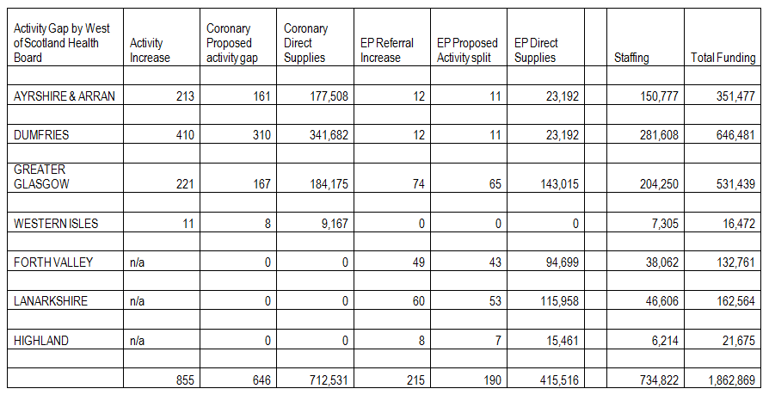

## Table 25

## 10. Economic appraisal

### 

### 10.1 Overview

A discounted cash flow for the shortlisted options has been undertaken over a 10 year life. Both the Net present Cost (NPC) and Equivalent Annual Cost (EAC) have been calculated. This has been contrasted against the do nothing option as recommended code of practice. This is intended to demonstrate the preferred option continues to offer value for money.

**The key elements used in the analysis are summarised below: -**

* initial capital outlay for each option exclusive of VAT.
* equipment lifecycle costs;
* total revenue costs for each option (including movements from the baseline position), and
* transitional and opportunity costs for each option

### 10.2 Options appraisal

In addition to the capital and revenue analysis described in the previous section, an economic analysis of the 4 options has also to be undertaken.

This includes the revenue and capital costs of the above options.

The results therefore of the economic appraisal are as follows:

|  |  |  |  |  |
| --- | --- | --- | --- | --- |
| **Description** | **Option 1**  **£’000** | **Option 2**  **£’000** | **Option 3a**  **£’000** | **Option 3b**  **£’000** |
| **NPC** | **22,268** | **21,875** | **15,649** | **15,213** |
| **EAC** | **2,226** | **2,187** | **1,565** | **1,521** |
| **Rank of financial appraisal** | **4** | **3** | **2** | **1** |

Table 26

The assumptions within the economic appraisal are as follows:

* The equipment costs have being calculated over a 10-year project life.
* The discount factor applied is 3.5%
* Exclusive of VAT

The preferred option from an economic and a financial analysis would be option 3b. The capital costs have been secured and this option requires additional annual revenue funding of £2.094M per annum inc depreciation. This is also reflected in the economic appraisal. NB it should be noted that the Economic Appraisal does not include depreciation.

## 11. Implications of not procuring a fifth Cath Lab

**Failure to initiate project**

Cath Lab capacity to support ‘waiting times’ will remain at existing levels with limited scope for further increase, reliant on short term and *adhoc* solutions including weekend lists and utilisation of mobile units, both of which are expensive service models, paying premium staff costs.

The need for increased capacity has been detailed in the Interventional Cardiology Strategy. As described, the demand across interventional cardiology is increasing and is projected to continue to do so. The service has fully explored leaner and more efficient ways of working and will continue to benchmark against similar services and to improve efficiency and workflow where possible. However, the scope for this to deliver the capacity to meet current and future demand is limited, particularly as GJF already perform in the top quartile of interventional cardiology service, demonstrating efficient utilisation of the current Cath Labs.

Recruitment and retention of staff is increasingly becoming a challenge, and it is important that we are a competitive employer. Many of the short term options rely on staff goodwill and overtime which is not sustainable. A fifth Cath Lab will provide additional core capacity which is appropriately funded and staffed.

The impact of not procuring a fifth Cath Lab will be –

1. Demand continues to exceed capacity
2. Long waiting times with coronary and EP patients breaching treatment time guarantee – see Figure 18
3. Inability to provide sufficient flexibility to appropriately deliver the unscheduled and urgent care
4. Ongoing challenges with recruitment and retention
5. Reliance on short term, expensive options to increase capacity.
6. Limited resilience – delays to planned maintenance and upgrades
7. Inability to grow and develop the service in response to new technologies and evidence, particularly in areas including Structural Heart Disease and ACHD services.

Figure 18: Projected Waiting List in Coronary Intervention with no additional capacity

## 12. Risk analysis

The following major risks have been identified at the onset of this project. A live risk register will be maintained by the Project Manager for the duration of the project. This will contain details of risks relating to the preferred option only and will be reviewed regularly by the Project Board.

| **Risk** | **Description** | **Control Measure** |
| --- | --- | --- |
| **Financial** |  |  |
| R1. Funding availability | The funding required to progress and complete the project is not made available: | ACCEPT– Dealing with this threat is out with the scope of this project |
| R2. Project overspend - equipment | The project will go over budget, exceeding the capital costs identified in the Capital Plan | REDUCE –Budget will be agreed for the duration of the project in Management Stage 1 (Project initiation). Costs will be based on tender returns and recent similar equipment purchases |
| R3. Project overspend – service delivery | The recurring revenue costs associated with the ongoing delivery of planned activity through the new lab will exceed those identified in the business case | REDUCE –Robust staffing models will be utilised to generate revenue staffing costs. Ongoing operational costs resulting from consumable usage will be based on current costs. |
| **Dependency change** |  |  |
| R4. Radiology re-design project delays | The separate project to re-design elements of the Radiology department may not be complete in time to accept delivery of the equipment or support the increase in patient throughput in line with the project schedule | REDUCE –The Radiology re-design project will share a common Project Board (Cross Sectional Imaging Group), ensuring this project is completed at the earliest possible opportunity. |
| R5. Unexpected change in regulatory standards | A regulatory change may be introduced forcing a change in specification and increasing costs beyond expected tolerances. Examples would include increased radiation protection controls | ACCEPT – Not a controllable risk. Recent changes to IRMER and IRR 17 will be taken into account during product evaluation and selection. This threat will continue to be monitored throughout the project |
| **Capacity & Demand** |  |  |
| R6. Insufficient recovery and bed spaces to accommodate planned increase in activity | Existing bed and recovery capacity needs to be increased in line with the projected increase of throughput | AVOID – The Project Board will ensure these requirements are appropriately addressed within the scope of the Radiology re-design project |
| R7. Equipment unable to fully support all patient activity | Equipment does not support the projected increase in activity and range of planned procedures. | AVOID – Ensure the specification is robust and is approved by senior users |
| R8 Future demand exceeds designed capacity | Future demand is higher than projected due to new technologies, clinical guidelines etc. | ACCEPT – Dealing with this threat is out with the scope of this project |
| R9. Training disruption | User training will require a significant commitment of staff resources from all user groups. There is a possibility that an appropriate level of staff will not have received training in line with the project plan | REDUCE – User training plans will be produced and progress monitored by the production of user training update reports |
| **Workforce** |  |  |
| R10. Delays recruiting suitably trained Radiographers | The service will not be fully staffed in time for the expected go live date and therefore unable to deliver on the expected activity | REDUCE – Recruitment will commence with sufficient time to allow staffing levels to be met. |
| R11. Delays recruiting suitably trained Cardiologists and EP Cardiologists | The service will not be fully staffed in time for the expected go live date and therefore unable to deliver on the expected activity with the preferred model | REDUCE – Recruitment will commence with sufficient time to allow staffing levels to be met. |
| R12. Delays recruiting suitably trained specialist nursing staff | The service will not be fully staffed in time for the expected go live date and therefore unable to deliver on the expected activity | REDUCE – Recruitment will commence with sufficient time to allow staffing levels to be met. |
| R13. Delays recruiting suitably trained Cardiac Physiologists and EP Cardiac Physiologists | The service will not be fully staffed in time for the expected go live date and therefore unable to deliver on the expected activity | REDUCE – Recruitment will commence with sufficient time to allow staffing levels to be met. |
| R14. Ability to change workforce models to suit the preferred option | Inability to revise workforce models / shift patterns. Inability to engage the current workforce. | REDUCE – Engagement with workforce will commence early in the project to ensure appropriate solutions are delivered |
| **Patient Experience** |  |  |
| R15. Patient stakeholder requirements not met | The project may not deliver the best possible technical/clinical solution to the patient | AVOID – Equipment will be purchased from an industry leading supplier with a proven tack-record. Ensure the specification is robust and is approved by senior users |
| R16. Radiation safety | The new equipment will not produce the expected minimised dose levels | AVOID – Ensure the specification is robust and is approved by senior user. Adequate provisions for radiation monitoring and reduction will be included in the specification |
| **Reputation** |  |  |
| R17. Inability to increase quality of service provision | Unable to increase quality of service as benchmarked against comparable peers. | REDUCE – The approved equipment solution will not restrict the continuous quality improvement of processes impacting on quality of service. |

Table27

## 13. Preferred option

### 13.1 Benefits and realisation monitoring

Benefits realisation will be achieved through a combination of ongoing project management and a formalised review of benefits included in the project closure report. Clear responsibility for benefits, collectively and individually is a key requirement for successful benefits realisation. These are detailed in the Service Objectives and Equipment Objectives tables below

#### 13.1.1 Expected benefits

**Service Objectives**

| **Objectives (In no particular order)**  ***Quality Criteria*** | **Related Success Criteria**  ***Acceptance Criteria*** | **Owner** |
| --- | --- | --- |
| **Addresses regional waiting times pressures in Coronary Intervention and EP**   * Supports the Scottish Government in addressing regional pressures in Coronary Intervention * Supports projected increase in activity | * Increased in-house activity will be demonstrated in GJNH activity statistics for the Regional Coronary Intervention and EP waiting times patient cohorts | **Main owner**  Executive lead – June Rodgers  **Associated**  Lynne Ayton, Alex McGuire |
| **Supports increased efficiency across all Interventional cardiology pathways of admission**   * Increases capacity to accommodate *emergency admission from SAS and local A&E* in a timely manner * The increased capacity will allow a greater volume of *elective admissions* to be processed * Urgent inpatient pathway – *Inter hospital transfers and direct NSTEMI admissions*, will be better served by a larger number of labs. This would also support the proposed expansion of Direct NSTEMI service | * Door to balloon times will remain at least on a par with our current UK leading average. Table below demonstrates we have the shortest median door to balloon time (2017/18)      * The increased lab capacity will better support definitive treatment for the average 250 elective coronary referrals and 62 EP referrals per month. * Waiting times statistics will demonstrate a reduction in patients waiting for treatment and a reduction in the period of time they are waiting. * Increase in the number of urgent inpatient transfers having their procedure within 72 hours of referral.   25iS0T1 | **Main owner**  Executive lead – June Rodgers  **Associated**  Lynne Ayton, Alex McGuire |
| **Meets current and future service demands across Interventional Cardiology**   * Supports the expansion of the *Electrophysiology* service to meet growing demand by providing increased Cath Lab capacity. * Supports *SACCS* in the delivery of an increasing number of complex interventions * Supports the predicted slow, steady growth in *SPVU* by accommodating expansion beyond the already fully utilised allocated session | * Waiting times statistics will demonstrate a reduction in patients waiting for treatment and a reduction in the period of time they are waiting. * Statistics will demonstrate an increase in SACCS patient throughput and complexity of caseloads. * Capacity will be available to flex up SPVU throughput to match increase in demand | **Main owner**  Executive lead – June Rodgers  **Associated**  Lynne Ayton, Alex McGuire |
| **Enables the relocation of the Device Implantation Service to an appropriate dedicated imaging environment**   * Provides high quality imaging to support implantation * Delivers the service in an environment with appropriate dose management to protect patients and staff * Addresses a long standing organisational risk centred around delivering this service with a C-arm in a Theatre environment | * Imaging will be provided on high quality digital angiography system * Established radiation protection controls found in dedicated imaging Cath Labs will be applied to this service * The organisational risk will be nullified | **Main owner**  Lynne Ayton  **Associated**  Alex McGuire,  Lynn Graham |
| **Increases the resilience of the EP service**   * EP functionality in 2 labs * Flexibility to run 2 parallel EP lists * Increased resilience if equipment failure to relocate to 2nd lab * Address single point of failure risk associated with delivering the service with multiple examples of one-off items of equipment. * Addresses lack of EP cabling infrastructure outwith CL2 | * Reduced cancellations due to equipment failure * Increased activity | **Main owner**  Lynne Ayton  **Associated**  Steven Friel |
| **Reduces the impact of downtime, including planned replacement and maintenance**   * Current waiting times pressures have effectively rendered the planned equipment replacement of the Cath Lab imaging systems unattainable. We have now reverted to a ‘replace on failure’ mode which will see increasing levels of breakdowns and unplanned downtime as the system continues to age. Over time, the technology will continue to be surpassed by newer systems delivering better diagnostic visualisation and improved workflow at lower doses. Eventually the system will develop a significant failure that will force replacement at a time not of our choosing. The resulting unplanned replacement will have a significantly increased period of downtime when compared to a planned replacement. Digital angiography systems are not purchased off the shelf, but are instead manufactured to order with lead-times measured in months. This will critically impact on the delivery of services. Mitigation will be mainly restricted to the hire of a mobile Cath Lab. This is a highly specialised and limited market where availability can not be guaranteed. | * The remaining Cath Labs will be replaced within a controlled project structure at a time suitable to the service | **Main owner**  Lynne Ayton  **Associated**  Steven Friel |
| **Supports development of the Structural Heart Disease Programme**   * Provides the GJNH TAVI service introduced in April 2018 with physical space to grow in line with predicted demand * Provides scope to deliver the TAVI service in an environment with theatre quality air filtration and a high volume of air changes. * Supports delivery of additional services such as:   + Left Atrial Appendage Closure (LAAC)   + Percutaneous Transcatheter mitral valve repair (mitraclip)   + Patent Foramen Ovale Closure In Cryptogenic Stroke (PFO) | * An increase in TAVI throughput will be demonstrated in GJNH statistics. | **Main owner**  Lynne Ayton  **Associated**  Alex McGuire, Mitchell Lindsay |
| **Provides high quality training and opportunities for staff professional development**  Improved environment  Increase in cases  Appropriately staffed lists  Increased complexity of cases and research opportunities  Development of training academy | * Recruitment and retention statistics – review unfilled vacancies in key staff groups * Recruitment to and from the Cardiac Physiology training academy * Reduction in sickness absence rates | **Main owner**  Lynne Ayton  **Associated**  Alex McGuire, Mitchell Lindsay |

Table 28

**Equipment Objectives**

| **Objectives (In no particular order)**  ***Quality Criteria*** | **Related Success Criteria**  ***Acceptance Criteria*** | **Owner** |
| --- | --- | --- |
| **Up to date technology**   * Stakeholders will benefit from the use of recent technology advances | * Patients will receive minimised radiation doses in line with our most recent equipment * Users will receive minimised radiation doses in line with our most recent equipment * Image quality will be on a par with our most recent equipment, providing excellent diagnostic visualisation * There is increased scope for multi modality integration | **Main owner**  Steven Friel  **Associated**  Mitchell Lindsay, Karen Main |
| **Value for money**   * The decision process will consider cost as a primary factor | * Value for money will be demonstrated and measurable through the procurement process | **Main owner**  Steven Friel  **Associated**  Brian Laughland |
| **Delivered in a timely manner**   * The project is delivered in the specified timescale | * Project timescale will be monitored by the project board with appropriate tolerances applied with respect to dependencies on related build projects | **Main owner**  Steven Friel  **Associated**  Lynne Ayton |
| **Optimise workflow**   * The unit will be compatible with the national Carestream PACS and RIS system * The new unit will be compatible with and integrate with existing GE archive/workstations * Will accommodate standardised working between labs * Disruption and down time due to installation of the new system will be minimised | * Full connectivity with RIS, PACS and Centricity Archive will be achieved * Full connectivity with the GE workstations will be achieved * Room will be usable for advanced cardiac intervention * The project plan will detail installation downtime and methods to reduce disruption. This will be reviewed by operational and clinical leads to ensure acceptability | **Main owner**  Karen Main  **Associated**  Steven Friel |
| **Management of Radiation exposure**   * Minimises patient and staff radiation exposure * Provides appropriate dose monitoring | * Patient exposure will be on a par with or better than diagnostic reference levels set by Clinical Physics * A system will be in place to real-time monitor staff exposure * Monitoring of patient doses will be performed automatically | **Main owner**  Karen Main  **Associated**  Steven Friel |
| **Image quality**   * Produces high quality imaging meeting the demands of Interventional Cardiology | * Image quality will, as a minimum, be on a par with recently purchased systems * The system will incorporate advanced imaging enhancement software * Clinical Physics will carry out acceptance testing and routine QA * Radiographers will carry out routine QA | **Main owner**  Mitchell Lindsay  **Associated**  Karen Main |
| **Future sustainability**   * Provides scope for development of the Interventional Cardiology service * Supports innovation | * There will be increased scope for multi modality integration * The system will be state of the art * The system will be a platform designed to accept new innovations and upgrades | **Main owner**  Steven Friel  **Associated**  Karen Main |
| **Safe**   * UPS backup for greater safety during power failure * Comply with relevant British and European standards and legislation * Fully compliant with MEIGaN Regulations | * UPS will be available for backup fluoroscopy * Acceptance testing will be carried out * Will meet MEIGaN requirements | **Main owner**  Steven Friel  **Associated**  Karen Main |

Table 29

## 14. Implementing the preferred option

### 14.1 Project Control

The Cross Sectional Imaging Group will function as the Project Board. The project will be managed using a methodology based on PRINCE 2. It will be split into a series of management stages, each requiring formal approval of the project board before initiation. All stages will be subject to adjustment in timescales and content resulting from continual project management, assessment of ongoing risks and reaction to incidents. This may provide additional scope for slippage or acceleration providing the risk assessment supports this. Financial approval will also be required by the Board’s Capital Group.

A CL5 Implementation Group has been established as a subgroup of the Cross Sectional Imaging Group. This group is responsible for devising an implementation plan to safely manage the augmentation of the existing Interventional Cardiology Service and the ongoing delivery of the clinical service during the period of build work. The plan will be a live document and will continue to be updated by the implementation group as the project progresses. This allows the group to react to new and developing risks and opportunities.

### 14.2 Project organisation

|  |  |
| --- | --- |
| Project board |  |
| Executive | June Rogers |
| Cross Sectional Imaging Project Operations Lead | Lynne Ayton |
| Project Manager | Steven Friel |
| Engineering Senior Supplier | Gerry Cox |
| RNM Clinical Specialities Manager | Alex McGuire |
| Clinical Lead – Consultant Cardiologist | Mitchell Lindsay |
| Senior User – Radiology | Jennifer Gilchrist /Karen Main |
| Senior User – Nursing | Jennifer Hunter |
| Senior User – Cardiac Physiology | Irene Crawford |
| Procurement Senior Supplier | Brian Laughland |
| Finance Senior Supplier | Lily Bryson |
| Infection Control Lead | Susan Robertson/Heather Gourlay |

Table 30

**Role: Project Board**

The Project Board will provide overall direction and management of the project. It will be accountable for the success of the project and has responsibility and authority for the project.

The Project Board will approve all major plans and authorise any major deviation from agreed Stage Plans. It will sign off the completion of each Stage as well as authorise the start of the next Stage. It will ensure that the required resources are committed and will arbitrate on any conflicts within the project or negotiate a solution to any problems between the project and external bodies. In addition, it will approve the appointment and responsibilities of the Project Manager and any delegation of its Project Assurance responsibilities.

**Role: Executive**

**June Rogers**

The Executive is responsible to the GJF Board

Specific Responsibilities:

* Ensure a tolerance is set for the project
* Authorise expenditure in conjunction with the Director of Finance and set stage tolerances
* Approve the end project report and lessons learned report
* Brief Senior management on progress
* Attend project Board meetings
* Recommend future actions on the project if tolerances are exceeded
* Approve project closure
* Overall business assurance i.e. ensuring that the project remains on target to deliver products which will achieve the expected business benefits and the project will complete within agreed tolerances for budget and timescale.

**Role: Cross Sectional Imaging Project Operations Lead**

**Lynne Ayton**

The Project Operations Lead is responsible to the Project Executive

Specific Responsibilities:

* Chairs Project Board meetings
* Guides project in context of other ongoing clinical priorities
* Provides day to day business assurances on the overall performance of the project

**Role: Project Manager**

**Steven Friel**

The Project Manager’s prime responsibility is to run the project on a day-to-day basis on behalf of the project board and to ensure that the project produces the required products, to the required quality standards and within the specified constraints of time and cost.

Specific Responsibilities:

* Maintain plans and monitor progress for the project as a whole
* Liaise with the suppliers to ensure that project deliverables are properly understood
* Liaise with all stakeholder groups and promote the project
* Business case production

In addition to the project management responsibilities detailed above, the Project Manager will also provide Medical Equipment Lifecycle Management input to all aspect of the project and a direct link to the National Imaging Equipment Group.

**Role: Engineering Senior Supplier**

**Gerry Cox**

Provides specialist input to key stages of the project. The Engineering Senior Supplier also provides a direct interface to parallel projects relating to re-design of the estate which have a direct impact on this project.

Note: This project does not include any turnkey works associated with the installation of the equipment

**Role: NRM Clinical Specialities Manager**

**Alex McGuire**

Manage operational activity across the Interventional Cardiology Service throughout the duration of the project.

Specific Responsibilities:

* Primary lead for business case production
* Business management assurance across all project stages
* Chairs the Implementation Group
* Capacity and demand analysis

**Role: Clinical Leads**

**Mitchell Lindsay**

Represents the Cardiologist and EP Cardiologist final users’ requirements. Provides assurances that the selected equipment and environment are fit for purpose and provide the necessary level of clinical diagnostic image quality.

**Role: Senior User - Radiology**

**Jennifer Gilchrist, Karen Main**

Represents the Radiographer final users’ requirements. Provides professional radiological guidance to the project as a whole and specifically:

* Lead user input to production of business case
* Radiation protection
* Image quality assurance
* Equipment ergonomics and workflow assurance
* Link to Radiologist equipment users
* Examination of current and projected throughput
* Defining training requirements
* Implementation planning

**Role: Senior User - Nursing**

**Jennifer Hunter**

Represents the Nursing final users’ requirements. Provides professional Nursing guidance to the project as a whole and specifically:

* Lead user input to production of business case
* Acts as patient advocate in all matters of design, selection and implementation of the preferred solution
* Environment workflow assurance
* Link to all Nursing users
* Examination of current and projected throughput
* Defining training requirements
* Implementation planning

**Role: Senior User – Cardiac Physiology**

**Irene Crawford**

Represents the Cardiac Physiology final users’ requirements. Provides professional Cardiac Physiology guidance to the project as a whole and specifically:

* Lead user input to production of business case
* Equipment ergonomics and workflow assurance
* Link to all Cardiac Physiology users
* Defining training requirements
* Implementation planning

**Role: Procurement Senior Supplier**

**Brian Laughland**

Procurement lead for project, providing specialist regulatory and procedural advice on all aspects of equipment purchase.

**Role: Finance Senior Supplier**

**Lily Bryson**

Acts as finance lead throughout the project with specific responsibility for the following:

* Setting financial tolerances
* Financial appraisal section of the business case
* Economic appraisal section of the business case
* Variation control

**Role: Infection Control Senior Supplier**

**Susan Robertson, Heather Gourlay**

Acts as Infection Control lead throughout the project with specific responsibility for the following:

* Identifying and quantifying Infection Control risks in relation to preparatory build and installation works
* Providing Infection Control assurances to the appropriateness of the selected medical equipment as per the National Prevention and Control of Infection Manual

### 14.3 Project stages

The project will be managed across a series of stages as described below.

Figure 19

**Management stage 1 (Initiation - Order)**

Project initiation

* Production of Project Brief
* Production of Business Case
  + Cross-Sectional Imaging Group
  + Capital Group approval
  + SMT approval
  + Board approval

Initiate medical equipment acquisition process

* Agree route to market
* Product evaluation
* Place order

Form user group to oversee implementation

* Business case assurance
* Implementation plan (dealing with disruption, capacity management during period of downtime)
* Training plan

Deliverables from Management stage 1

|  |  |
| --- | --- |
| Deliverable (product) | Responsible |
| Project initiation | |
| Project Brief | Project Manager / Head of Radiology |
| Business case | Project Manager / NRM operational lead |
| Initiate medical equipment acquisition process | |
| Procurement initiation | Project manager / Procurement |
| Product specification including turnkey requirements | Project Manager / Head of Radiology / Head of Estates |
| Equipment selection | Project Manager / Senior Users - Radiology / Clinical Lead –Cardiology |
| CMR for equipment | Project manager |
| Form user group to oversee implementation | |
| Implementation plan | Head of Radiology / Lead Radiographer MR |
| Training plan | Head of Radiology / Lead Radiographer MR |
| Supplier project plan | Equipment Supplier |

Table 31

**Management Stage 2 (Commissioning and implementation)**

Some aspects of this management stage overlap stage 2.

Deliverables from Management stage 2

|  |  |
| --- | --- |
| Deliverable (product) | Responsible |
| Updated project plan reflecting turnkey and Equipment installation | Project Manager |
| Implementation plan update | Head of Radiology / Lead Radiographer CL |
| User training plan update | Lead Radiographer CL |
| Equipment acceptance reports | Medical Physics Radiology Specialist |
| Commissioning report | Medical Physics Radiology Specialist |
| Hand over of Product | Senior users |

Table 32

**Project Closure**

A project close report will be presented to the Project Board (Cross Sectional Imaging Group) approximately six months after the ‘go live’ date of the lab. The report will be compiled by the Project Manager in consultation with key stakeholders, including the objective owners identified in the in the Benefits Realisation Arrangements section of this business case.

Deliverables from project closure stage

|  |  |
| --- | --- |
| Deliverable (product) | Responsible |
| Lessons learnt report | Project manager |
| Project closure report  Lessons Learnt  Benefits realisation analysis | Project Manager |

Table 33

### 14.4 Project timetable

The following timetable is a brief summary of key milestones and initial timescales. A full project plan and detailed stage plans will be used by the project board to manage the project. The dates provided are reasonable estimates based on market knowledge but are subject to change beyond our control. Increased certainty around the dates will come with the selection of the equipment provider.

|  |  |
| --- | --- |
| Description | Milestone |
| Present business case to Cross Sectional Imaging Group | 15/05/19 |
| Present business case to Capital | 22/05/19 |
| Present business case to SMT | 06/06/19 |
| Present business case to Board | 20/06/19 |
| Complete Management Stage 1 | 01/12/19 |
| Go live | March 2020 (Estimated) |
| Project Closure | July 2020 (Estimated) |

Table 34

## Appendix 1: Benefits scoring details

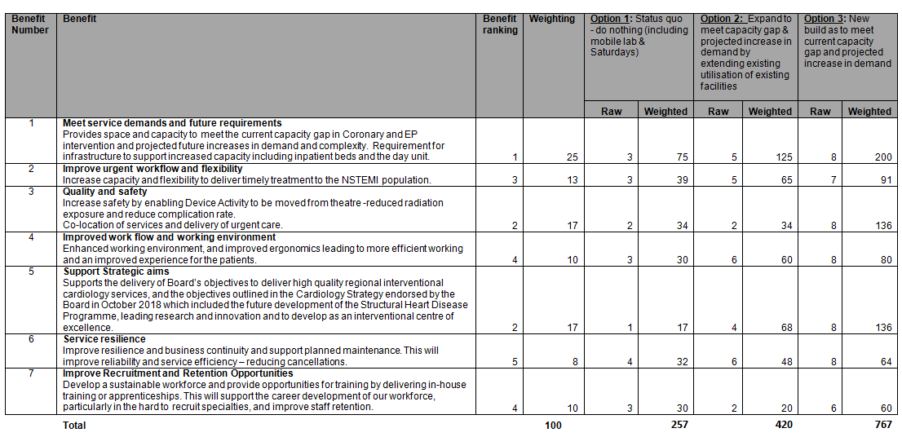

## Appendix 2: Risk scoring details

