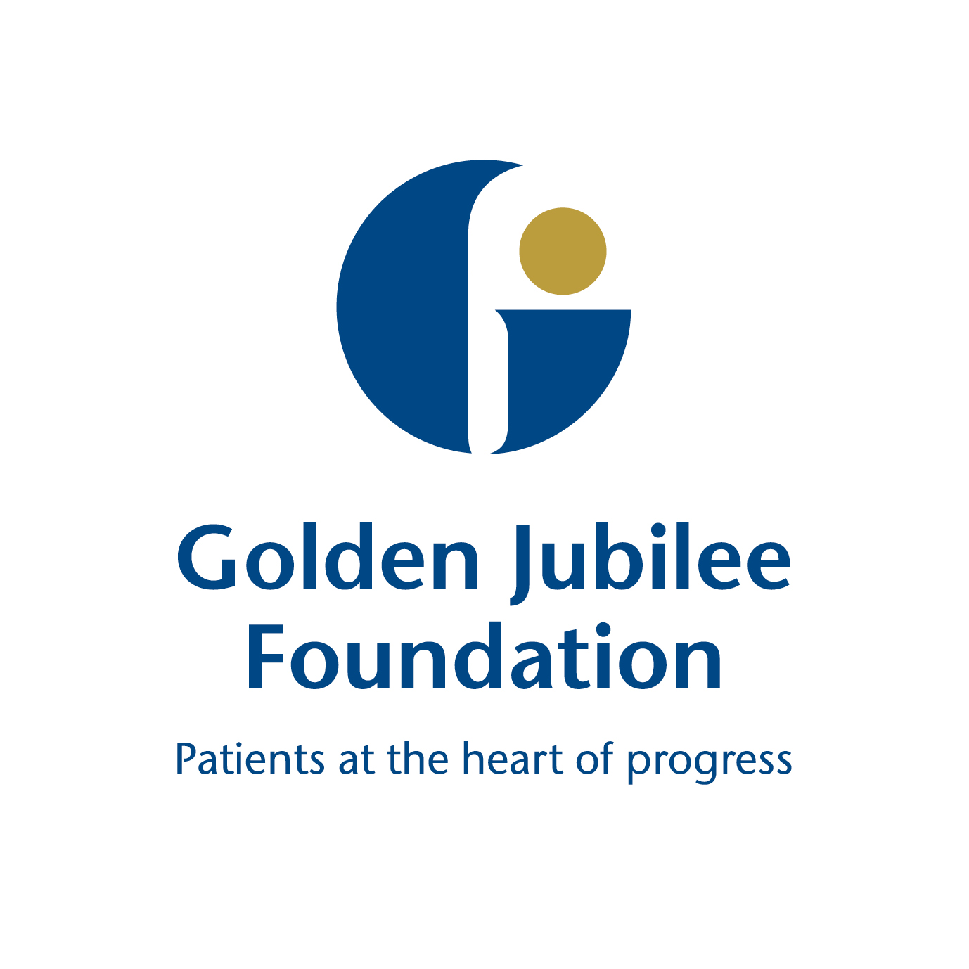
Board Meeting: 14 February 2019

Subject: Endowments Sub Committee update – 5 February 2019
Recommendation: | Board members are asked to:
  Discuss and Note | X
  Discuss and Approve
  Note for Information only

______________________________________________________________________

1 Background

The following key points were agreed at the meeting and have been split into the three high level quality ambitions of person centred, safe, and effective.

Person Centred
Mutually beneficial partnerships between patients, their families and those delivering healthcare services which respect individual needs and values and which demonstrate compassion, continuity, clear communication and shared decision-making.
- A training plan for Endowment fundholders is established with sessions arranged for groups of fundholders to ensure that they understand the governance arrangements around management and use of endowment funds. A declaration form will be signed by each fundholder, confirming that they have attended this training and an update of the names trained will be presented to the next meeting.
- A proposal was presented to members to approve the surplus from Cafe Latte to the Golden Jubilee Foundation Charity as an unrestricted fund. Members asked that approval for the fund transfer awaits the new costing profile for the Cafe’s running costs.
Safe
There will be no avoidable injury or harm to people from healthcare they receive, and an appropriate, clean and safe environment will be provided for the delivery of healthcare services at all times.
- Endowment Fund balances and transactions as at 31 December 2018 were reviewed and a breakdown was provided on Small Business Research Initiative innovation funds. It was noted there are a number of longstanding legacy funds within the board funds which have been inherited, it was agreed to obtain legal advice in how these can be accessed.
- An Interim Review of Endowment Fund Charter was undertaken and recent changes to Endowments Sub Committee membership was amended within the Terms of Reference. There will be further actions and recommendations pending the actions resulting from the Office of the Scottish Charity Regulator (OSCR) review of NHS Tayside.
Effective
The most appropriate treatments, interventions, support and services will be provided at the right time to everyone who will benefit, and wasteful or harmful variation will be eradicated.
- Dr Barry Klaassen, Accident and Emergency Consultant at NHS Tayside and Project Lead for the Scottish Emergency Medicine Projects in Malawi attended the meeting to give a presentation on £1m funding awarded by Scottish Government for the development of an Adult Emergency Care Centre in Blantyre, Malawi. Approval was sought from the Endowments Sub Committee to transfer these restricted funds from the Scottish Government’s International Development Division to the Innovation Fund. Assurance was given that the funding would be in accordance with the charity criteria and would be disbursed strictly in accordance with Scottish Government International Division Grant Schedule in line with robust scrutiny. On that basis, members approved the transfer of funds for the Malawi Project.

The next meeting is scheduled for: Tuesday 16 April 2019.

Phil Cox
Chair, Endowments Sub Committee
5 February 2019

(Julie Carter, Director of Finance)

