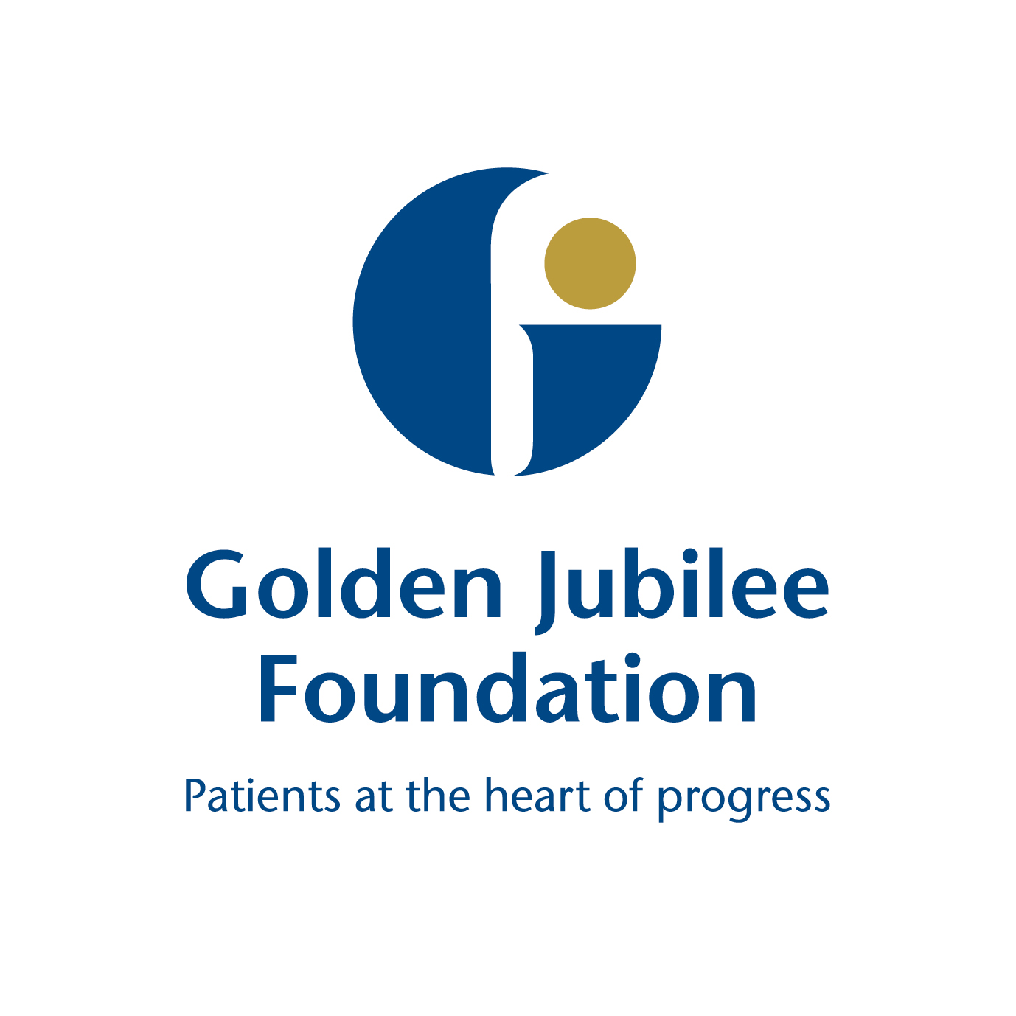
Board Meeting: 14 February 2019

Subject: Audit and Risk Committee update - 5 February 2019
Recommendation: | Board members are asked to:
  Discuss and Note | X
  Discuss and Approve
  Note for Information only

1 Background

The following key points were agreed at the meeting and have been split into the three high level quality ambitions of person centred, safe, and effective.

Person Centred
Mutually beneficial partnerships between patients, their families and those delivering healthcare services which respect individual needs and values and which demonstrate compassion, continuity, clear communication and shared decision-making.
- Audit Scotland presented the NHSScotland overview report and the challenges faced by Health Boards in the future. A good discussion took place including how the Golden Jubilee can contribute to the 2018/19 report.
- Updated Terms of Reference in line with the new Audit Handbook were presented with amendments noted. These will be presented to the February Board meeting.
- The following Audit Scotland Reports recently published were noted by members and action plans applicable were discussed:
- NHS Tayside Report
- Health and Social Care Integration Report – this report will be presented to
Senior Management Team
- NHS in Scotland 2018 – this was discussed in detail at the presentation from
Audit Scotland
- Withdrawal from European Union Report – a paper is being presented to the
February Board
- Prevention of Fraud update was provided on work being undertaken within the Board in regard to fraud prevention and also work ongoing with Counter Fraud Services (CFS). Follow–up actions on communications were agreed.

- National Fraud Initiative Checklist was prepared which is reviewed by external audit. Assurance was given that payroll matches released are similar to last year and there were no concerns. It was agreed it would be helpful to circulate the CFS newsletter to members.
- Cost Control paper on hospital expansion was provided and reviewed by the Committee. No concerns were raised but it was agreed that, in order to understand this in more detail, the Programme Director and Joint Cost Advisor would attend the Committee meeting.
- Financial Risk Appraisal on the Construction Industry was presented to the committee as this is particularly relevant to our current building expansion plans. Members approved the tolerance levels and mitigating actions.
Safe
There will be no avoidable injury or harm to people from healthcare they receive, and an appropriate, clean and safe environment will be provided for the delivery of healthcare services at all times.
- Board Risk Register and Enterprise Risk update was provided. Members discussed the EU withdrawal risk, which will be taken to the February Board for discussion. All other recommendations were approved.
- Draft Assurance Mapping was presented and members were satisfied with the layout and agreed with the three stage approach.
- Governance Statement Guidance was noted by the committee and it was agreed for consistency that a standard template for annual reports would be issued to all committees for populating.
Effective
The most appropriate treatments, interventions, support and services will be provided at the right time to everyone who will benefit, and wasteful or harmful variation will be eradicated.
- Internal Audit Progress Report was presented with two completed audits reported on: Use of Estates and Capacity Planning. There were no concerns to note.
- External Audit Plan for 2019/20 was presented with a detailed overview provided and there were no concerns to note.
- Internal Audit Recommendations Follow up Report was presented in a new format and members were encouraged to feedback any comments to auditors. Overall this was well received.
- Review of the Standing Orders was presented with amendments highlighted for members to note. Following discussion it was determined that there is further work required and it was therefore agreed that this be a holding document.

The next meeting is scheduled for: Tuesday 16 April 2019.
Karen Kelly
Chair, Audit and Risk Committee
5 February 2019

(Julie Carter, Director of Finance)

