Board Meeting: | 14 February 2019 | 
Subject: | Board Performance Report
Recommendation: | Board members are asked to:
  Discuss and Note | X
  Discuss and Approve
  Note for Information only

__________________________________________________________________

- Introduction

The Board is asked to discuss the content of the performance report covering matters discussed at the January 2019 meeting of the Performance and Planning Committee. This pack includes a snapshot of the waiting list position at 3 January 2019.

- Board Exception Report – Key Performance Indicators (KPIs)
- Effective KPIs
- Person-centred KPIs
- Safe KPIs

- Divisional Exception Reports
(a) Surgical Services
(b) Regional and National Medicine

- Waiting lists – Cardiac Surgery, Thoracic Surgery and Cardiology.

- Corporate Balanced Scorecard (Appendix 1)

2 Recommendation
Board members are asked to note the update for the current reporting period.

June Rogers
Director of Operations
30 January 2019

(Carole Anderson, Head of Strategy and Performance)

Board Exception Report
Improved performance 
Same performance ⬄
Worse performance 

Effective Board Performance update – January 2019
KPI | Details |  |  |  | Tolerance |  |  | Sep 2018 |  |  | Oct 2018 |  |  | Nov 2018 |  |  | Target |  |  | On Track
Elective Acute Ward Bed Occupancy | Combined occupancy position for NSD, 2 East, 2 West, 3 East, 3 West |  |  |  | >90.1% = Red  86-90%= Green  78-85.9% = Amber  <77.9% = Blue |  |  | 76.6% |  |  | 79.0% |  |  | 81.7% |  |  | 86-90% |  |  | ⇧
Interventional Cardiology Wards Bed Occupancy | Combined occupancy position for 2C, 2D and CCU |  |  |  | 87.4%- 100% = R  81% -87.3% = G  77%-80.9%= A  <76.9% = B |  |  | 81.6% |  |  | 78.8-7% |  |  | 81.4% |  |  | 81-87.3% |  |  | ⇧
Critical Care Wards Bed Occupancy | Combined occupancy position for ICU1, ICU2, HDU2, HDU3 |  |  |  | ≥ 84.8% = R  73 – 84.7% = G  63.4 – 72.9% = A  ≤ 63.3% = B |  |  | 65.7% |  |  | 76.6% |  |  | 75.1% |  |  | 70-90% |  |  | ⇩
Analysis
Bed occupancy in the elective acute wards increased in both October and November. The increase was a result of increased occupancy in the NSD ward, 2 West and 3 East.
Within the NSD ward, bed occupancy was reported above the target occupancy level for both October and November. This is the first time that the NSD ward has reported two successive months as having “red” occupancy since the same period in 2017.
Ward 2 West’s bed occupancy returned to the target occupancy range during November. This is the first time that the optimal occupancy range has been achieved since October 2017. Bed occupancy on ward 3 East in November was reported at the highest level in the scorecard period (since April 2016).
Overall Interventional Cardiology ward’s bed occupancy has reported relatively constant occupancy since June 2018.
Bed occupancy within the Critical Care units increased in October and has remained within the target "green" occupancy for November.

KPI |  | Details |  |  | Tolerance |  | Oct 2018 |  |  | Nov 2018 |  |  | Dec 2018 |  |  | Target |  |  |  |  | On Track
Ophthalmology Cancellation Rate |  | Percentage of Ophthalmology patients cancelled on day of procedure |  |  | Achieved = G  Not Achieved = R |  | 1.5% |  |  | 3.0% |  |  | 2.2% |  |  | Monthly 3% cancellation rate |  |  |  |  | ⇧
Plastic Surgery Cancellation Rate |  | Percentage of Plastic Surgery patients cancelled on day of procedure |  |  | Achieved = G  Not Achieved = R |  | 6.5% |  |  | 2.6% |  |  | 0.0% |  |  | Incremental reduction from baseline position of 5% to 3% by March 2019 |  |  |  |  | ⇧
General Surgery Cancellation Rate |  | Percentage of General Surgery patients cancelled on day of procedure |  |  | Achieved = G  Not Achieved = R |  | 13.6% |  |  | 12.7% |  |  | 5.6% |  |  | Incremental reduction from baseline position of 9% to 5% by March 2019 |  |  |  |  | ⇧
Orthopaedic Cancellation Rate |  | Percentage of Orthopaedic patients cancelled on day of procedure |  |  | Achieved = G  Not Achieved = R |  | 4.8% |  |  | 2.6% |  |  | 3.2% |  |  | Monthly 3% cancellation rate |  |  |  |  | ⇩
Cardiac Surgery Cancellation Rate |  | Percentage of Cardiac Surgery patients cancelled on day of procedure |  |  | Achieved = G  Not Achieved = R |  | 11.8% |  |  | 17.3% |  |  | 19.0% |  |  | Incremental reduction from baseline position of 16% to 8% by March 2019 |  |  |  |  | ⇩
Cardiology Cancellation Rate |  | Percentage of Cardiology patients cancelled on day of procedure |  |  | Achieved = G  Not Achieved = R |  | 9.6% |  |  | 2.1% |  |  | 7.7% |  |  | Incremental reduction from baseline position of 5.5% to 3% by March 2019 |  |  |  |  | ⇩
Analysis
December was the eighth successive month ophthalmology reported cancellations within the 3% cancellation target. Plastic surgery and general surgery reported improved performance during December. There were no plastic surgery cancellations in December whilst general surgery reported its lowest cancellation rate since May 2018.
Orthopaedic surgery narrowly missed its 3% cancellation target for December. There were 12 orthopaedic cancellations, nine of which were due to the patient not being fit.
Emergency procedures, a lack of operating time and critical care bed availability negatively impacted the cardiac surgery cancellation rates during November and December. Prior to this cancellations within cardiac surgery had been improving, being either within or very close to the target since April 2018.
In December there were three patients cancelled for cardiology procedures from 39 scheduled procedures.
KPI |  |  | Details |  | Tolerance |  |  | Sep 2018 |  |  | Oct 2018 |  |  | Nov 2018 |  |  | Target |  |  | On Track
Treatment Time Guarantee (TTG) |  |  | Percentage of patients admitted within 12 weeks |  | 100% = Green  95-99.9% = Amber  ≤94.9% = Red |  |  | 92.2% |  |  | 87.8% |  |  | 88.8% |  |  | 0 |  |  | ⇧
Analysis
In November 178 patients were treated over the 12 week TTG. This included six cardiac surgery, 114 coronary, 13 device, 44 electrophysiology and one lead extraction patient.

KPI |  |  |  | Details |  | Aug 2018 |  |  | Sep 2018 |  | Oct 2018 | Nov 2018 |  |  | Dec 2018 |  |  | Target | On Track
Orthopaedic Day of Surgery Admission Rate (Primary Joint Replacement) |  |  |  | Target for 70% of Orthopaedic Primary Joint Replacement admissions to be DoSA, rising to 75% from October 2018. |  | 61.6% |  |  | 59.8% |  | - | - |  |  | - |  |  | 75% from October 2018 | ⇩
Thoracic Surgery Day of Surgery Admission Rate |  |  |  | Target for 44% of Thoracic Surgery admissions to be DoSA by March 2019 |  | 26.7% |  |  | - |  | - | - |  |  | - |  |  | 44% by March 2019 | ⬄
Cardiac Surgery Day of Surgery Admission Rate |  |  |  | Target for 15% of Cardiac Surgery major procedure admissions to be DoSA by March 2019 |  | 11.8% |  |  | 6.4% |  | 5.4% | 8.7% |  |  | 8.3% |  |  | 15% by March 2019 | ⇩
Analysis
Cardiac surgery day of surgery admissions (DoSA) improved in November. This was in part due to the approval of a protocol allowing MSSA patients to be treated in the community rather than being admitted the day prior to surgery. The increased cancellation numbers due to lack of operating time and emergency procedures have impacted cardiac surgery DoSA figures. DoSA patients tend to have a lower clinical priority are at a greater risk of cancellation.
There were 194 Orthopaedic DoSA admissions in August and 183 in September. No updated figures are available for thoracic DoSA due to the calculation method reliance on coded data and a number of outstanding coding episodes.
A method for calculating DoSA rates removing the requirement for coded data is being used for cardiac surgery and has recently been developed for orthopaedic and thoracic surgery. The updated calculation does not replicate the existing measurement so it is not proposed that this will be adopted until the beginning of the next financial year.
During the development of the updated DoSA calculation a formula issue was identified within the Corporate Balance Scorecard which was incorrectly inflating the Thoracic DoSA rates. Following detailed examination of the data this has been rectified with earlier DoSA rates retrospectively corrected.

Safe Board Performance update – January 2019
Due to the quarterly reporting of safe key performance indicators there is no update at this time.

Person Centred Board Performance update – January 2019
KPI |  |  | Details |  | Tolerance |  |  |  | Sep 2018 |  |  |  | Oct 2018 |  |  |  | Nov 2018 |  |  |  |  | Target |  | On Track
Total complaints (stage 1 & stage 2) |  |  | Measured as a percentage against the volume of patient activity |  | ≤ 0.10% = Green  0.11% - 0.14% = Amber  ≥0.15% = Red |  |  |  | 0.03% |  |  |  | 0.06% |  |  |  | 0.05% |  |  |  |  | ≤0.10% |  | ⇧
Analysis
In November four complaints were received. Two Stage One and two Stage Two. November was the third successive month where complaints as a percentage of patient activity have been below the 0.1% target.
KPI | Details |  |  |  |  | Tolerance |  |  |  | Sep 2018 |  |  |  | Oct 2018 |  |  |  | Nov 2018 |  |  | Target |  |  | On Track
Sickness absence | Percentage hours lost due to staff sickness absence as reported via SWISS |  |  |  |  | Achieved = Green  Not achieved = Red |  |  |  | 4.74% |  |  |  | 5.34% |  |  |  | 4.66% |  |  | ≤4% |  |  | ⇧
Analysis
Following four successive monthly reductions in the sickness absence rate, October's sickness was reported as the highest since May 2018. November's sickness absence showed a 0.68% improvement compared to October. This was the lowest sickness absence rate since September 2017.
KPI | Details |  |  |  |  |  | Tolerance |  |  |  | Oct 2018 |  |  |  | Nov 2018 |  |  |  | Dec 2018 |  |  | Target |  | On Track
Job Planning Surgical Specialties: Consultants | Current, signed off job plans on eJP system as a percentage of headcount |  |  |  |  |  | Achieved = Green Not achieved = Red |  |  |  | 61.3% |  |  |  | - |  |  |  | 72.1% |  |  | Oct 18: 50%  Dec 18: 75%  Mar 19: 100% |  | ⇧
Job Planning Surgical Specialties: SAS Doctors | Current, signed off job plans on eJP system as a percentage of headcount |  |  |  |  |  | Achieved = Green Not achieved = Red |  |  |  | 83.3% |  |  |  | - |  |  |  | 71.4% |  |  | Oct 18: 50%  Dec 18: 75%  Mar 19: 100% |  | ⇩
Job Planning Regional and National Medicine: Consultants | Current, signed off job plans on eJP system as a percentage of headcount |  |  |  |  |  | Achieved = Green Not achieved = Red |  |  |  | 69.2% |  |  |  | - |  |  |  | 69.2% |  |  | Oct 18: 50%  Dec 18: 75%  Mar 19: 100% |  | ⬄
As of the end of December 2018 58 out of 81 (71.6%) doctors had completed their job plans. A target of 75% completion had been set for the end of December; this was narrowly missed by each area.
44 out of 61 Surgical Services consultant’s job plans have been completed. Five out of seven Surgical Services SAS doctor’s job plans have been completed. Whilst there have been no additional job plans completed since the previous reporting of this key performance indicator in October the number of SAS doctors has increased which has reduced the completion rate from 83% to 71%. Nine out of 13 Regional and National Medicine consultant’s job plans have been completed.
KPI |  | Details |  | Tolerance |  |  |  | Aug 2018 |  |  |  | Sep 2018 |  |  |  | Oct 2018 |  |  |  | Nov 2018 |  |  | Target | On Track
Medical Appraisals of relevant doctors in 2018/19 |  | Completed appraisal interview and Form 4 |  | Achieved = Green Not achieved = Red |  |  |  | 1.5% |  |  |  | - |  |  |  | - |  |  |  | 17.7% |  |  | July 18 - 30%  Nov 18 - 60%  Mar 19 - 100% | ⇧
Golden Jubilee Foundation has responsibility for the appraisal of 124 medical staff. As of the end of November, 22 medical appraisals had been completed, including Form 4 completion. The completion rate of 17.7% is behind the 60% target which had been set for November. However, it is expected that all appraisals will be completed again this year.

Surgical Services Division Performance Board Performance Update – January 2019

ISSUE | ACTION | RESPONSIBLE LEAD | TIMESCALE
Critical Care | November and December data shows an increase in overall demand on critical care compared to the previous months. Cardiology bed usage increased significantly in December.  The Critical Care Cardiac Enhanced Recovery After Surgery (ERAS) group has now been established to work on ERAS locally within the department and feed into the wider ERAS forums. | Lynn Graham | Ongoing
Cardiac Surgery | Recent months have proved extremely challenging in cardiac surgery as increasing referrals particularly within the urgent and priority group, a large waiting list and emergency activity rising have caused significant operational challenges. Despite November being one of the highest volume cardiac surgery activity months in recent years, the service struggled to meet the 12 week treatment time guarantee (TTG). Six patients in November and five in December were treated over TTG.  Significant bed challenges within critical care and level three surgical wards in December led to cancellations. When combined with the inability to operate on elective patients over the festive period, due to limited blood supplies, there has been an impact on the waiting list. In order to meet clinical demand a number of patients will not be able to be treated within 12 weeks. A recovery plan is currently being developed to minimise the impact where possible.  The ongoing improvement work with the patient flow team continues. An established group is now looking at critical care flow and work is also ongoing to engage with staff around the extended theatre day project. The patient flow scheduling/ admin project has progressed with consultant electronic vetting commencing in December.  The number of patients receiving anaesthetic assessment continues to increase. The addition of another consultant anaesthetist is helping to achieve high volumes of anaesthetic assessment.  A strategic projects bid was submitted alongside a bid through the Scottish Government sponsored Attend Anywhere programme, to further enhance the quality service given to our cardiac patients through the presence of a cardiac pharmacist in pre-assessment to assist in the areas of medicines counselling and improving medicines governance. | Lynn Graham | Ongoing
Thoracic | The service has now successfully treated over 50 patients with Robotic Assisted Thoracic Surgery (RATS). A third thoracic surgeon and one clinical fellow completed robotic training at the end of November. This has increased the number of RATS procedures from two to four cases per week, in line with the Business Case trajectories.  A consultant led sub-group of the Thoracic Enhanced Recovery Forum has been exploring the opportunities for post operative day zero patients to recover within the ward setting rather than utilising critical care. Protocols around the conditions for this to be carried out safely are currently being developed and a visit to Oxford to review their enhanced monitoring beds for thoracic patients is being organised for February.  Referral numbers decreased towards the end of the calendar year allowing the service some limited recovery following a surge earlier in the year. The absence of one whole time equivalent thoracic surgeon means that there remains some clinical pressure within the service and the planned shutdown of elective operating during the festive period has added to the waiting list challenge. In November and December all non-cancer patients were treated within nine weeks and all cancer patients were treated within the 31 day pathway. A locum thoracic consultant has been appointed for six months due to start at the beginning of February. | Lynn Graham | Ongoing
Orthopaedics | In October 19% of primary total hip replacement patients were discharged on post-operative day (PoD) one and this increased to 20% in November. The trajectories for PoD two and three discharge following primary total hip replacement and PoD three discharge following primary total knee replacement were all exceeded in both October and November. The percentage of patients discharged on PoD two following primary total knee replacement improved in October and exceeded the trajectory in November for the first time in four months.  The Day of Surgery Admission (DoSA) rate for August was 62% and this dropped slightly during September to 60%. A short life working group has been set up by the Enhanced Recovery Lead to try and understand the barriers to increasing this figure and achieving the national 75% target. | Christine Divers | Ongoing
Ophthalmology | Ophthalmology activity increased during December when the mobile unit became operational four days per week. Interviews for a joint appointment post with NHS Forth Valley are scheduled for the first week in April. A joint post with NHS Dumfries and Galloway has been approved and will progress to advertisement. It is hoped to secure more substantive posts which will reduce the reliance on visiting consultants as we move towards the expansion. | Lynn Graham | Ongoing
Theatre Utilisation | The Theatre Utilisation and Productivity Group continue to focus on the plan of work for 2018-19.  The aim to reduce on the day theatre cancellations continues in line with the agreed targets for each clinical specialty. A short life working group has recently been formed to concentrate on reducing both general surgery and endoscopy cancellations. A social media campaign is planned to start in February.  A review of cost per case in line with the national theatres project has promoted dialogue with clinicians and active changes in procedural costs within general surgery and ophthalmology.  We will be participating in the national sharing learning event in March 2019 and will be looking to showcase some of the work underway. We have also submitted abstracts to the national NHS Scotland event for consideration. | June Rogers | Ongoing

Regional and National Medicine Division Performance Board Performance Update – January 2019

ISSUE | ACTION | RESPONSIBLE LEAD | TIMESCALE
Scottish National Advanced Heart Failure Service (SNAHFS) Transplant Update | As at 7 January 2019 there were 24 patients on the transplant waiting list. These include one urgent and one super urgent patient. Seven transplants have been carried out during 2018/19. | Lynne Ayton | Ongoing
Scottish Adult Congenital Cardiac Service (SACCS) | A new consultant appointment was made in October, however it is likely to be some time until the successful candidate is available to take up post. A locum will be appointed in the interim and is expected to take up post at the end of January.  The recent appointment of a locum radiologist will support additional SACCS MRI capacity until January 2019.  As previously mentioned, there is a significant gap with outpatient demand significantly outstripping capacity. The SACCS outpatient waiting list has 1622 patients on the return waiting list. Of these, 587 had a recall date prior to 31 December 2018, with 499 having no appointment date. Measures have been put in place to address the shortfall but to date these are having minimal impact. Further work is progressing to carry out a full demand and capacity analysis. | Lynne Ayton | Ongoing
Interventional Cardiology | The significant pressures previously reported in cardiology are continuing with over 1,000 patients on the waiting list. Unfortunately this position has worsened with the loss of elective activity over the festive period.  As part of the recovery plan a mobile cath lab has been located in front of the hospital. The first cases were carried out in the lab on 7 January 2019, with 500 procedures expected to be carried out during the three months it is on site. It is expected that the waiting list will start to reduce steadily with the additional planned activity through the mobile unit.  Every attempt is being made to increase Electrophysiology activity in order to reduce the backlog of patients. A further request has been made to the Scottish Government for funding to support a second, EP capable mobile lab, for a minimum of 20 weeks from June (when the mobile lab is available). | Lynne Ayton | Ongoing
Transcatheter aortic valve implantation (TAVI) | As of 31 December 2018, 64 patients had been successfully treated with excellent outcomes. Activity is progressing in line with our plan of carrying out 84 procedures during the first year. | Lynne Ayton | Ongoing
Scottish Pulmonary Vascular Unit (SPVU) | Discussions have progressed with NHS Lothian regarding the establishment of an outreach clinic for patients in the East of Scotland. The first monthly outreach clinic has been scheduled for 26 February.  There has been a significant improvement in waiting times over the last 12 months with a reduction in the time new patients are waiting for their first appointment. As of 3 January 2018 no patients were waiting over six weeks.  The service’s annual review took place in November with the first six months data for 2018/19 being presented. This detailed increases in demand and activity being experienced currently within the service. | Lynne Ayton | Ongoing
Cardiac Physiology | There is national recognition of the challenges faced in recruitment and retention of cardiac physiology staff. The situation at GJNH is presents operational challenges given the highly specialist nature of the work.  Two locums have been recruited to support the existing workforce. Additionally, it was agreed to advertise student positions and to train physiologists to work in the cath lab. Three trainees have been appointed and are due to start in January. | Lynne Ayton | Ongoing
Radiology | The second CT scanner has been delivered and is in the process of being commissioned. However there has been some delay with the construction of the recovery area due to contractor issues.  The scheduled replacement of the primary MRI scanner was signed off at the December Board meeting. The project is moving forward to implementation. | Lynne Ayton | Ongoing
Lung Transplant | The project board to investigate the feasibility of a lung transplantation service at the Golden Jubilee has been reinstated. Medical leadership will be provided by the Medical Director whilst NSD have also offered their support. | Lynne Ayton | Ongoing

Cardiac Surgery Inpatient Waiting List
This is a snapshot of the cardiac surgery inpatient waiting list as at 3 January 2019 with a total of 274 patients waiting for surgery. Approximately 66% of the total waiting list are patients that are on the available waiting list (180 patients) and 34% (94 patients) were unavailable.

Figure 2: As a percentage of the total waiting list, the number of unavailable patients was 27% (73 patients) were for medical reason and 8% (21) were patients advised unavailability.

Figure 1 | Figure 2

Thoracic Surgery Inpatient Waiting List

As of 3 January 2019 there were 61 patients (Figure 4) on the Thoracic Surgery Inpatient waiting list.

The distribution of patients is 57% (35 patients) on the available waiting list and 43% (26 patients) were on the unavailable list.

Figure 5: As a percentage of the total waiting list there were 4 patients (6%) medically unavailable patients and 22 patients (36%) advised that they were unavailable.

Figure 4 | Figure 5
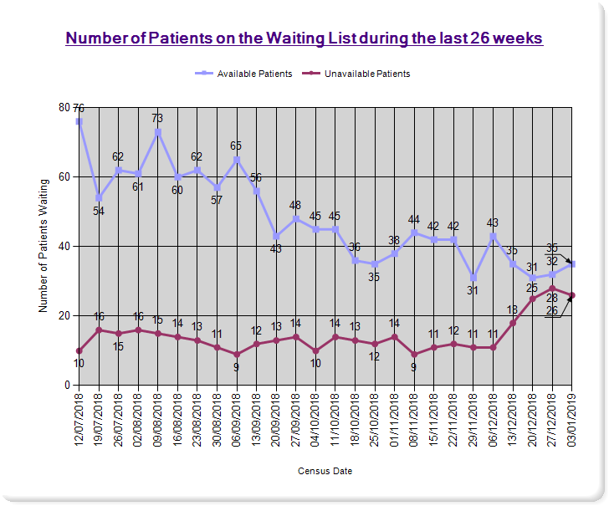 | 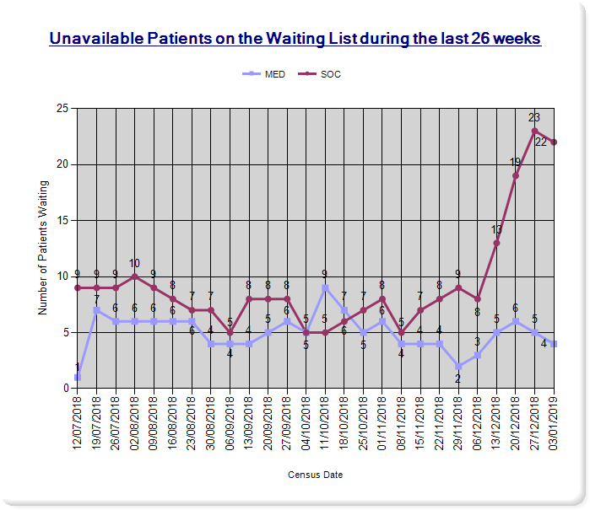
Cardiology Inpatient Waiting List
Figure 6 illustrates the number of cardiology patients on the waiting list during the last 26 weeks. On 3 January 2019 a total of 1112 patients were on the cardiology waiting list with around 98% (1086) patients on the available list. In addition to this, 2% (26) of patients were unavailable. The number of people on the cardiology inpatient waiting list has increased by 5% on the previous reporting period (up from 1051 patients).

Figure 6
