Golden Jubilee Foundation

Workforce Monitoring Report

1 April 2017 to 31 March 2018

Contents
1 Executive Summary 5
1.1 Introduction 5
1.2 Equality and Diversity 5
1.3 Recruitment Activity 6
1.4 Sickness Absence 6
1.5 Performance Management 6
2 Current Workforce 7
2.1 Employee Turnover 9
3 Recruitment 11
4 Sickness Absence 12
4.1 Boardwide Sickness Absence 12
4.2 Long Term and Short Term Sickness Absence 12
4.3 Sickness Absence by Division 13
4.4 Sickness Absence by Age and Gender 13
4.5 Reasons for Sickness Absence 14
5 Work Life Balance 16
5.1 Special Leave 16
5.2 Parental Leave 17
5.3 Maternity Support (Paternity) Leave 18
6 Equality and Diversity 19
6.1 Gender 19
6.1.1 Workforce Breakdown 19
6.1.2 Recruitment Activity 20
6.1.3 Training Activity 21
6.1.4 Career Progression 21
6.1.5 Turnover 21
6.2 Age 21
6.2.1 Workforce Breakdown 21
6.2.2 Recruitment Activity 23
6.2.3 Training Activity 24
6.2.4 Career Progression 24
6.2.5 Turnover 24
6.3 Race 25
6.3.1 Workforce Breakdown 25
6.3.2 Recruitment Activity 25
6.3.3 Training Activity 26
6.3.4 Career Progression 26
6.3.5 Turnover 26
6.4 Religion and Belief 26
6.4.1 Workforce Breakdown 26
6.4.2 Recruitment Activity 27
6.4.3 Training Activity 28
6.4.4 Career Progression 28
6.4.5 Turnover 28
6.5 Disability 28
6.5.1 Workforce Breakdown 29
6.5.2 Recruitment Activity 29
6.5.3 Training Activity 30
6.5.4 Career Progression 30
6.5.5 Turnover 30
6.6 Sexual Orientation 30
6.6.1 Workforce Breakdown 30
6.6.2 Recruitment Activity 31
6.6.3 Training Activity 31
6.6.4 Career Progression 31
6.6.5 Turnover 32
6.7 Marriage and Civil Partnership 32
6.8 Trans Staff 32
6.9 Pregnancy and Maternity 32
7 Development 33
7.1 Sickness Absence 33
7.2 Disability Confident 33
7.3 Glasgow Centre for Inclusive Living (GCIL) 33
7.4 Human Factors Training 33
7.5 Unconscious Bias Training 33
7.6 Staff Experience and iMatter 33
7.7 Recruitment 34
7.7.1 Investors in Young People 34
7.7.2 Recruitment Plan 34
7.7.3 Apprenticeships 34
7.7.4 Prince’s Trust Scotland 34
7.8 Equalities Information 34
7.9 Mandatory Training 34
7.10 Role Models 35
7.11 Data Collation 35
7.12 See Me: End Mental Health Discrimination 35

Executive Summary

Introduction
This Workforce Monitoring Report covers the period from 1 April 2017 to 31 March 2018.

The table below summarises the comparison of key workforce information over the last six years, during which the headcount of Board employees has risen from 1448 (as at 31 March 2013) to 1821 (as at 31 March 2018), an increase of 373 (25.76%). In the last twelve months the difference is +32 (1.79%). In part the increase over this time period is as a result of the continued expansion programme within the Board.

The ratio of female to male staff remains at almost 3:1, with only slight fluctuations over the last six years. This year the actual percentage split is 71.38% female and 28.62% male as a proportion of whole time equivalent staff.

Over each of the last six years the highest proportion of staff members has continuously been in the 40 to 49 age group. This is very closely followed by those in both the 50 to 59 and 30 to 39 age groups. In March 2018 all were over 26%, but under 27%, of the workforce.

As at 31 March 2018 just less than 70% two thirds of members of staff identify themselves as “White Scottish”, while 6.68% consider themselves to be in a minority ethnic group. This represents a rise in both of these groups since the previous year.

In March 2018 just under a quarter of staff identified their religion as “Church of Scotland”, which has been the most numerous religious group cited by employees over each of the last six years.

With regard to disability, the proportion of staff members employed by the Board who have commented on whether or not they consider themselves to be disabled has increased over the last six years, having risen from 0.90% in 2013 to 1.70% in 2018.

The majority of staff members indicate that they are heterosexual, with the proportion increasing over the last six years from 69.74% to 76.72%, which is likely to be linked to the fall in the number who gave no information or declined to comment, which collectively has fallen from 28.80% in March 2013 to 21.36% in March 2018.

 |  | March 2013 | March 2014 | March 2015 | March 2016 | March 2017 | March 2018
Headcount |  | 1448 | 1583 | 1688 | 1751 | 1789 | 1821
Female:Male ratio |  | 3:1 | 3:1 | 3:1 | 3:1 | 3:1 | 3:1
Age bracket with highest proportion of staff |  | 40 to 49 | 40 to 49 | 40 to 49 | 40 to 49 | 40 to 49 | 40 to 49
Race | White Scottish | 58.48% | 63.87% | 66.70% | 66.91% | 67.02% | 69.28
Race | Minority Ethnic | 6.37% | 6.82% | 6.70% | 5.58% | 5.98% | 6.68%
Religion – Church of Scotland |  | 23.34% | 23.94% | 25.20% | 23.52% | 23.31% | 23.39%
Percentage of staff with a disability |  | 0.90% | 0.95% | 1.18% | 1.08% | 1.63% | 1.70%
Sexual orientation – heterosexual |  | 69.74% | 71.20% | 72.63% | 75.00% | 75.74% | 76.72%

Equality and Diversity
Every twelve months a Workforce Monitoring Report is presented to the Senior Management Team and the Board in line with the Equality Act (Specific Duties) (Scotland) Regulations 2012 and the PIN Policy “Embracing Equality, Diversity and Human Rights in NHS Scotland”. The PIN policy supports monitoring of the protected characteristics of sex, age, race, religion or belief, disability, sexual orientation, marriage and civil partnership, gender reassignment, and pregnancy and maternity, as defined in the Equality Act 2010.

The Report also highlights the monitoring of the current workforce, recruitment, sickness absence and work-life balance.

Recruitment Activity
In the year from 1 April 2017 to 31 March 2018 370.77 whole time equivalent (WTE) vacancies were reported across the Board. When the service wishes to fill a vacant post it must be approved by the Workforce Review Group, which meets fortnightly.

The year saw the appointment of 211 posts. It also saw an increase in headcount of 32, which equates to an increase in the total workforce of 1.79%, due to continued expansion of our services.

Sickness Absence
For the 12 months between 1 April 2017 and 31 March 2018 the sickness absence percentage for the Board was 5.07%, against the national standard of 4.00%. This compares less favourably with the previous year’s 4.73%. Management and Human Resources continue to closely monitor sick leave and engage with and support members of staff who exceed Board targets.

Performance Management
There is continued use by all staff groups within the Board of performance management systems that have been implemented to maintain staff motivation and build upon skills and competencies. The year 2017-2018 saw 100% of medical staff with a prescribed connection to the Board undertake an appraisal. By the end of January 2018, when the new TURAS Appraisal system was introduced, 90.00% of staff members under Agenda for Change terms and conditions had completed their Knowledge and Skills Framework Personal Development Review. The performance of senior managers is reviewed annually and continues with 100% compliance.

Current Workforce

As at 31 March 2018 the Board employed 1789 headcount (1633.10 WTE) members of staff, excluding “Bank” workers. The majority of these are in substantive permanent posts, but a small number are in fixed term posts, such as Locum Consultants or Clinical Fellows in the Medical and Dental job family. The total number is an increase of 32 (19.79 WTE) on the previous year. The table and charts below represent how these were split by Division as at 31 March 2015, 2016, 2017 and 2018.

Division | 31 March 2015 |  | 31 March 2016 |  | 31 March 2017 |  | 31 March 2018
Division | Head | WTE | Head | WTE | Head | WTE | Head | WTE
Corporate | 419 | 372.27 | 437 | 386.60 | 437 | 393.84 | 474 | 418.60
Golden Jubilee Conference Hotel | 82 | 75.98 | 91 | 82.58 | 94 | 85.43 | 95 | 87.28
Regional and National Medicine | 384 | 341.89 | 395 | 350.17 | 414 | 367.93 | 392 | 351.57
Surgical Specialties | 803 | 730.49 | 828 | 756.31 | 844 | 766.11 | 860 | 775.65
Total | 1688 | 1520.63 | 1751 | 1575.66 | 1789 | 1613.31 | 1821 | 1633.10

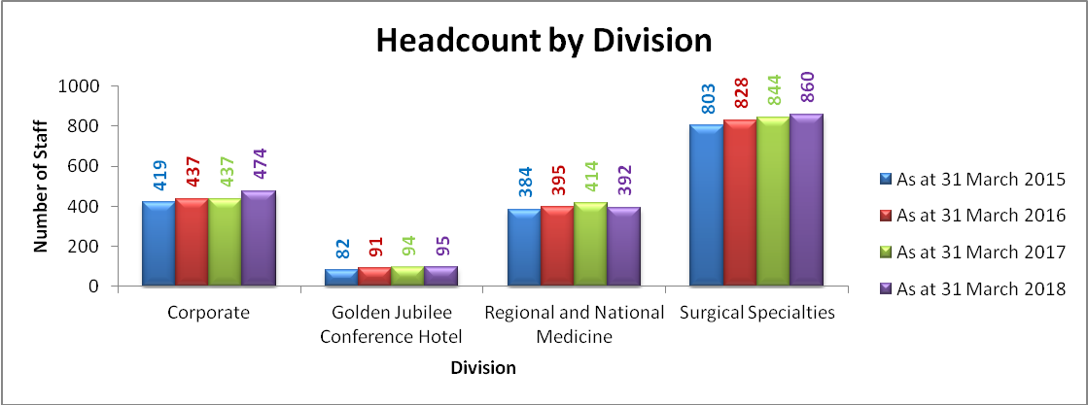

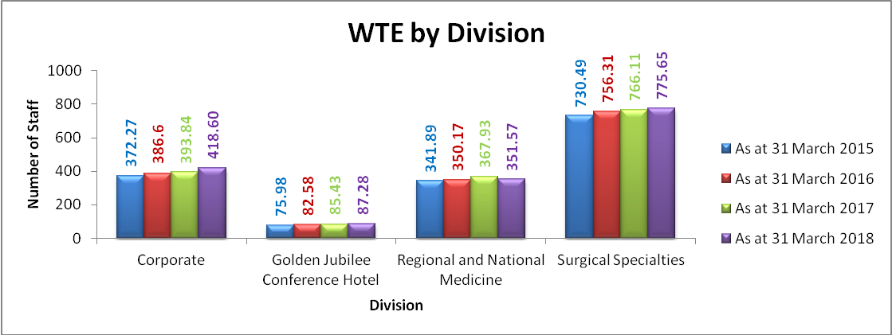

Whereas the table and charts above look at the workforce at the end of each the last three financial years, those below compare workforce headcount at 31 March each year since 2012. The table, and especially the chart, show the steady growth in headcount in each of the Divisions at the end of the financial year, and extrapolated trend lines indicate the likely ongoing increase in headcount. As a caveat it should be pointed out that the speed and phasing of possible future expansions have not been taken into account in the trend line, so future numbers could be very different.

Division | Mar-12 | Mar-13 | Mar-14 | Mar-15 | Mar-16 | Mar-17 | Mar-18
Corporate | 361 | 357 | 388 | 419 | 437 | 437 | 474
Golden Jubilee Conference Hotel | 72 | 77 | 82 | 82 | 91 | 94 | 95
Regional and National Medicine | 312 | 319 | 362 | 384 | 395 | 414 | 392
Surgical Specialties | 685 | 695 | 751 | 803 | 828 | 844 | 860
Total | 1430 | 1448 | 1583 | 1688 | 1751 | 1789 | 1821

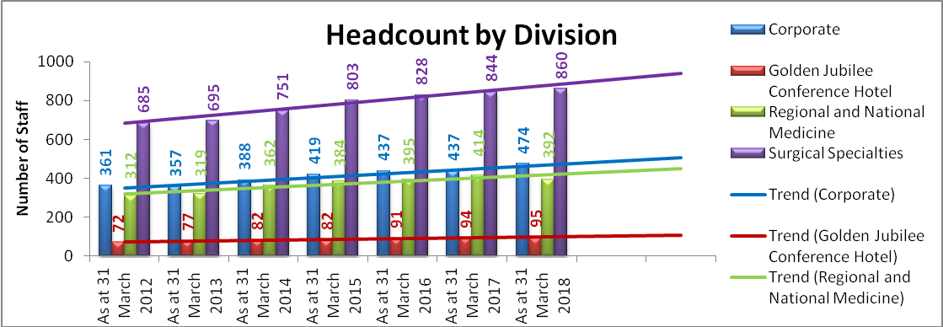

This increasing trend can also be seen clearly when looking at the chart below, which shows the overall monthly headcount for the Board from April 2016 to March 2018.

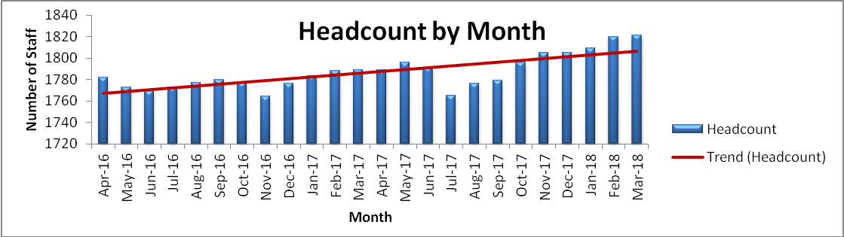

Just less than 45% of the workforce as at 31 March 2018 was in the Nursing and Midwifery job family, as can be seen from the table below. The next largest job family, at under 17% was Administrative Services.

Job Family | WTE | % WTE | Headcount | % Headcount
Administrative Services | 272.19 | 16.67% | 304 | 16.69%
Allied Health Professions | 109.43 | 6.70% | 127 | 6.97%
Healthcare Sciences | 85.01 | 5.21% | 95 | 5.22%
Medical and Dental | 127.30 | 7.79% | 130 | 7.14%
Medical Support | 18.29 | 1.12% | 19 | 1.04%
Nursing and Midwifery | 732.12 | 44.83% | 819 | 44.98%
Other Therapeutic | 39.67 | 2.43% | 53 | 2.91%
Personal and Social Care | 2.00 | 0.12% | 2 | 0.11%
Senior Managers | 10.00 | 0.61% | 10 | 0.55%
Support Services | 237.09 | 14.52% | 262 | 14.39%
Total | 1633.10 | 100.00% | 1821 | 100.00%

As well as substantive and fixed term members of staff the Board also uses “Bank” workers, which provides flexibility to increase staff over and above its core staff cohort at busier times and to cover unexpected absences, such as sick leave. As at 31 March 2018 there were 409 bank workers providing the Board with service, of which 311 came under Agenda for Change and 98 were in the Medical and Dental job family.

Employee Turnover
For the year under review the proportion of leavers was 8.70% of the overall staffing (source: ISD), a slight increase on the previous year, as can be seen below. The ongoing trend since April 2011 has been for a slight increase in employee turnover. This turnover is greater than for the other Special Boards (7.30% for 01.04.17 to 31.03.18) and the overall NHS Scotland turnover (6.60% at 31 March 2018).

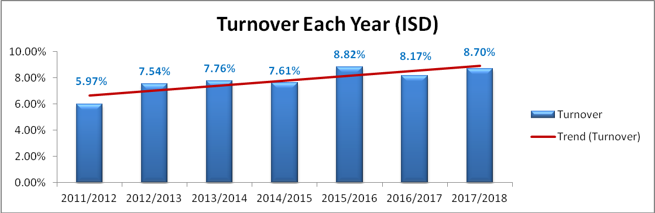

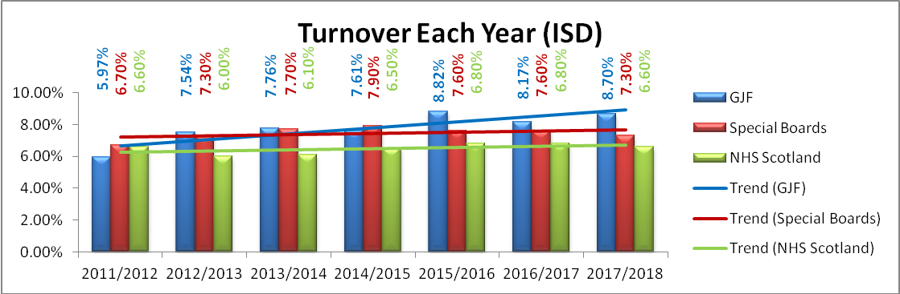

A monthly breakdown of employee turnover for April 2017 to March 2018 by headcount, comparing it to April 2016 to March 2017, is shown below. The August peak in turnover due to the junior doctor rotation can clearly be seen in August each year. In 2016/2017 the doctors left in July, while in 2017-2018 they left in August. 2017-2018 was the last year that this spike will relate to the junior doctor rotation, as from August 2018 the doctors in training will be employed by NHS Greater Glasgow and Clyde, NHS Lothian and NHS Grampian while on placement at GJNH. The trend lines show that between the start and end of 2016/2017 and the start and end of 2017-2018 the turnover trend was decreasing, at almost exactly the same rate each year.

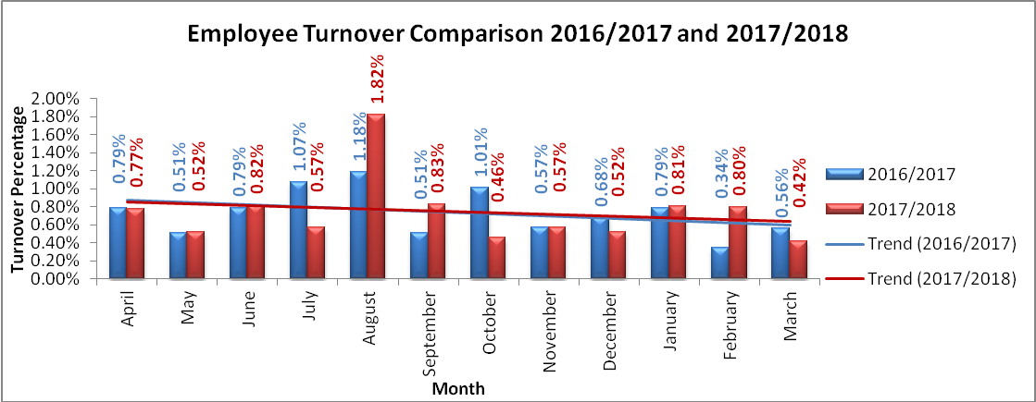

The majority of members of staff who leave the Board’s employment participate in an exit interview with a member of the HR Team. However, in some cases exit interviews are not carried out: either the employee may not want to participate or has already left by the time HR is informed. The chart below highlights reasons for leaving given by those who left the Board’s employment between April 2017 and March 2018. It shows the reasons for leaving as a percentage of the total number of leavers. The most common reason for leaving was due to the end of a fixed term contract, which accounted for 112, or 44.44% of, leavers. Of these 107 were members of medical staff: 84 were doctors in training in rotational posts; and 23 were Clinical Fellows, who tend to receive contracts for six or twelve months. Leaving to take up new employment in NHS Scotland was the second most popular reason for terminating employment: 21.83% of leavers cited this as their reason for leaving.

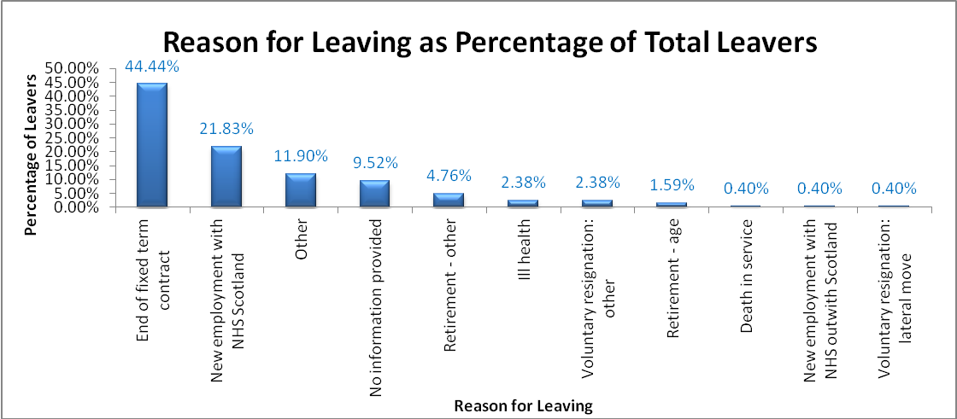

Recruitment

During the monitored period there were a total of 370.77 whole time equivalent vacancies across the Board. The greatest proportion of vacancies was within our largest Division, Surgical Services, as can be seen in the chart below:

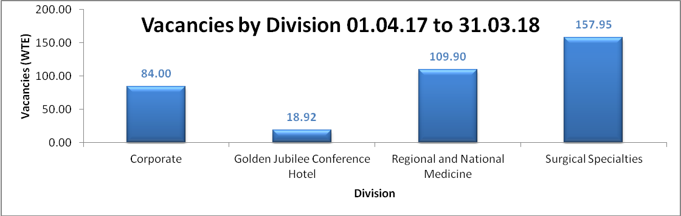

The job family with the largest number of vacancies during the year was, as in the previous year, Nursing and Midwifery with 153.25, followed by Administrative Services with 78.60. The chart below shows the job family breakdown of vacancies for the monitored period.

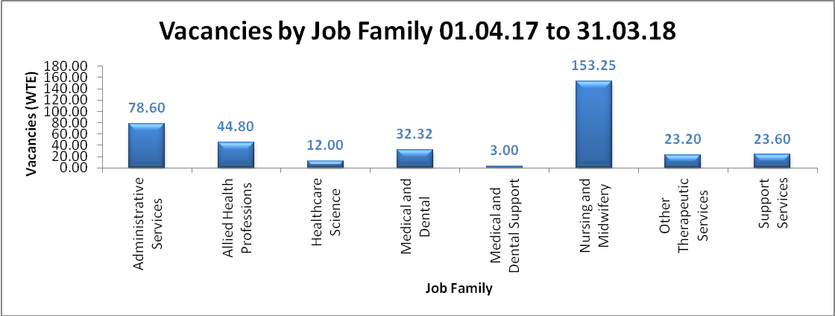

During the year a total of 1775 applications were processed by the Recruitment Team, of which 862 were shortlisted, and 211 of those shortlisted were appointed to posts. Further details on the breakdown of applicants, both successful and otherwise will be provided within the “Equality and Diversity” section of this report.

Sickness Absence

Boardwide Sickness Absence
Sickness absence is recorded by the service on the Scottish Standard Time System (SSTS) and statistics relating to the levels of sickness absence at a Departmental, Divisional and Board level are reported monthly to stakeholders by the Human Resources Department. The long term national standard for sickness absence is 4%. Over the monitored period the levels of sickness absence for the Board were higher than the national standard each month, as can be seen in the chart below. The average monthly rate of sickness absence for 2017-2018 came in at 5.07%, compared to 4.73% for the previous year.

Human Resources continues to work closely with service management to manage sickness absence across the organisation, with the aims of supporting those on sick leave during their absence, providing assistance to enable those on sick leave to return to work, and helping managers to ensure that their staff remain at work.

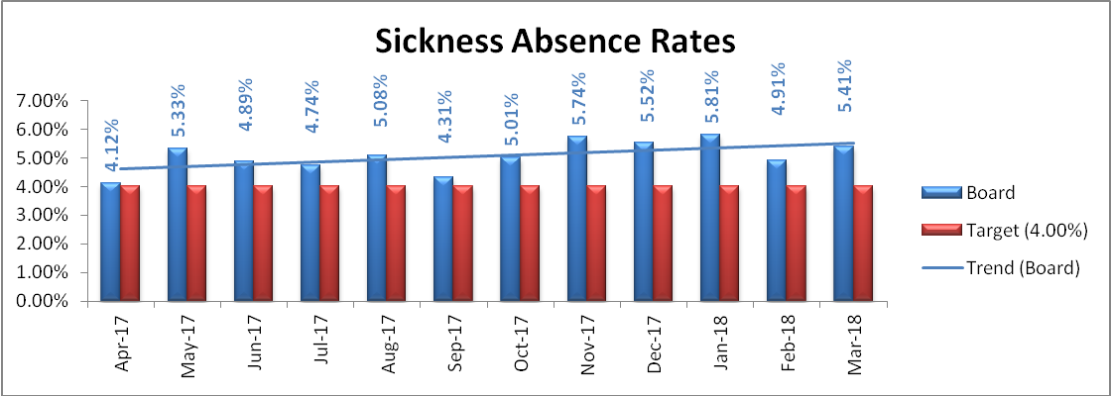

Long Term and Short Term Sickness Absence
Further analysis splits absences down into long term and short term, with long term representing absences over 28 days. The trend for long term absences is a flat line over the year, whereas in the previous year the trend was decreasing slightly. The average monthly long term sickness absence rate is 1.91%. As with the previous year, the main issue over the period monitored relates to the increasing trend in short term sickness absence, which is slightly increasing over the year. The average monthly rate of short term sickness absence was 3.16%.

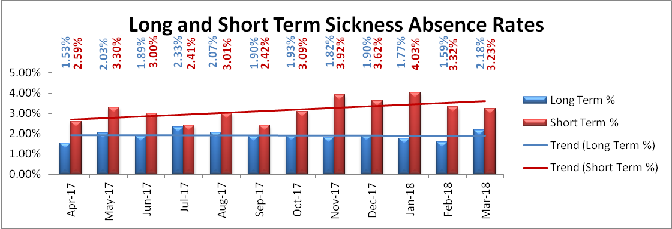

Sickness Absence by Division
The chart below highlights the total, short term and long term sickness absence rates for each of the four Divisions over the monitored period. Only the Golden Jubilee Conference Hotel (2.21%) falls under the 4.00% national target, while the other three Divisions did not meet the target.

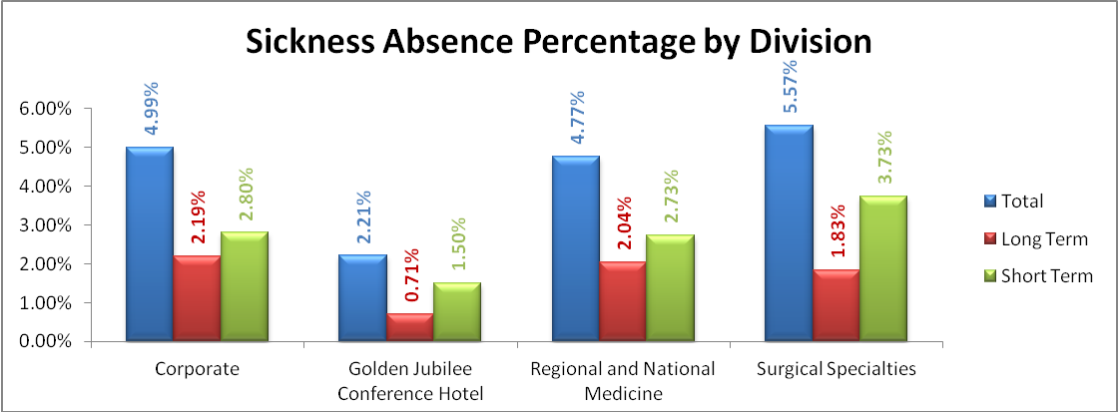

Throughout the year the sickness absence trend has been decreasing for Regional and National Medicine and flat for the Golden Jubilee Conference Hotel. However, the trend for both Corporate and Surgical Specialties has been for increasing rates of sickness absence over the monitored period, especially in Corporate.

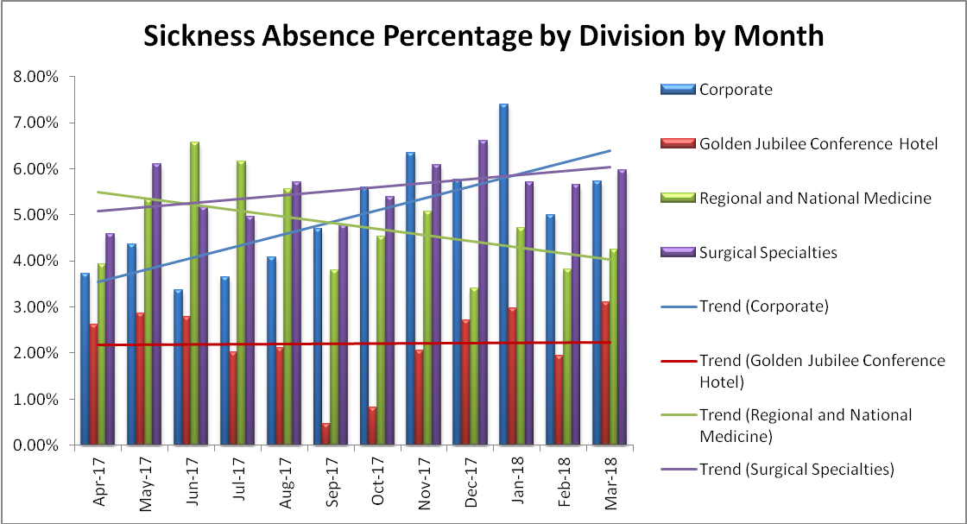

Sickness Absence by Age and Gender
The two charts below look at the proportion of sickness absence by age range and gender for the period under review and compare that with the proportion of staff by age range and gender as at 31 March 2018. Three age ranges have almost exactly the same proportion of staff: 30 to 39 (26.53%); 40 to 49 (26.70%); and 50 to 59 (26.61%). It is the 50 to 59 age range that has the largest proportion of sickness absence at 28.54%, closely followed by the 40 to 49 age range at 28.08%.

Unsurprisingly the three age ranges with the highest proportion of staff also have the highest proportion of female staff, which again is almost the same: 30 to 39 (19.32%); 40 to 49 (17.83%); and 50 to 59 (19.70%). They are almost evenly matched in the proportion of sickness absence that they have too: 30 to 39 (21.36%); 40 to 49 (21.96%); and 50 to 59 (22.79%).

The age range that was most under-represented in the sickness absence statistics when compared to the proportion of staff that it comprised was the 20 to 29 year olds, which made up 14.73% of the workforce, but only 9.09% of sickness absence.

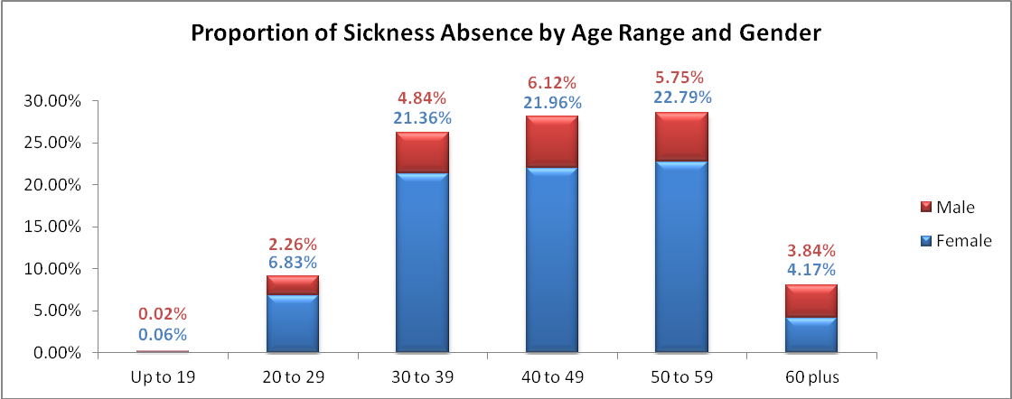

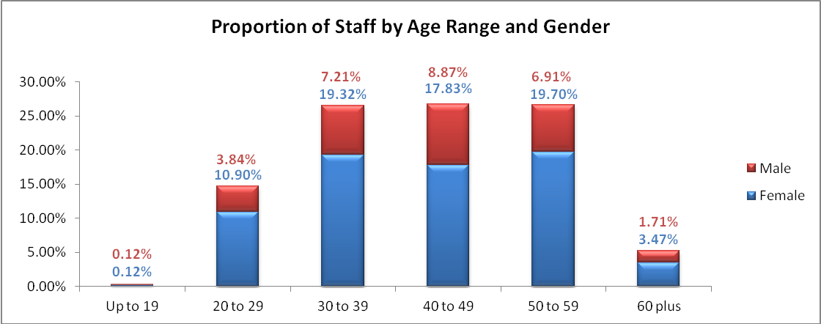

Reasons for Sickness Absence
When sickness absence is recorded on SSTS an absence reason has to be entered on to the system. The proportionate absence breakdown is shown in the table below for sickness absence reasons that caused more than 1.00% of sickness absence. The most commonly cited reason for sickness absence during the monitored period was “Anxiety/stress/depression/other psychiatric illnesses”, which made up slightly more than one fifth of sickness absences recorded. This is a decrease on the previous year, when it caused just over one quarter of sickness absence.

Members of staff who are absent with work related stress are asked to complete a work stress risk assessment questionnaire in order to bottom out work related issues. Options are considered to put in place support mechanisms that can help employee back to work and to stay at work on their return. Referrals can be made to Occupational Health and employees have the opportunity to attend cognitive behavioural therapy and employee counselling. Additionally Learning and Organisational Development can help employees to manage stressful situations through education and training.

Sickness Absence Reason | Hours Lost | Proportion of Sickness Absence
Anxiety/stress/depression/other psychiatric illnesses | 33160.35 | 20.24%
Cold, cough, flu - influenza | 16084.07 | 9.82%
Other musculoskeletal problems | 14261.17 | 8.70%
Gastro-intestinal problems | 11894.21 | 7.26%
Unknown causes/not specified | 11318.02 | 6.91%
Other known causes - not otherwise classified | 10891.38 | 6.65%
Injury, fracture | 9889.13 | 6.03%
Genitourinary & gynaecological disorders - exclude pregnancy related disorders | 9066.49 | 5.53%
Back problems | 7700.69 | 4.70%
Chest & respiratory problems | 6900.09 | 4.21%
Pregnancy related disorders | 6204.00 | 3.79%
Benign and malignant tumours, cancers | 5412.03 | 3.30%
Ear, nose, throat (ENT) | 4628.65 | 2.82%
Heart, cardiac & circulatory problems | 3187.75 | 1.95%
Blood disorders | 2123.00 | 1.30%

Work Life Balance

In August 2018 the Board updated its suite of policies that have been developed to provide members of staff with a range of flexible working options and leave arrangements to help them to balance their lifestyle, whilst maintaining and promoting the best possible service to patients. These policies are based on the Partnership Information Network’s “Supporting the Work-Life Balance PIN Policy”, which should help the Board to ensure effective recruitment and retention of staff, improve quality of life for its staff by assisting them to balance life and work responsibilities, increase motivation and job satisfaction, reduce absenteeism, improve performance, increase productivity and staff engagement, and ultimately improve service delivery. A Carers’ Guide will be finalised and available in 2018-2019, which will provide further support to managers and members of staff, highlighting the range of flexible working policies and sources of support for all members of staff within the Board.

Special Leave
Special leave allows management to pursue an appropriate response to a variety of situations, which are not covered by other types of leave available to members of staff, including amongst others:
- the necessary and unexpected need for a member of staff to provide care to any person who reasonably relies on the employee for assistance on an occasion where the person falls ill or is injured;
- an employee who suffers a bereavement; and
- members of staff who perform civic and public duties.

The special leave policy allows for absence where normal arrangements break down without notice or where an urgent and unforeseen situation arises.

In the monitored period a total of 25507.95 hours of special leave were recorded, broken up by Division as shown in the chart below. This total is considerably higher than the previous year (15193.61 hours), which can in the main be accounted for by the increase in special leave in March caused by adverse weather conditions with the “Beast from the East”. This is represented in the second chart below.

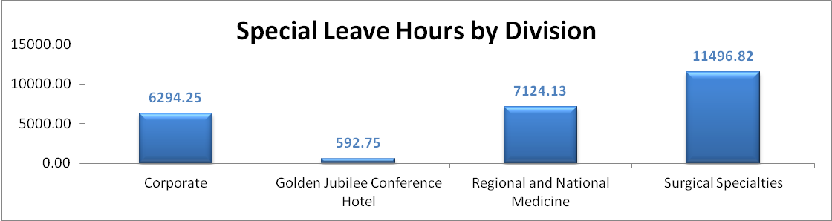

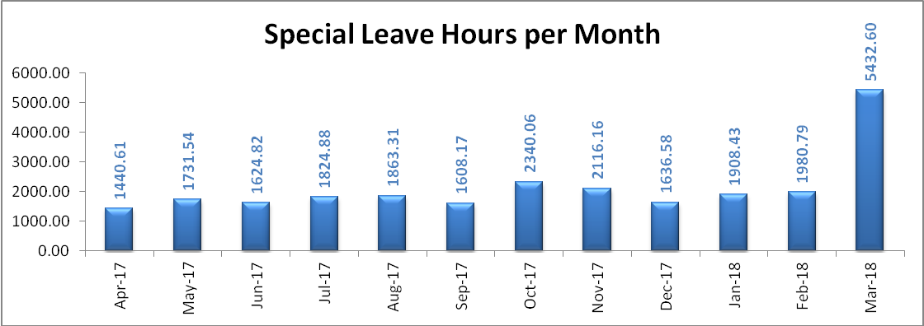

The top reasons for requesting special leave are listed below, with time off for adverse weather accounting for just under 30% of special leave. The next three reasons each accounted for almost exactly the same proportion of special leave over the year: phased return, bereavement leave and carer leave, all with over 11%, but under 12%, of the proportion of special leave.

Row Labels | Percentage of Special Leave
Bad weather conditions | 28.42%
Phased Return | 11.88%
Bereavement | 11.48%
Carer | 11.34%
Medical or dental appointment | 9.80%
Compassionate | 7.64%
Emergency / domestic issues | 6.33%
Phased retiral | 6.29%
Business Out | 1.61%
Other Special | 1.47%

Parental Leave
Parental leave is expressly for the purpose of allowing parents to spend quality time with their children and to assist in balancing this with work commitments, thus improving their participation in the workplace.

Between 1 April 2017 and 31 March 2018 a total of 7848.08 hours of parental leave were used, an increase of 388.20 hours on the previous year. The breakdown of parental leave by Division is as shown below:

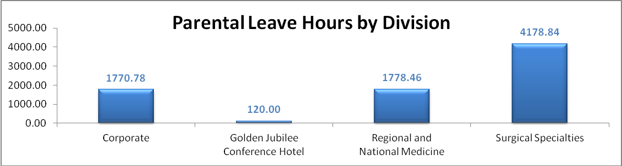

The monthly breakdown of parental leave across the Board during the monitored period is shown below. As has been seen in previous years there is a clear peak for parental leave in August, during the school summer holidays. Lesser peaks can be seen in April, February and October, which coincide with the Easter and half-term holidays.

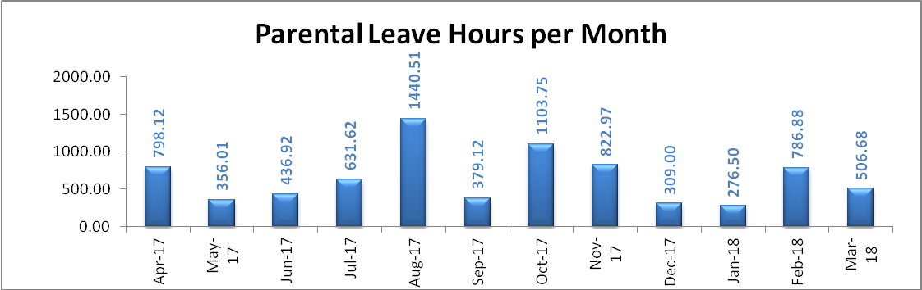

Unfortunately statistics on the use of shared parental leave cannot be provided for this monitoring period, as SSTS does not allow for this to be recorded other than as maternity leave or parental leave, either paid or unpaid.

Maternity Support (Paternity) Leave
Maternity support (paternity) leave applies to biological and adoptive fathers, nominated carers and same-sex partners, and allows time off for employees who wish to provide maternity support.

During the monitored period employees used a total of 1020.60 hours of maternity support (paternity) leave (a decrease of 63.40 hours on the previous year), as shown below:

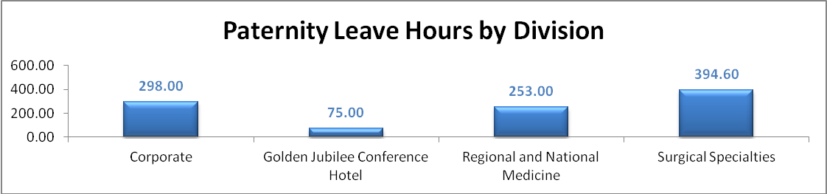

The monthly breakdown of maternity support (paternity) leave across the Board during the monitored period is shown below.

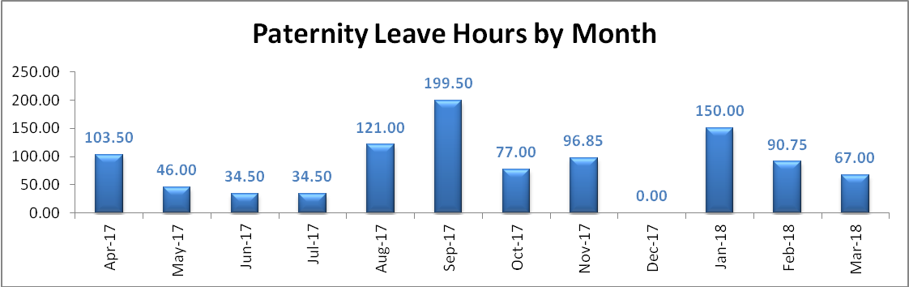

Equality and Diversity
The Board is committed to supporting dignity at work by creating an inclusive working environment. The Embracing Equality Diversity and Human Rights Policy places equality, diversity and human rights at the heart of everything the Board does. The information covered in this section is based on self-reporting by the Board’s staff and job applicants, and is collected at the point of engagement via the Staff Engagement Form or during the application process.

This section covers the protected characteristics as defined in the Equality Act 2010:
- gender;
- age;
- race;
- religion and belief;
- disability;
- sexual orientation;
- marriage and civil partnership;
- gender reassignment; and
- pregnancy and maternity.

It should be noted that in considering information relating to equality and diversity some numbers are so low that reporting them might enable identification of those employees in those numbers. Therefore, in some instances in the information shown below, where numbers of employees in a group are fewer than five, those numbers may be aggregated under a group such as “Other”.

The Board trains members of staff to champion diversity and currently has 13 diversity champions.

Gender

Workforce Breakdown
As in previous monitored periods the Board’s workforce continues to be predominantly female (1339 headcount), with women representing over 70% of the workforce as at 31 March 2018. There were 482 men employed at that date:

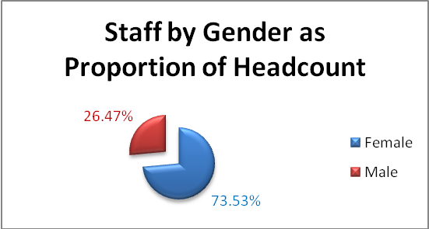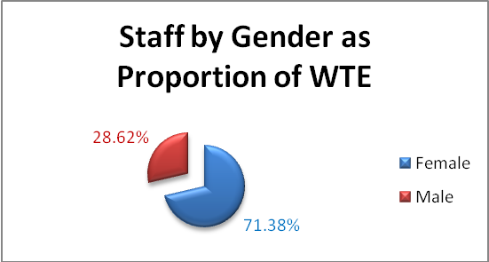

This continues the pattern of previous years:

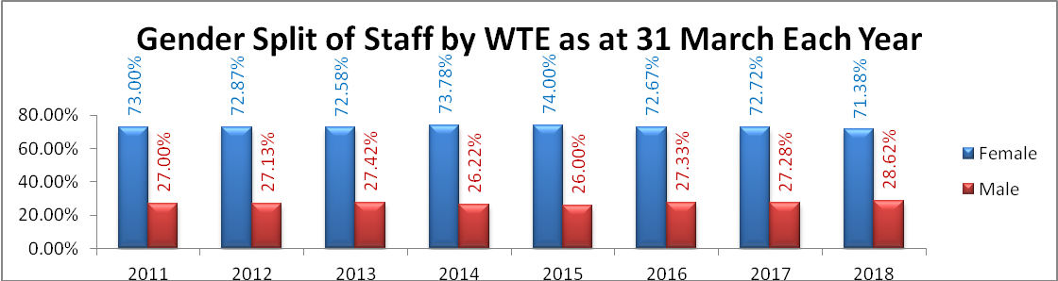

While gender split in Scotland is roughly 50:50, the largest job family in the Board is “Nursing and Midwifery”, which has traditionally been a female dominated profession, resulting in a higher proportion of female to male staff. The higher proportion of job families within the Board have a female majority, with only “Medical and Dental”, “Personal and Social Care” and “Support Services” having more male than female staff:

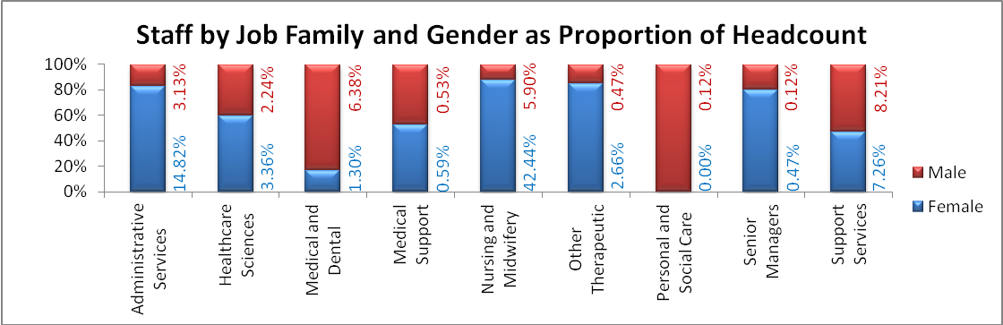

Recruitment Activity
As part of the recruitment process applicants are asked to provide equality monitoring information. While the majority of applicants do provide this information, some choose not to. This can be seen in the charts below, in which a number of applicants for posts opted to choose neither “Male” nor “Female”, or did not state a gender.

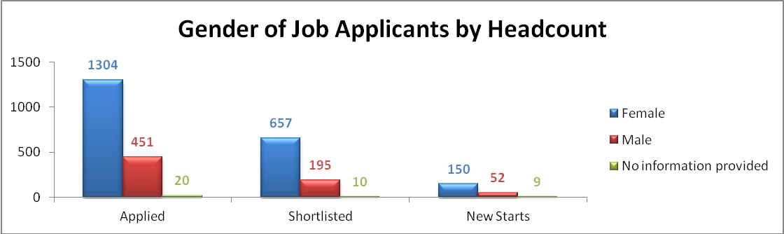

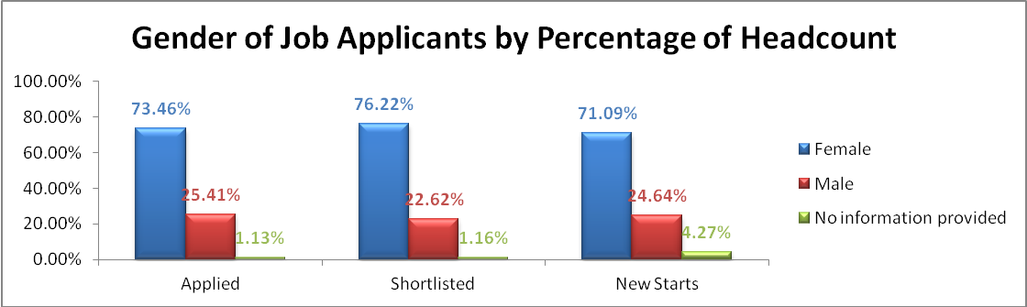

During the monitored period 25.41% of applicants for posts were male, as were 22.62% of those shortlisted and 24.64% of new starts, which indicates roughly proportionate appointment of male new starts in relation to male applicants. It should be noted that short-listing of applicants takes place without equality information being made available to the person short-listing, with the aim of ensuring equality.

The Board is also rolling out unconscious bias training, which should help interviewers to ensure that they do not take potential biases relating to stereotypes associated with protected characteristics into the interview room, thereby helping to ensure objective interviewing.

Training Activity
The split by gender of training activity undertaken during the monitored period favours female participation in training events when compared to their proportion of the workforce: they comprise 71.38% of the workforce, but undertook 78.25% of training activity. This is a slight fall in the proportion of training activity on the previous year, as can be seen from the chart below:

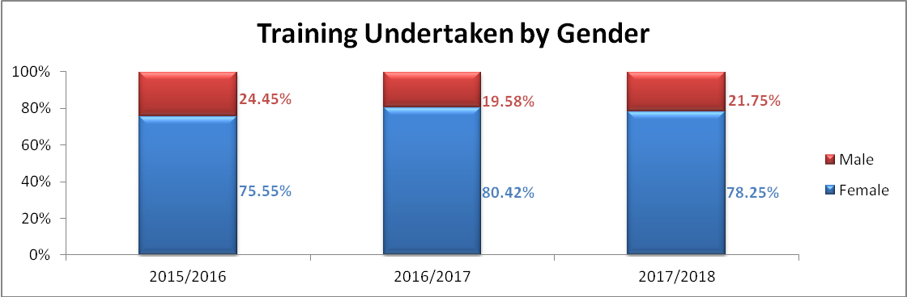

Career Progression
The monitored period saw a total of 16 promotions among the Board’s staff, all but one of which were permanent promotions. The remaining was a fixed term promotion. Of the 16 promotions during the monitored period the split was even: 50% female and 50% male, which indicates that males were overrepresented in promoted posts compared to their proportion of the staff cohort, where they make up only 28.62%.

Turnover
As previously reported ISD has indicated that employee turnover for the year was 8.70% of overall staffing headcount for the year. Of these leavers 63.59% were female and 36.41% male as a proportion of headcount, indicating that males were over-represented as leavers, as they made up 26.47% of the workforce at the end of March.

 | Leavers |  | Workforce
 | Headcount | % Headcount | Headcount | % Headcount
Female | 124 | 63.59% | 1339 | 73.53%
Male | 71 | 36.41% | 482 | 26.47%
Total | 195 | 100.00% | 1821 | 100.00%

Age

Workforce Breakdown
Over the last few years the age profile of the Board’s workforce has changed very little, with minor annual fluctuations in the proportion of the workforce that each age group comprises. However, over the last couple of years the proportion of total staff in the 50 to 59 age group has increased by roughly 4% and the proportion of those in the 60 plus age group has increased by approximately 2%. There has been a roughly commensurate fall in the proportion of staff in the 40 to 49 age group. The Board continues to monitor the age range of staff to allow it to carry out succession planning activities for future requirements.

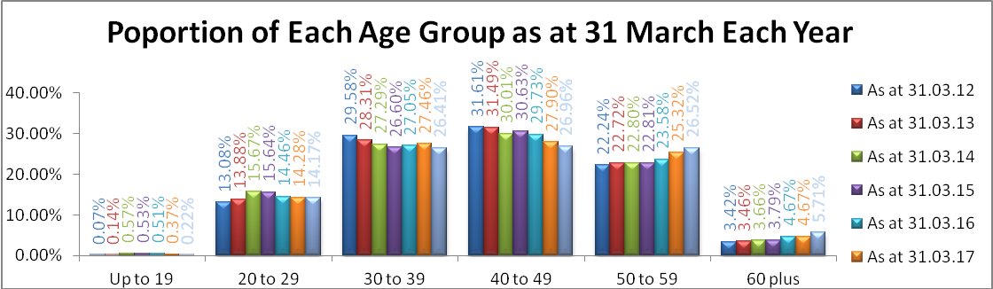

The following charts highlight the age ranges of the workforce in each of the job families, as at 31 March 2018.

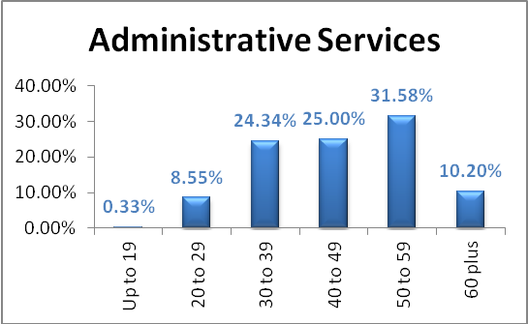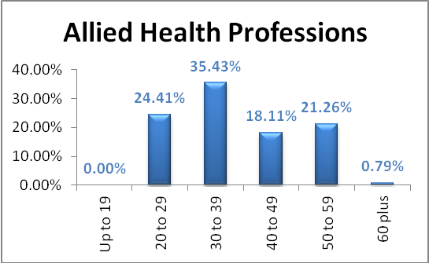

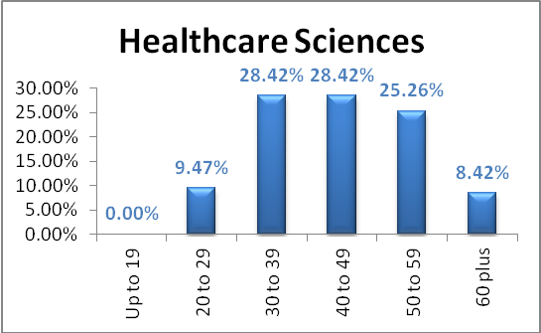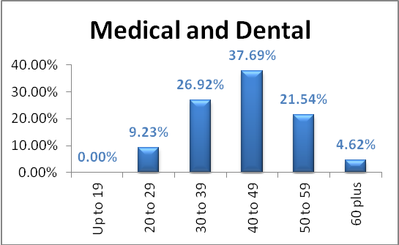

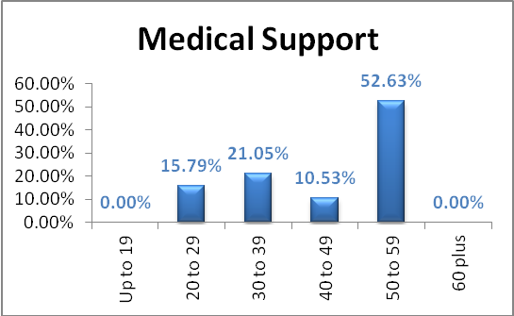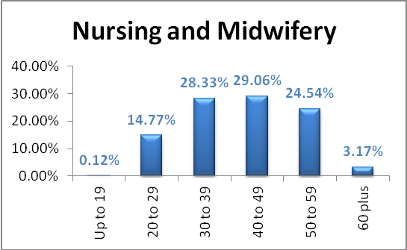

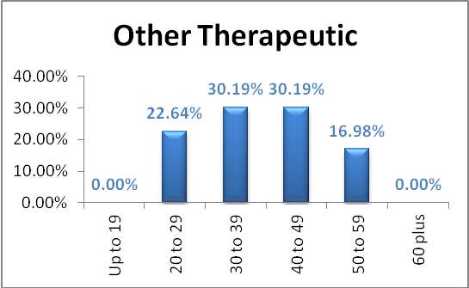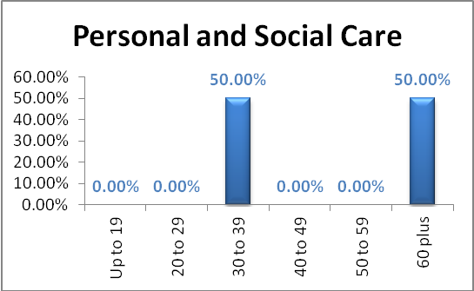

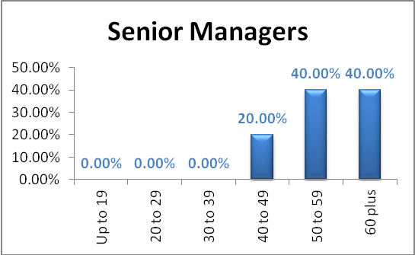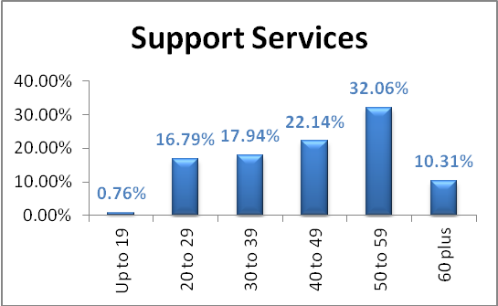

Recruitment Activity
The age range that supplied the largest number of applicants (510, 28.73%) and the second largest number of those who were shortlisted (229, 26.57%) was 20 to 29, also provided the largest number of new starts (71, 33.65%). The largest number of those shortlisted was in the 30 to 39 age range (244, 28.31%). Compared to the number of applicants those in the 20 to 29 age range were appointed to a greater proportion of new starts posts than those in other age ranges (33.65% of new starts compared to 28.73% of applicants).

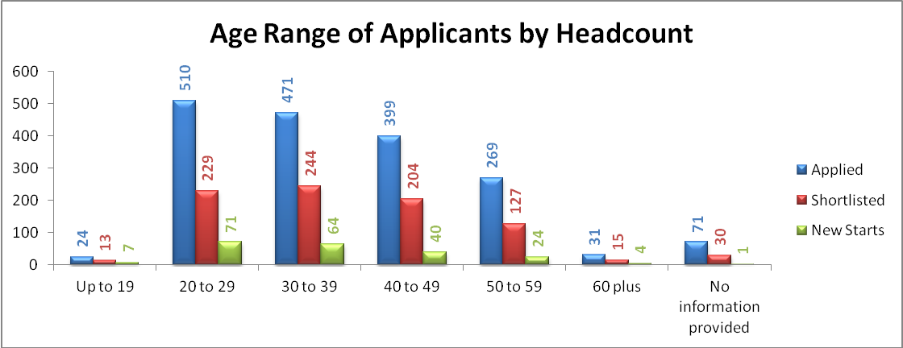

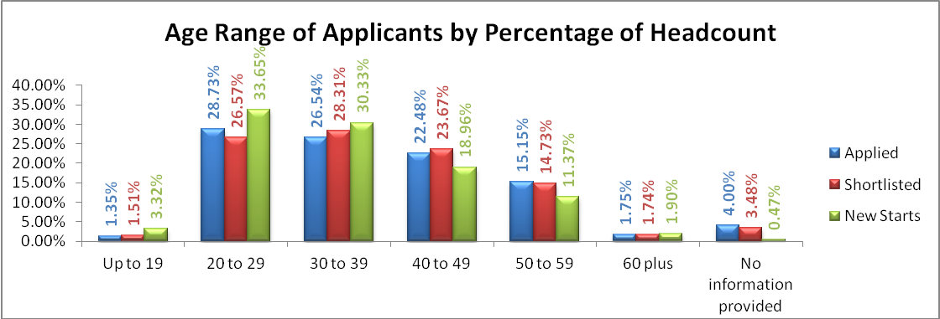

Training Activity
The proportion of training undertaken by each age range during the period monitored closely reflects the proportion of the workforce that age range comprises, as can be seen from the chart below.

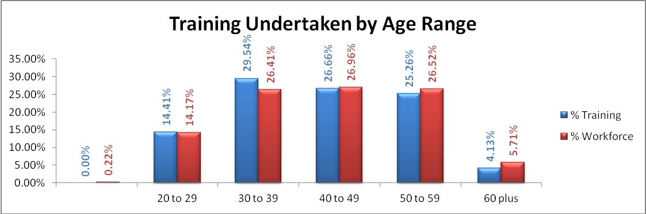

Career Progression
The monitored period saw a total of 16 promotions among the Board’s staff, the vast majority of which (15) were permanent. Employees in the following age groups were promoted: 20 to 29; 30 to 39; 40 to 49; and 50 to 59. However, the numbers in each group are so low that listing them may provide information enabling identification of the successful applicants.

Turnover
Turnover by age range during the period under review is shown in the table below. The turnover in the 50 to 59 age range is much lower than would be expected compared to their proportion of the workforce (12.31% turnover, compared to 26.52% of workforce).

 | Leavers |  | Workforce
 | Headcount | % Headcount | Headcount | % Headcount
Up to 19 | 0 | 0.00% | 4 | 0.22%
20 to 29 | 33 | 16.92% | 258 | 14.17%
30 to 39 | 64 | 32.82% | 481 | 26.41%
40 to 49 | 45 | 23.08% | 491 | 26.96%
50 to 59 | 24 | 12.31% | 483 | 26.52%
60 plus | 29 | 14.87% | 104 | 5.71%
Total | 195 | 100.00% | 1821 | 100.00%

Race

Workforce Breakdown
At the end of the monitored period the largest proportion of employees identified themselves as “White – Scottish”, coming in at 69.28% of the workforce, an increase of more than 2% on March 2017. The next largest group were those that did not provide any information on their ethnicity, with 11.93%, compared to 13.47% the previous year.

Year on year the number of employees who do not provide information on their race is falling, and the Recruitment Team continues to be proactive in encouraging new members of staff to ensure that equality monitoring information is included on the staff engagement form, even if the staff member completed “Declined to comment”. Minority ethnic groups made up 6.68% of the workforce, compared to 4.00% of the Scottish population as a whole (source: Scotland’s 2011 census). At March 2017 minority ethnic groups made up 5.81% or the workforce, so the change in the monitored period was +0.87%.

The percentage workforce breakdown by ethnicity is shown in the table below as at the end of March each year from March 2012:

 | Mar-12 | Mar-13 | Mar-14 | Mar-15 | Mar-16 | Mar-17 | Mar-18
White – Scottish | 56.60% | 58.48% | 63.87% | 66.70% | 66.91% | 67.02% | 69.28%
No information provided | 24.44% | 22.56% | 16.87% | 14.80% | 13.90% | 13.47% | 11.93%
White – Other British | 5.00% | 4.36% | 4.42% | 4.40% | 5.24% | 4.92% | 4.54%
White – Other | 2.71% | 3.04% | 3.41% | 3.40% | 5.18% | 5.54% | 3.45%
Declined to comment | 4.65% | 5.19% | 4.61% | 4.00% | 3.19% | 3.07% | 2.88%
Asian – Indian | 1.88% | 1.73% | 1.90% | 2.00% | 1.77% | 2.01% | 2.49%
White – Irish# | N/A | N/A | N/A | N/A | N/A | N/A | 1.24%
Asian – Other | 1.53% | 1.38% | 1.39% | 2.40% | 1.48% | 1.40% | 1.11%
Other Ethnic Group | 3.19% | 3.25% | 3.54% | 1.50% | 1.37% | 1.62% | 0.90%
Mixed or Multiple Ethnic Group# | N/A | N/A | N/A | N/A | N/A | N/A | 0.76%
Asian – Pakistani* | N/A | N/A | N/A | 0.40% | 0.57% | 0.56% | 0.69%
Asian – Chinese | N/A | N/A | N/A | N/A | N/A | N/A | 0.37%
African* | N/A | N/A | N/A | 0.40% | 0.40% | 0.39% | 0.36%

* In 2012, 2013 and 2014 Asian – Pakistani was counted in "Other Asian" and African was counted in "Other Ethnic Group", as the number of staff members was too low to identify separately.
# In the years prior to 2018 White – Irish, Mixed or Multiple Ethnic Group and Asian – Chinese staff members were counted in "Other Ethnic Group", as the number of staff members was too low to identify separately.

Recruitment Activity
The majority of applicants for vacant posts identify themselves as “White – Scottish”, making up 75.32% of applicants, 77.26% of those shortlisted and 73.46% of new starts. The group that stands out, where the proportion of new starts is much higher than that of applicants and those who were shortlisted, is where the new starter did not provide any information on their ethnicity, standing at 6.64% of new starts, compared to only 1.80% of applicants and 1.51% of those who were shortlisted.

Altogether applicants who identified themselves as from a minority ethnic group made up 10.42% of applicants, 10.32% of those shortlisted and 8.53% of new starts over the period monitored. This compares to 11.28% of applicants, 9.69% of those shortlisted and 9.57% of new starts in the period between 1st April 2016 and 31 March 2017.

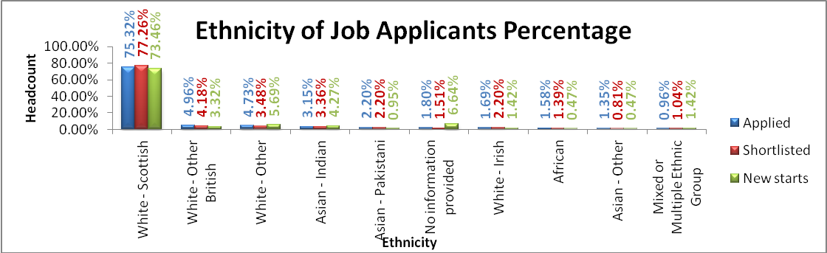

Training Activity
When considering training activity undertaken during the monitored period in terms of the ethnicity of the participants, with the exception of “Asian – Indian”, the percentage corresponds with the proportion of the workforce those ethnic grouping represent. Members of staff identified as “Asian – Indian” make up 2.49% of the workforce, but participated in 6.67% of training carried out:

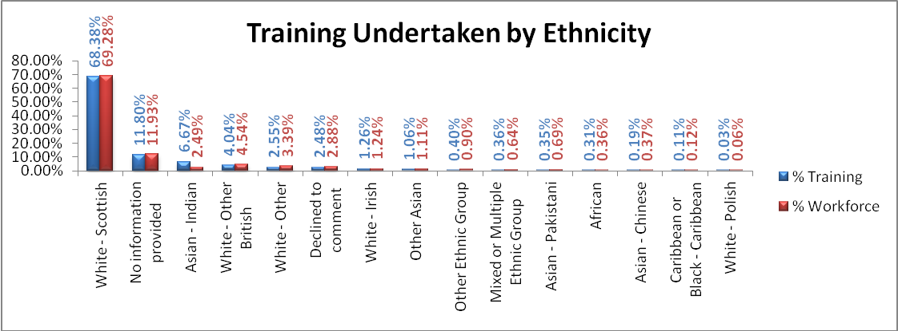

Career Progression
During the period under review, of the 15 permanently promoted staff 10 (66.67%) identified as “White – Scottish”, compared with 69.28% of the workforce. The remaining 5 promoted staff came from several of the other identified ethnic groups. However, the numbers are so small the splitting them may enable identification of the successful applicants.

Turnover
During the period under review the majority of leavers were “White – Scottish”. The proportion of them was considerably lower than the proportion of the workforce they make up: 49.23% against 68.92%. The proportion of leavers for whom no information on ethnicity was provided was almost double the proportion it represents in the workforce: 24.62% compared to 12.52%. The remaining leavers were split across several ethnic groupings, but the numbers are so low that listing them may allow for identification of those employees who left.

Religion and Belief

Workforce Breakdown
As with other protected characteristics new starts are asked to provide information in respect of their religious and faith beliefs, as part of the staff engagement process. Over the last few years the quality of information provided has improved, with fewer people not providing information on religion and beliefs in the monitored period than in previous years, as can be seen in the chart below. Of those who provided information the largest proportion of staff identify themselves as “Church of Scotland”, which has been the case since at least March 2012, with the second largest group identifying themselves as “Roman Catholic”.

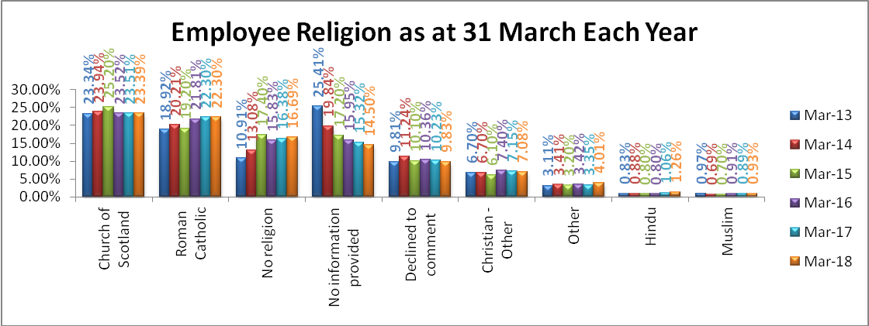

*Faiths which are represented by fewer than 5 members of staff (eg Jewish, Sikh, Buddhist) are not reported individually, but captured within “Other”.

Recruitment Activity
Of applicants for jobs in the monitored period the largest number identified themselves as “Roman Catholic”, followed by “No religion”, as can be seen from the charts below. The percentage breakdown of those who applied, who were shortlisted and were new starts is roughly proportionate, with the exception of: “No information provided” and “Christian – other”, where the proportion of new starts were higher than those who applied and those who were shortlisted; and “Church of Scotland” and “Roman Catholic”, where the proportion of new starts was lower when compared to the percentage of those who applied and those who were shortlisted.

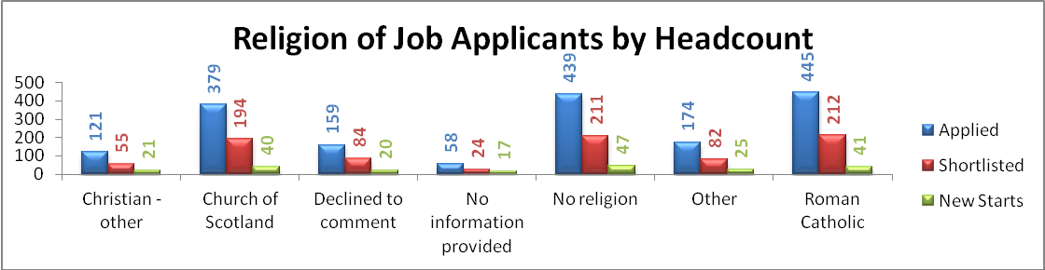

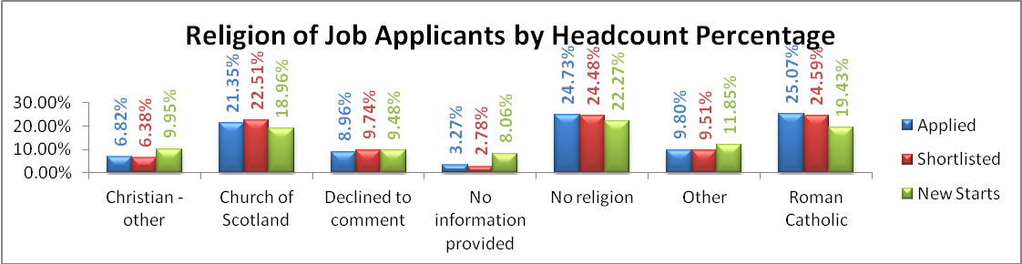

*Faiths which are represented by fewer than 5 applicants in the “New Starts” column (Buddhist, Hindu, Jewish, Muslim, Sikh and Other) are not reported individually, but captured within “Other”.

Training Activity
The chart below shows that members of each religious group undertook roughly proportionate training in relation to that group’s size within the workforce:

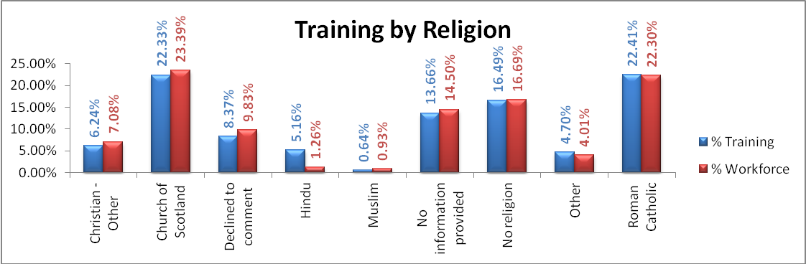

Career Progression
Members of staff who identified in the following groupings were permanently promoted in the year under review. However, the number of promotions in each group was fewer than five, so is not provided:
- Church of Scotland;
- declined to comment;
- no information provided;
- no religion;
- other; and
- Roman Catholic.

Turnover
During 2017-2018 turnover of staff was highest in the group of staff who had not provided information on their religion: 27.18% of turnover compared to 14.50% of staff. “Church of Scotland”, the largest religious group that staff members declared was underrepresented in turnover: they comprised 23.45% of staff and only 14.36% of turnover.

 | Leavers |  | Workforce
Religion | Headcount | % Headcount | Headcount | % Headcount
Christian - Other | 15 | 7.69% | 129 | 7.08%
Church of Scotland | 28 | 14.36% | 426 | 23.39%
Declined to comment | 20 | 10.26% | 179 | 9.83%
No information provided | 53 | 27.18% | 264 | 14.50%
No Religion | 34 | 17.44% | 304 | 16.69%
Other * | 9 | 4.62% | 113 | 6.21%
Roman Catholic | 36 | 18.46% | 406 | 22.30%
Total | 195 | 100.00% | 1817 | 100.00%

*Faiths which are represented by fewer than 5 applicants in the “Leavers Headcount” column (Buddhist, Hindu, Jewish, Muslim, Sikh and Other) are not reported individually, but captured within “Other”.

Disability
During the monitored period the Golden Jubilee Foundation has been part of the “Disability Confident” scheme. The Board automatically received the Level 2 – Disability Confident Employer badge for 12 months at the time of transfer. The Board is now at Level 3 – Disability Confident Leader.

Disability Confident aims to help businesses to employ and retain disabled people and those with health conditions. The scheme was developed by employers and disabled people’s representatives to make it rigorous but easily accessible. The scheme is voluntary and access to guidance, self-assessments and resources is completely free.

Through “Disability Confident” the UK Government will work with employers to fulfil these aims and objectives:
- challenge attitudes towards disability;
- increase understanding of disability;
- remove barriers to disabled people and those with long term health conditions in employment; and
- ensure that disabled people have the opportunities to fulfil their potential and realise their aspirations.

Further information on “Disability Confident” can be found at https://www.gov.uk/government/collections/disability-confident-campaign.

Workforce Breakdown
A large majority of our workforce continues to identify themselves as having “No disability”, with the proportion growing from 81.19% in March 2012 to 87.24% in March 2016. At the end of this monitored period it had fallen slightly to 86.44%. During this time the proportion of staff that has not provided information on their disability status has steadily fallen from 16.08% in 2012 to 11.86%. The proportion of staff members who identify themselves as “Disabled” has remained relatively steady over the same time period at around 1.00%, but this year increased to 1.70%:

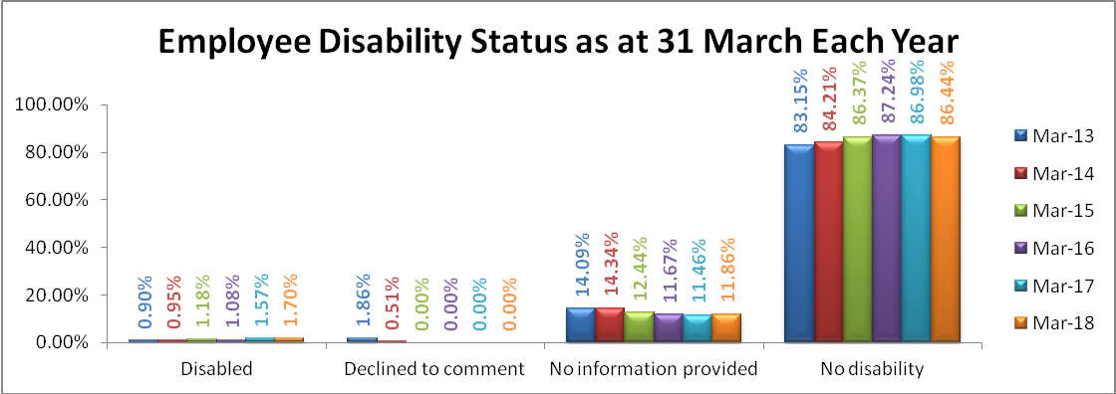

Recruitment Activity
Of applicants successfully appointed, those for whom no information was provided regarding their disability status made up 14.19% of new starts in the monitored period, but only 1.78% of applicants and 1.34% of those who were shortlisted. Those identifying themselves as “Disabled” made 5.60% of applications and 4.29% of new starts.

It is recognised that ideally we should have zero “No information provided” for new starts. Our Recruitment Team is proactive in encouraging those who do not wish to comment to use the “Decline to comment” option on the staff engagement form. It is hoped that as eESS has now been implemented in the Board it will lead to a reduction in “No information provided” for new starts.

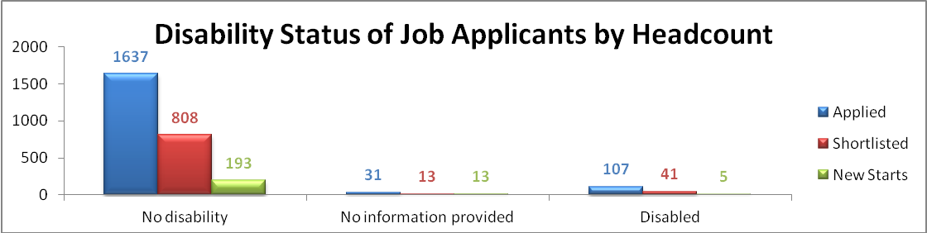

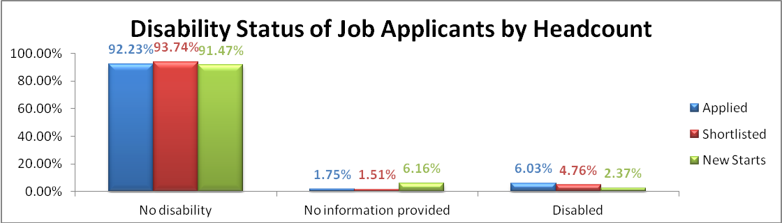

Training Activity
Members of staff who declared themselves to be disabled undertook 2.06% of all training carried out in 2017-2018. This compares slightly favourably to their proportion of the workforce – 1.70%.

Career Progression
None of the members of staff who were promoted between April 2017 and March 2018 had indicated that they had a disability.

Turnover
Of the 195 members of staff who left the Board’s employment in 2017-2018 two had declared themselves to be disabled.

Sexual Orientation

Workforce Breakdown
Trend analysis of sexual orientation over the last seven years indicates that the proportion of staff members who identify themselves as “Heterosexual” continues to grow, as can be seen in the chart and table below, while those who have not provided any information has reduced steadily over the same period. The number who declined to comment is also decreasing. To help improve the accuracy of information the Recruitment Team ensures that new members of staff completing engagement forms are asked to complete all parts of the Equal Opportunities Information section of the engagement form, reminding them that replying “Declined to comment” is an acceptable response, and preferable to not providing any information.

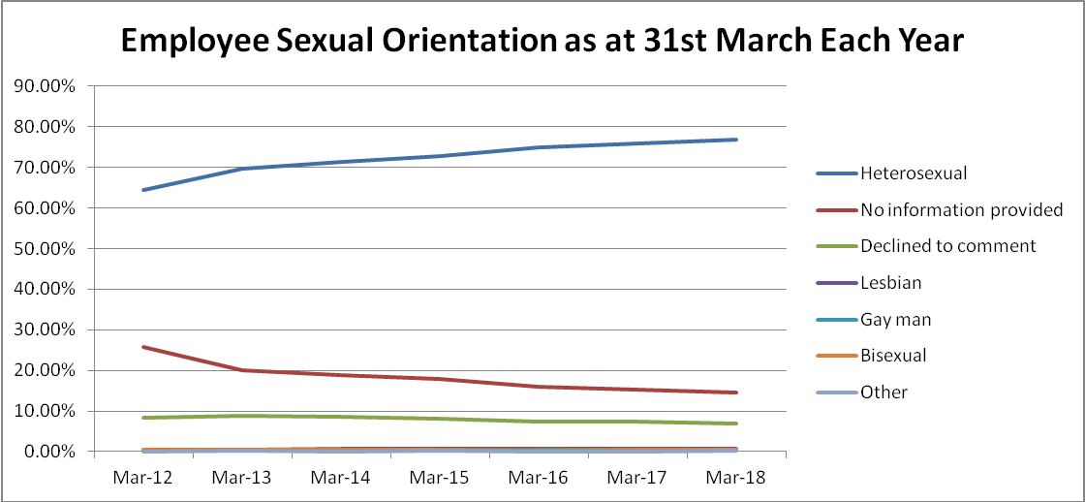

 | Mar-12 | Mar-13 | Mar-14 | Mar-15 | Mar-16 | Mar-17 | Mar-18
Heterosexual | 64.49% | 69.74% | 71.20% | 72.63% | 75.00% | 75.74% | 76.72%
No information provided | 25.81% | 19.96% | 18.87% | 17.77% | 16.00% | 15.37% | 14.44%
Declined to comment | 8.47% | 8.84% | 8.53% | 8.12% | 7.46% | 7.32% | 6.92%
Lesbian | 0.41% | 0.57% | 0.60% | 0.65% | 0.68% | 0.61% | 0.82%
Gay man | 0.34% | 0.32% | 0.30% | 0.30% | 0.40% | 0.45% | 0.49%
Bisexual | 0.48% | 0.44% | 0.48% | 0.41% | 0.34% | 0.39% | 0.38%
Other | 0.00% | 0.13% | 0.00% | 0.12% | 0.11% | 0.11% | 0.22%
Total | 100.00% | 100.00% | 100.00% | 100.00% | 100.00% | 100.00% | 100.00%

Recruitment Activity
The table below highlights the number and proportion of people who applied for posts, were shortlisted and came on board as new starts in the monitored period, split by declared sexual orientation:

 | Applied |  | Shortlisted |  | New starts
Heterosexual | 1617 | 91.10% | 790 | 91.65% | 180 | 85.31%
Declined to comment | 64 | 3.61% | 31 | 3.60% | 8 | 3.79%
No information provided | 37 | 2.08% | 15 | 1.74% | 14 | 6.64%
Gay man | 24 | 1.35% | 9 | 1.04% | * | *
Lesbian | 19 | 1.07% | 11 | 1.28% | * | *
Bisexual | 9 | 0.51% | * | * | * | *
Other | * | * | * | * | * | *
Grand Total | 1775 | 100.00% | 862 | 100.00% | 211 | 100.00%

* Where the declared sexual orientation of applicants is represented by 5 or fewer applicants the numbers are not given.

Training Activity
As can be seen from the chart below training provided during the period under review by sexual orientation almost matches the proportion expected for that group as a proportion of the workforce. However, both gay men and lesbians were underrepresented in training compared to the proportion of the workforce that they make up:

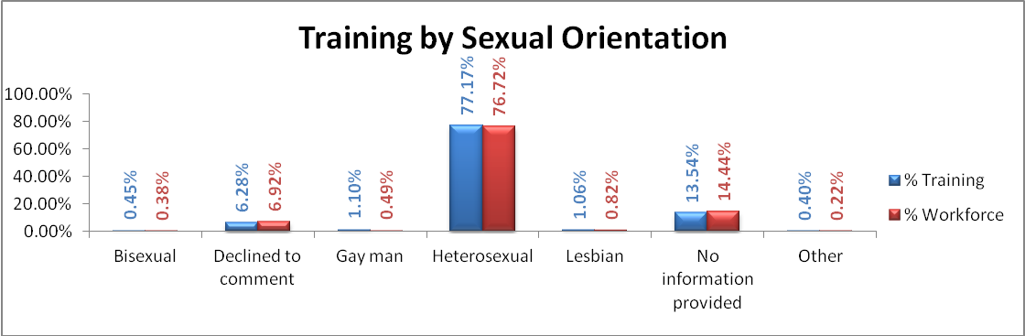

Career Progression
The majority of promoted staff have declared themselves to be “Heterosexual” – 11 out of 16 promoted posts (68.75%), which is somewhat below the proportion of staff as a whole who identify as “Heterosexual” (76.72%) . The remaining promoted posts declined to comment on their sexual orientation or did not provide any.

Turnover
During the period under review turnover by sexual orientation broadly mirrored workforce proportions, as can be seen below, with slightly more people who provided no information leaving than were represented in the workforce, and fewer people who identified as Heterosexual leaving than were represented in the workforce.

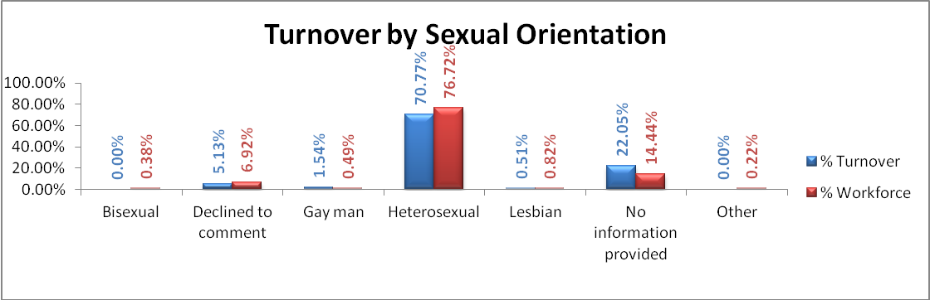

Marriage and Civil Partnership
As reported in previous monitoring the majority of staff in the monitored period chose not to provide information on their marital status. The information remains relatively constant for the other options available to our staff members too, as can be seen in the chart below. It may be the case that we may see a drop in “No information provided” in the next monitoring period, as the new HR system, eESS, requires this to be inputted. It should be pointed out that this was the first year that the option to enter “Civil Partnership” was available.

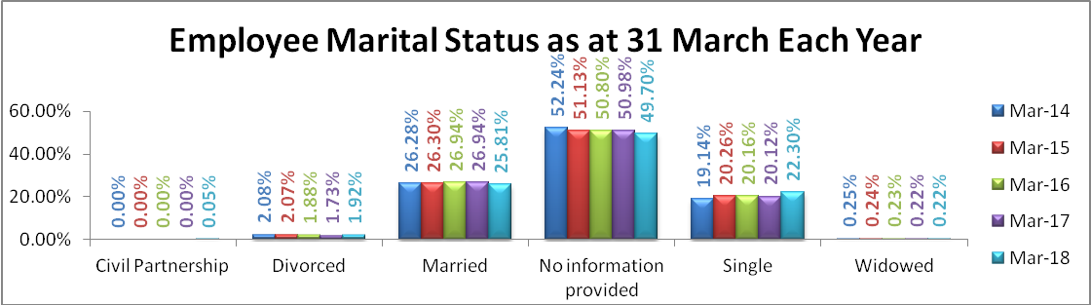

Trans Staff
The staff engagement form does not directly ask new members of staff to confirm if they have undergone gender reassignment, or are in the process of doing so, although the national application form does. However, it does ask them whether they describe themselves as trans. During the monitored period no members of staff identified as trans.

It should be noted that the new HR system, eESS, allows members of staff to amend their personal details, including equalities information. It also contains the question “Have you, are you or do you plan to undergo gender reassignment (changing sex)?” Members of staff have the option to respond “Yes”, “No”, “Don’t know” or “Prefer not to say”. It is expected that this will be built into the new national electronic Recruitment system, which it is hoped will directly feed eESS with the details of successful candidates, including equalities information.

Pregnancy and Maternity
During the monitored period a total of 52 members of staff went on maternity leave, while 57 returned from maternity leave. A further 14 both commenced and returned from maternity leave within the year.

Development

Sickness Absence
As in previous years, improving attendance at work, and reducing sickness absence statistics, was an ongoing priority for the Human Resources Team, managers, Occupational Health and Physiotherapy during 2017-2018. The focus on improving attendance at work has led to Human Resources and managers working to strict guidelines: they meet with members of staff who have had more than four absences in a twelve-month period; or who have been on long-term absence for more than 28 days. They work with Occupational Health and Physiotherapy to help staff members remain at work, or support them to return to work when appropriate.

2018-2019 will see continuing efforts to improve attendance at work, and support employees who are off sick to return to work as appropriate.

Disability Confident
In February 2018 the Board was confirmed as a Level 3 Disability Confident Leader. We are one of only nine employers in Scotland to have achieved this status, and the only NHS Board in Scotland. This status is validation of the work that happens throughout the Board in relation to those with disabilities. We are continuously looking for opportunities to enhance this work and to help other organisations, who may need advice or support.

Glasgow Centre for Inclusive Living (GCIL)
Glasgow Centre for Inclusive Living (GCIL) is a community business run by disabled people, working for and with disabled people. It is a registered charity and company limited by guarantee. GCIL Employment has developed and delivered innovative and unique services to address the barriers experienced by disabled people when attempting to access the labour market since 2001.

GJF is currently working with GCIL to provide training and employment opportunities for graduates, who may otherwise be excluded from employment. GJF currently has one graduate on a 2 year work programme from GCIL and in 2018-2019 the Board hopes to recruit a further graduate.

Human Factors Training
In March 2016 the Board began the training of all 1800 members of employees in Human Factors, a one day training course which takes account of the fact that the majority of errors and complaints in the NHS are due to human factors: systems, human interaction, environment, equipment and personal issues. By the end of this monitoring period 1082 members of staff had undertaken the training day. Training will continue throughout the next monitored period. The aim of the training is to improve patient care and help staff to focus on adopting safety positive behaviours.

Unconscious Bias Training
The Board is looking for a provider of unconscious bias training, with the aim of trialling it in the Human Resources and Learning and Organisational Development teams, before training the Senior Management Team and rolling it out to the wider organisation in 2018-2019. Unconscious bias training aims to end discrimination and bias within an organisation, by asking individuals to consider their behaviours and the impact they have on that organisation’s openness to diversity.

Staff Experience and iMatter
1118 of 1775 staff (62.98%) completed the iMatter questionnaire in 2018, giving an Employee Engagement Index (EEI) score of 78. The thermometer rating relating to overall staff feelings towards the organisation remained a positive 7.38, which is a slight decrease from 7.48 in 2017. Out of 143 teams to participate in the service, 100 (69.93%) achieved the required response rate to generate a report. This represents a decrease in the proportion of teams that received a report in 2017, which stood at 79.29% (82 out of 111).

71.32% of teams generated a timeous action plan to introduce change or improvement following on from receipt of the results of the iMatter questionnaire. The HR team supported members of staff and managers in the completion of the action plans and further work will be undertaken to explore some of the areas where reports and action plans were not created or progressed, in order to support these teams.

Recruitment

Investors in Young People
The Board hold Investors in Young People Gold status and continues to work to maintain and develop this, which includes working with the recently introduced young person’s forum to consider some of our working practices seen through the eyes of a young person, for example our recruitment and work placement processes. We are working to introduce an online forum to enable easier communication with this group of staff.

Recruitment Plan
A draft recruitment plan has been prepared, sharing a variety of different recruitment methods to support the planned expansion within the hospital. Work has begun to develop the Board’s recruitment page on the website and also to improve the documentation available to applicants.

The new national recruitment system is being finalised, with an implementation plan that will see all NHS Scotland Boards using it by the end of 2019. The pilot Boards will start using the system in February 2019. It is anticipated that we will be in phase 2 of the implementation plan.

Apprenticeships
The Board will continue to support the Modern Apprenticeship scheme run by Skills Development Scotland, and plans to introduce further apprenticeships over the next twelve months.

We have introduced our first Graduate Apprenticeship in Cyber Security. This is being undertaken by an existing member of the e-Health team and is fully funded by Skills Development Scotland.

The Board is likely to introduce further apprenticeships as part of the hospital’s future expansion. The contractors working on the building project are being encouraged to consider apprenticeships for local young people as part of their contract with the Board.

Prince’s Trust Scotland
The Board has commenced work to incorporate the Prince’s Trust Scotland Employability Partnership “Get into Healthcare” into the ongoing work of the Board. This is at an early stage, and is a youth employability partnership between NHS Scotland and the Prince’s Trust Scotland to promote careers access and youth employment across the service in Scotland.

Equalities Information
One of the things that is apparent when reading the main body of this report is that many members of staff have chosen not to provide information in relation to their protected characteristics. This is slowly improving year by year, and over the monitored period the Recruitment Team continued to make sure to ask new starts to complete this information on their engagement form, even if they mark that they “Declined to comment”.

It is anticipated that an improvement in information relating to protected characteristics will take place following the introduction of the electronic employee support system, “eESS”, the new Scotland-side HR system, which gives members of staff the opportunity to update their information personally, rather than having to go through HR, their manager or Payroll Services. eESS was implemented within the Board in May 2018.

Mandatory Training
Within the Board all members of staff must attend Corporate Induction and undertake four mandatory training topics:
- hand hygiene;
- fire safety;
- valuing diversity; and
- safe information handling.

Over and above these topics the various professions have subjects that are mandatory for them to undertake, such as medical staff carrying out blood transfusion and death certification training. It is also now mandatory for nursing staff to undertake manual handling training.

Role Models
A first tranche of staff members nominated as role models is in place and will be formally launched before Christmas 2018. These role models represent different parts of the Foundation family and are drawn from diverse backgrounds. They have been nominated and selected by peers due to the recognition that they are good champions of the Board’s values and are keen to promote diversity and inclusion. It is hoped that more role models will be added during 2019-2020 and will ultimately feature in internal campaigns and external recruitment promotion.

Data Collation
The National Boards are looking at how data is collated, including workforce related data, and how this can be automated. In 2018-2019 an exercise will commence to move National Boards onto the same reporting platform (Tableau), using current data sources.

See Me: End Mental Health Discrimination
See Me is Scotland's Programme to tackle mental health stigma and discrimination. It is funded by Scottish Government and Comic Relief and is managed by SAMH and The Mental Health Foundation. The Board is working with See Me to look at mental health in the workplace and to help to end mental health discrimination for staff members and patients. In 2018-2019 the Board will ask members of staff to complete a short staff survey to help improve mental health and tackle stigma.

