

**NHS Golden Jubilee**

1. **Annual Delivery Plan 2024/25 Quarter 3 Update**

NHS Golden Jubilee’s (NHS GJ) Annual Delivery Plan (ADP) and Delivery Planning Template sets out the Board’s priorities for the year following Scottish Government planning guidance. Boards are required to submit quarterly returns to Government providing updates and assurance on delivery. The Planning team has engaged with operational leads and Executive team to present the Quarter 3 (Q3) end position, and projections for Quarter 4 (Q4). A final and high-level overview of overall progress of all deliverables is provided in the final section of this note.

Boards are required to share their internal Delivery Plan progress or performance reports to inform on progress with the intent of ensuring receipt of clear and consistent information whilst reducing workload and duplication of reporting. As a result, the Planning team reviewed the approach to Delivery Planning and developed a new simplified Delivery Planning Template which has formed the basis of reporting on 2024/25 ADP delivery from Quarter 2 (Q2) onwards. Due to the simplification of the template between Quarter 1 (Q1) and Q2, comparison and monitoring progress between the two quarters was not undertaken. For the purposes of the current and remaining quarter, Q2 has been treated as the baseline against which Q3 and Q4 will be measured.

The Q3 update provides a progress update against priority actions at the end of December 2024. The priority actions have been identified in line with Scottish Government Planning Guidance, which is structured around the national NHS recovery drivers, five of which pertain to NHS Golden Jubilee:

* Planned Care
* Cancer Care
* Health Inequalities and Population Health
* Workforce
* Digital Services and Innovation Adoption

While NHS GJ does not have a driver focusing on primary and community care responsibilities, and is not required to report on this, we will continue to work with referring Boards and other partners as they progress actions to enable earlier intervention and care in the community. NHS GJ recognises the importance of collective ‘whole-system’ collaboration in order for NHS Scotland to recover core services, continue to improve levels of productivity and achieve sustainable improved outcomes for patients throughout Scotland.

This Q3 Delivery Planning Template was submitted to the Scottish Government on **12 March 2025.**

Progress of priority actions for the Centre for Sustainable Delivery (CfSD) have been excluded from this review note. Following discussion with NHS Education for Scotland (NES), NHSSA will continue to complete the ADP2 template which is submitted to the NHSSA Executive Programme Group (EPG). CfSD have adopted a similar approach by producing an update report for EPG. The ADP2 template and CfSD report will be submitted to Scottish Government as appendices to the review note.

1. **Quarter 3 End Position**

**Table 1** shows the overall RAG status of the Board’s 12 deliverables at quarter end: 7 Green RAG status indicators, 5 Amber, and zero Red:

|  |  |  |  |  |
| --- | --- | --- | --- | --- |
| **RAG Status** | | **Q1 Position** | **Q2 Position** | **Q3 Position** |
| ● | Unlikely to complete on time / meet target | N/A | - | - |
| ● | At risk - requires action | N/A | 1 | 5 |
| ● | On track | N/A | 11 | 7 |
| ● | Complete | N/A | - | - |
|  | **Total** | **N/A** | **12** | **12** |

**Table 1: Q3 End Position**

The total number of deliverables has remained unchanged from Q1.

Due to issues highlighted in **Table 2** below, the following five deliverables have been assigned Amber RAG status at Q3 end:

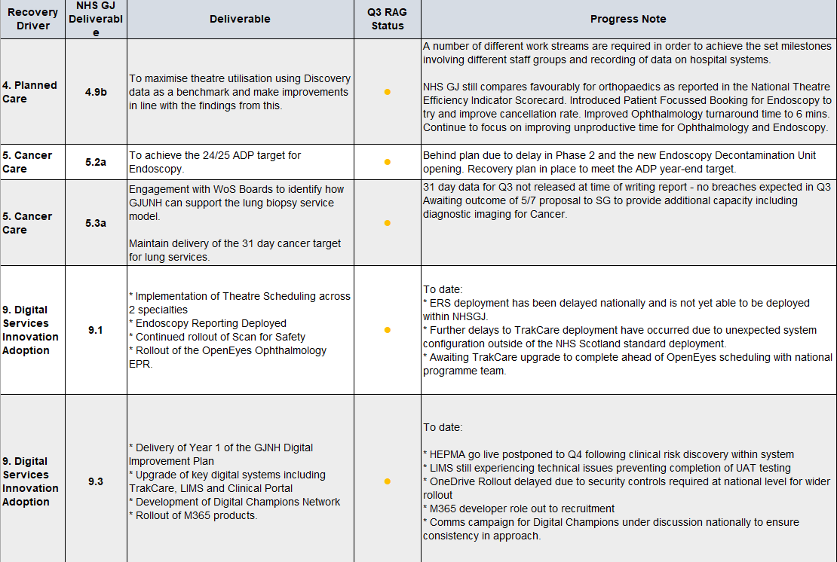***Table 2: Q3 Amber Deliverables***

The remaining 7 deliverables which are on track include one improvement from Amber in Quarter 2 following achievement of planned milestones for the Workforce deliverable 8.4: “An implementation plan for eRostering in 2024/25 with a view to implementing across all services and professions by 31st March 2027.”

For completeness, the Q3 deliverables current status and progress is set out in **Table 3** below:

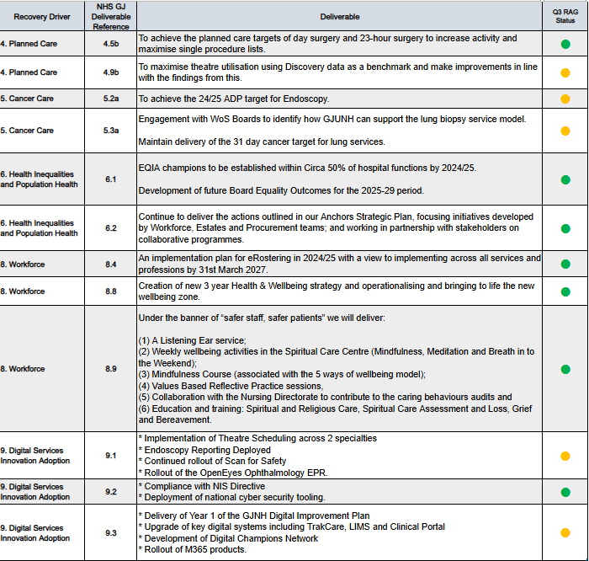

**Table 3: Q3 Overview of Deliverables**

1. **Projected Quarter 4 End Position**

Operational leads have undertaken assessment of the projected position of deliverables to Q4 end (March 2025). Based on current intelligence it is likely that the status of all 12 deliverables will remain unchanged at Q4 End as presented in **Table 4** below:

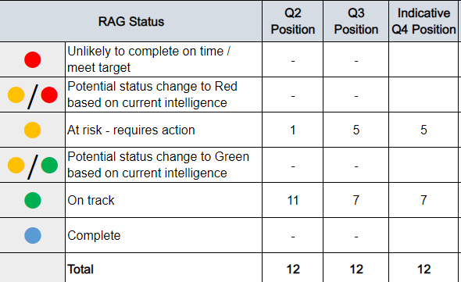

**Table 4: Q4 Indicative End Position**

To provide a comprehensive overview, further detail on the progress of the 7 Green and 5 Amber deliverables projected to remain unchanged to Q4 end has been provided in **Table 5** below:

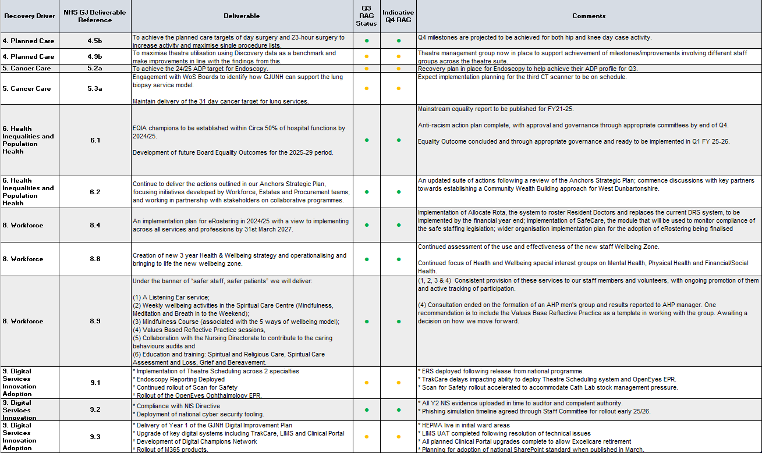***Table 5: Q4 Projections***

1. **Overall Progress**

**Table 6** below provides a high-level overview of the overall progress for deliverables to date, including Q3 end position and Q4 projections:

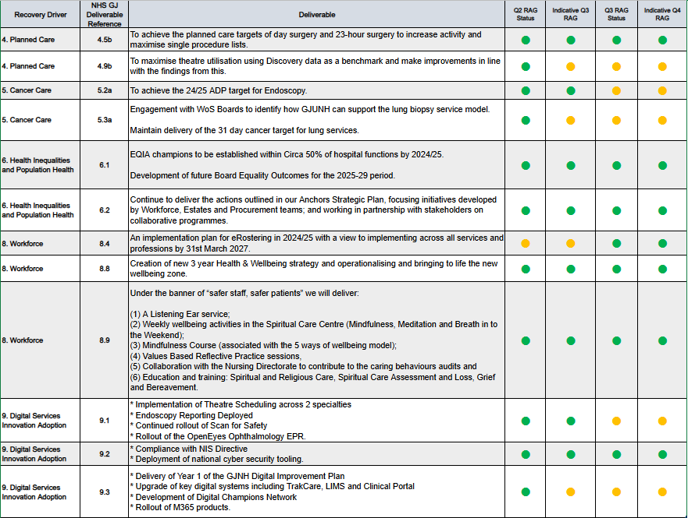***Table 6: Overall Deliverable Progress to Date***