

Whistleblowing Performance Report

-----------------------

Quarter 3 – October to December 2024

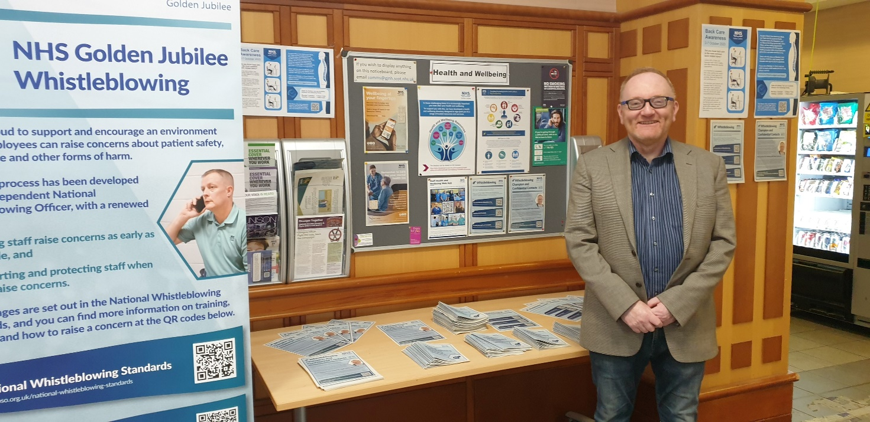

December 2024 – Quarter 3

# **Contents**

**Contents** 2

**1.0 Context** 3

**2.0 Areas covered by the Report** 4

**3.0 Quarter 2 Performance** 4

**4.0 Learning, changes or improvements to services** 5

**5.0 Level of staff perception, awareness and training** 6

**6.0 Speak Up Week Outcomes** 7

**7.0 Whistleblowing Oversight Group** 10

**8.0 Conclusion** 11

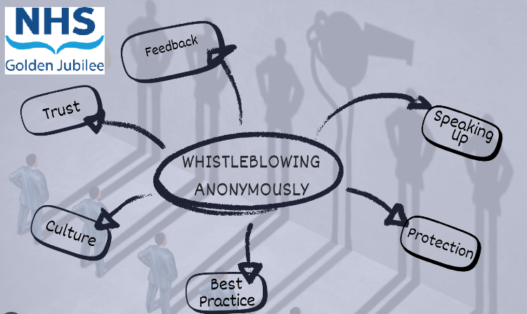

# **1.0 Context**

The National Whistleblowing Standards (the Standards) set out how all NHS service providers in Scotland must handle concerns that have been raised with them about risks to patient safety and effective service delivery. They apply to all services provided by or on behalf of NHS Scotland and must be accessible to all those working in these services, whether they are directly employed by the NHS or a contracted organisation. This includes students, trainees, volunteers and ex-employees for up to six months.

“Whistleblowing” is defined as: *“…when a person who delivers services or used to deliver services on behalf of a health service body, family health service provider or independent provider (as defined in section 23 of the Scottish Public Services Ombudsman Act 2002) raises a concern that relates to speaking up, in the public interest, about an NHS service, where an act or omission has created, or may create, a risk of harm or wrong doing.”*

This report will demonstrate our performance in the national key indicators as required by the Independent National Whistleblowing Officer (INWO) and includes key areas of Whistleblowing handling, as well as highlighting outcomes and providing more detail on any Whistleblowing themes. Over time, this approach will illustrate trends in and more importantly, allow us to evidence necessary improvement and learning in response to the trends and themes demonstrated.

During Speak Up week we engaged with our staff to build on the culture where everyone confidently can raise a concern and where they know that any concerns raised, will be thoroughly investigated, with any lessons learned being taken forward by the organisation.

The Standards specify high level principles plus a detailed process for investigating concerns which all NHS organisations in Scotland must follow. NHS Health Boards have particular responsibilities regarding the implementation of the Standards:

• ensuring that their own whistleblowing procedures and governance arrangements are fully compliant with the Standards.

• ensuring there are systems in place for primary care providers in their area to report performance data on handling concerns.

• working with higher education institutions and voluntary organisations to ensure that anyone working to deliver NHS Scotland services (including students, trainees and volunteers) has access to the Standards and knows how to use them to raise concerns

This reports provides an overview of the outcome from Speak Up week and the performance update for Quarter 3.

# **2.0 Areas covered by the Report**

The national Whistleblowing Standards (the Standards) set out how all NHS Service providers in Scotland must handle concerns that have been raised with them about risk to patient safety and effective service delivery.

Under the terms of the Standards, the quarterly performance report must contain information on the following indicators:

1. Total number of concerns received.

2. Concerns closed at stage 1 and stage 2 of the whistleblowing procedure as a percentage of all concerns closed.

3. Concerns upheld, partially upheld and not upheld at each stage of the whistleblowing procedure as a percentage of all concerns closed in full at each stage.

4. The average time in working days for a full response to concerns at each stage of the whistleblowing procedure.

5. The number and percentage of concerns at each stage which were closed in full within the set timescales of 5 and 20 working days.

6. The number of concerns at stage 1 where an extension was authorised as a percentage of all concerns at stage 1.

7. The number of concerns at stage 2 where an extension was authorised as a percentage of all concerns at stage 2.

NHS Golden Jubilee’s approach to the implementation of the standards was key to ensuring that staff feel safe, supported and have confidence in the fairness of the processes should they feel they need to raise concerns.

In NHS Golden Jubilee the agreed governance route for reporting on whistleblowing is to Clinical Governance Committee with any staff concerns being shared with Staff Governance and Person Centred Committee and then onward to the Board.

# **3.0 Quarter 2 Performance**

**Indicator 1 - Total number of concerns, and concerns by Stage**

During Quarter 3, October to December 2024, no Whistleblowing Concerns were received.

**Indicator 2 – Concerns closed at Stage 1 and Stage 2 of the whistleblowing procedure as a percentage of all concerns closed.**

To date there has been one Whistleblowing Concern received, during 2022/23 that was concerned with the adequacy of arrangements within NHS Golden Jubilee for the provision of First-Aid to employees, patients and visitors. The lessons learned are continually being reviewed.

**Indicator 3 - Concerns upheld, partially upheld and not upheld at each stage of the whistleblowing procedure as a percentage of all concerns closed in full at each stage.**

The definition of a stage 1 concern - Early resolution is for simple and straightforward concerns that involve little or no investigation and can be handled by providing an explanation or taking limited action, within 5 working days.

No stage 1 concerns were received in Q3 this year.

The definition of a stage 2 concern – are concerns which tend to be serious or complex and need a detailed examination before the organisation can provide a response within 20 working days.

No stage 2 concerns were received in Q3 this year.

**Indicator 4 - The average time in working days for a full response to concerns at each stage of the whistleblowing procedure.**

No Whistleblowing Concerns were raised during Quarter 3 this year.

**Indicator 5 - The number and percentage of concerns at each stage which were closed in full within the set timescales of 5 and 20 working days.**

No Whistleblowing Concerns were raised during Quarter 3 this year.

**Indicator 6 - The number of concerns at stage 1 where an extension was authorised as a percentage of all concerns at stage 1.**

No Whistleblowing Concerns were raised during Quarter 3 this year.

**Indicator 7 - The number of concerns at stage 2 where an extension was authorised as a percentage of all concerns at stage 2.**

No Whistleblowing Concerns were raised during Quarter 3 this year.

# **4.0 Learning, changes or improvements to services**

Learning, changes or improvements to services can be limited by the need to maintain confidentiality of individual Whistleblowers.

In relation to local and system-wide learning processes awe have now captured these through the Speak Up Week Conclusion, Section 6.0.

As part of this year’s iMatter survey an additional two questions were included which specifically related to raising concerns. It should be noted that these questions were not specifically in relation to Whistleblowing but relate to raising concerns in a general sense.

# 

# **5.0 Level of staff perception, awareness and training**

It is difficult to quantify staff perceptions. However we continue to promote the Senior Managers and staff training and will continue to monitor uptake, effectiveness and appropriateness as required.

Our Communications Team will continue to promote raising awareness and further actions in relation to this topic and is discussed later in the report.

NHS Golden Jubilee participated in the recent National Speak Up Week held on 30 September 2024 with the theme ‘Enabling Speaking Up’. This was a networking opportunity across NHS Health Boards discussing how ‘speak up’ methodologies could be implemented within organisations. The five main areas were Leadership and Speak Up Culture, Access to the Process, Psychological Safety, Understanding the Experiences of All Involved and Building Trust. We used quotations received from our Executive and Non-Executive cohort to support the process. We also provided a short survey to give staff the opportunity to, anonymously, let us have their view on the Whistleblowing process.

The Non-Executive Whistleblowing Champion meets with the Confidential Contacts on a periodic basis to ensure any Whistleblowing Concerns are signposted as a support to staff.

It is recognised that this is a learning process and that processes and communications may require to be changed or developed as feedback from updated Whistleblowing processes is received.

The current levels of Training for staff are shown as:

|  |  |  |
| --- | --- | --- |
| **Short Resource Hierarchy - Resource Name** | **Learning Status - Status** | **Learners** |
| Whistleblowing : an overview | Completed | 513 |
| Whistleblowing : for line managers | Completed | 53 |
| Whistleblowing : for senior managers | Completed | 43 |

This training has improved each quarter (up 10 from Q2) with staff continuously undertaking the learning.

# **6.0 Speak Up Week Outcomes**

NHS Golden Jubilee participated in the recent National Speak Up Week held on 30 September to 4 October 2024 with the theme ‘Enabling Speaking Up’. This was a networking opportunity across NHS Health Boards discussing how ‘speak up’ methodologies could be implemented within organisations. As Monday 30 September was a Public Holiday the five main areas were covered as follows.

**Tuesday 1 October - Leadership and Speak Up Culture**

* Leaders set the tone and speak up culture which is integral to creating a safe space in which to speak up
* Importance of leaders listening and that staff can speak up without fear of detriment

**Spotlight on access to the whistleblowing process**

* Everyone has the opportunity to speak up and be listened to
* Confidence to speak up. If not, why not?
* Information and guidance available to all?

**Wednesday 2 October - Psychological safety**

* Colleagues feel safe to ask questions and express opinions
* Leaders offer reassurance that the views of colleagues are important and that difficult questions and challenge of assumptions are welcomed
* Mistakes are an opportunity to learn and grow
* Includes the live event Wednesday 2 October 11:00-12:00 Liz Humphreys, Non-Executive Director and Whistleblowing Champion for the Scottish Ambulance Service and Public Health Scotland, in conversation with Paul Johnston, Public Health Scotland Chief Executive

<https://inwo.spso.org.uk/news/register-now-attend-our-live-speak-week-2024-events>

**Thursday 3 October - The value of understanding the experiences of all those involved in the whistleblowing process**

* Feedback is crucial to the process
* Be open
* Turn learning into action and report learning
* Confidentiality
* Includes the live event Thursday 3 October 10:30-11:30 Elaine Cameron, Head of Investigations INWO, hosts a panel discussion with Louise Ballantyne, Head of Engagement NHS Grampian, Caroline McDowall, Work Well Specialist Lead & Speak Up Ambassador NHS Lothian, Hannah Monaghan, Consultant Pathologist and Head of Pathology, Speak Up Ambassador and Confidential Contact NHS Lothian

<https://inwo.spso.org.uk/news/register-now-attend-our-live-speak-week-2024-events>

**Friday 4 October - Building trust**

* Essential in creating an environment for everyone to feel they can speak up
* Confidentiality maintained at all times
* Concerns will be listed to, taken seriously and investigated thoroughly and impartially
* There will be meaningful action and change as a result

We used quotations received from our Executive and Non-Executive cohort to support the process. The quotations were used during Speak Up Week and were displayed within the area next to the canteen. Our Communications Team also used these quotations within reminder emails sent to staff for each day of the Speak Up Week. The quotations were:

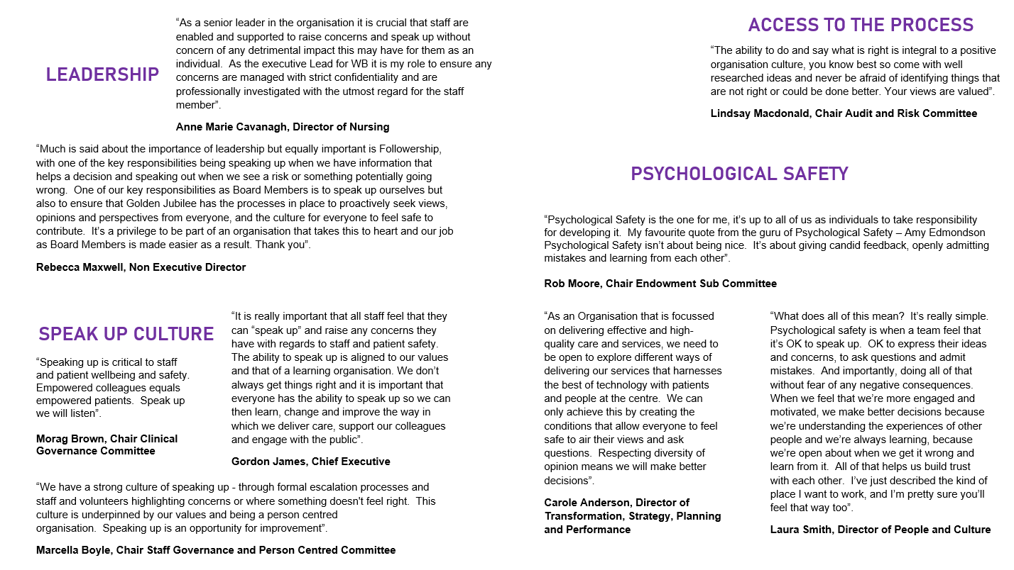

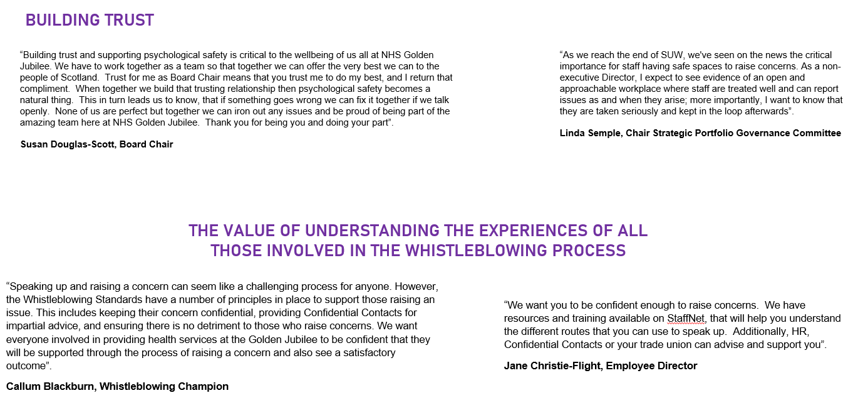

We also advised staff on the Whistleblowing Reporting Process and the Governance Framework around Whistleblowing.

Over the four days, we asked staff to complete a short survey to give them the opportunity to let us know, anonymously, their view on the Whistleblowing process. We received 130 responses which equated to 5% of the workforce at that time. The questions we asked and responses received are noted below.

1. Do you know what a Whistleblowing Concern is?

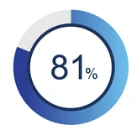 of our workforce are aware of what a Whistleblowing Concern is.

1. Do you know how to raise a Whistleblowing Concern?

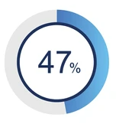 of our workforce know how to raise a Whistleblowing Concern

1. Do you understand the process around raising a Whistleblowing Concern?

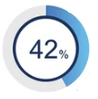 of our workforce understands the process around raising a Whistleblowing Concern

1. Have you ever thought about raising a Whistleblowing Concern?

If yes, what stopped you?

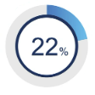 of our workforce have thought about raising a Whistleblowing Concern.

When asked why, we received the following quotes:

|  |
| --- |
| * Having to deal with the person and fear colleagues would find out |
| * Unsure of impact to me |
| * Do not know how and where to start |
| * Manager played it down |
| * Little faith in management |
| * Not sure it would have made any difference |
| * Fear/lack of support |
| * No action would be taken |
| * Previous problems not being kept confidential by management and nothing being done |
| * Not being confidential |
| * Is it really anonymous? Not sure |
| * Fear of consequences |
| * Repercussion(s) |
| * Fear of backlash |
| * Got scared |
| * Management / members of the team / uncomfortable |
| * Not sure if it is relevant |
|  |

1. Are you aware of the Whistleblowing information on the Intranet?

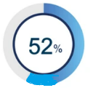 of our workforce were aware of the Whistleblowing information on the intranet.

1. Would you be interested in becoming a Confidential Contact?

 Members of staff have put forward their details to become a Confidential Contact.

The Whistleblowing Oversight Group has now reviewed these responses and the following plan of action has been agreed.

**Action Plan**

1. Ensure Whistleblowing is featured withineDigest communications quarterly.
2. Paperwork left at Main Street West lifts to be reviewed and updated on a quarterly basis.
3. Promote the work of the Confidential Contact.
4. To point staff to the new Corporate Governance intranet pages where information on Whistleblowing will be featured. These pages will include anonymised examples of positive outcomes following concerns raised.

# **7.0 Whistleblowing Oversight Group**

The Whistleblowing Oversight Group (‘the Group’) was established in September 2024 to provide assurance to the Clinical Governance Committee, Staff Governance and Person Centred Committee and NHS GJ Board that Whistleblowing Concerns are being discharged in relation to the National Whistleblowing Standards and Once for Scotland Policies. A Terms of Reference have also been established.

The Group are responsible for the oversight of all Whistleblowing arrangements within NHS Golden Jubilee and will ensure that guidance and processes are in place to deliver the requirements of the National Whistleblowing Standards. The Group meet on a quarterly basis and the Chair is the Non-Executive Whistleblowing Champion.

The Group support, oversee and enable the appropriate quarterly and annual reporting to the Clinical Governance Committee and also share the report for noting with the Staff Governance and Person Centred and NHS GJ Board.

One of the main functions of the Group is to support, oversee and plan for the ‘Speak Up’ weeks that are held each year, to ensure these are meaningful, manageable and memorable.

# **8.0 Conclusion**

It is recognised that this is a learning process and that processes may require to be changed or developed as feedback from updated Whistleblowing processes is received.

In line with the National Whistleblowing Standards, we reiterate our commitment to dealing responsibly, openly and professionally regarding any whistleblowing concern we may receive.

This quarterly report will form part of our Annual Report 2024/25 as we continually raise the profile of Whistleblowing and our commitment to support everyone to ‘speak up’ at the earliest opportunity.



Confidential Contacts: Mary McAuley and Lorraine Lester – Taken during Speak Up Week 2024