# NHS Golden Jubilee

### **Meeting: NHS Golden Jubilee Board Meeting**

### **Meeting date 12 December 2024**

### **Title:** **2024/25** Annual Delivery Plan Quarter 2 Update

### **Responsible Executive/Non-Executive: Carole Anderson – Director of Transformation, Strategy, Planning and Performance**

Report Author: Zaid Tariq – Deputy Director of Quality, Performance, Planning and Programmes

Ewen McGregor – Senior Planning Manager

### **Laura Morrison – Planning and Improvement Lead**

### 

## 1 Purpose

### This is presented to NHS Golden Jubilee Board for:

### Discussion

### This report relates to a:

* Annual Operational Plan

### This aligns to the following NHS Scotland quality ambition(s):

* Safe
* Effective
* Person Centred

**This aligns to the following NHSGJ Corporate Objectives:**

* Leadership, Strategy and Risk
* High Performing Organisation
* Optimal Workforce
* Facilities Expansion and Use
* Centre for Sustainable Delivery
* NHS Scotland Academy and Strategic Partnerships
* Culture, Wellbeing and Values

## 2 Report summary

## 2.1 Situation

This paper and the accompanying presentation provides the NHS Golden Jubilee (GJ) Board with an overview of key messages from the NHS GJ Annual Delivery Plan (ADP) Quarter 2 (Q2) update. The NHS Scotland Academy (NHSSA) ADP2 Delivery Planning Template (DPT) and Centre for Sustainable Delivery (CfSD) Strategic Portfolio Governance Committee (SPGC) are included as appendices.

Recognising the need to provide NHS Golden Jubilee’s (NHS GJ) Executive Leadership Team (ELT) with timely assurance and delivery updates, the Quarter 2 review was considered by ELT on 29 October. Following discussion at the Finance and Performance Committee (FPC), the Q2 update was submitted to Scottish Government on 20 November.

## 2.2 Background

Scottish Government proposed a new approach to quarterly monitoring of progress against plans for 2024/25. This approach requested Boards to share their internal Delivery Plan progress or performance reports to inform on progress with the intent of ensuring receipt of clear and consistent information whilst reducing workload and duplication of reporting. The Q2 update provides information on progress against deliverables at end of September 2024 and a RAG status indicator for each deliverable.

The new simplified DPT has been developed to monitor progress of priority actions in line with Scottish Government Planning Guidance which is structured around the ten national NHS recovery drivers:

* Primary and Community Care
* Urgent and Unscheduled Care
* Mental Health
* Planned Care
* Cancer Care
* Health Inequalities and Population Health
* Women and Children’s Health
* Workforce
* Digital Services and Innovation Adoption
* Climate

The new approach to quarterly reporting was supported by ELT on 2 October with agreement to implement from Q2 onwards. The quarterly update Q2 DPT was considered by ELT on 29 October and discussed by FPC on 19 November.

## 2.3 Assessment

Senior organisational leads have reviewed and updated the templates for their respective areas. A short narrative progress update has been provided for each of the deliverables and RAG indicator statuses assigned. The Q2 DPT is available on request should members wish to view the detail which was submitted to Scottish Government on 20 November.

Table 1 outlines the overall RAG status of the Board’s deliverables at Q2 end:

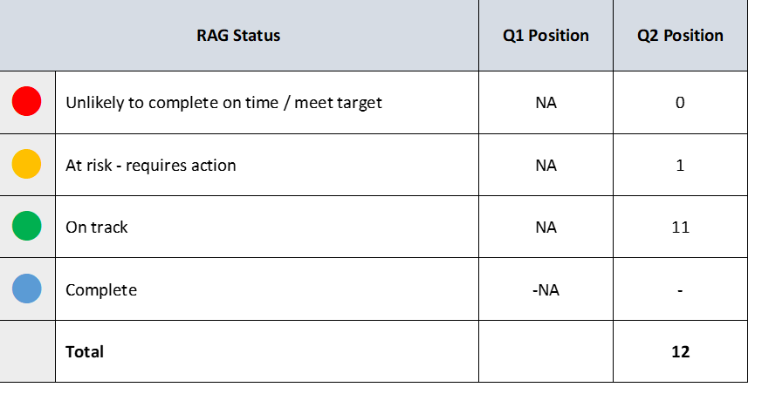

Table 1: Q2 end position

A one-off progress report was produced during Quarter 1 (Q1) while the new simplified DPT was being developed, as a result there is no comparison available between Q1 and Q2. This will be reinstated from Q3 onwards.

Following discussion with NHS Education for Scotland (NES), NHS Scotland Academy (NHSSA) will continue to complete the ADP2 template. The NHSSA ADP2 update is included for note as appendix 1.

The Centre for Sustainable Delivery (CfSD) continue to submit bi-monthly programme reports to the Strategic Portfolio Governance Committee (SPGC). The CfSD SPGC programme report is included as appendix 2.

Further detail will be provided in the presentation to the Board on 12 December.

### 2.3.1 Quality/ Patient Care

No direct impact – progress monitoring.

### 2.3.2 Workforce

No direct impact – progress monitoring.

### 2.3.3 Financial

No direct impact – progress monitoring.

### 2.3.4 Risk Assessment/Management

Risks will be assessed and managed locally within lead divisions / departments. Where necessary risks will be escalated through existing risk escalation hierarchy.

### 2.3.5 Equality and Diversity, including health inequalities

DPTs form part of the Board’s internal Delivery Plan progress reporting framework. The Delivery Plan sets out NHS Golden Jubilee’s priorities for 2024-2027. These include services to patients, and organisational development priorities affecting staff. Relevant Board strategies and policies including Diversity and Inclusion Strategy, Equality Outcomes, and Health and Wellbeing Plan were considered in developing the Delivery Plan.

An impact assessment has not been completed as the contents of this paper and appendices are progress updates on existing signed-off plans, and do not therefore require an additional EQIA.

### 2.3.6 Other impacts

**Climate Emergency and Sustainability**

No direct impact – progress monitoring.

### Communication, involvement, engagement and consultation

The Board has carried out its duties to involve and engage external stakeholders where appropriate:

* Organisational leads, throughout September and October 2024

### Route to the Meeting

This has been previously considered by the following groups as part of its development. The groups have either supported the content, or their feedback has informed the development of the content presented in this report.

* Executive Leadership Team, 29 October 2024
* Finance and Performance Committee, 19 November 2024

## 2.4 Recommendation

NHS Golden Jubilee Board members are asked to note the quarterly updates of NHS Golden Jubilee’s Q2 Delivery Planning Template.

## List of appendices

The following appendices are included with this report:

* Appendix 1: NHSSA Q2 ADP2
* Appendix 2: CfSD SPGC Programme Update Report