# 

### Meeting: NHS Golden Jubilee Board

### Meeting date: 19 November 2024

### Title: Health and Safety Quarter 2 Report 2024/25

### Responsible Executive/Non-Executive: Jonny Gamble, Director of Finance

### Report Author: David Wilson, Head of Health and Safety

## Purpose

### This is presented to NHS GJ Board for:

* Awareness

### This report relates to a:

* Legal Requirement
* Local Policy

### This aligns to the following NHS Scotland quality ambition(s):

* Safe
* Effective
* Person Centred

**This aligns to the following NHSGJ Corporate Objectives:**

* Leadership, Strategy and Risk
* Facilities Expansion and Use

## 2 Report summary

## 2.1 Situation

NHS GJ Board is asked to note the following key points:

* The Risk Register has been reviewed to enable current risk entries to transition onto new risk register platform which will be hosted within Datix. Reasonably foreseeable risks are listed and scored individually with consideration of additional control measures and actions identified. This leads to an impact score which allows focused actions based on highest area of risk. The number of risks from the previous reporting period has therefore condensed from 21 to 10.
* No reportable incidents to HSE in this period.
* Health and Safety related adverse incidents remain low with no significant trends
* There have been no high risk rated events in this time period.
* There has been no regulatory enforcement action in this time period.
* Scottish Fire and Rescue Service (SFRS) attended the Hotel site to undertake annual Fire Safety Audit and Inspection.
* Safety Action notice (helipad operations)

## Background

The Health and Safety at Work etc. Act 1974 is the primary legislation covering health and safety in the UK. Sections 2 (6) and 2 (7) of this Act requires employers to formally consult their employees on matters that affect their health and safety. NHS Golden Jubilee has decided that the most effective way to discharge these requirements will be through the formation of Divisional Health and Safety Forums and Health and Safety Committee.

The main purpose of the committee is to foster a culture whereby the promotion of the health and safety of employees, patients, visitors, contractors and suppliers becomes an integral part of our organisation’s activities.

The Health and Safety Committee Terms of Reference set out a number of aims and these are summarised below:

* To encourage safe working practices and safeguards for all staff and others in line with health and safety legislation.
* To promote safety consciousness within staff at every level in order to effect a reduction in the level of accidents.
* To promote appropriate courses of training in health and safety for all staff.
* To consider concerns expressed by management and staff in relation to health and safety matters.
* To agree a program of workplace inspections, receive reports and make recommendations on action required.
* To monitor progress against health and safety action plan.

## 2.3 Assessment

Appendix 1 contains the Health and Safety Quarter 2 Report for 2024/2025

### 2.3.1 Quality/ Patient Care

Ensuring we deliver safe patient care.

### 2.3.2 Workforce

Ensures we provide staff a safe working environment in accordance with NHS Staff Governance Standards.

### 2.3.3 Financial

In accordance with SFIs and existing resources.

### 2.3.4 Risk Assessment/Management

Key risks highlighted within Appendix 1.

### 2.3.5 Equality and Diversity, including health inequalities

Not applicable (N/A).

### 2.3.6 Other impacts

N/A.

### Communication, involvement, engagement and consultation

The Board has carried out its duties to involve and engage external stakeholders where appropriate. The purpose of this report is a means for communication, engagement and consultation.

### Route to the Meeting

As above (2.3.7) this update is for information sharing and provides a platform for further discussion at the Forum and Committee meetings.

## 2.4 Recommendation

* **Awareness** – For Members’ information only.

## List of appendices

The following appendices are included with this report:

* Appendix No 1, Health and Safety Quarter 2 Report 2024/2025.

**APPENDIX 1**

**HEALTH AND SAFETY COMMITEE QUARTER 2 REPORT 2024/25 (1 July – 30 September 2024)**

1. **KEY HIGHLIGHTS**
   1. Health and Safety Audit and Inspection

* System Live 26 June 2024
* Communications sent as part of launch (emails, Managers Hub, e-Digest)
* User guide issued
* Multiple training sessions delivered
* 92 users assigned to monthly Health and Safety Inspections
* 69 Audits due each month, 5 teams 100% compliant, 36 teams submitted 0%.
* Breakdown of these departments will be presented at Divisional Health and Safety Forums where members will be encouraged to engage with the agreed inspection process. We will continuously review the system and take actions to appropriately reduce the risk.
  1. Fire Safety

Fire Safety Group

At the September round of Health and Safety Forum meetings, there was agreement to form a Fire Safety Group to support the management of fire safety. Like other specialist safety groups (e.g. Electrical Safety, Medical Gas Safety, Ventilation etc.) this group will report through the Health and Safety Forums and onto Health and Safety Committee. Part of the intended remit of the group will be to agree risk and support implementation of appropriate actions to mitigate those risks and to action reports from enforcing authorities. The first meeting for this group will be scheduled for November 2024

Fire Risk Assessment

Internal fire risk assessments have been carried using the NHS Scotland agreed Fire Safety Management system template. A small number of improvements have been identified which will be presented for discussion and action at the Fire Safety group.

Fire Safety Audit and Inspection

The Scottish Fire and Rescue Service carried out an audit and inspection of the Hotel on 01.08.24

From a positive perspective, unwanted fire alarm signal reporting and investigation in Datix was commended as it demonstrates commitment to learn from incidents. Monthly inspections were also seen as good practice as it places responsibility at a local level.

There were 12 recommendations in total:

* Consideration of evacuation/training drills
* Confirmation of damper test/inspection records
* Ceiling tiles missing
* Blocked exit (auditorium)
* ‘Keep clear’ signage missing from auditorium exit.
* Various fire doors not closing fully/excessive gap at top/middle of doors
* Emergency lighting not operating correctly
* Consider additional directional signage at ground floor studio.
* Clear fibres from tumble dryer in housekeeping store
* Clear build up of fibres from extract grill at Level 4 lift foyer
* Adjust loose smoke detector head at level 4 linen room
* Consideration of securing doors to staff areas at bedroom corridors to prevent unauthorised access.

Reactive job lines have been raised and being actioned via Estates. Progress with all actions will be monitored via the Fire Safety Group.

* 1. Policy Approval

The following documents have been approved at last Health and Safety Committee:

* Bomb Threat Policy (virtual approval subject to minor amendment on front cover sheet) – virtual approval date 10/10/24
* Respiratory Protection Equipment (RPE) Policy

The RPE will be sent to Partnership Forum 11th November for final approval and then subsequent upload to share point.

The following documents were shared with the Health and Safety Divisional Forums for review and approval September 2024:

* Security Policy
* Control of Contractors Policy

Both of these policies are shared with the Health and Safety Committee for approval October 2024.

**2. ONGOING OR EMERGING RISKS**

The Risk Register has been reviewed to enable the current risk register entries to transition onto the new risk register platform which will be hosted within datix. Reasonably foreseeable risks have been listed and scored individually with consideration of additional control measures and actions identified. This has led to an impact score which will allow focused actions based on the highest area of risk. The number of risks from the previous reporting period has therefore condensed from 21 to 10. The current 10 are listed below.

|  |  |
| --- | --- |
| Risk ID | Risk Title |
| HS1 | Violence and Aggression |
| HS2 | Fire Safety |
| HS3 | Lift Entrapment |
| HS4 | Infrastructure of Site |
| HS5 | Out of Hours Resilience |
| HS6 | On site Traffic Management - Emergency Vehicles |
| HS7 | On site Traffic Management – Slips, trips, falls |
| HS8 | Building Fabric – engineering failures |
| HS9 | Ability to respond to issues |
| HS10 | Limited Manual Handling Service Provision |

Risk grading tool:

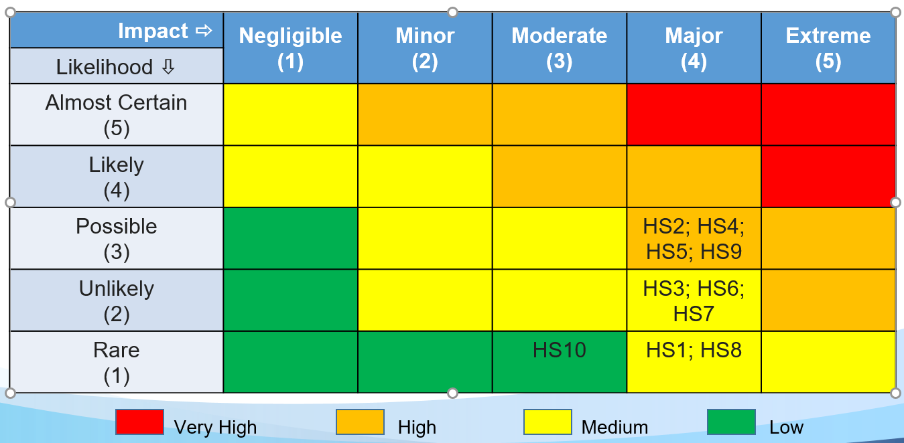

The above 10 risks will be housed within new datix system and anticipate that this will be presented at next Health and Safety Committee February 2025.

**2.1 SAFETY ACTION NOTICE**

The Board has received Safety Action Notice (SAN) 2404 from NHSS Assure (issued 13 September 2024). The SAN explains that Bristow UK SAR (Search and Rescue) air operator has withdrawn services/operations at NHS Golden Jubilee HHLS (and 22 other HHLS sites across the UK) as they are not currently assured that appropriate safeguarding is in place and in compliance with CAP1264 (latest version issued by the UK Civil Aviation Authority (CAA) April 2024).

As such, an overhaul of existing NHS GJ helipad management procedures is needed to satisfy the requirements of the updated guidance and requires endorsement by the Chief Executive to allow the HHLS at NHS GJ to be reopened for UK SAR.

An SBAR is being developed for presentation via the appropriate governance routes in order to identify short and long term proposals to meet the requirements of the SAN.

**3. ADVERSE EVENT REPORTING**

3.1 RIDDOR

The Reporting of Injuries, Diseases and Dangerous Occurrences Regulations (RIDDOR) require the reporting of specified work related accidents, diseases and dangerous occurrences to the Health and Safety Executive (HSE). In this reporting period there has been no reportable incidents to HSE.

3.2 ADVERSE INCIDENTS

Staff are encouraged to ensure that all Health and Safety related incidents (employees, patients, contractors, and visitors) are reported via Datix. The top 5 sub categories for this reporting period (1st July 2024 – 30th September 2024) are included in table below:

|  |  |
| --- | --- |
|  |  |
|  |  |
|  |  |

The highest sub category accounting for 9 events relates to contact/collision incidents. There are no trends relating to location of events or nature of the incidents (for example, a range of various bumps/bruises from collision with door, bumping head against equipment, etc.). No trends in the location (department) for these incidents (catering x1, outpatients x1, hotel x1, Theatres x2, surgical admissions x1, vanguard x1, engineering x2). All were risk rated as ‘minor’, except one rated as ‘moderate’. The moderate event refers to contractor finger laceration whilst working on lifts.

The joint highest sub category also with 9 events is ‘slips, trips and falls’. There are no trends in terms of location (housekeeping x1, pharmacy x1, hospital external groundsx1, Labs x1, hotel x1, critical care x1, theatres x 2, and surgical admissions x1). All minor risk rated, excluding one incident that was ‘moderate’ rated relating to staff member slipping on actichlor within theatres. No obvious patterns/trends evident within this sub category.

The second highest sub category accounting for 8 events relates to ‘contact with sharps’. All minor risk rated. The locations of these incidents ranged (1x critical care, 1x 3west, 1x CCU, 1x medical physics, 1x 4 east, 1x housekeeping, 2 x theatres). The review of the sharps investigation question set on datix requires to be reviewed and will be addressed in line with new datix software.

The third highest sub category with 7 incidents relates to exposure to unsafe environmental conditions. In terms of location (catering x 1, Theatres x4, critical care x1, research x1). There was a mix of types of incidents within this sub category, i.e. contractor failing to follow HAI scribe, laptop being used in operating theatre. One moderate risk rated event linked to build up of heat in room that houses UPS batteries. Estates fully involved in the investigation as evidenced via datix.

The joint third highest sub category with 7 events is ‘exposure to hazardous substances’. In terms of location (3x theatres, 1x cath lab, 1x critical care, 2x labs). The 3 in theatres were all blood splash related, whilst the 2 in labs relate to outer containers of samples contaminated with blood. All minor risk rated.

1. **PROJECTIONS FOR NEXT QUARTER:**

FUTURE INITIATIVES

4.1 Initiation of Fire Safety Group

4.2 Fire Safety Policy Review

4.4 Review Helipad Policy

4.5 Continued support to the roll out of the Health and Safety Audit and Inspection programme (additional virtual training sessions to be rolled out).

4.6 Renewed focus on Respiratory Protective Equipment (mask fit testing)

4.7 Monthly Matters focus for next reporting period. Respiratory Protective Equipment; Helipad Operations; Site Security including Access/Egress.