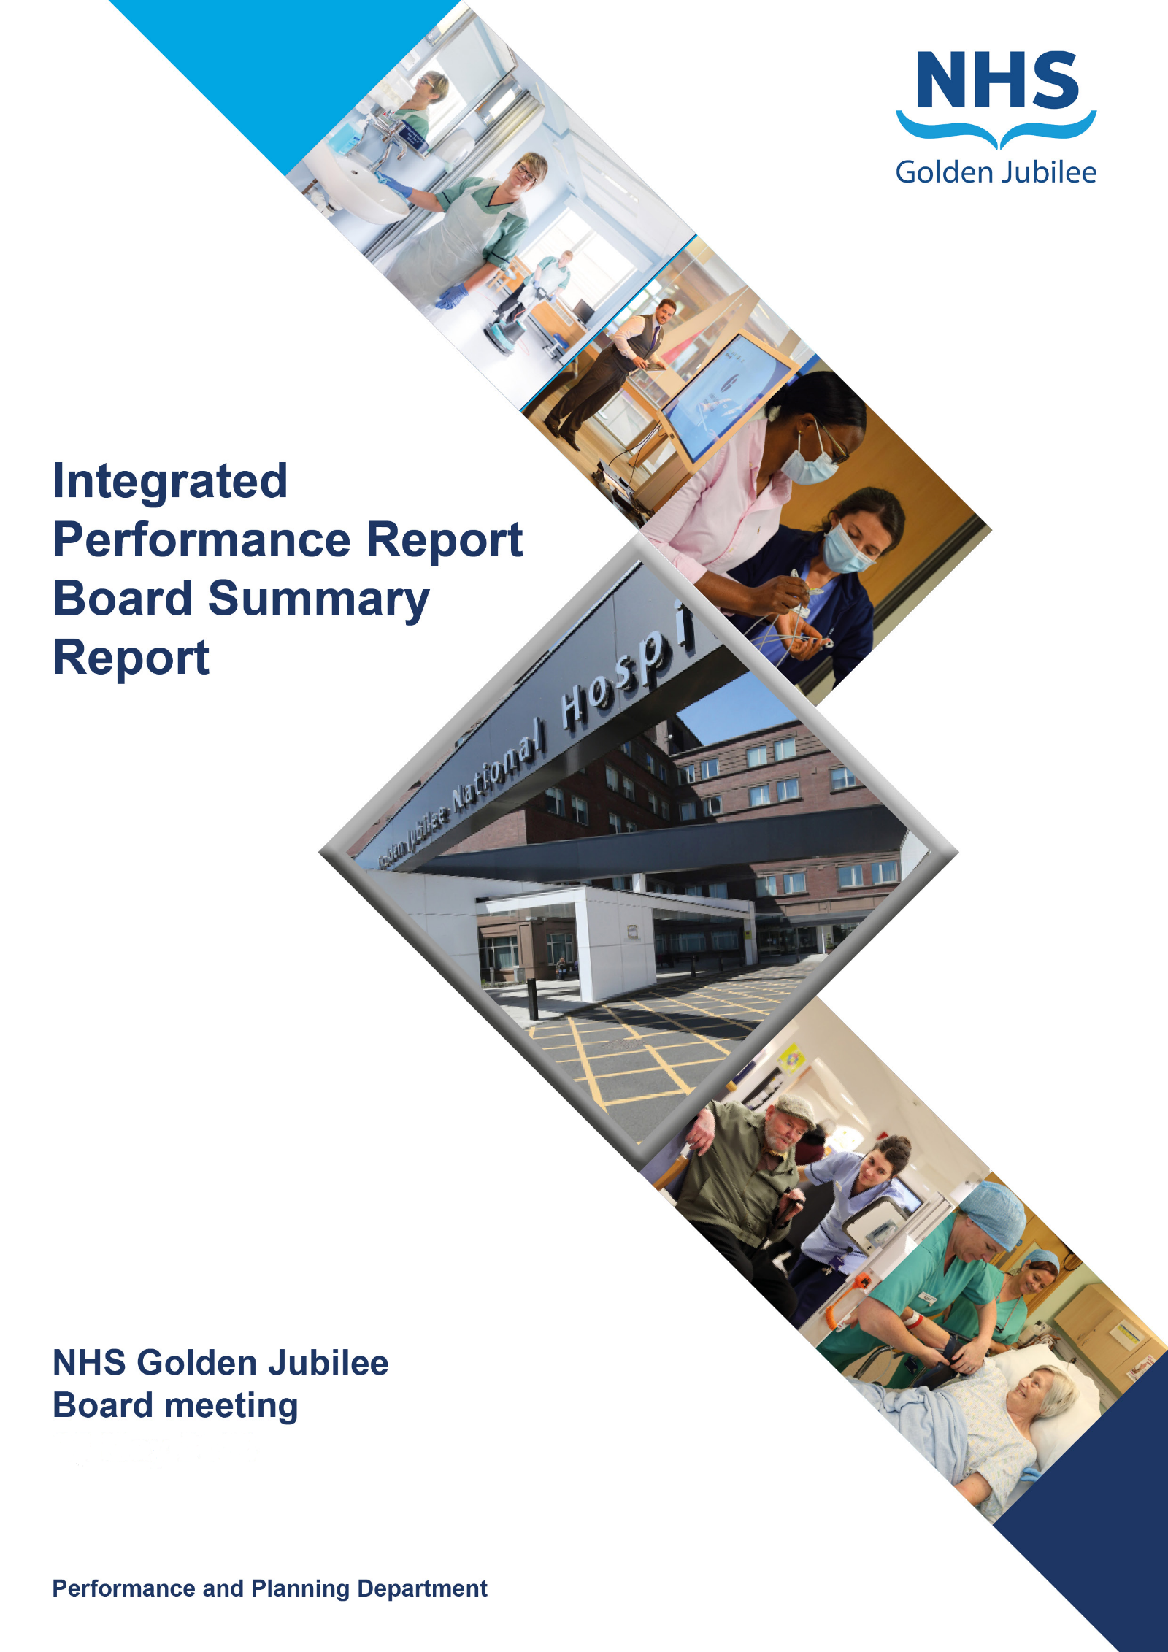

**Quality, Performance, Planning & Programmes**

**12 December 2024**

**BoARD SUmMARy Report**

**Produced in September 2024**

**Data reported up to END of August 2024**

**For submission to:**

* **Board Meeting – 12 DECEMBER 2024**

# Contents

**Introduction 2**

**Performance Summary Dashboard 5**

**Integrated Performance Report: Executive Summaries 7**

# Section A: Introduction

The purpose of the Integrated Performance Report (IPR) is to provide assurance on NHS Golden Jubilee’s performance relating to National Standards, local priorities and significant risks.

The IPR comprises four section with each section being considered in detail by the appropriate Standing Committee:

* Section A Introduction
* Section B:1 Clinical Governance
* Section B:2 Staff Governance
* Section B:3 Finance, Performance & Planning

This Board Summary Report of the IPR is presented to the Board and contains the summaries from each section of the full IPR.

**Gordon James Jonny Gamble Carolynne O’Connor**

**Chief Executive Director of Finance Director of Operations & Deputy CEO**

Performance Summary Dashboard – Guidance



Statistical Process Control – Guidance



Board Performance Dashboard



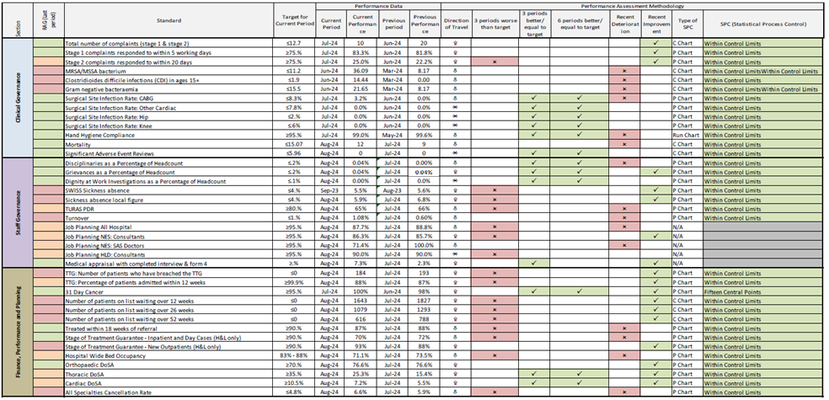

At each meeting, the Standing Committees of NHS Golden Jubilee consider targets and standards specific to their area of remit using the Integrated Performance Report (IPR). There is a section of the IPR which provides a summary of performance Standards and targets identified as areas of note which is reproduced below. Topics are grouped under the heading of the Committee responsible for scrutiny of performance.

# Section B: 1 Clinical Governance

|  |  |  |
| --- | --- | --- |
| **Clinical Governance** | | |
| **KPI** | **RAG** | **Position:** |
| Total complaints (Stage 1 and 2) by volume |  | In July 2024 there were 10 complaints reported. Latest position available at time of reporting. |
| Stage 1 complaints response time |  | In July 2024, there were six Stage 1 complaints, five were responded to within the five day target (83%). Latest position available at time of reporting. |
| Stage 2 complaints response time |  | In July 2024 there were four Stage 2 complaints, one was responded to within the twenty day target (25%). Latest position available at time of reporting. |
| Mortality |  | The mortality figure for August 2024 was reported as 12. |
| Significant adverse events |  | There were zero significant adverse event reviews in August 2024. |
| MRSA/MSSA cases |  | There were zero instances of Staphylococcus aureus Bacteraemia (SAB) reported in July 2024. The rate per 100,000 bed days was 0.0 in July 2024. Latest position available at time of reporting. |
| Clostridiodes Difficile |  | There were zero Clostridiodes Difficile Infections (CDI) reported in July 2024. The rate per 100,000 bed days was 0.0 in July 2024. Latest position available at time of reporting. |
| Gram Negative Bacteraemia |  | There were zero reported instances of Gram Negative Bacteraemia in July 2024. The rate per 100,000 bed days was 0.0 in July 2024. Latest position available at time of reporting. |
| SSI: Hips & Knees |  | There were zero Hip & Knee SSIs reported in July 2024. Latest position available at time of reporting. |
| SSI: Cardiac |  | There were two Cardiac SSIs reported in July 2024. Latest position available at time of reporting. |

**Clinical Governance Executive Summary**

**Executive Summary**

In July 2024 we received six Stage 1 complaints and four Stage 2 complaints.

83.3% (five) of the Stage 1 complaints that were investigated were responded to within guidance timescale of 5 days. One was contacted with in the 10 working days (day 6).

The average time taken to complete and respond to the Stage 1 complaints, was 4.1 working days.

There was one stage 2 complaint closed within the guidance timescale of 20 working days. Two stage 2 complaint breached the 20 day timescales and these have subsequently been closed (26 working days and 48 working days). One Stage 2 complaint remains open and has therefore breached the 20 day timescale.

Mortality data for August 2024 was within control limits (n=12).

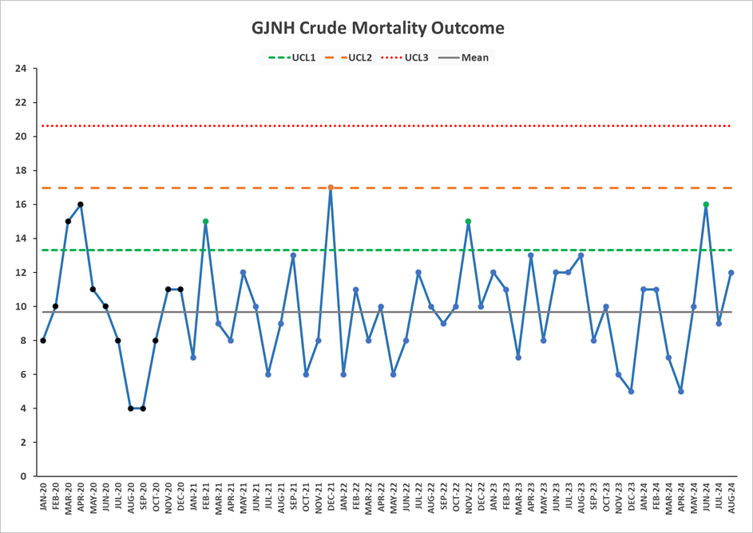

* The baseline data has been recalculated from January 2020 in line with reporting of other quality measures.

No whistleblowing concerns have been raised during August 2024.

No whistleblowing concerns have been raised during June 2024.

**Healthcare Associated Infection Report - August 2024**

**Key Healthcare Associated Infection Headlines**

* ***Staphylococcus aureus* Bacteraemia –** 0 cases to report in Aug.
* ***Clostridioides difficile* infection**- 0 cases to report in Aug.
* **Gram Negative/E.coli Bacteraemia (ECB)**- 0 cases to report in Aug.
* **Hand Hygiene-** The bimonthly report from July shows an overall compliance of 99%. Next Report due September HAIRT.
* **Cleaning and the Healthcare Environment -Facilities Management Tool**

**Housekeeping Compliance: 98.7** % **Estates Compliance:** **97.38%**

Both compliance rates are above national trajectories.

* **Orthopaedic Surgical Site Surveillance-** 0SSI to report August**.**
* **Cardiac Surgical Site Surveillance**- One superficial Cardiac SSI to report in August.
* **Other HAI Activity Overview**
* Significant PCIT support to Phase 2 commissioning pre & post handover
* Enhanced HAI SCRIBE activity is ongoing to support Phase 2 and associated refurbished/linked work task orders.
* The HCAI AMR/Policy Unit are planning an engagement event in conjunction with HAI Executive leads on 2nd October 2024. The focus will be –

Programme updates

Commissioning & Governance

New ways of working

# Section B: 2 Staff Governance

|  |  |  |
| --- | --- | --- |
| **Staff Governance** | | |
| Disciplinaries |  | There was one disciplinary case raised in August 2024. |
| Grievances |  | There was one grievance case raised in August 2024. |
| Dignity of work |  | There were zero dignity cases raised in August 2024. |
| Local Sickness absence |  | Sickness absence in August 2024 was reported at 5.9%. This is within control limits. |
| Turnover |  | Turnover in August 2024 was reported as within control limits at 1.1%, however this is above the target. |
| Medical appraisal with completed interview & form |  | The appraisal year for medical staff runs from 1 April to 31 March. As at 30 September 2024, 13 doctors out of 177 had completed their 2024/2025 appraisal. |
| TURAS Appraisal rates |  | Position for August 2024 reported as 65%. |
| Job Planning: All hospital |  | As at 30 September 2024, 121 of the 138 job plans for 2024/2025 had been signed off. |

**Staff Governance Executive Summary**

In August 2024, NHS Golden Jubilee’s sickness absence rate is 5.9%, the 0.9% less than previous month. Across the Directorates, sickness absence was as follows:

* Corporate: 4.6% (-0.9 % on June);
* Golden Jubilee Conference Hotel: 3.0% (-1.5%);
* Heart, Lung and Diagnostic Services: 6.6% (+0.2%); and
* National Elective Services: 6.8% (-1.9%).

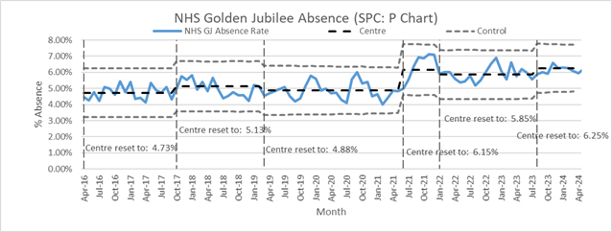

The rolling 12-month sickness absence rate for the Board was 6.0%. The 12-month breakdown for the Directorates was:

* Corporate: 4.6%;
* Golden Jubilee Conference Hotel: 3.6%;
* Heart, Lung and Diagnostic Services: 6.9%; and
* National Elective Services: 6.6%.

“Anxiety/stress/ depression/other psychiatric illnesses” was the highest cause of sickness absence in July, accounting for 22.4% of all sickness absence (down 1.0% on July).  It accounted for 1.3% of contracted hours.  It was the main cause of absence in three Directorates:

* Corporate: 14.7% of sickness absence, and 0.7% of contracted hours;
* Golden Jubilee Conference Hotel: 39.7% and 1.2%;
* Heart, Lung and Diagnostic Services: 26.5% and 1.7%; and
* National Elective Services: 22.2% and 1.5%.

In the Hotel, “Anxiety/stress/ depression/other psychiatric illnesses” was the main cause of absence, accounting for 39.7% of all sickness absence

**Turnover**

In July, turnover for NHS Golden Jubilee stood at 1.1%, up on July’s 0.5%.  This was due to 32 people leaving employment in August.  The Directorate breakdown was as follows:

* Corporate: 0.7% (+0.2% on July);
* Golden Jubilee Conference Hotel: 0.0% (-1.1%);
* Heart, Lung and Diagnostic Services: 1.0% (+0.2%); and
* National Elective Services: 1.7% (+1.2%).

The rolling 12-month turnover rate for the Board was 8.2%. The 12-month breakdown for the Directorates was:

* Corporate: 9.6%;
* Golden Jubilee Conference Hotel: 3.4%;
* Heart, Lung and Diagnostic Services: 5.8%; and
* National Elective Services: 9.9%.

**Agenda for Change appraisal**

Within the twelve months to 31 August 2024, 65% of staff who come under the Agenda for Change terms and conditions completed their appraisal using TURAS, which is 2% lower than the previous month. The Directorate breakdown is as follows:

* Corporate: 63% (-1% on June);
* Golden Jubilee Conference Hotel: 58% (-9%);
* Heart, Lung and Diagnostic Services: 59% (-1%); and
* National Elective Services: 75% (+1%).

**Medical appraisal**

The appraisal year for medical staff runs from 1 April to 31 March. As at 5 September 2024, 4 doctors out of 176 had completed their 2024/2025 appraisal, and 8 had an ARCP.  While this completion rate may be low, it is standard for this time of year, as appraisals tend to be completed in the third or fourth quarter of the year.

**Medical job planning**

In December 2023, we closed almost all medical job plans on the Allocate job planning system for 2023/2024, and started new job plans for the year starting 1 April 2024. As at 5 September 2024, 7 of the 135 job plans for 2024/2025 were sitting in discussion; 2 were not published; 5 was awaiting first manager sign off, 1 was awaiting second manager sign off; and 120 had been signed off.

# Section B:3 Finance, Performance and Resources

|  |  |  |
| --- | --- | --- |
| **Finance & Performance** | | |
| Lung Cancer 31 Day |  | In July 2024, nationally reported performance was 100% (39/39). Latest position available. |
| TTG: Number of patients who have breached the TTG |  | In August 2024 there were 184 patients who exceeded their twelve week treatment time guarantee. |
| TTG: Percentage of patients admitted within 12 weeks |  | The percentage of patients admitted within their twelve week treatment time guarantee was reported at 88% during August 2024. |
| SoT Guarantee – Inpatient and DC cases (H & L only) |  | 70% of Heart and Lung patients were admitted within 12 weeks in August 2024. |
| DOSA rate: Cardiac Surgery |  | There were five DoSA cases in August 2024 (7.2%). |
| DOSA rate: Thoracic Surgery |  | There were 20 DoSA cases in August 2024 (25.3%). |
| DOSA rate: Orthopaedics |  | In August 2024 there were 278 Orthopaedic primary joint admissions, 213 (76.6%) of which were on the day of surgery. |
| Theatre Cancellation Rates |  | In August 2024, the overall hospital cancellation rate was 6.6% (176/2669) Within Control Limits. |
| Hospital Bed Occupancy |  | Hospital wide bed occupancy was reported as 71.1% in August 2024. Within Control Limits. |
| National Comparison Table, Corporate Dashboard, Waiting list & Productivity table | | |
| The GJNH nationally reported elective cancellation rate, in July 2024, was reported as 5.9%. This ranked GJNH as 3 out of 15. The Scotland rate was 8.4%. | | |
| Golden Jubilee comparative performance against the national 31 Day Lung Cancer target is reported using the Information Services Division (ISD) nationally published position. In July 2024 GJNH reported 100% of eligible patients treated within the target (Ranked 1 out of 22). | | |
| Health Protection Scotland published figures for Quarter 1 2024 report a GJNH incidence rate (per 100,000 total occupied bed days) of 0 for CDiff incidence, 7.4 for SAB and 14.9 for Ecoli. The Scotland rates were 12.6, 17.0 and 35.6 respectively. Latest position available. | | |
| Corporate sickness rate in August 2024 was 5.7%.  Departments over the 4% threshold were: Business Services, Catering, Clinical Education, Clinical Governance, Estates, Infection Control, Marketing and Communications, Occupational Health, Research, Pharmacy, Procurement and QPPP. | | |
| Referral numbers in August 2024 were 3440 (-568).  The total outpatient waiting list decreased by 318 from 1965 to 1647.  The total inpatient waiting list month end position increased by 71 from 5397 to 5468.e number of patients waiting over 52 weeks | | |
| For current inpatient waiters the number waiting between 12-26 weeks increased to 564 (+30).  The number of patients waiting 26-52 weeks decreased to 463 (-42).  The number of patients waiting >52 weeks increased to 616 (-172). | | |