

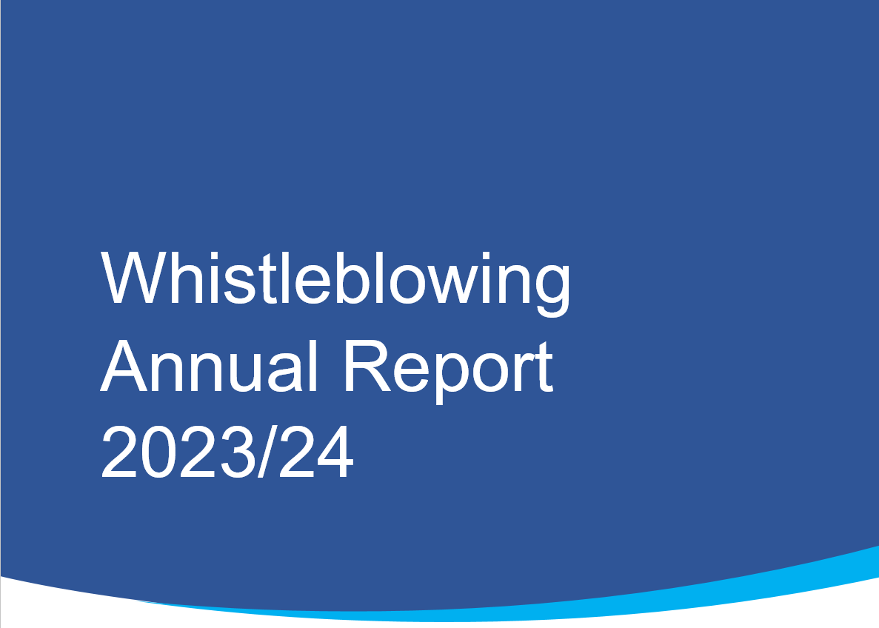

July 2024

# **Contents**

**Contents** 2

**1.0 Introduction** 3

**2.0 Background** 4

**3.0 Concerns Received** 4

**4.0 Whistleblowing Annual Return and Key Performance Indicators** 5

**5.0 Whistleblowing themes, trends and patterns** 5

**6.0 Independent National Whistleblowing Officer referrals and investigations** 5

**7.0 Governance** 6

**8.0 Conclusion** 6

# **1.0 Introduction**

This is NHS Golden Jubilee’s second Annual Whistleblowing report since the new Independent National Whistleblowing Officer (INWO) National Standards came into for on 1 April 2021.

“Whistleblowing” is defined as: *“…when a person who delivers services or used to deliver services on behalf of a health service body, family health service provider or independent provider (as defined in section 23 of the Scottish Public Services Ombudsman Act 2002) raises a concern that relates to speaking up, in the public interest, about an NHS service, where an act or omission has created, or may create, a risk of harm or wrong doing.”*

This report provides details of a Whistleblowing concern raised by staff within NHS Golden Jubilee. This report will demonstrate our performance in the national key indicators as required by the INWO and includes key areas of Whistleblowing handling, as well as highlighting outcomes and providing more detail on any Whistleblowing themes. Over time, this approach will illustrate trends in and more importantly, allow us to evidence necessary improvement and learning in response to the trends and themes demonstrated.

As per the requirements of the Standards, all NHS Scotland Health Boards are required to publish an Annual Whistleblowing Report, setting out performance in handling any whistleblowing concerns.

This is NHS Golden Jubilee’s second Annual Whistleblowing Report covering the period 1 April 2023 to 31 March 2024.

INWO were invited to NHS GJ Board Seminar on Thursday 26 October 2023 to give an overview of the INWO service and its national leadership role in providing support and guidance to NHS Health Boards.

We continue to engage with our staff to build on a culture where everyone confidently can raise a concern and where they know that any concerns raised, will be thoroughly investigated, with any lessons learned being taken forward by the organisation.

This reports provides an overview of our performance and a chronological summary of activities delivered over the year, as per our quarterly Whistleblowing updates.

# **2.0 Background**

The national Whistleblowing Standards (the Standards) set out how all NHS Service providers in Scotland must handle concerns that have been raised with them about risk to patient safety and effective service delivery.

The Standards also require that Boards publish an annual report setting out performance in handling whistleblowing concerns. The annual report will summarise and build on the quarterly reports produced by the Board, including performance against the requirements of the Standards, Key Performance Indicators (KPIs), the issues that have been raised and the actions that have been or will be taken to improve services as a result of concerns.

NHS Golden Jubilee’s approach to the implementation of the standards was key to ensuring that staff feel safe, supported and have confidence in the fairness of the processes should they feel they need to raise concerns.

In NHS Golden Jubilee the agreed governance route for reporting on whistleblowing is to Clinical Governance Committee with any staff concerns being shared with Staff Governance and Person Centred Committee and then onward to the Board.

# **3.0 Concerns Received**

Since 1 April 2023, our Confidential Contact Service signposted staff within a number of different areas. As for whistleblowing concerns, none were raised during the year 2023/24.

However there was one whistleblowing concern received during 2022/23, concerned with the adequacy of arrangements within NHS Golden Jubilee for the provision of First-Aid to employees, patients and visitors. The lessons learned have continued to be reviewed during 2023/24.

There were no concerns raised from students, trainees or volunteers.

Whistleblowing continues to be highlighted to new staff as part of the Corporate Induction Programme and to newly appointed managers and leaders during training sessions. Although it is not mandatory for all staff to undertake the eLearning Whistleblowing Turas Module, it continues to remains a priority for all management level staff, supervisors, line managers, those who may receive concerns and those involved in Whistleblowing investigations. For 2023/24, 243 line managers and senior managers have completed the appropriate Turas modules and there is a continued push to increase that number. It is positive to note that the module completions have increased every quarter.

On Tuesday 5 September 2023, some staff attended the Scottish Speak Up Conference. This event was independently organised by a group of speak up ambassadors and was supported by several speakers from organisations, which included the Independent National Whistleblowing Officer and the Scottish Government. The day concluded with reflections from the Independent National Whistleblowing Officer on the National Whistleblowing Standards since their launch in April 2021.

NHS Golden Jubilee participated in the National Speak Up Week held on 2 to 6 October 2023. This was a networking opportunity across NHS Boards discussing how ‘speak up’ methodologies could be implemented within organisations. NHS GJ used the week to give all staff further opportunities to learn more about the Standards and how to raise a concern. The Whistleblowing Champion did a video presentation and the roles of the Confidential Contacts and how they can be contacted were highlighted.

The Non-Executive Whistleblowing Champion meets with the Confidential Contacts to ensure any whistleblowing concerns are signposted as a support to staff.

All concerns raised are reported and discussed at the Clinical Governance Committee, Staff Governance and Person Centred Committee and the Board.

As there were no concerns reported the details of the Key Performance Indicators (KPIs) are noted below.

# **4.0 Whistleblowing Annual Return and Key Performance Indicators**

In 2023/24 NHS GJ did not receive any whistleblowing concerns. However, we continue to learn and develop from the experiences of those involved in whistleblowing. Attached at Appendix 1 is the Year End Reporting Tool required to be completed for onward sharing with INWO.

# **5.0 Whistleblowing themes, trends and patterns**

This section in future annual reports will provide information on themes from Whistleblowing concerns being raised and will aid identification of any improvement priorities and to progress learning in a targeted manner. Due to only receiving one concern, it is not possible to show the themes at this time. Feedback will be provided in future reports.

# 

# **6.0 Independent National Whistleblowing Officer referrals and investigations**

A clear indicator of the satisfaction of those who raise concerns can be derived from the number of concerns that are escalated to the Independent National Whistleblowing Officer (INWO).

At this current time, there have been no referrals to the INWO.

# **7.0 Governance**

The Whistleblowing Champion has been included as a Member in the Terms of Reference of the Clinical Governance Committee for 2023/24, reflecting the role that the Committee has in overseeing implementation of the standards within NHS

GJ.

Quarterly updates on whistleblowing were presented to the Clinical Governance Committee and then onward to the Board on the following dates:

Quarter 1 – 7 September 2023

Quarter 2 – 14 November 2023

Quarter 3 – 7 March 2023; and

Quarter 4 – 16 July 2024.

# **8.0 Conclusion**

It is recognised that this is a learning process and that processes may require to be changed or developed as feedback from updated Whistleblowing processes is received.

In line with the National Whistleblowing Standards, we reiterate our commitment to dealing responsibly, openly and professionally regarding any whistleblowing concern we may receive.

Throughout 2023/24, as advised in Section 7 above, the Clinical Governance Committee and NHS GJ Board were kept advised of any developments. We continually raise the profile of Whistleblowing and our commitment to support everyone to speak up at the earliest opportunity.