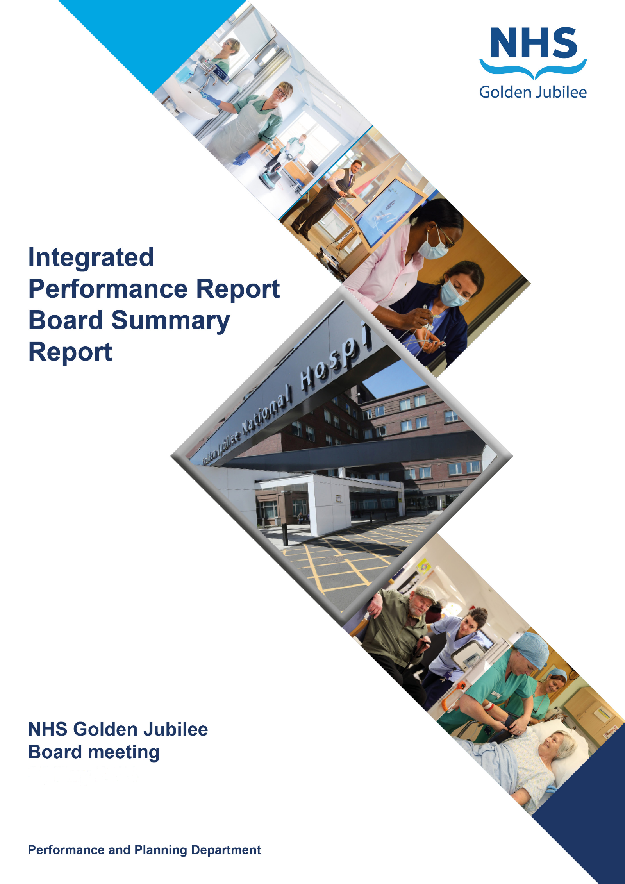

**Quality, Performance, Planning & Programmes**

**30 May 2024**

**BoARD SUmMARy Report**

**Produced in March 2024**

**Data reported up to END of FEbruary 2024**

**For submission to:**

* **Board Meeting – 30 May 2024**

# Contents

**Introduction 2**

**Performance Summary Dashboard 5**

**Integrated Performance Report: Executive Summaries 7**

# Section A: Introduction

The purpose of the Integrated Performance Report (IPR) is to provide assurance on NHS Golden Jubilee’s performance relating to National Standards, local priorities and significant risks.

The IPR comprises four section with each section being considered in detail by the appropriate Standing Committee:

* Section A Introduction
* Section B:1 Clinical Governance
* Section B:2 Staff Governance
* Section B:3 Finance, Performance & Planning

This Board Summary Report of the IPR is presented to the Board and contains the summaries from each section of the full IPR.

**Gordon James Michael Breen Carolynne O’Connor**

**Chief Executive Director of Finance Director of Operations & Deputy CEO**

Performance Summary Dashboard – Guidance



Statistical Process Control – Guidance



Board Performance Dashboard – Part 1





At each meeting, the Standing Committees of NHS Golden Jubilee consider targets and standards specific to their area of remit using the Integrated Performance Report (IPR). There is a section of the IPR which provides a summary of performance Standards and targets identified as areas of note which is reproduced below. Topics are grouped under the heading of the Committee responsible for scrutiny of performance.

# Section B: 1 Clinical Governance

|  |  |  |
| --- | --- | --- |
| **Clinical Governance** | | |
| **KPI** | **RAG** | **Position:** |
| Total complaints (Stage 1 and 2) by volume |  | In January 2024 there were 18 complaints reported. Latest position available. |
| Stage 1 complaints response time |  | In January 2024, there were 12 Stage 1 complaints, all 12 were responded to within the five day target (100%). Latest position available. |
| Stage 2 complaints response time |  | In January 2024 there were six Stage 2 complaints, zero were responded to within the twenty day target (0%). Latest position available. |
| Mortality |  | The mortality figure for February 2024 was reported as six. |
| Significant adverse events |  | There was one significant adverse event review in February 2024. |
| MRSA/MSSA cases |  | There were zero instances of Staphylococcus aureus Bacteraemia (SAB) reported in February 2024. The rate per 100,000 bed days was 0.0 in February. |
| Clostridiodes Difficile |  | There were zero Clostridiodes Difficile Infections (CDI) reported in February 2024. |
| Gram Negative Bacteraemia |  | There were zero reported instances of Gram Negative Bacteraemia in February 2024. |
| SSI: Hips & Knees |  | Surveillance recommenced in July with zero SSIs reported in February 2024. |
| SSI: Cardiac |  | Surveillance recommenced in October with two SSIs reported in February 2024. |

**Clinical Governance Executive Summary**

**Executive Summary**

In January 2024 we received 12 Stage 1 complaints and six Stage 2 complaints.

100% of the Stage 1 complaints that were investigated were responded to within guidance timescale (5 days) n=12.

The average time taken to complete and respond to the Stage 1 complaints, was 4.2 working days.

0% of the Stage 2 complaints were investigated and responded to within 20 working days therefore none were compliant with the guidance timescale (20 days) n=0. Three Stage 2 complains were complete and responded to after the 20 working day guideline. The average time taken to close these three Stage 2 complaints was 29 working days. The remaining three Stage 2 complaints from January are ongoing and have therefore already breached the 20 day timescale.

Mortality data for February 2024 was within control limits (n=6).

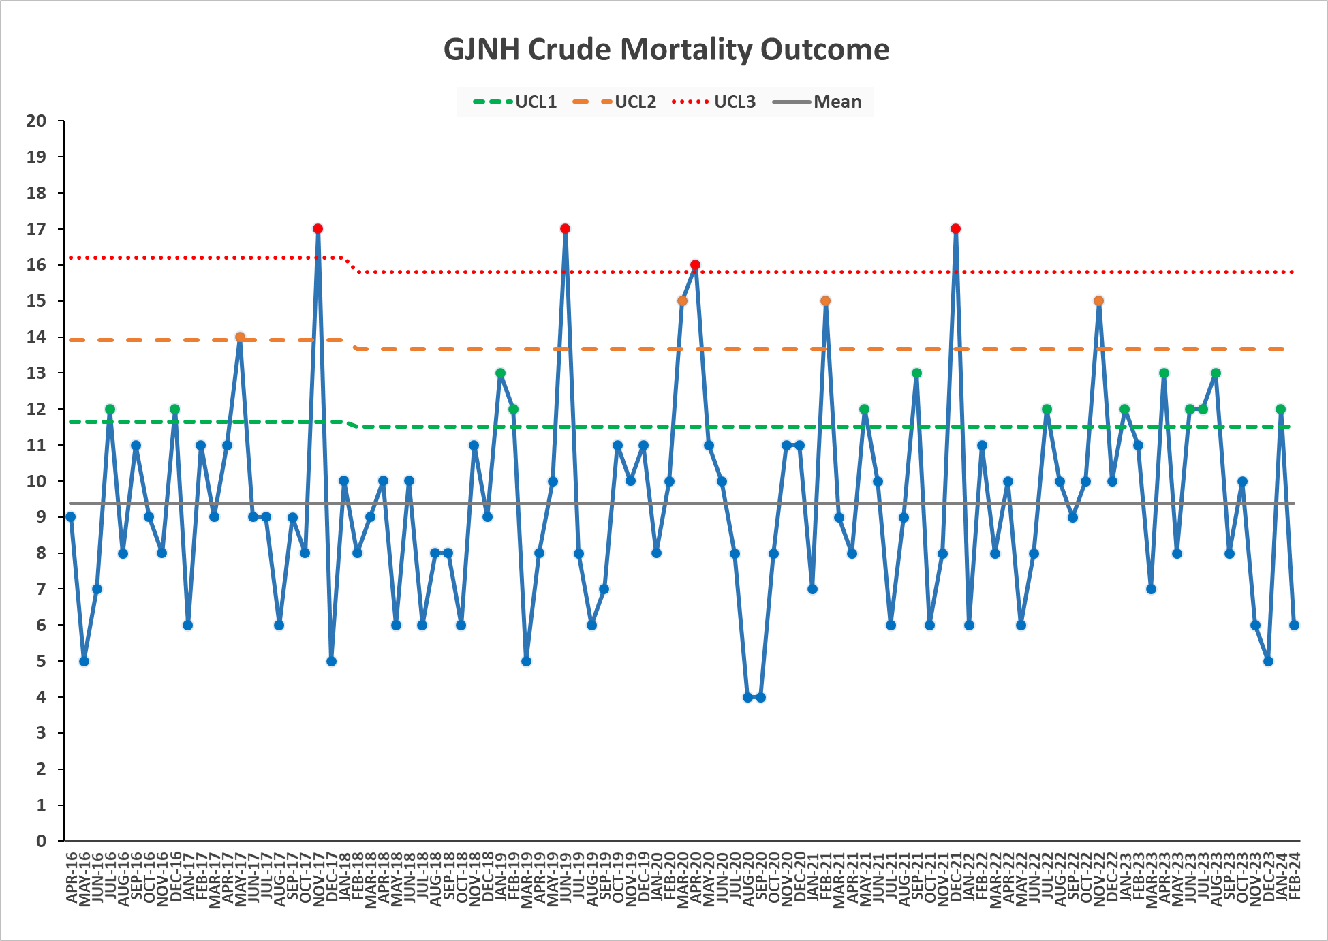

No whistleblowing concerns have been raised during February 2024.

**Key Healthcare Associated Infection Headlines**

* ***Staphylococcus aureus* Bacteraemia-** 0 cases to report in February.
* ***Clostridioides difficile* infection (previously known as *Clostridium difficile***) – 0 cases to report in February, and nil reported since September 2023.
* **Gram Negative/E.coli Bacteraemia (ECB)** – 0 cases to report in February.
* **Hand Hygiene-** The bimonthly report from January 24 indicates a combined compliance score of 98%. Next report March 24.
* **Cleaning and the Healthcare Environment -Facilities Management Tool**

**Housekeeping Compliance: 98.76**% **Estates Compliance: 95.23** %

* **Orthopaedic Surgical Site Surveillance-** No SSI to report in February. Remains within control limits.
* **Cardiac Surgical Site Surveillance**- No SSI to report in February. Remains within control limits.
* **Other HAI Activity Overview**

**Transfer of key HAI data to SharePoint**

PCIT have been working with Clinical Governance to build and transfer key HAI data to SharePoint. Aligning HAI data location with SPSP data, will facilitate ease of access, data entry and review of HAI data for clinical colleagues.

This key data includes-

* Standard Infection Control Precautions (SICPs) compliance data entry and outcome data allowing both individual and service overview
* Alert organism data by clinical area
* Prevention and Control of Infection Annual Review data by clinical area and service.

Site transfer planned March.

# Section B: 2 Staff Governance

|  |  |  |
| --- | --- | --- |
| **Staff Governance** | | |
| Disciplinaries |  | There were zero disciplinary cases raised in February 2024. |
| Grievances |  | There were zero grievance cases raised in February 2024. |
| Dignity of work |  | There were zero dignity cases raised in February 2024. |
| Local Sickness absence |  | Sickness absence in February 2024 was reported at 6.3%. This is within control limits. |
| Turnover |  | Turnover in February was reported as within control limits at 0.3%. |
| Medical appraisal with completed interview & form |  | The appraisal year for medical staff runs from 1 April to 31 March. To date, 84 doctors out of 168 had completed their 2023/2024 appraisal, and one had an ARCP. |
| TURAS Appraisal rates |  | Position for February 2024 reported as 60%. |
| Job Planning: All hospital |  | The year end position for job planning for 2023/24 is now complete.  The 2024/25 round of job planning is underway, 45 of the 131 job plans for 2024/2025 are sitting in discussion; 30 were awaiting the clinician’s sign off; 10 were awaiting first manager sign off; 17 were awaiting second manager sign off; 2 were awaiting third manager sign off, and 27 had been signed off. |

**Staff Governance Executive Summary**

**Sickness absence**

In February 2024, NHS Golden Jubilee’s sickness absence rate is unchanged from the January position remaining at 6.3%. Across the Directorates, sickness absence was as follows:

* Corporate: 5.1% (+0.1% on January);
* Golden Jubilee Conference Hotel: 3.9% (-2.0%);
* Heart, Lung and Diagnostic Services: 6.4% (-0.6%); and
* National Elective Services: 7.3% (+0.6%).

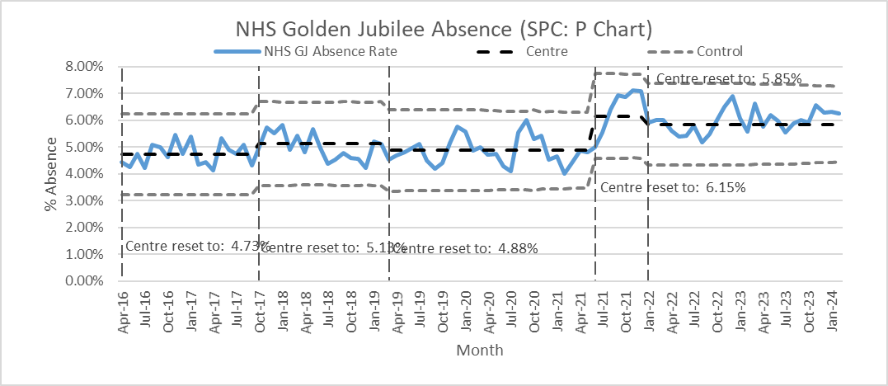

The rolling 12-month sickness absence rate for the Board was 5.5%. The 12-month breakdown for the Directorates was:

* Corporate: 4.5%;
* Golden Jubilee Conference Hotel: 3.2%;
* Heart, Lung and Diagnostic Services: 6.0%; and
* National Elective Services: 6.0%.

“Anxiety/stress/ depression/other psychiatric illnesses” was the highest cause of sickness absence in February, accounting for 22.8% of all sickness absence, 1.4% lower than January’s figure of 21.4%. It accounted for 1.4% of contracted hours. It was the main cause of absence in three Directorates:

* Corporate: 24.9% of sickness absence, and 1.3% of contracted hours;
* Golden Jubilee Conference Hotel: 31.7% and 1.2%;
* Heart, Lung and Diagnostic Services: 29.2% and 1.3%; and
* National Elective Services: 15.8% and 1.2%.

“Cold, cough, flu - influenza” was the second top cause of sickness absence overall in February, accounting for 13.3% of sickness absence hours.

**Turnover**

In February, turnover for NHS Golden Jubilee decreased to 0.3%, down from 0.7% in January. This was due to seven people leaving employment. The Directorate breakdown was as follows:

* Corporate: 0.3% (-0.4% on January);
* Golden Jubilee Conference Hotel: 0.0% (+/-0.0%);
* Heart, Lung and Diagnostic Services: 0.1% (-0.4%); and
* National Elective Services: 0.5% (-0.4%).

The rolling 12-month turnover rate for the Board was 8.5%. The 12-month breakdown for the Directorates was:

* Corporate: 8.4%;
* Golden Jubilee Conference Hotel: 9.2%;
* Heart, Lung and Diagnostic Services: 7.8%; and
* National Elective Services: 9.4%.

**Agenda for Change appraisal**

Within the twelve months to 29 February 2024, 60% of staff who come under the Agenda for Change terms and conditions completed their appraisal using TURAS, which is the same rate 2% higher than the previous month. The Directorate breakdown is as follows:

* Corporate: 55% (+7% on January);
* Golden Jubilee Conference Hotel: 65% (-1%);
* Heart, Lung and Diagnostic Services: 59% (+/-0%); and
* National Elective Services: 64% (+6%).

**Medical appraisal**

The appraisal year for medical staff runs from 1 April to 31 March. As at 7 March 2024, 84 doctors out of 168 had completed their 2023/2024 appraisal, and one had an ARCP. This is an increase of 33 on the previous month.

**Medical job planning**

In December 2023, we closed almost all medical job plans on the Allocate job planning system for 2023/2024, and started new job plans for the year starting 1 April 2024. As at 7 March 2024, 45 of the 131 job plans for 2024/2025 were sitting in discussion; 30 were awaiting the clinician’s sign off; 10 were awaiting first manager sign off; 17 were awaiting second manager sign off; 2 were awaiting third manager sign off, and 27 had been signed off.

# Section B:3 Finance, Performance and Resources



# Finance



**NHS GOLDEN JUBILEE**

**SUMMARY FINANCIAL REPORT**

**MONTH 11**

**AS AT 29th February 2024**

|  |
| --- |
| **FINANCIAL POSITION 29th February 2024 (MONTH 11)** |
| **EXECUTIVE SUMMARY** |
| 1. **2023/2024 to 2025/26 FINANCIAL PLAN**   The NHS Golden Jubilee Board in March 2023 approved a 3 year break-even Financial Plan for the period 2023/24 to 2025/26. The Month 11 forecast position is still assuming a continued break-even position, although the delivery of significant levels of savings in still required in each of the 3 years of the plan through a combination of recurring and non-recurring measures.  **DELIVERY OF 2023/24 FINANCIAL PLAN**   |  |  | | --- | --- | | **Current Risk Rating** | **Low** |   For 2023/24 a break-even outturn position requires the delivery of -£6.66m of in-year savings /budget reductions through a combination of recurring and non-recurring measures.  The Year to Date (YTD) core revenue position as at the end of February 2024 is a favourable variance of £969k. This represents a favourable % variance of 0.47%.  Following the workstreams reviewing the revised SLA with HL&D NSD SLAs as well as confirmation of forecast performance across the Topslice SLAs, a significant update on both Pays and Non-pays across both Divisions has released recurring budgets to reflect the costs associated with this year’s ADP and SLA reviews.  The Month 11 position shows the impact of this re-alignment of both Pays and Non-pays, resulting in the improvement in the YTD position.  **2023/2024 TO 2025/26 FINANCIAL PLAN**   |  |  | | --- | --- | | **Current Risk Rating** | **Very High** |   March 2023 Financial Plan  2024/25 and 2025/26 also require the delivery of significant savings to achieve a break-even outturn position in both of the years.  March 2024 Financial Plan  The proposed 2024/25 to 2026/27 3 year plan was submitted to SG on 15th March 2024, following approval at FPC. This shows a savings requirement of (£9.944m) for 2024/25, rising to (£11.028m) for 2025/26 and (£11.481m) for the final year of the plan in 2026/27.    Whilst savings plans are being developed mainly around workforce challenges, including enhanced vacancy management, review of agency costs and Waiting list initiatives, there remains a significant gap to identify in 2024/25 at this time.  The final March 2024 financial plan is being taken to the NHS GJ Board meeting on 28th March for final approval. |
| 1. **2023/24 CORE INCOME POSITION**      |  |  | | --- | --- | | **Current Risk Rating** | **Low** |   Income is £1.846m or 0.89% above the Financial Plan at Month 11. The main over-performance continues to be around service SLAs and Hotel income generation. |
| 1. **2023/24 CORE EXPENDITURE POSITION**   Core Expenditure is -£877k or -0.42% above the Financial Plan at Month 11.  **PAY COSTS**   |  |  | | --- | --- | | **Current Risk Rating** | **Medium** |   In overall terms, Pay costs at Month 11 are underspent by £1.086m or 0.78% below plan, primarily reflecting the level of vacancies across Nursing in particular.  Further analysis is provided within the relevant section of the main report.  **NON PAY COSTS**   |  |  | | --- | --- | | **Current Risk Rating** | **Very High** |   In overall terms, Non Pay costs at Month 11 are overspent by -£1.962m equating to -2.95% above YTD budget across a number of Board expenditure categories. This position has been improved following the rebasing of SLAs across both HL&D and NES Divisions, to better reflect the baseline funding required to deliver this year’s associated ADP. However significant pressures continue across Facilities Management (FM) and Surgical Supplies.  Further analysis is provided within the relevant section of the main report. |
| 1. **2023/24 EFFICIENCY REQUIREMENT**  |  |  | | --- | --- | | **Current Risk Rating** | **Medium** |   There is a -£6.66m efficiency requirement within the Financial Plan to achieve the targeted break-even position for 2023/24.  **FULL YEAR SAVINGS PLAN**  Savings schemes identified to-date, as part of the Month 11 review, show that the efficiency target will be met in full by the year-end.  Forecast savings of £6.297m have been identified as at Month 11, leaving a remaining £0.369m which will be identified by the year end. **£4.510m of this total has been identified non-recurrently,**  with **c**. **£1.787m recurrently** delivered.  This leaves an on-going recurring challenge of **£4.9m** which has been carried forward into next year’s financial planning assumptions. |
| 1. **NON-CORE REVENUE POSITION**  |  |  | | --- | --- | | **Current Risk Rating** | **Low** |   Non-Core position at Month 11 is anticipated to be break-even (expenditure matched by SG Income). |
| 1. **CAPITAL INCOME AND EXPENDITURE**  |  |  | | --- | --- | | **Current Risk Rating** | **Medium** |   Capital allocations of £4.270m have been confirmed by Scottish Government at Month 11 with ‘anticipated’ allocations expected of a further £10.042m which would result in an overall funded 2023/24 Capital Plan of £14.312m. This has been updated following the latest cost control meeting with the Board’s Phase 2 cost advisors, reducing the value of expected works carried out down significantly by the end of this financial year. The remaining balance of the Phase 2 works will be carried into the next financial year. The capital position will continue to be reviewed on a monthly basis and updated accordingly. |