# 

# NHS Golden Jubilee

### **Meeting: NHS Golden Jubilee Board**

### **Meeting date: 14 December 2023**

### **Title: 2023/24 Annual Delivery Plan Quarter 1 and 2 Update**

### **Responsible Executive/Non-Executive: Carole Anderson – Director of Transformation, Strategy, Planning and Performance**

### **Report Author: Rikki Young – Head of Planning**

### **Nicole Sweeney – Planning and Improvement Lead**

## 1 Purpose

### This is presented to the Board for:

### Noting

### This report relates to a:

* Annual Operation Plan
* NHS Golden Jubilee Strategy
* Government policy/directive

### This aligns to the following NHS Scotland quality ambition(s):

* Effective

**This aligns to the following NHSGJ Corporate Objectives:**

* Leadership, Strategy and Risk
* High Performing Organisation
* Optimal Workforce
* Facilities Expansion and Use
* Centre for Sustainable Delivery
* NHS Scotland Academy and Strategic Partnerships

## 2 Report summary

## 2.1 Situation

Scottish Government requested that all boards provide quarterly updates on delivery of Annual Delivery Plans (ADP) via submission of Delivery Planning templates. Due to Scottish Government’s timescale for approval and sign-off of the 2023/24 ADP, the draft Quarter 1 and Quarter 2 templates were submitted in tandem to Scottish Government on 30 October 2023. Recognising the need to provide the Board’s Executive Leadership Team (ELT) with timely assurance and delivery updates, the Quarter 1 review was considered by ELT on 31 August, with Quarter 2 update considered on 25 October.

This paper and the accompanying presentation provides the Board with an overview of key messages from the Quarter 1 and Quarter 2 ADP review.

## 2.2 Background

NHS Golden Jubilee’s Annual Delivery Plan (ADP) 2023/24 sets out the Board’s delivery priorities in line with a number of prescribed Scottish Government priorities, with delivery plans providing more detail within a number of clinical and non-clinical areas. The ADP does not seek to provide full coverage across all board activities, and was developed in line with the commission from Scottish Government.

The reviewed Delivery Planning Templates provide Scottish Government with updates and assurances on progress board deliverables to the end of June for Quarter 1, and for July to September for Quarter 2. This includes updated RAG status indicators for each deliverable, and any changes to identified risks / controls, or delivery milestones.

NHS Golden Jubilee’s 2023/24 Delivery Planning Template covers the following priority areas as outlined by Scottish Government:

* National Recovery Drivers
* Finance and Sustainability
* Workforce
* Values Based Health & Care
* Improvement Programmes

The quarterly return for Quarter 1 and Quarter 2 was approved by the Executive Leadership team, and submitted in draft to Scottish Government on 30 October 2023.

## 2.3 Assessment

In approving the new 2023/24 ADP, the Board and Committees agreed to a single, more focussed template. Reporting to the Board and Committees is now based on a ‘highlight’ approach. This approach is reflected in the higher-level presentational approach to the quarterly reporting adopted for this review.

The Q1 and Q2 Delivery Planning Templates are available on request should members wish to view the detail submitted to Scottish Government.

Table 1 outlines the overall RAG status of the Board’s deliverables as Q1 and Q2 end:

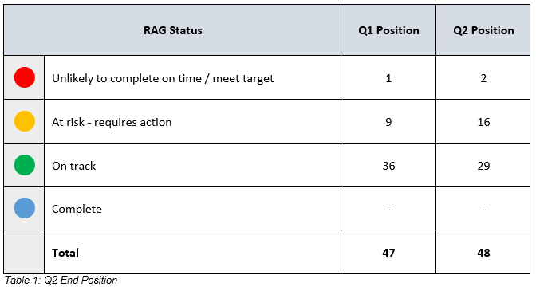

*Table 1: Q1 and Q2 end position*

Deliverables increased from 47 to 48 at the end of Quarter 2 due to the inclusion of an additional Equality and Diversity deliverable under ‘Workforce’. There was an increase in Amber and Red deliverables in Quarter 2 in comparison to Quarter 1, and a reduction in those reported Green in comparison to Quarter 1. Golden Jubilee teams continue to work to recover the position, with projections for Quarter 3 suggesting an improved position at the end of the next quarter.

Further detail will be provided in the presentation to the Board on 14 December.

### 2.3.1 Quality/ Patient Care

No direct impact – progress monitoring.

### 2.3.2 Workforce

No direct impact – progress monitoring.

### 2.3.3 Financial

No direct impact – progress monitoring.

### 2.3.4 Risk Assessment/Management

Deliverable risks are assessed and managed locally within Divisions / departments. Where necessary, risks are escalated through existing risk escalation hierarchy. No new or emerging risks were escalated through NHS GJ’s risk management framework.

### 2.3.5 Equality and Diversity, including health inequalities

Delivery Planning Templates form part of the Board’s ADP submission. The ADP sets out the Board’s delivery priorities to March 2024. These include services to patients, and organisational development priorities affecting staff. Relevant Board strategies and policies including Diversity and Inclusion Strategy, Equality Outcomes and Health and Wellbeing Plans were considered in developing the ADP.

### 2.3.6 Other impacts

**Climate Emergency and Sustainability**

Not Applicable.

### Communication, involvement, engagement and consultation

The Board carried out its duties to involve / engage external stakeholders as appropriate:

* Internal: Quality, Performance, Planning and Programmes and organisational leads engagement throughout August, September, and October.

### Route to the Meeting

This has been previously considered by the following groups as part of its development. The groups have either supported the content, or their feedback has informed the development of the content presented in this report.

* Quarter 1 Update - Executive Leadership Team, 31 August 2023
* Quarter 2 Update - Executive Leadership Team, 25 October 2023
* Quarter 1 and Quarter 2 Update – Finance and Performance Committee, 14 November 2023

## 2.4 Recommendation

NHS Golden Jubilee Board members are asked to note the Quarter 1 and Quarter 2 updates.

## List of appendices

The following appendices are included with this report:

* n/a