|  |  |
| --- | --- |
| **Document Title:** | **2022-23 Procurement Annual Report** |
| **Document No:** | **2023 AR 001** |
| **Department:** | **Procurement** |
| **Approval:** | **Executive Leadership Team** |



# Table of Contents

1 Table of Contents 1

2 Introduction 2

3 Summary of Regulated Procurements 2021/22 3

4 Procurements not complying with NHS Golden Jubilee Procurement Strategy 3

5 Community Benefits 3/4

6 Fair Work First 4

7 Supported Businesses 5

8 Proposed Regulated Procurements 2022/23 and 2023/24 5/6

9 Reference Documents / Appendices 6

10 Glossary of Terms 6

# Introduction

To comply with the Procurement Reform (Scotland) Act 2014 (The Act), NHS Golden Jubilee is required to publish a Procurement Report annually detailing information on all regulated procurement activity. This report reflects information for the period 1st April 2022 to 31st March 2023. In addition to reporting previous activity, the report includes information on regulated procurements that are planned for the next two-year period (1st April 2023 – 31st March 2025).

A regulated procurement is any procurement for goods or services with an estimated value over the life of the contract of £50,000 or more and any such procurement for works with an estimated value over the life of the contract of £2,000,000 or more.

The professional management of procurement activity is an important factor contributing towards the efficient operation of NHS Golden Jubilee and the attainment of corporate objectives. It is essential for patients, staff and stakeholders that projects, supplies and services are delivered on time to NHS Golden Jubilee within optimum commercial arrangements.

NHS Golden Jubilee had a total expenditure with third party providers of £80.7 million net of VAT (based on financial year 2022/2023 data).

The current Procurement Strategy positions procurement activity visibly within NHS Golden Jubilee’s objectives. This establishes Board level commitment to and involvement in the management of the procurement deliverables. The strategy addresses key procurement issues over a 3-year time-frame and is subject to annual review. The Audit and Risk Committee approved the strategy in April 2022.

The strategy is delivered through the line management accountability structures with clear targets and timescales being established in relation to improvement in procurement activity undertaken at strategic and operational levels. These targets are reflected within the individual performance plans of the Head of Procurement and other Senior Managers.

The report owner is:

**Iain Skene**

**Head of Procurement**

**NHS Golden Jubilee**

**Golden Jubilee National Hospital**

**Agamemnon St**

**Clydebank**

**G81 4DY**

# Summary of Regulated Procurements 2022/23

The following is a list of regulated procurements for the NHS Golden Jubilee completed during the period 1st April 2022 to 31st March 2023.

|  |  |  |  |  |
| --- | --- | --- | --- | --- |
| **Project Name** | **Contract**  **Value** | **Awarded Supplier** | **Community**  **Benefits** | **Fair Work**  **First** |
| Endoscopic Vein Harvest (EVH) Tools | 1,485,759‬ | Getinge Limited | N | Y |
| Endoscopic Vein Harvest (EVH) Table  Attached Monitor | £94,854 | Carioprecision | N | N |
| Cath Lab 1 (Angiography Digital Bi-Plane,  Injector Head, Workstation Advantage) | £915,750 | Siemens Healthcare Ltd | N | N |
| Monitoring (4E EMU) | £71,141 | Cardioprecision Ltd | N | N |
| Theatre Changing Refurb/Medical Physics  Refurb | £754,781 | MPMH | N | N |
| Ultrasound Rooms Refurbishment | £600,598 | MPMH | N | N |
| Docking Stations and Shuttles trolley system | £130,000 | Burlodge | N | N |
| Supply of Electrophysiology Systems with Associated Hardware and Consumables | £8,977,775 | Abbott Medical U.K. Ltd | N | N |
| Supply of Electrophysiology Systems with Associated Hardware and Consumables | £8,977,775 | Medtronic Limited | N | N |
| Provision of Banking Services | £74,655 | Royal Bank of Scotland | N | N |
| NHS Golden Jubilee Cardiac Perfusion Consumables | £1,264,750 | Medtronic Limited | N | N |
| NHS Golden Jubilee Cardiac Perfusion Consumables | £1,264,750 | Terumo UK Ltd | N | N |
| NHS Golden Jubilee Car Park Works | £2,500,000 | Kier Construction | N | N |
| Medical Services for Eye centre | £441,457 | Synaptik (mini comp) | N | N |

Further detail for each procurement exercise is contained in Appendix 1.

# Procurements not complying with NHS Golden Jubilee Procurement Strategy

In compliance with the Procurement Reform (Scotland) Act 2014 (The Act) NHS Golden Jubilee is required to provide information on any Procurement that did not comply with the Board Procurement Strategy.

This confirms that all of the regulated procurements awarded over the period April 2022 to March 2023 complied with the Board Procurement Strategy requirements.

# Community Benefits

Boards are required to provide details of Community Benefits where they exist.

The Golden Jubilee University National Hospital (GJUNH) expansion projects aspire to make a positive social and economic impact, particularly within the West Dunbartonshire area, by maximising employment, training and business opportunities and supporting education activities throughout the development of the project.

All employment related requirements must be provided for and filled by New Entrants.

Opportunities should be maximised by West Dunbartonshire residents where possible.

New Entrant means:

• A person who is trained and employed to do a specific job for a minimum of 26 weeks and is leaving an educational establishment or training provider; or

• A person who is trained and employed to do a specific job for a minimum of 26 weeks that has been non-employed with no experience; or

• A person with relevant experience who has been unemployed for at least three months and is seeking employment.

The Principal Supply Chain Partners (PSCPs) are required to report on the sustainment of all employment opportunities created, in response to the agreed community benefits, on a quarterly basis throughout the duration of the expansion projects and up-to one year after project completion or until the end of the apprenticeship framework. The table below shows primary contractor targets for recruitment for the current phase of the project:

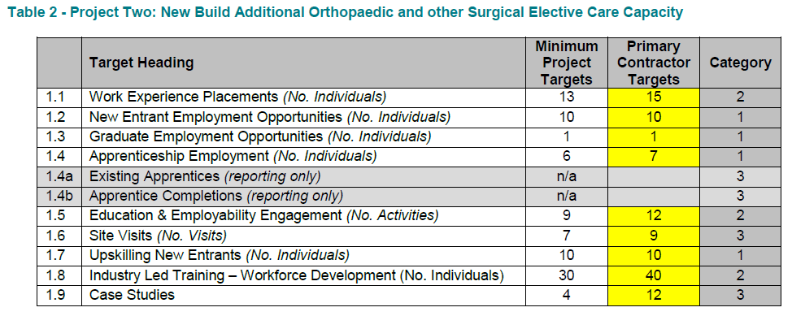

SME Development

Kier held “Meet the Buyer” events to encourage local SME’s and Third Sector Organisations (TSO’s) to be part of the expansion projects. These events were held during both the preconstruction stage and during the project delivery phase. Kier targets a minimum of 55% of work packages to be spent with local SMEs.

# Fair Work First

The Scottish Government expect public bodies to promote Fair Work First in all relevant procurements. Confirmation is given that the total number of Procurements where it was relevant to include Fair Work First criterion was one.

# Supported Businesses

The Scottish Government encourages Public Sector bodies to utilise the Services of supported businesses wherever appropriate opportunities arise, and to seek the services of those Companies on the Framework Agreement.

NHS Golden Jubilee Procurement Strategy confirms our commitment to ensuring that the Framework Agreement will be utilised wherever appropriate, and consideration will be given to supported business contractors during the tendering exercise.

# Proposed Regulated Procurements 2023/24 and 2024/25

The following is a list of regulated procurements likely to be undertaken during the next two financial years. Definitive start dates and go live dates are dependent on allocated capital and final approval to proceed.

|  |  |  |  |
| --- | --- | --- | --- |
| **Project Name** | **Budget** | **Start Date** | **Go Live Date** |
| Endobronchial ZEPHYR valves (Pulmonary valves) | TBC | In Progress | TBC |
| Supply of Medical and Surgical Devices and Consumables | TBC | In Progress | TBC |
| Electrical Contracting Framework (NHS Lanarkshire led) | TBC | In Progress | TBC |
| Plumbing Contracting Framework (NHS Lanarkshire led) | TBC | In Progress | TBC |
| Value Knowledge Impact Partnership Framework | TBC | In Progress | TBC |
| ECMO Oxygenator | TBC | In Progress | TBC |
| Managed Service Orthopaedic Theatres | TBC | In Progress | TBC |
| Hotel Catering Framework | TBC | TBC | TBC |
| Riverside Light | TBC | TBC | TBC |
| Hotel Lease Vehicle | TBC | TBC | TBC |
| Hospital Lease Vehicle | TBC | TBC | TBC |
| Soft Tissue Knee Surgery | TBC | TBC | TBC |
| Foot & Ankle equip | TBC | TBC | TBC |
| Nanoscope equipment | TBC | TBC | TBC |
| Movable Items (Patient Beds/Trolleys, Lifting Equipment etc.) | TBC | TBC | TBC |
| Plumbing Materials | TBC | TBC | TBC |
| Shredding Contract | TBC | TBC | TBC |
| Ventilation | TBC | TBC | TBC |
| Small Works Framework | TBC | TBC | TBC |
| Portable Electrical Equipment | TBC | TBC | TBC |
| Equipment Disposable | TBC | TBC | TBC |
| Catering Equipment Maintenance & Repair Service Contract | TBC | TBC | TBC |
| TV Set for Hotel | TBC | TBC | TBC |
| Da Vinci Instruments Decontamination with NHSGG&C | TBC | TBC | TBC |
| Catering Equipment Maintenance & Repair Service Contract  (Hotel 3rd Extension May 24) | TBC | TBC | TBC |
| **Project Name** | **Budget** | **Start Date** | **Go Live Date** |
| Blood Transfusion Analysers - Equipment, Service, Reagent/Consumables | TBC | TBC | TBC |
| Blood Glucose Monitoring - Equipment & Consumables | TBC | TBC | TBC |
| Biochemistry Analysers - Equipment, Service, Reagents/Consumables/Calibrators | TBC | TBC | TBC |

# Reference Documents / Appendices

[Procurement Reform (Scotland) Act 2014](http://www.legislation.gov.uk/asp/2014/12/contents)

<https://www.legislation.gov.uk/asp/2014/12/part/1>

**Appendix 1: Regulated Procurements 2022-2023**

**Appendix 2: Board** [Procurement Strategy](http://www.nhsaaa.net/media/3201/procurementstrategy13-18.pdf) 2021-2024

# Glossary of Terms

|  |  |
| --- | --- |
| GJUNH | Golden Jubilee University National Hospital |
| Framework Agreement | In the context of this document a contract establishing a supplier  or suppliers with agreed terms and conditions for the supply of goods services or works established for one or more Health  Board who will call off as required. |
| EP | Electro Physiology |
| ECG | Electro Cardiography |
| CCO | Continuous Cardiac Output |
| MRI | Magnetic Resonance Imaging |
| VEAT | Voluntary ex-anti Transparency |
| CT | Computerised Tomography |
| CSPD | Central Sterile Processing Department |