NHS Golden Jubilee

Meeting: NHS Golden Jubilee Board

Meeting date: 28 September 2023

Title: Clinical Governance Annual Learning Summary

Responsible Executive/Non-Executive: Mark MacGregor, Executive Medical Director

Report Author: Katie Bryant, Head of Clinical Risk and Governance

1 Purpose

This is presented to the group for:
- Awareness

This report relates to a:
- Government policy/directive

This aligns to the following NHSScotland quality ambition(s):
- Safe
- Effective
- Person Centred

This aligns to the following NHSGJ Corporate Objectives:
- High Performing Organisation – Establishing the conditions for success to enable excellent outcomes and experience for patients and staff

2 Report summary

2.1 Situation
This paper presents the annual update on themes and trends from adverse events, feedback and associated learning.

2.2 Background
Annual Learning Report looking across the organisation at adverse events and complaints to support identification of trends/ themes for learning and considering this in the context of our improvement work.

This paper presents the sixth annual report as there was no report during 2021-2022 due to significant staffing challenges within the Clinical Governance Team.

2.3 Assessment
Appendix 1 provides a detailed Annual Learning Summary report on adverse events, significant adverse events, feedback and learning.

2.3.1 Quality/Patient Care
Work has commenced to implement the feedback given by stakeholders to ensure our process is able to deliver a high quality of patient care and experience throughout the SAER process.

2.3.2 Workforce
The management of significant adverse events and feedback undoubtedly presents challenges in various forms to the workforce both from a psychological and capacity perspective. The organisation is reinforcing support mechanisms for those involved whilst ensuring that learning is the focus of the outcome of the reviews.

2.3.3 Financial
There is a potential for financial impact to the organisation in relation to claims as a result of adverse events.

2.3.4 Risk Assessment/Management
Significant adverse event reviews and feedback are managed on a case by case basis and risk assessment is supported where required, this is further embedded within action plans if appropriate.

2.3.5 Equality and Diversity, including health inequalities
An impact assessment has not been completed as this paper provides a report following an analysis of data.

2.3.6 Other impacts
Potential for reputational impact due to the nature and content of the report.

    - Communication, involvement, engagement and consultation
The Board has carried out its duties to involve and engage external stakeholders where appropriate:

- Clinical Governance Risk Management Group – Extra Ordinary Meeting 04 September 2023

    - Route to the Meeting
This has been previously considered by the following group as part of its development. The group has either supported the content and given appropriate feedback and this has informed the development of the content presented in this report.

- Clinical Governance Risk Management Group – Extra Ordinary Meeting 04 September 2023

2.4 Recommendation

- Awareness – For Members’ information only.

3 List of appendices

The following appendices are included with this report:

- Appendix No 1, Annual Learning Summary

ANNUAL LEARNING SUMMARY

- Introduction

In 2016 it was agreed to develop an Annual Learning Report looking across the organisation at adverse events and complaints to support identification of trends/ themes for learning and considering this in the context of our improvement work.

This paper presents the sixth annual report as there was no report during 2021-2022 due to significant staffing challenges within the Clinical Governance Team.

An overview of adverse events reported within the year is given with exploration of the top 3 categories. The Significant Adverse Events are considered in a separate section followed by formal complaints. Links to improvement work are made throughout the report.

- Adverse Events

2.1 Overview
Chart 1 below shows the number of adverse events reported per month as a count and against activity figures, data is shown over the last four years for comparison:

Chart 1 – SPC Chart of Adverse Events by Month
(01/12/2018 – 31/03/23)
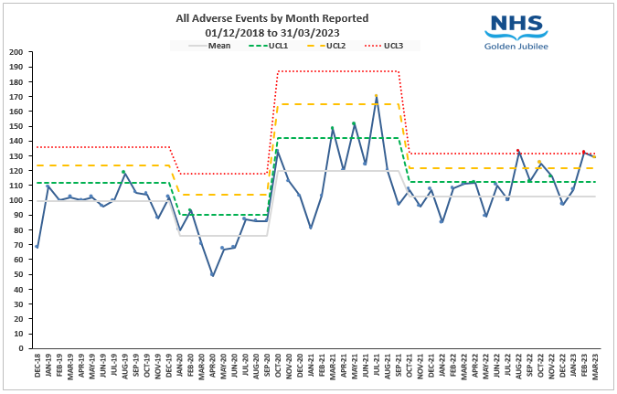
During 2022-2023 there was an average of 112 events per month, which is a decrease on the previous year’s average of 115. This reporting period has seen the incident reporting rate settle to almost pre-pandemic rates. It should be noted that the new median is slightly higher however this could be related to the increased activity across the organisation as we continue to grow and expand. There were two months where incident reporting fell out with the third upper control limit – August 2022 (n=133) and February 2023 (n=132). It can be seen that August appears to have a consistently higher level of incident reporting.

The charts below show a comparison of events reported during August for the preceding four years in an attempt to illustrate whether specific areas had contributed to the August 2022 breach of upper control limit 3. To illustrate this, we have created comparative Pareto charts below.

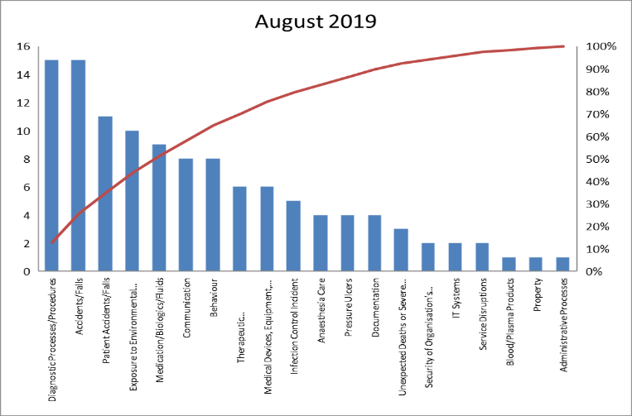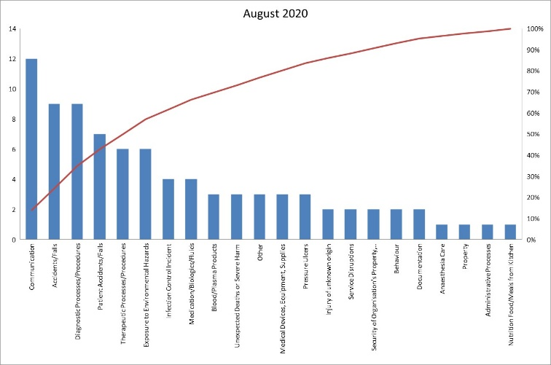
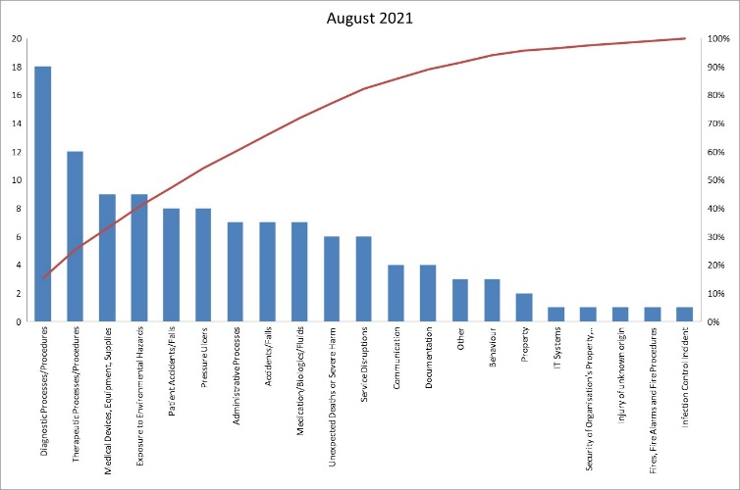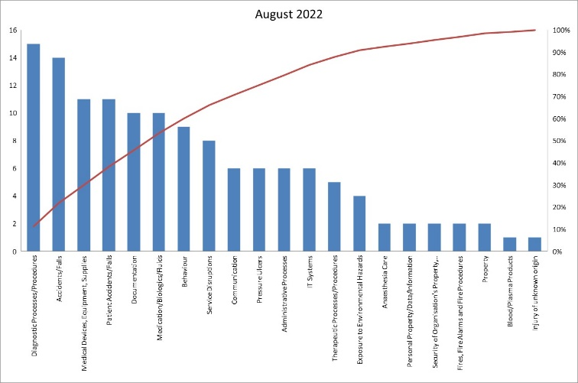

The above Pareto charts demonstrated that Diagnostics has been the significant contributing factor to the overall total of 149 events reported for August 2022 and the reason for the breach, which is a similar picture to the previous Annual Learning Summary. Further analysis can be found in section 2.2.1, however it should be noted that August is the month where the new cohort of junior medical staff take up post and, historically there have been some teething issues with this staff group ‘learning the ropes’. This is something that could be considered as part of the programme for induction into clinical services for the new junior doctors.

The following tables show the top 5 categories and also identify the top 5 locations where these incidents occurred.

Chart 2 – GJNH Top 5 Adverse Events

The top 5 categories this year demonstrate a slight change compared to the previous report’s data with ‘Communication’ being replaced by ‘Therapeutic Processes/Procedures’; this can be attributed to the return to a more regular level of patient flow following the COVID-19 pandemic. The top 3 categories are analysed in further detail later in the report.

The chart below shows the trend of events rate in the top 5 locations where they occur:

Chart 3 – GJNH Top 5 Locations of Events

The top 5 locations are similar to the previous year with the exception of Labs and 4 East Orthopaedic; the latter is a new location since the pandemic and the labs issues have seen a significant increase in the number of issues related to pathology samples with incomplete information. All other areas in the top 5 locations have seen a degree of stability in incident reporting numbers compared to the previous report; ICU2 and ward 3 East have both reduced slightly.

On review of the events reported during 2022/2023 the top 5 services are shown in the following chart.

Chart 4 – GJNH Top 5 Services

There has been a 70% increase in Orthopaedic adverse events and on further review this could be related to an increase in patient flow through the department (11,825 occupied bed days in 2021/2022 compared to 12,764 occupied bed days in 2022/2023) and the perceived increase in frailty in patients within the service. There has also been a 55% increase in adverse events related to Interventional Cardiology; again this could be related to an increase in patient flow through the department (6,370 occupied bed days in 2021/2022 compared to 7,033 occupied bed days in 2022/2023) and the continued promotion of reporting within the service; particularly related to mortality and morbidity via the Structured Review process.

On review, an event is assessed and given a severity grading score. The figure below shows a comparison over the previous four years of incidents by severity, as we would expect, the majority of events sit within the lower end of severity, the higher severity events are considered in more detail later in the report. It can be seen that only 1.5% of all events reported have been graded either major/extreme and there has been a slight increase in the number of ‘major’ events compared to last year. (The dataset contains incidents that have not yet been graded [n=73], for the purposes of the figure below these have been excluded.)

Chart 5 – GJNH Events by Severity
(01/04/2019 to 31/03/2023)

2.2 Top 3 Adverse Event Categories

The following section discusses briefly the top trending categories over the year. The top 3 categories remain the same as the previous report and all have seen a slight increase in overall number of events reported.

2.2.1 Diagnostic Processes/Procedures (n=159)

The top category of events reported during 2022/2023 was Diagnostic Processes/Procedures. The following chart shows these events by subcategory and this demonstrates 87% are related to Laboratory Investigations/Interpretations. In previous reports, the main subcategory related to Radiology events; on review this has reduced by 38% compared to the previous Annual Learning Summary. Further investigation has highlighted that this reduction is not related to a resolution of the core issue (electronic system focussed) however this has been realised through concerted efforts by the Radiology team to ensure robust contingencies are in place to counteract the issues experienced due to the system constraints

Chart 6 – GJNH Diagnostic Processes/Procedure Events by Subcategory

On further review of the Laboratory Investigations/Interpretations events there is an overriding theme within this category in relation to pathology samples. During the year there were a number of services expanded within National Elective Services division which had an impact on the number of pathology samples. There is a currently a Service Level Agreement (SLA) with NHS Greater Glasgow and Clyde for processing NHSGJ pathology samples as we do not do this locally. The increase in pathology samples triggered a review of the cause. The Laboratory team had not been advised that services were expanding and this would generate additional samples, nor that these samples should be processed at the appropriate NHS board for the patient.

The Laboratory Quality Manager linked in with the appropriate Service Managers to ascertain what the process for pathology samples for these patients should be and put in place some additional processes for lab staff. A flowchart was created for lab staff to follow for allocating samples to the appropriate labs offsite, the Quality Manager spoke to the theatre teams regarding filling in the request forms appropriately, a new NHSGJ pathology sample form was created to clearly identify samples going to other labs as NHSGJ samples. The process continues to be monitored and any issues are being addressed as they arise. To date, the accurate completion of pathology request forms from theatres continues to be an issue and work is ongoing to address this with the theatre teams and lab staff.

2.2.2 Patient Accidents/Falls (n=138)

The number of patient accidents/falls incidents has increased by 23 events compared to the previous year (n=115). This category includes accidents such as sharps injuries as well as falls, however falls account for 95% of the events within this category.

The charts below detail the patient falls by month and per 1000 occupied bed days.

Chart 7 – GJNH Patient Falls by Month

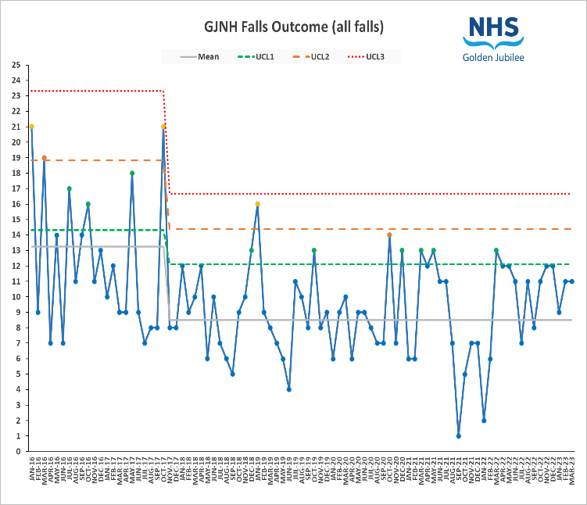

Chart 8 – Inpatient Falls per 1,000 OBD

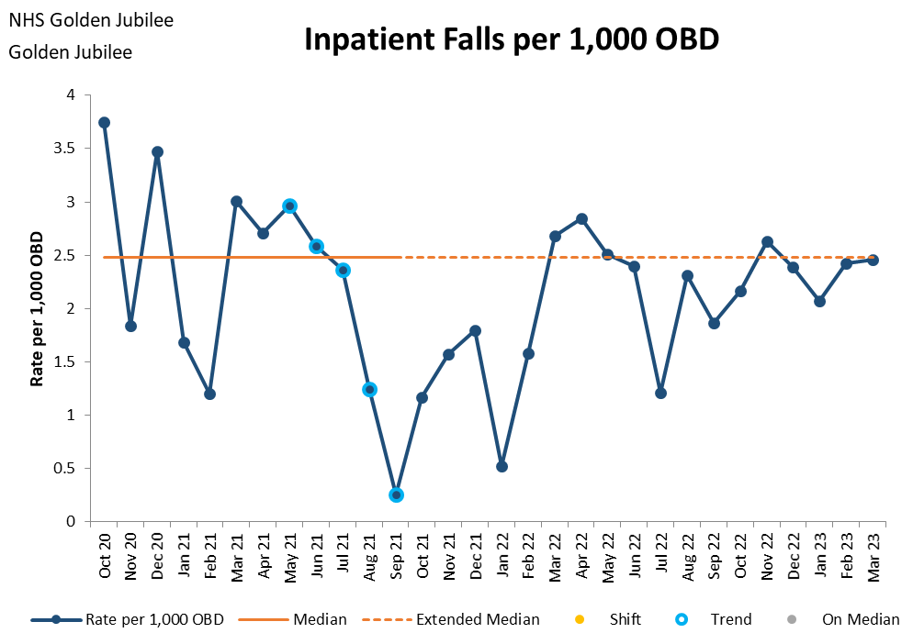
As seen in Chart 7 there has been a significant increase in the patient falls events across the site. In the past year, 11 of the 12 points have been above the mean. The average number of falls per month (2022/2023) has risen to 11, which is three more than the average of the previous year.

The trend in location of this category of events shows that 3 East (n=34), 4 East Orthopaedics (n=27), Orthopaedic Enhanced Recovery Ward (n=22) and 3 West (n=16) are the areas with the highest number of falls/accidents.

Chart 9 – Falls/Accidents

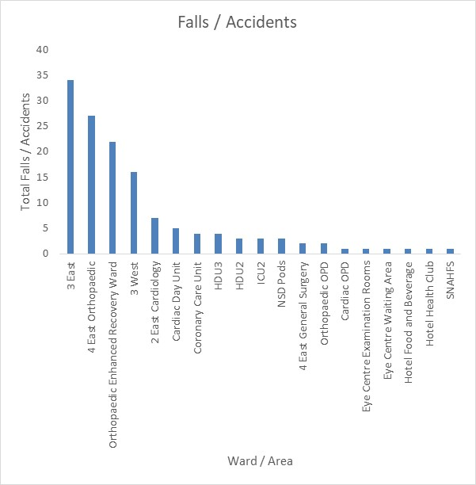

There was a total number of 7 falls with harm in which 2 of these progressed through the Significant Adverse Event Review process; this is the same number of falls progressing to SAER compared to 2021/2022. One of the Significant Adverse Event Reviews has now completed and the other one is in its final approval stage. 5 of these falls were reviewed using the Initial Assessment Tool, these have been presented to the services related at the Clinical Governance meetings and learning has been implemented.

The Falls Minimisation Group (FMG) took the decision to re-brand following a session with Healthcare Improvement Scotland; the focus for this group is more around how to mobilise patients safely taking a more positive approach. The Safe Mobilisation Group (SMG) scrutinise falls outcome data monthly. Wards were previously supported with high or increased levels of falls with a support visit. A new section has been added to Datix that triggers when Slips/Trips/Falls are selected as sub-categories. It will then be mandatory to complete questions on Post Fall Review, Interventions and Post Fall Questions. Wards trigger based on breaching their upper control limits on their falls outcome charts (either upper control limit 1, 2 or 3) or by showing an increased number of falls, or by experiencing a fall with harm.

Due to the increased number of falls within Critical Care the falls prevention care bundles were stepped up for HDU2, HDU3, ICU1 and ICU2. Across the NHSGJ, the median of 96% for FP1 equals the previous year and the median of 98% for FP2 is equal to the previous year.
It is important to note the comparison of falls resulting in harm in relation to patient falls. During the year the level of falls with harm remained low at 4% (n=5). This is a reduction of three compared to the previous year.

In June 2023, a Safe Mobilisation workshop took place in Training Room 5 which was multi-disciplinary and had representation from nursing, rehabilitation, clinical education and pharmacy. Feedback from the day was positive and the SMG agreed to hold similar sessions at regular intervals (potentially 6 monthly) to ensure that relevant new recruits are captured throughout the year.

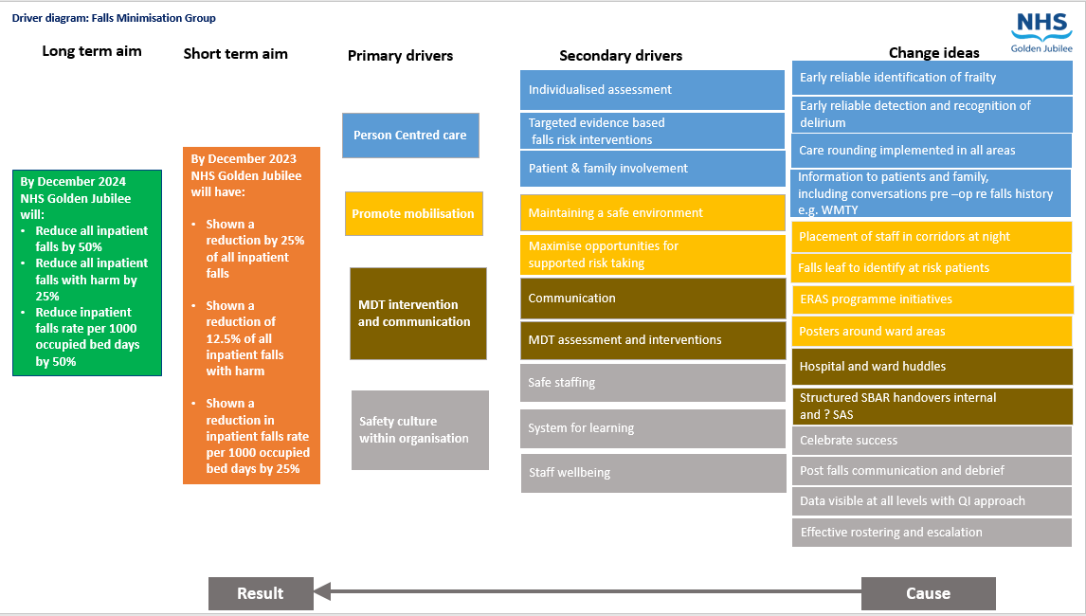
The SMG chair and key leaders feel that it was important to continue to capture learning from all areas. Improving our falls numbers remains a high priority for the NHSGJ. A Driver Diagram has been created to support continue improvement for 2023/2024.

2.2.3 Staff Accidents/Falls (n=106)
Staff Accidents/Falls features in the top 3 reported categories of events for 2022/2023; none of these event were graded major/extreme. The following chart shows these events by sub category.
Chart 10 – Staff/Visitor Accidents/Falls by Subcategory

Sharps injuries is the top reported sub category amongst staff accidents. When compared to the number of Occupational Health attendances for sharps and splash injuries, there was a total number of 76 members of staff who attended Occupational Health. This means that 42% were reported on Datix; this has been recognised by the Occupational Health team and work is underway to target areas with poor reporting. 42% of all sharps injuries are attributable to theatre areas with the largest specialty being cardiac theatres (n=5).

On review of the staff falls the areas that see the highest number of falls are in the critical care department reporting 2 events during the year; these figures are not alarming and do not highlight any requirement for additional staff training for manual handling.

The staff accidents/falls reported under the sub category ‘contact/collision with objects’ are largely related to equipment/machinery and fixtures and fittings e.g. light fittings, doors, ceiling tiles; these account for 60% of this sub category of events.

Trends related to staff incidents are reported and monitored via the Health and Safety Committee on a quarterly basis.

2.3 Significant Adverse Events
There was a total of 46 adverse events reported during 2022/2023. There were 19 Significant Adverse Event Reviews (SAER) commissioned, 25 were concluded at Initial Assessment Tool stage and at the time of reporting two events were still under consideration for SAER.

When compared to 2021/2022 there is a decrease of 45% of events commissioned as SAER. As a percentage of the total incidents reported, during 2022-2023 there were 1.42% reviewed as SAER compared to 2.57% in the previous year.

All events with severity major or extreme will trigger an Initial Assessment to consider if an SAER is required however the severity of the event is not the only indicator. The chart below shows that a large number of SAERs involved events that were severity moderate. There was a large number of events reported which were patient deaths in Cardiology that were considered for Initial Assessment Tool however were not deemed appropriate to review; the Cardiology team routinely record all patient deaths on Datix for consideration on the appropriate level of review either via SAER process or M&M.

Chart 11 – Severity of Significant Adverse Events

In line with the previous year and concerns about engagement in the SAER process we reviewed in detail the time taken to report and commission Significant Adverse Event reviews was analysed.

Event to Reporting Date

Number of events | 19
Range | 0 days – 124 days
Mode | 0/1 days
Average | 15 days
% that met policy deadline (24 hrs to report) | 53% (10/19)

The table below outlines the reasons for the delay in reporting over events that took more than 5 working days to report.

Days to report | Service | Reason for delay in reporting
124 | Cardiology | Joint review with NHS GGC. Logged on Datix when advised of event by NHS GGC and made aware of NHSGJ involvement.
62 | SACCS | Not initially identified as a potential SAER – benefit in reviewing identified by clinical team after significant discussion amongst clinicians
36 | SACCS | Identified for SAER via Cardiology structured review process
31 | SNAHFS | Post-transplant death reported following discussion at SNAHFS CG meeting
17 | SNAHFS | Post-transplant death reported following discussion at SNAHFS CG meeting

Excluding these five events the average time to report the remaining SAERs was 1.3 days; when compared to the average during 2020 – 2021 this is 24.7 days less which shows a significant improvement in reporting events.

Appendix A provides an overview of the significant adverse events, their status and outcome where applicable.

The charts below show both the overall SAE reporting over the previous five years and a t-chart for the SAER’s that have been reported during the previous three years.

Chart 12 – Total Significant Adverse Events by Month Reported
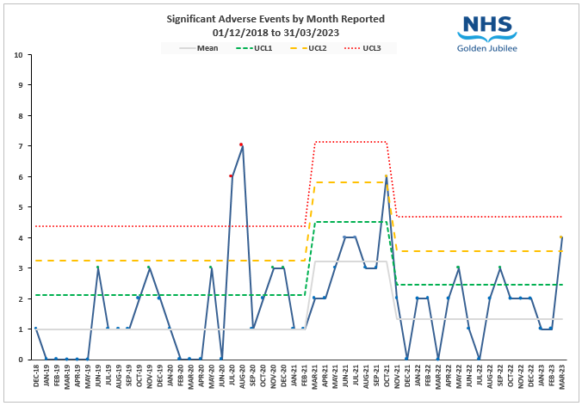
Chart 13 – Days between SAERs Reported
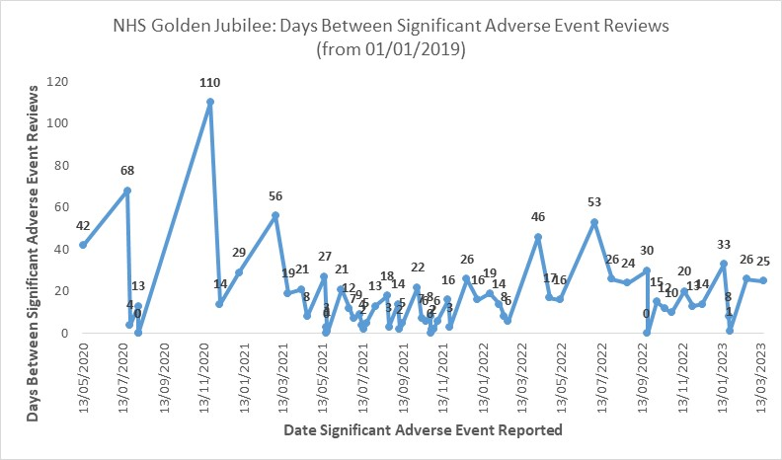
Chart 14 – SAER’s by Category
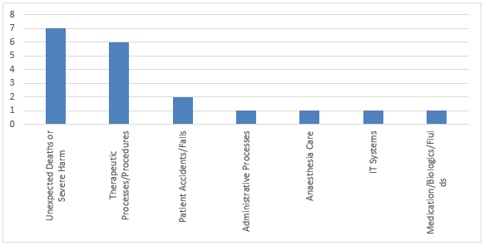
It can be seen from chart 14 that the most prevalent categories related to SAER’s is ‘unexpected deaths/severe harm’ and ‘therapeutic processes/procedures’. This is not unexpected as these categories of events are more likely to result in more severe harm and is the same pattern seen in previous years.

The following chart shows the Significant Adverse Events by service; this demonstrates the majority occurred within National Services Division and Interventional Cardiology. There was a combination of events related to SNAHFS patients (n=4) and SACCS patients (n=3) within the NSD events. This is a change in trend when compared to previous reports where Cardiac Services and Interventional Cardiology were traditionally the highest reporting services.

Chart 15 – SAER by Service
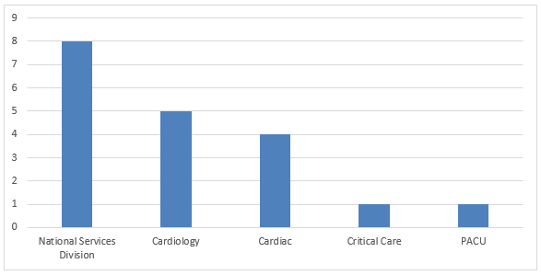
One of the significant adverse events involved a patient who had undergone cardiac transplant surgery and subsequently died. Three of the SNAHFS events related to post transplant patient deaths; these events automatically trigger the SAER process as stated in the Adverse Event Policy. The process for commissioning SAER following transplant patient deaths was reviewed during the year 2022/2023 following a few events resulting in little or no learning; the majority of events highlighted good practice. It was agreed that any transplant patient death up to 30 days post-transplant would continue to be automatically reviewed via the SAER process.

Learning:

Although there has been a variety of learning points generated from SAER’s during the year, there is one clear overriding theme; this relates to communication. There are a number of different aspects of communication improvements including:

- Communication with relatives and patients in terms of involvement in decision making
- Clearer handovers between clinical teams on transferring patients (both internally and externally)
- Involvement of medical team in patient transfers
- Clear documentation of any communication in relation to a patients care

Documentation is also often highlighted as a learning point from SAER’s however it has also been noted that there are areas in the organisation where this is exemplar. When services ensure good documentation this enables those reviewing SAER’s and also investigating patient complaints and claims to do so with relative ease.

The process for reviewing action plans has been revised following the restructuring of the Clinical Governance reporting structure. All open actions from SAER’s are reviewed at service clinical governance meetings on a monthly basis. Those actions that are cross divisional will be monitored via the Clinical Governance Risk Management Group (CGRMG). There has also been an emphasis placed on open SAER actions that are more than 3 months past the expected completion date; these are detailed at each CGRMG meeting and both Divisional Management Teams are reviewing these on a more regular basis. Given the additional focus placed on SAER actions, the past year has seen an improvement in the completion of these however, the timescales for completing is still challenging.

On completion of a SAER investigation, each case if given an outcome code based on the following descriptors:

- Appropriate care, well planned and delivered.
- Issues identified but they did not contribute to the event.
- Issues identified which may have caused or contributed to the event.
- Issues identified which directly related to the cause of the event.

The following chart shows the outcome codes for the SAER reviews during 2022/2023.

Chart 16 - SAER Outcome Codes

In 24% of cases an outcome code of 4 was agreed, meaning that we felt issues were identified and the issues were directly linked to the cause of the event. In 47% of cases an outcome of 3 was agreed meaning that we have felt there was issues that may have caused or contributed to the event. In 23% of cases an outcome of 2 was concluded which is not unusual as generally when looking back in detail there are learning points identified that can inform future practice. One of the cases concluded at an outcome of 1 which was a transplant death that was triggered automatically.
The overview within the appendix shows the status of the action plans for these events. It is vital especially in the 3 and 4 outcomes that we ensure robust action plans with escalation of any issues in delivery. We are actively working to improve the processes supporting this within the revised CG structure and a more focused report to support enhanced tracking.

- Complaints

3.1 Overview

The Scotland complaints Handling Procedure incorporates a reporting structure with 9 new Key Performance Indicators (KPI) and is reported appropriately through the Clinical Governance structure within NHSGJ.

- During 2022/2023 there were 118 complaints received (Stage 1 (57) and Stage 2 (61)). There has been an overall increase of 4% (Stage 1 (53) and Stage 2 (61)) in Stage 1. Which is expected due to the COVID-19 pandemic measures being lifted and services resuming to a more pre pandemic level.
- There were 12 stage 1 complaints that escalated to a stage 2.
- 34 (60%) of the 57 stage 1 complaints were responded to within 5 working days’ timescales, Four stage 1 complaints were withdrawn.
- 12 (20%) of 61 stage 2 complaints were responded to within 20 working days’ timescales. There were 7 stage 2 complaints withdrawn.
- The top three categories were Clinical Treatment (30), Cancellations of surgery/procedure (20) and waiting list (19).
- There were 6 complaints progressed to a Significant Adverse Event Review (SAER).
- There were 6 cases referred to the Scottish Public Services Ombudsman (SPSO).
- There were 67 concerns received during 2022/23; this represents a 51% increase compared to the previous year. The majority related to waiting times and cancellation of surgery/procedure.
- Compliments were the highest feedback, with 212 being received during 2022/23.

Chart 17 – NHS GJ Complaints by Service (Top 6) 2022/2023

The above chart shows the top 6 services that the complaints relate to. Orthopaedics, Cardiac Services and Interventional Cardiology have all featured in the top 3 services for 3 of the 4 preceding financial years.

Chart 18 – NHS GJ Complaints by Categories – Two Year Comparison 2021-22 – 2022/23

Chart 18 shows the top 6 categories for complaints. The top themes are Clinical Treatment, being the highest over the past three years. Cancellation of surgery/ procedure, Staff Attitude and Waiting list have been in the top 4 themes over the past three years.

In this year we have had three complaints that escalated to a Significant Adverse Event Review (SAER). All learning and actions related to SAERs is detailed in Appendix A.

The following is a summary of some of the improvements to the service from feedback received during 2022/23:

- Staff to ensure that any duplicate referrals are removed to avoid patients being booked in error.

- Nursing staff to reiterate to patients the importance of wearing anti-embolism stockings.

- Deaf Awareness training to be organised for CME session via Equalities lead.

- Staff reminded of attitude during interactions with patients/families to ensure they comply with NHS GJ values.

- Staff within service that complaint related to were given training on clearly labelling information on booking form and reminded to remain vigilant for potential delay information.

SPSO

We had six cases referred to the Scottish Public Services Ombudsman (SPSO) in the year. One case has been reviewed by SPSO and has not been upheld; this related to Cardiac Services. The remaining 5 cases are still under review by SPSO at the time of this report.

Compliments

As noted in the overview, there were 212 compliments formally logged; this is an increase of 32% compared to the previous Annual Learning Summary. The wards and staff members continuously receive thank you card/letters/messages and general complimentary feedback on a daily basis, which is not formally logged. There are 2 departments logging their own compliments, and this will continue to be rolled out to other services over the upcoming year.

Orthopaedics and Cardiac Services received the highest number of compliments; this is a change to the previous report with Cardiac Services replacing Interventional Cardiology as the second highest service.

Conclusion & Recommendations

We acknowledge given the lack of an Annual Learning Summary for 2021/2022, it is not possible to make clear direct comparisons to the previous year and the report prior to this included the period during COVID therefore was not a normal year in terms of adverse events, activity and feedback. The overall adverse event reporting rate has recovered from the downturn we experienced during the covid pandemic. We have seen a slight increase in reporting overall and a significant improvement in the time taken for incidents to be reported (particularly in terms of SAER’s); this was an area noted for improvement in the last Annual Learning Summary. We continue to see steady increase in the number of complaints received, both stage 1 and stage 2 and response times remain to be challenging often due to the complexity of complaints.

The featuring of Labs adverse events in the top 3 categories is unusual. The review of the cause of this has highlighted the need to ensure that all supporting services linked to main specialties are involved from the outset in discussions around service expansion. This may have alleviated the issues encountered with the pathology samples and is learning that can be translated across other supporting services.
Previous reports have highlighted challenges with completing actions following SAER’s. Whilst this continues to be a challenge there has been a concerted effort from Divisional Management Teams, Services via CG meetings and also individual action owners in addressing this. A process for escalation of actions will be reviewed alongside escalation of issues around SAER timescales, complaint response timescales and completion of adverse event investigations within a timely manner. Another focus for SAER actions continues to be ensuring the actions are SMART and realistic timescales for achieving the action are set.

In conclusion, there are a few areas for the organisation to focus on from the analysis of the data within the Annual Learning Summary:

- A focussed piece of work relating to communication within the organisation, with external partners and also with patients and their relatives. This was highlighted as a theme from SAER actions and has also been a key element of various complaints.

- Where services are expanding all key stakeholders, in particular support services, should be involved in the discussions around the implementation and impact on support services. This should be in a proactive manner rather than reactive as was the case in relation to pathology sample issues.

- Development of key process measures to improve on timescales for the completion of SAERs will be a focus for 2023/24. This will be a preparatory piece of work bearing in mind the imminent publication of an updated National Framework for Adverse Event Management. This will allow the organisation to identify the key challenges associated with delays and assist in targeting remedial action.

- Continued development of support resources/training for all those involved with the SAER process; this is work in progress and has been identified as learning from some SAERs and the SAER focus group undertaken with key stakeholders.

In terms of the themes previously identified and recommendations made in previous reports an update on progress on these is detailed below:

- Education sessions via CME and CG Forums to raise awareness and understanding of the SAER process and need for timely engagement with this with the aim of reducing the time it takes to report these events on Datix and commence the review process – partially completed – reporting times has significantly improved and a focus group has been undertaken with an action plan in place to refine the SAER process

- Review via CGRMG of the High Risk MDT for Cardiac Surgery to update fully on progress to date and barriers to implementation – action closed and High Risk patients discussed at MDT

- Assurance from the SLWG on the process to support review of radiology reports with audit data to confirm compliance – this SLWG concluded with a plan in place for each service to develop internal processes for review radiology reports. The infrastructure to support this in electronic systems, although not 100% ideal, was developed as far as our current systems would allow.

- Scheduled updates from the Medicines Improvement Group on work plan progression to support escalation of issues and alignment to SAER learning – this action is ongoing and is a focus for the Director of Pharmacy

- Surgical Safety work plan to be progressed across Theatres to encompass the WHO Surgical Safety elements of safety brief, pause and sign out and the Stop before You Block work underway to ensure robust, quality processes in place. Some pilot projects are underway in all aspects that can provide the basis for wider programme. – Some elements of surgical safety work have been completed however the theatres team are currently reviewing the best way to continue this work via a theatre specific working group.

Appendix A - GJNH SAER Investigations

Ref | Month of Event | Division | SAER Short Title | Investigation Status | Outcome code | Key Learning | Action Plan Status
DW-8477 | April 2022 | HLD | Readmission to hospital - anticoagulation | Completed in December 2022 | 4 | - Standardised surgical handover  - Patient handover sticker for type of prosthesis used  - Realistic medicine partnership working for patient involvement in decision making  - Develop and provide further education for confirmation bias  - Inclusion of patients type and duration of anticoagulation/anti-platelet on CIS Care Plan  - Develop protocol for patients post-surgery anti-platelet therapy | Partially completed
DW-8533 | April 2022 | HLD | Patient fall 3 East - fracture | Completed in February 2023 | 2 | - Clear documentation required at all times and recorded in patient notes  - Consideration of the falls assessment documentation in terms of high/low risk of falls  - Staff to take notice of staff and relatives concerns  - Development of infographic for safe use of telemetry | Partially completed – one action outstanding in relation to falls assessment documentation
DW-8596 | May 2022 | HLD | TAVI patient deaths on waiting list | Completed in September 2022 | 4 | - Review processes to ensure effective training and education for referrers.  - Prospective rolling audit of mortality and significant morbidity  - Urgent provision of additional session  - Strengthening of worsening advice guidance | Complete
DW-8790 | July 2022 | HLD | Clinical deterioration contributed to fall | Review complete - progressing via CG forums | 3 | Action plan under development
DW-8972 | August 2022 | HLD | 7 French sheath in situ | Completed in April 2023 | 3 | - Standardise the equipment being used  - Arterial lines be transduced leaving theatre  - Staff in Critical Care to ensure every line is documented on CIS and included in handovers.  - CHA system in theatres being introduced to link with CHA in ICU
DW-9115 | August 2022 | HLD | Transplant patient death Aug 2022 | Review complete - progressing via CG forums | 1 | - The accessibility of specialist Consultant Microbiologists to be reviewed, to ensure cover with expert knowledge in transplant, to ensure patient care managed clinically appropriate | Complete
DW-9116 | September 2022 | HLD | Transplant patient death Sept 2022 | Completed in July 2023 | 2 | Action plan under development
DW-9170 | October 2022 | HLD | SACCS patient death - delayed transfer | Completed May 2023 | 3 | - Implement the recording of verbal communication with other health boards by using comments section on clinical portal  - eHealth to review alternative electronic system in order to NHS GJ to access other Health Boards imaging in a timely manner  - Develop and implement a flow chart for clear guidance on escalation process for bed availability to support medical and nursing staff in timely transfer.  - Introduce daily consultant-led review of patient whereupon earlier or subtle signs of deterioration may have been appreciated and acted upon. | Partially completed
DW-9224 | October 2022 | HLD | Death in CCU - D&G transfer | Review complete - progressing via CG forums | 4 | Action plan under development
DW-9263 | October 2022 | HLD | Lost documentation - e-Health concerns | Review complete - progressing via CG forums | 4 | Action plan under development
DW-9354 | July 2022 | HLD | Cardiology patient death - GGC and private sector involvement | Review complete - NHSGG&C leading on SAER |  | Action plan under development
DW-9394 | November 2022 | HLD | Post op bed availability issue (CCU/ICU) | Review complete - progressing via CG forums | 3 | Action plan under development
DW-9447 | December 2022 | HLD | NSD patient - transferred to ICU | Review complete - progressing via CG forums | 3 | Action plan under development
DW-9536 | January 2023 | HLD | SACCS patient death following cardiac surgery | Review complete - progressing via CG forums | 3 | Action plan under development
DW-9576 | January 2023 | HLD | Unavailable equipment during Cardiac Arrest call | Review complete - NHSGG&C leading on SAER | 2 | Action plan under development
DW-9577 | December 2022 | HLD | SACCS patient - neurological injury | Review not complete
DW-9693 | December 2022 | HLD | SACCS patient complication following cardiac surgery | Review complete - progressing via CG forums | 2 | Action plan under development
DW-9813 | March 2023 | HLD | Transplant patient death Mar 2023 | Review complete - progressing via CG forums | 3 | Action plan under development
DW-8882 | July 2022 | NES | Allergic reaction to Midazolam | Completed in May 2023 | 3 | - Clear communication between relevant groups of staff administering medication and caring for patients in the pre-op area  - Reinstatement of the emergency buzzer system within the PACU area. Ensure the necessary drugs available in the pre-operative area  - SLWG to be set up a review the safe sedation policy within the perioperative area. | Partially complete

