**Item 4.1**

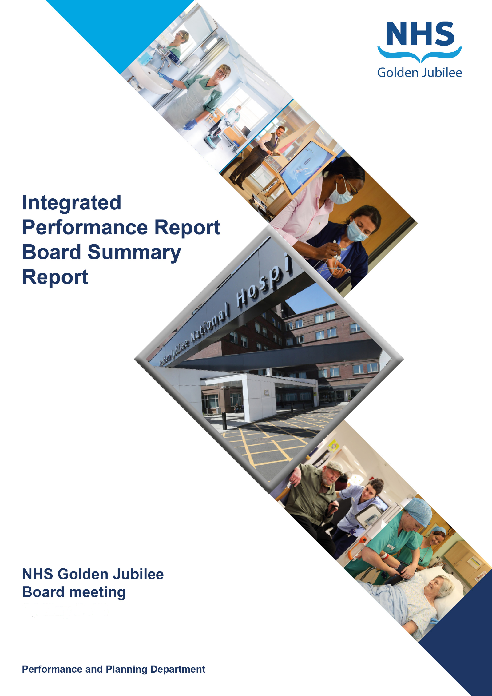

**28 September 2023**

**BoARD SUmMARy Report**

**Produced in August 2023**

**Data reported up to END of July 2023**

**For submission to:**

* **Board Meeting – 28 September 2023**

# Contents

**Introduction 2**

**Performance Summary Dashboard 5**

**Integrated Performance Report: Executive Summaries 7**

# Section A: Introduction

The purpose of the Integrated Performance Report (IPR) is to provide assurance on NHS Golden Jubilee’s performance relating to National Standards, local priorities and significant risks.

The IPR comprises four section with each section being considered in detail by the appropriate Standing Committee:

* Section A Introduction
* Section B:1 Clinical Governance
* Section B:2 Staff Governance
* Section B:3 Finance, Performance & Planning

This Board Summary Report of the IPR is presented to the Board and contains the summaries from each section of the full IPR.

**Gordon James Michael Breen Carolynne O’Connor**

**Chief Executive Director of Finance Director of Operations & Deputy CEO**

Performance Summary Dashboard – Guidance



Statistical Process Control – Guidance



Board Performance Dashboard – Part 1





Board Performance Dashboard – Part 2



At each meeting, the Standing Committees of NHS Golden Jubilee consider targets and standards specific to their area of remit using the Integrated Performance Report (IPR). There is a section of the IPR which provides a summary of performance Standards and targets identified as areas of note which is reproduced below. Topics are grouped under the heading of the Committee responsible for scrutiny of performance.

# Section B: 1 Clinical Governance

|  |  |  |
| --- | --- | --- |
| **Clinical Governance** | | |
| **KPI** | **RAG** | **Position:** |
| Total complaints (Stage 1 and 2) by volume |  | In June 2023 there were 16 complaints reported (an additional two stage 2 complaints are being reviewed for inclusion). Latest position available. |
| Stage 1 complaints response time |  | In June 2023, there were 11 Stage 1 complaints, seven were responded to within the five day target (64%). Latest position available. |
| Stage 2 complaints response time |  | In June 2023 there were five Stage 2 complaints, three were responded to within the twenty day target (60%). Latest position available. |
| Mortality |  | The mortality figure for July 2023 was reported as 12. |
| Significant adverse events |  | There were three significant adverse event reviews in July 2023. |
| MRSA/MSSA cases |  | There were zero instances of Staphylococcus aureus Bacteraemia (SAB) reported in July 2023. |
| Clostridiodes Difficile |  | There were zero Clostridiodes Difficile Infections (CDI) reported in July 2023. |
| Gram Negative Bacteraemia |  | There were zero reported instances of Gram Negative Bacteraemia in July 2023. |
| SSI: Hips & Knees |  | Surveillance recommenced in July with zero SSI reported in July 2023. |
| SSI: Cardiac |  | Surveillance recommenced in October with five SSIs reported in July 2023. |

**Clinical Governance Executive Summary**

In June 2023 we received 11 Stage 1 complaints and 7 Stage 2 complaints. Three of the stage 2 complaints (60%) were closed within the guidance timescale (20 days), two stage 2 complaints were still open at time of reporting however have already breached timescales. 63% of stage 1 complaints were responded to within guidance timescale (5 days) n =7.

The average time to respond to stage 1 complaints was 5.7 working days to be completed and closed. The average time to respond to stage 2 complaints (of those closed) was 16 days.

Mortality data for July 2023 has breached the first upper control limit (n=12) for the second month in a row.

No whistleblowing concerns have been raised during July 2023

**Key Healthcare Associated Infection Headlines**

* ***Staphylococcus aureus* Bacteraemia-** 0 cases to report in July.
* ***Clostridioides difficile* infection (previously known as *Clostridium difficile***) – 0 cases to report.
* **Gram Negative/E.coli Bacteraemia (ECB)** – 0 cases to report.
* **Hand Hygiene**

The bimonthly report from July 23 indicates a combined compliance score of 97%.

3 East reported a compliance rate of 75%, this has been addressed by the SCN and awareness raising via safety brief. 3 East staff will also monitor moving forward if compliance is affected by visiting specialties.

* **Cleaning and the Healthcare Environment -Facilities Management Tool**

**Housekeeping Compliance: 97.94**% **Estates Compliance: 96.91**%

* **Orthopaedic Surgical Site Surveillance**- No SSI to report.
* **Cardiac Surgical Site Surveillance**- No SSI to report.

**Other HAI Activity Overview**

No national update to provide for this reporting period.

# Section B: 2 Staff Governance

|  |  |  |
| --- | --- | --- |
| **Staff Governance** | | |
| Disciplinaries |  | There were zero disciplinary cases raised in July. |
| Grievances |  | There was one grievance cases raised in July 2023. |
| Dignity of work |  | There were no dignity cases raised in July 2023. |
| Local Sickness absence |  | Sickness absence in July 2023 was reported at 5.5%. This is within control limit. In July absence due to COVID-19 reasons was 0.1% same as the previous month. |
| Turnover |  | Turnover in July was reported as within control limits at 0.7%. |
| Medical appraisal with completed interview & form |  | A new round of appraisals began in April for 2023/2024. One doctor out of 152 have completed their 2023/24 appraisal. |
| TURAS Appraisal rates |  | Position for July 2023 reported as 69% (+1% from last month.) |
| Job Planning: All hospital |  | To date, 99 of the 125 job plans for 2023/4 have been signed off, 14 were in discussion, 7 are awaiting sign off by the doctor, with the remainder at various stages of the process. |

**Staff Governance Executive Summary**

**Sickness absence**

In July 2023, the Board’s sickness absence rate stood at 5.5%, down 0.5% on the previous month.

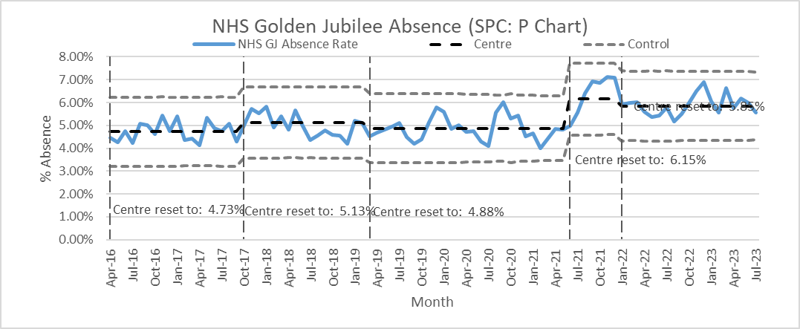

**Sickness absence**

Across the Directorates, sickness absence was as follows:

* Corporate: 4.2% (-0.4% on June);
* Golden Jubilee Conference Hotel: 3.6% (-0.9%);
* Heart, Lung and Diagnostic Services: 6.5% (+0.8%); and
* National Elective Services: 6.2% (-1.6%).

The rolling 12-month sickness absence rate for the Board was 5.6%. The 12-month breakdown for the Directorates was:

* Corporate: 4.4%;
* Golden Jubilee Conference Hotel: 3.5%;
* Heart, Lung and Diagnostic Services: 6.0%; and
* National Elective Services: 6.4%.

“Anxiety/stress/ depression/other psychiatric illnesses” continued to be the highest cause of sickness absence in July, accounting for 28.9% of all sickness absence, 1.0% higher than June’s figure of 27.9%. It was the main cause of absence in all four Directorates:

* Corporate: 38.0%;
* Golden Jubilee Conference Hotel: 51.6%;
* Heart, Lung and Diagnostic Services: 22.0%; and
* National Elective Services: 28.9%.

“Injury, fracture” was the second top cause of sickness absence overall in July, accounting for 9.1% of sickness absence (down from 11.5% the previous month). The third top reason for sickness absence was “Back problems”, coming in 8.5%.

**COVID-19**

In July, COVID-19 special leave accounted for 0.1% of all contracted hours, the same as the previous month. The Directorate breakdown was:

* Corporate: 0.0%;
* Golden Jubilee Conference Hotel: 0.0%;
* Heart, Lung and Diagnostic Services: 0.2%; and
* National Elective Services: 0.1%.

With absence due to COVID-19 continuing at such a low rate for several months in a row, we will no longer report this on a monthly basis, unless there is a resurgence in infection rates.

**Agenda for Change appraisal**

Within the twelve months to 31 July 2023, 69% of staff who come under the Agenda for Change terms and conditions completed their appraisal using TURAS, which is 1% higher than the previous month. The Directorate breakdown is as follows:

* Corporate: 67% (+2% on June);
* Golden Jubilee Conference Hotel: 47% (+8%);
* Heart, Lung and Diagnostic Services: 70% (-2%); and
* National Elective Services: 72% (same).

**Medical appraisal**

The appraisal year for medical staff runs from 1 April to 31 March. As at 4 August 2023, 1 doctor out of 152 had completed their 2023/2024 appraisal.

**Medical job planning**

In February 2023, we closed almost all medical job plans on the Allocate job planning system for 2022/2023, and started new job plans for the year starting 1 April 2023. At the time of writing this report, 99 of the 125 job plans for 2023/2024 had been signed off, 14 were in discussion, 7 were awaiting sign off by the doctor, 2 were awaiting sign off by the first manager, 1 was awaiting sign off by the second manager, and 2 were in lockdown.

# Section B:3 Finance, Performance and Resources

