Duty of Candour Annual Report

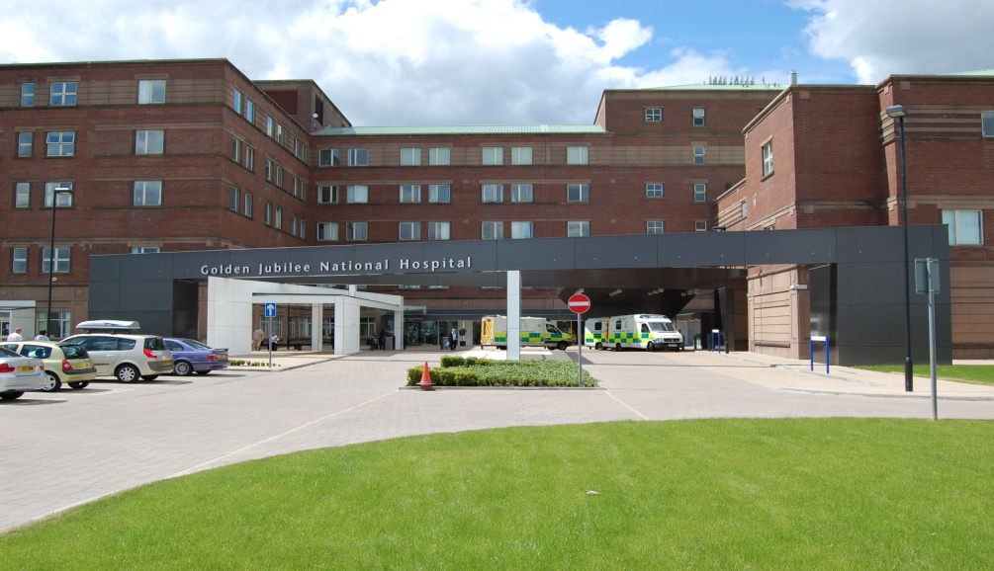

2022 – 2023

- Introduction

All health and social care services in Scotland have a Duty of Candour (DoC). This is a legal requirement which means that when unintended or unexpected events happen that result in death or harm as defined in the Act, the people affected understand what has happened, receive an apology, and that organisations learn how to improve for the future.

An important part of this duty is that we provide an annual report about how the DoC is implemented in our services. This report describes how we have operated the DoC during the time between 1 April 2022 and 31 March 2023.

- About Golden Jubilee National Hospital

NHS Golden Jubilee has always aimed to ensure that we support the delivery of NHS Scotland’s national health priorities. Our focus since our establishment has been to meet NHS Board demands and deliver equity of access to high quality healthcare for as many patients as possible so that they benefit from our clinical expertise and excellent facilities.

- COVID-19 Impact

During the COVID-19 pandemic, non-urgent services were paused in line with government guidelines. Even though this challenging time has passed, the ongoing impact of remobilization and returning to ‘business as usual’ has been felt within the SAER process. This mainly links to delays in investigations and approving reports.

NHS Golden Jubilee have not triggered the Duty of Candour procedure for any events directly attributed to COVID-19.

- Our Policies and Procedures

Each Adverse Event is reported and reviewed via the Datix system. The procedure for reviewing each level of incident is set out in the Adverse Events Management policy. The Adverse Events Management policy and supporting tools/guidance have been updated to reflect the introduction of DoC.

The decision on DoC is built into the Significant Adverse Event Review (SAER) process. All severity 4 and 5 adverse events are automatically escalated as potential SAER. Legislation requires that a clinical person must make the final decision on Duty of Candour. The Initial Assessment Tool (IAT) that supports review of SAERs is completed by the Clinical Governance Lead and/ or Clinical Nurse Manager depending on the type of event. This includes a specific question relating to the Duty of Candour status. The completed assessment and recommendation of Duty of Candour is then approved by the Division Management Team (DMT) which includes an Associate Nurse and Medical Director. Any IATs that do not progress for review are discussed at the service Clinical Governance Forum with multi-disciplinary representation to ensure learning is captured and tis offers further opportunity for any challenge on the level of review and DoC status.

Each adverse event is reviewed with a focus on learning from what has happened, regardless of the level of harm. If there is potential to learn from an error this should be harnessed and taken forward. On completion of an adverse event review actions are identified and these are monitored to completion via the Clinical Governance reporting framework.

All staff receive training regarding adverse event reporting and the implementation of DoC at via the corporate induction e-learning package. More in depth training is delivered to those responsible for reviewing incidents on Datix and a programme of investigation training and supporting toolkit is being refreshed for staff who could potentially take part in a Significant Adverse Event investigation; this will take the form of blended learning utilising webinars, MS Teams sessions and in-person training where possible.

We know that being involved in a significant adverse event can be difficult for staff as well as those affected by the event. We have support available to staff in the form of the formal line management structure. In addition to this we have the Spiritual Care Lead and the Occupational Health team who are available to provide staff support in different forms following significant adverse events, where required. NHS Golden Jubilee staff also benefit from access to the TimeforTalking Employee Assistance Programme. This service works alongside the current range of health and wellbeing support available through NHS Golden Jubilee, both internally and externally and is available via telephone, online or face-to-face counselling for staff.

Further to this, patients/families are offered the support of our Spiritual Care Lead and clinicians where required.

- Duty of Candour Activity 2022-2023

During the reporting period, four events triggered the organisational Duty of Candour; table 1 below shows the breakdown of these in relation to the outcome of the event, specific detail regarding the events is documented in appendix 2.

During this period there were no families that requested to meet to discuss the findings of a DoC investigation.

Table 1: Duty of Candour rationale
Nature of unexpected or unintended incident where Duty of Candour applies | Number
A person died | 1
A person suffered permanent lessening of bodily, sensory, motor, physiologic or intellectual functions | 0
Harm which is not severe harm but results or could have resulted in:
An increase in the person’s treatment | 2
Changes to the structure of the person’s body | 1
The shortening of the life expectancy of the person | 0
An impairment of the sensory, motor or intellectual functions of the person which has lasted, or is likely to last, for a continuous period of at least 28 days | 0
The person experiencing pain or psychological harm which has been, or is likely to be, experienced by the person for a continuous period of at least 28 days. | 0
The person required treatment by a registered health professional in order to prevent:
The person dying | 0
An injury to the person which, if left untreated, would lead to one or more of the outcomes mentioned above. | 0
Total | 4

Regardless of DoC status, when adverse events occur, the appropriate team makes contact with patients and/or families to advise of an event and the investigation process.

- DoC Events

Of the four events that triggered the DoC, two remain open at the time of reporting; these reviews are projected to breach timeframes, however effective communication will continue with those involved in the process. In all of the DoC cases, relevant parties were advised a review was taking place. Both of the closed DoC events a copy of the final report with an offer made to meet to discuss the content of the report with the patient/family. This will also occur with the two that remain open, once reports are finalised.

Timescales for conducting and concluding SAER’s has remained a challenge due to a number of factors and this has had an impact on the 90-day timescale for completion of DoC review. None of the four events reported during the reporting period have met the DoC process requirements including meeting the 90-day timescale for completion of the review process. It is acknowledged that meeting the timescales for DoC has been challenging during this period. The Clinical Governance team work closely with the Divisional Management Teams to improve compliance with timeframes and will monitor this throughout the year making necessary amendments where indicated.

- Learning

Further to the review of the events that triggered the DoC various learning points were identified.
Some of the learning that has been completed includes:

- Development of protocol for patients post-surgery – antiplatelets
- Standardised Surgical Handover
- Consideration of the falls assessment document
- Ensure consistent approach to documentation
- Consideration to be given to the utilisation of a sticker for patient handover which would clearly identify the type of prosthesis the patient has had.

Some of learning currently being implemented includes:

- Inclusion of patients type and duration of anticoagulant/antiplatelet on Clinical Information Systems (CIS-internal system used within critical care) Care Plan
- Teams to be reminded that patient and family concerns should be taken on board at the time of discussion

The implementation of learning from SAER’s has also been a challenge and the Clinical Governance team have been working closely with the Division Management Teams and services to progress action points in a more timely manner.

- Conclusion

This is the fifth year of the DoC being in operation. The organisation continues to learn and refine processes to ensure adherence to the DoC process.

This report will be disseminated via the Clinical Governance reporting structure for internal information and will also be published on our public website as per the DoC legislation. The Scottish Government will be made aware of the publication of this report and we are aware that they may, for the purposes of compliance with the DoC provision, request information regarding the content of this report.

Appendix 1 – DoC Criteria

Incident which activates the duty:
The DoC procedure must be carried out by the responsible person as soon as practicable after becoming aware that an individual who has received a health, social care or social work service has been the subject of an unintended or unexpected incident, and in the reasonable opinion of a registered health professional has resulted in or could result in:

- death of the person
- a permanent lessening of bodily, sensory, motor, physiologic or intellectual functions
- an increase in the person’s treatment
- changes to the structure of the person’s body
- the shortening of the life expectancy of the person
- an impairment of the sensory, motor or intellectual functions of the person which has lasted, or is likely to last, for a continuous period of at least 28 days
- the person experiencing pain or psychological harm which has been, or is likely to be, experienced by the person for a continuous period of at least 28 days
- the person requiring treatment by a registered health professional in order to prevent –

  - the death of the person, or
  - any injury to the person which, if left untreated, would lead to one or more of the outcomes mentioned above.

