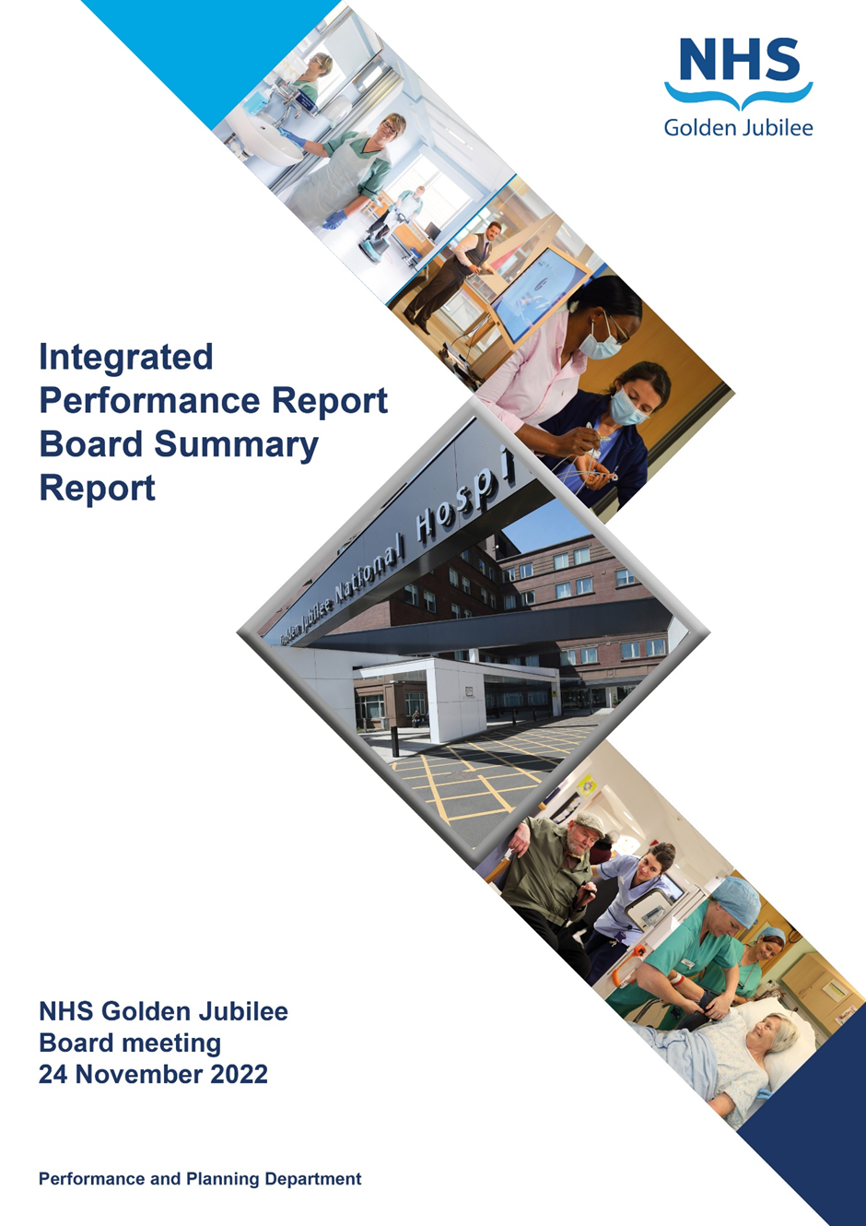

**24 January 2023**

**BoARD SUmMARy Report**

**Produced in January 2023**

**Data reported up to END of November 2022**

**For submission to:**

* **Board Meeting – 24 January 2023**

# Contents

**Introduction 2**

**Performance Summary Dashboard 5**

**Integrated Performance Report: Executive Summaries 7**

**Finance report 15**

# Section A: Introduction

The purpose of the Integrated Performance Report (IPR) is to provide assurance on NHS Golden Jubilee’s performance relating to National Standards, local priorities and significant risks.

The IPR comprises four section with each section being considered in detail by the appropriate Standing Committee:

* Section A Introduction
* Section B:1 Clinical Governance
* Section B:2 Staff Governance
* Section B:3 Finance, Performance & Planning

This Board Summary Report of the IPR is presented to the Board and contains the summaries from each section of the full IPR.

**Gordon James Michael Breen Carolynne O’Connor**

**Chief Executive Director of Finance Director of Operations & Deputy CEO**

Performance Summary Dashboard – Guidance



Statistical Process Control – Guidance



Board Performance Dashboard – Part 1





Board Performance Dashboard – Part 2



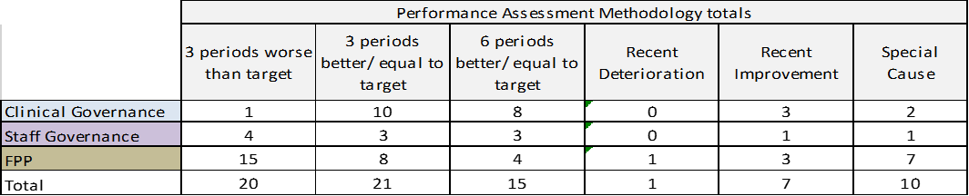

At each meeting, the Standing Committees of NHS Golden Jubilee consider targets and standards specific to their area of remit using the Integrated Performance Report (IPR). There is a section of the IPR which provides a summary of performance Standards and targets identified as areas of note which is reproduced below. Topics are grouped under the heading of the Committee responsible for scrutiny of performance.

# Section B: 1 Clinical Governance

|  |  |  |
| --- | --- | --- |
| **Clinical Governance** | | |
| **KPI** | **RAG** | **Position:** |
| Total complaints (Stage 1 and 2) by volume |  | In October 2022 there were twelve complaints reported. Latest position available. |
| Stage 1 complaints response time |  | In October 2022, there were four Stage 1 complaints, two of which were responded to within the five day target (50%). Latest position available. |
| Stage 2 complaints response time |  | In October 2022 there were eight Stage 2 complaints which did not meet the target. Latest position available. |
| Mortality |  | The mortality figure for November 2022 was reported as 15. |
| Significant adverse events |  | There were three significant adverse event reviews in November 2022. |
| MRSA/MSSA cases |  | There was one instance of Staphylococcus aureus Bacteraemia (SAB) reported in November 2022. |
| Clostridiodes Difficile |  | There were zero Clostridiodes Difficile Infections (CDI) reported in November 2022. |
| Gram Negative Bacteraemia |  | There was one reported instance of Gram Negative Bacteraemia in November 2022. |
| SSI: Hips & Knees |  | Surveillance recommenced in July with one SSI reported in November 2022. |
| SSI: Cardiac |  | Surveillance recommenced in October with two SSIs reported in November 2022. |

**Clinical Governance Executive Summary**

In October we received eight stage 2 complaints and four stage 1 complaints = Totalling 12 for the month.

50% of stage 1 complaints were responded to within timescale (5 days) n = 2 with the average requiring 7.25 working days to be completed and closed.

12.5% of stage 2 complaints were responded to within guidance timescale (20 days) n = 1 and the average time to respond was 26 working days.  Two stage 2 complaints are still open.

The reasons for the delays in timescales were multi factorial.

Mortality data was out with control limits n = 15 for November 2022

All inpatient deaths will be considered for review as part of the relevant service M&M process and any learning identified from individual cases will be captured within the relevant service level CG meetings as well as within the M&M process itself.

There was one whistleblowing concern raised during Quarter 2, the outcome of this is being progressed through appropriate governance groups.

**Key Healthcare Associated Infection Headlines**

* ***Staphylococcus aureus* Bacteraemia-** One SAB to report for November -source Vascath.

Since April 22, 9 SAB have been noted.

In 21/22, 7 SAB were reported in total.

Local AOP target and national target has been breached for 2022/23

* ***Clostridioides difficile* infection (previously known as *Clostridium difficile***)- 0 cases to report.
* **Gram Negative/E.coli Bacteraemia (ECB)**- 1 ECB to report. Source-CAUTI
* **Hand Hygiene**- Overall hand hygiene compliance for November was 99%. Next report January 2023.
* **Cleaning and the Healthcare Environment -Facilities Management Tool**

**Housekeeping Compliance: 96.95**% **Estates Compliance: 95.44**%

* **Orthopaedic Surgical Site Surveillance**- Surveillance recommenced mid July 2021.

Problem Assessment Group re-convened to review risk factors and sources of an increase in orthopaedic SSI following identification of a further two SSI cases and four SSI related SAB between May and August 2022. No SSI have been identified in November.

A SLWG has been established and will be chaired by the Associate Medical Director to take forward the requirements from PAG1-5 which will inform the initial work of the SLWG.

* **Cardiac Surgical Site Surveillance**- SSI rates within control limits.

**HAI Related Activity Update-** Ongoing SCRIBE activity to support PHASE 2 associated refurbishment.

# Section B: 2 Staff Governance

|  |  |  |
| --- | --- | --- |
| **Staff Governance** | | |
| Disciplinaries |  | There was zero disciplinary cases raised in November |
| Grievances |  | There were no grievance cases raised in November 2022. |
| Dignity of work |  | No dignity cases were raised in November 2022. |
| Local Sickness absence |  | Sickness absence in November 2022 was reported at 6.5%. This is within control limit. In November, absence due to COVID-19 reasons was 0.4% (+0.2%) |
| Turnover |  | Turnover in November 2022 was reported as within control limits at 1%. |
| Medical appraisal with completed interview & form |  | A new round of appraisals began in April 2022.  Performance is 13% (21/161) for November 2022. |
| TURAS Appraisal rates |  | Position for November 2022 reported as 57% (+5% on last month.) |
| Job Planning: All hospital |  | New job plans start for the year April 2022. In October 2022 performance was reported as 81% (98/121) signed off with others at various stages of the process. |

**Staff Governance Executive Summary**

**Sickness absence**

In November 2022, the Board’s sickness absence rate stood at 6.5%, up 0.5% on the previous month.

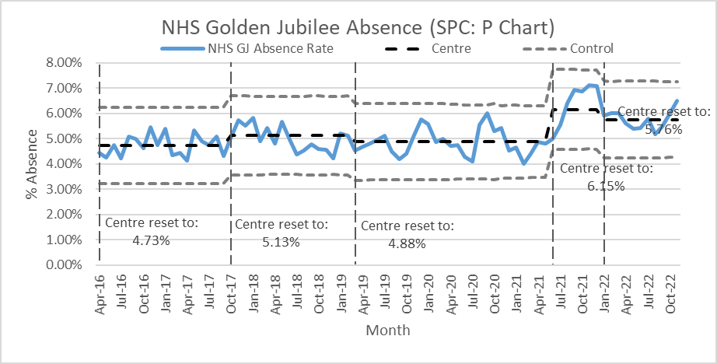

**Sickness absence**

In November 2022 the Board’s sickness absence rate stood at 6.5%, up 0.5% on the previous month. Across the Directorates, sickness absence was as follows:

* Corporate: 6.1%, up 0.8% on the previous month;
* Golden Jubilee Conference Hotel: 4.0%, up 1.8% on October;
* Heart, Lung and Diagnostic Services: 6.0%, 0.4% lower than the previous month; and
* National Elective Services: 7.8%, which was 1.1% higher than in October.

“Anxiety/stress/ depression/other psychiatric illnesses” continued to be the highest cause of sickness absence in October, accounting for 21.7% of all sickness absence, 0.5% lower than October’s figure of 22.1%. It was the main cause of absence in three of the Directorates:

* Corporate: 22.8% (down from 25.8% in October);
* Golden Jubilee Conference Hotel: 80.7% (up from the previous month’s 41.7%); and
* National Elective Services: 28.3% (up from 22.9%).

In Heart, Lung and Diagnostic Services, “Unknown causes/not specified” was the highest cause of sickness absence in October, accounting for 14.4% of recorded absence, closely followed by “Injury, fracture” at 13.8%.

The second top cause of sickness absence in November was “Injury, fracture”, accounting for 10.3% of sickness absence hours. “Cold, cough, flu - influenza” was third, at 9.8%.

**COVID-19**

August 2022 was the last month that we recorded absences from work due to the Coronavirus as special leave. From 1 September, with the exception of the first ten days of absence due to testing COVID-19 positive, which we still record as special leave, we record all other COVID-19 absence “Covid-related illness”.

In November, COVID-19 special leave accounted for 0.4% of all contracted hours, up from 0.2% the previous month. The Directorate breakdown was:

* Corporate: 0.2% (up from 0.1%);
* Golden Jubilee Conference Hotel: 0.0% (the same as October and September);
* Heart, Lung and Diagnostic Services: 0.5% (0.3% the previous month); and
* National Elective Services: 0.4% (the same as October).

Covid-related illness under sickness absence accounted for 0.4% of contracted hours in November. The Directorate breakdown was:

* Corporate: 0.4%;
* Golden Jubilee Conference Hotel: 0.0%;
* Heart, Lung and Diagnostic Services: 0.3%; and
* National Elective Services: 0.5%.

**Agenda for Change appraisal**

Within the twelve months to 30 November 2022, 57% of staff who come under the Agenda for Change terms and conditions completed their appraisal using TURAS, which is 5% higher than the previous month. The Directorate breakdown is as follows:

* Corporate: 48%, 10% higher than October;
* Golden Jubilee Conference Hotel: 44%, 2% lower than the previous month;
* Heart, Lung and Diagnostic Services: 64%, 3% higher than October; and
* National Elective Services: 64%, 10% higher than the previous month.

**Medical appraisal**

The appraisal year for medical staff runs from 1 April to 31 March. As at 7 December 2022, 21 doctors out of 161 (13.0%) had completed their 2022/2023 appraisal or had an ARCP. This is an increase on five from the previous month. December and January should see an increase in activity in this area.

**Medical job planning**

At the end of December 2021 all medical job plans on the Allocate job planning system were closed for 2021/2022, and new job plans were started for the year starting 1 April 2022. To date 98 (81.0%) of 121 job plans have been signed off, while one is awaiting first management sign off, 15 await to be signed off by the doctor, and 7 are in discussion. Please note that several of the job plans awaiting sign off by the doctor or in discussion have only started working for NHS GJ in October or November.

# Section B:3 Finance, Performance and Resources

|  |  |  |
| --- | --- | --- |
| **Finance & Performance** | | |
| Finance – Manage within annual budget limit |  | As at month eight the position reported was as a total surplus of £74k. Latest position available. |
| Finance – Efficiency savings |  | The latest available position (M8) has £1.858m efficiency savings identified. Latest position available. |
| Cancer 31 Day |  | In September 2022, nationally reported performance was 96.7% (29/30). One colorectal breach. Latest position available. |
| TTG: Number of patients who have breached the TTG |  | In November 2022 there were 140 patients who exceeded their twelve week treatment time guarantee. |
| TTG: Percentage of patients admitted within 12 weeks |  | The percentage of patients admitted within their twelve week treatment time guarantee was reported at 90.6% during November. |
| SoT Guarantee – Inpatient and DC cases (H & L only) |  | 83.7% of Heart and Lung patients were admitted within 12 weeks in November 2022. |
| DOSA rate: Cardiac Surgery |  | There were four DoSA cases in November 2022 (5.5%). A new profile for the year has been agreed. |
| DOSA rate: Thoracic Surgery |  | There were 21 DoSA cases in November 2022 (23.3%). A new profile for the year has been agreed. |
| DOSA rate: Orthopaedics |  | In November 2022 there were 218 Orthopaedic primary joint admissions, 134 (62%) of which were on the day of surgery. |
| Theatre Cancellation Rates |  | In November 2022, the overall hospital cancellation rate was 5.7% (150/2622). Within Control Limits. |
| Hospital Bed Occupancy |  | Hospital wide bed occupancy was reported as 80.5% in November 2022. Above Upper Control Limits. |
| Hotel: Income |  | Reporting for November 2022, position was on plan (19.5%). |
| Hotel: Room Occupancy |  | November 2022 reported position 75.3% against target of 67.5%. |
| Hotel: Conference Room Occupancy |  | November 2022 reported position 61.5% against target of 66.2%. |
| Hotel: Delegates |  | November 2022 reported 0.7% against target of >-5%. |
| Hotel: Patient Bed Usage |  | November 2022 reported 4.6% against target of >-5%. |
| Hotel: Not for Profit % |  | November 2022 reported 56.8%, against target of 50-60%. |
| Hotel: Pro Quality Score |  | November 2022 reported 89% against target of >86%. |
| National Comparison Table, Corporate Dashboard, Waiting list & Productivity table | | |
| The GJNH nationally reported elective cancellation rate, in October 2022, was reported as 5.9%. This ranked GJNH as 5 out of 14 (Excluding NHS Lothian). The Scotland rate was 8.8% (Excluding NHS Lothian). | | |
| Golden Jubilee comparative performance against the national 31 Day Cancer target is reported using the Information Services Division (ISD) nationally published position. For Quarter 2 2022 GJNH reported 100% of eligible patients treated within the target (Ranked 1st). | | |
| Health Protection Scotland published figures for Quarter 2 2022 report a GJNH incidence rate (per 100,000 total occupied bed days) of 0 for CDiff incidence and 40.3 for SAB. The Scotland rates were 14.3 and 17.3 respectively. | | |

**NHS Golden Jubilee**

**Summary Finance Report**

**As at 30 November 2022 – Month 8**

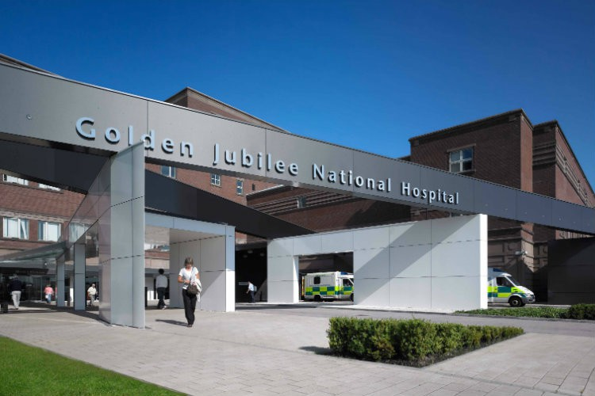

1. EXECUTIVE SUMMARY

|  |  |  |
| --- | --- | --- |
|  |  | **Finance Position as at 30 November 2022 – Month 8 Report** |
| **1.1** | **Delivery of**  **Financial**  **Plan** | The year to date (YTD) Core Revenue position as at the end of November 2022/23 is a surplus of **£74k** in line with the planned breakeven forecast position. There are still significant financial challenges in the system including the full identification of this year’s savings target, which is being managed within the overall level of resource to-date.  Final agreement of anticipated core funding RRL allocations from Scottish Government as at November 2022, are confirmed at £**78.2247m** of **£122.169m**. |
| **1.2** | **Efficiency**  **Performance** | Divisions have identified high-level schemes of **£2.526m** by March 2023. Further schemes are in development to  achieve **£3m** by the end of the year. This leaves a remaining in-year gap of **£1.697m.** |
| **1.3** | **Capital Expenditure** | The original capital expenditure plan approved was **£40.267m**. At November 2022 the revised plan for capital  expenditure is **£36.220** with actual expenditure incurred to date of **£13.202m**. A separate more detailed capital project  is provided to committee which covers the projects in more detail. |
| **1.4** | **Income** | Income is **£0.484m** above plan as at month 8. This reflects the ongoing performance of the GJC Hotel (**£0.547m**) and  the revised forecast SLA positions on the top slice arrangements (mainly Orthopaedic activity). |
| **1.5** | **Expenditure** | Expenditure is (**£0.410m)** overspent YTD with the largest pressure related to increasing levels of activity reported against surgical supplies **(£1.391m**) offset by the YTD pay underspends of **£0.816m**. This reflects the level of vacancy challenge within the Board, specifically across nursing and clinical support areas. |
| **1.6** | **Annual Delivery Plan**  **2022/23 to 2024/25** | The Board’s revised ADP reports the increase in the activity plan from **32,913** across all areas to **36,291** by March  2023, an increase of **3,778** cases/exams (+~10%). The Planned Care funding of **£5m** has been reviewed to ensure expenditure on additional capacity proposals are within the final funding confirmed. (previously bids totalled **£5.63m**). |

|  |  |  |
| --- | --- | --- |
|  |  | **Key Actions** |
| **1.1** | **Recovery Workforce**  **Budget, in post and**  **Release review** | Finance continue to work with HLD to confirm the remaining level of funding issued non-recurrently against recurring  posts. The current level of costs associated with posts funded with non-recurrent funding streams are estimated to be  c. £0.952m. The Division has been asked to identify strategies to reduce this level of resource in the system back  to recurrent funding levels. |
| **1.2** | **Efficiency Meetings** | Services meet regularly with finance and procurement teams to proactively review and identify savings opportunities.  The focus is now on the identification of recurring and sustainable savings in the new financial year and beyond.  Engagement has been very good across all areas, but this is a particularly challenging are to deliver on when existing pressures on service to increase capacity for Phase 2 expansion continue to be a priority. Finance continue to link the Financial Improvement Group (FIG) to ensure initiatives put forward by other Boards are fully considered. |
| **1.3** | **Agreement of final outstanding allocations**  **from SG** | There are still some significant anticipated allocations which require to be finalised by SG. Whilst many of these now  have revised estimates of expenditure to the year end, some allocations are within baseline expenditure plans for  2022/23 therefore require final approval as soon as possible. This issue will be highlighted again in the next SG sponsorship meeting before Christmas. |
| **1.4** | **2023/24 to 2025/26**  **Financial Plan and**  **Annual Delivery Plan** | Discussion with Scottish Government has commenced to progress the next financial planning and annual  development plan. The current timetable is for submission in June 2023. Clarity on timetable and financial  assumptions are being discussed at CFN to ensure consistency across Scotland in planning assumptions moving  forwards. |

**Core Revenue Financial Performance as at 30 November 2022, Month 8**

The Core Revenue position for November 2022 reflects a surplus of **£74k**.

The table below highlights the key variances:

**Table 1: - Summary Core position as at Month 8**



**Key Points**

* Golden Jubilee Conference Hotel income is above plan but this is offset by under recovery of NSD Services YTD.
* Efficiencies now identified total £2.526m across the Divisions. A further £0.367m of schemes have been identified to be delivered by the year-end, leaving an in-year forecast gap of £1.697m
* Impact of activity and case mix YTD, combined with inflationary pressures are reflected in the non-pay over spend within surgical supplies.
* Recruitment challenges continue. There has been a significant increase in WLIs and agency medical costs in recovering activity in-month.
* The pay award for 2022/23 when finalised is assumed to be cost neutral for NHS GJ due to being fully funded by SG.

**Total Income Performance as at 30 November 2022**

The table below represents an extract of the summary financial position against Core Income, comprised of the Revenue Resource Limit (RRL) and other Core income (mainly SLA income from Heart & Lung and National Services) as at Month 8, 30 November 2022.

**Table 2 – Total Core Funding as at Month 8**



**The key areas of Income movement driving the above are:**

* Cardiac is under plan due to a reduction in the ACT Clinical Fellows income of £70K, Medical Training income of £30k and Non-West of Scotland cardiac activity is £38k below the financial plan. Thoracic activity is £45k below the financial plan, whilst Cardiology activity is now £118k ahead of the financial plan.
* NHS Golden Jubilee Conference Hotel (NHS GJCH) continues to generate revenue beyond the expected amount as at month 8. The hotel is now reporting £130K in month and £547k YTD over-performance relating to the overall increase in occupancy and conference bookings.

**Total Expenditure Performance as at 30 November 2022**

|  |
| --- |
| **Key Issues:**  **Medical Pays**  The key areas of pressure continue to be across:-  **HL&D**  Cardiac medical pays – (£174k) YTD relating to Agency Locum Registrar spend and  WLIs.Cardiology medical pays – (£468k) YTD, NSD pressures relating to SNAHFS  business case reflects a gap of (£60K YTD). SACCS business case gap of (£175k) YTD.  SLA agreement with GGC rota shows an increase with pressures on the Junior Doctors.  This is offset with vacancies across the other specialities mainly Radiology and SNRRS.  **NES**  General Surgery medical pays – (£531K) YTD activity has increased as well as vacancies which are mainly  covered by WLIs – recruitment is underway for substantive staff.  Ophthalmology medical pays – (£22k), Agency Locum Consultant cover this month.  Orthopaedic medical pays – (£140k), increased Agency Locum costs covering rota gaps. |
| **Nursing Pays**HL&D – there is a return to an underspend within the division and although there is still  the use of Agency within Critical care this is being managed on a monthly basis.  NES released a further £104k in-month non-recurring efficiency savings due to Vacancy  Slippage reviews.  **Other pays** Mainly within clinical areas due to vacancies within both HL&D and NES Divisions and  specifically CSPD, Med Physics, Labs, Perfusion and Rehabilitation, however Corporate services continue to  show slippage with workforce recruitment challenges. |
| **Non-Pays**  HL&D - Surgical supplies continues to be the significant driver of pressure (£1.391m) YTD,  Cath Lab is (£1.15m) of this total-the service is reviewing various aspects of this to  confirm the main drivers relating to case mix, increasingly complex patients, inflationary  pressures and increased levels of stock holding.  NES activity has increased in month with overspends in Pharmacy (£59k) YTD and Surgical  Supplies (£182k) related to the activity through Cardiac and Orthopaedic Theatres.  On-going supply issues with manufacturers are driving increases in prices, as well as  Increased ordering with bulk deliveries to minimise service disruption. |
|  |
|  |
|  |
|  |
|  |
|  |
|  |
|  |
|  |
|  |
|  |
|  |
|  |
|  |
|  |
|  |
|  |
|  |
|  |
|  |

Table 3 provides a high level summary of the key expenditure variances across Pay and Non-Pay budget lines

**Table 3 – Total Expenditure as at Month 8**



**Division Performance 2022/23**

Table 4 below provides a further breakdown of the key YTD variances for both Pay and Non-Pay budget lines across all four divisions- HL&D, NES, Corporate and NHS GJCH

**Table 4- Board expenditure by Division – November 2022/23**



**Key Issues**

* Recruitment to key vacancies continues to be prioritised by the Board as a whole, there are recruitment events in the calendar and

discussions taking place to enable line managers to offer posts on the day of the event.

* Reviews of locum, overtime and WLIs expenditure as highlighted above are ongoing, linked in with service gaps, absence

management and job plans.

* The continuation of challenges and risks including workforce vacancies, cost pressures such as energy prices and continued

inflation uplifts on consumables continue to be managed within the current position.

* Detailed analysis is underway to fully understand the increased expenditure levels within the Cath Labs. Current focus is being placed on identifying the changes in case-mix, inflationary pressures, clinical variation as well as levels of stock holding. This work is planned to be completed in January 2023 with input from finance, procurement and service.
* Service planning meetings for 2023/24 have commenced during November 2022 to inform specialty requirements and ensure

alignment with annual budget processes and financial planning assumptions. These will also incorporate the activity assumptions built into any revised SLA activity plans.

* This use of medical agency in both junior and consultant areas within HL&D and NES divisions is reflected in a total cost incurred of

£211K in November 2022. It is expected that the gaps in service related to this expenditure with continue until the end of December 2022 in orthopaedics, and for the remainder of the year in ophthalmology. This is being monitored closely by the finance team on a week on week basis.

* The NHS Golden Jubilee Conference Hotel bedroom sales have exceeded budget in month by £130k. A further increase of

78.5% in the leisure market and 76% increase in self-pay patients has helped to support an overall increase of 43.7% on the initial budget. Continued shortfalls in NHS delegate numbers are eroding the gains from the association markets. Work is ongoing to re-engage with previous NHS and association bookers to help fill the key date gaps.

* Whilst the pay award is yet to be agreed, the assumption is that the baseline recently confirmed as part of the budget statement will fund any increased pay costs in 2022/23. Therefore, the effect of the final pay award in 2022/23 is assumed to be cost neutral.

**Annual Delivery Plan 2022/23 to 2024/25**

As referenced earlier within the Executive summary (Section 1.6) the final revised ADP activity plan aligned with the financial plan and the Annual Delivery Plan submission document. This reflected increased activity of 3,778 cases (from 32,513 to 36,291) excluding Radiology or 6,390 increased activity including Radiology. To enable this an associated costs increase of £1.886m relates to this activity change and funding managed via the SLA monitor top-slice.

The Board continues to monitor performance against the updated ADP activity target and weekly reports through the PUM and activity performance updates with SG at the Planned Care meetings. 2023/24 Annual Delivery Plan timeline for submission has been communicated to NHS Boards as June 2023. The Performance Planning, Divisional, HR and Finance teams will work collaboratively in completion of the 2023/24 ADP.

**Confirmation of Covid Funding Allocations 2022/23**

The Board has received a Covid funding allocation of £2.2m for 2022/23, including prior months Test and protect funding of £0.243m. This equates to total funding of £2.443m against current forecast Covid related costs to March 2023 of £2.897m. The reduction in allocation received results in a gap of £0.457m.

The Board continues to review and monitor expenditure and income implications directly attributable to Covid through the FPR route, the main contributors are within GJCH income loss and the ongoing recovery recurring workforce costs not yet released or re-aligned from within the recovery workforce approved.

The Scottish Government has made it clear that the only costs being funded in 2023/24 will relate to Test and Protect and Vaccinations, with the expectation of Boards resolving on-going recovery costs from within their own baselines. This will require the remaining recovery costs, particularly within HLD to be identified and either reduced or eliminated as per original plans.

**Efficiency Savings and Financial Improvement Performance**

Efficiencies now identified total £2.526m across all Divisions – a small reduction due to previously expected drug savings unachieved in this financial year.

The current efficiency gap as identified in the revised financial plan submission is £4.590m. To-date schemes of £2.526m FYE are

identified across the Divisions for month 8, leaving a balance of £2.1m still to be met. A further £0.367m of efficiency opportunities is forecast

reducing the remaining balance to £1.697m.

The level of unconfirmed funding streams continue to be a further challenge and may affect the future level of efficiency plans

required, however the finance team continue to work diligently with Scottish Government to mitigate this risk.

NHS GJ is represented within the Scottish Government Financial Improvement meetings, working to drive forward collaborative opportunities and meet with SG to review progress against efficiency performance regularly. It is expected, as has been noted in this month’s report, that there will continue to be an improvement in the delivery of in-year and recurring schemes by the financial year-end.

**Table 8 – Efficiency Savings as at month 8**



£1.858m of savings YTD have been reported as achieved as at month 8, this is an increase on estimates for this point in the financial year, however it is important to note that this excludes the unidentified savings balance noted above.

£1.442m of the achieved £1.858m position relates to non-recurring schemes, mainly from recruitment gaps within nursing and clinical areas due to on-going recruitment challenges. At this stage of the year only 24% of the schemes identified have been found recurrently.

The approach to identification of efficiency savings moving forwards, will move away from reliance on non-recurrent slippage to recruitment and focus on identifying real opportunities to deliver sustainable savings from recurring budgets.

**Non-Core Performance**

The main elements of non-core funding that are included within the Board are;

* Depreciation for core capital items – this is an annual transfer from core RRL each year with the budget based on a detailed depreciation budget prepared annually in line with our approved capital plan and existing capital items. This reflects a breakeven position for the year to date.
* Depreciation for donated capital items – this is an annual budget forms part of exchequer funding; this relates to items that have been purchased using donated funds.
* AME Provisions – this is part of Annually Managed Expenditure and is managed and funded centrally. The original £40k estimate in 2022/23 will fluctuate throughout the year with the final amount being identified by year-end. As this is based on movement in claims and estimates from the CLO this number changes on a monthly basis in addition the Board element of its share of the CNORIS pot is only identified at year-end and is expected to be cost neutral.

At the end of month 8, the Board movement in provision has decreased by £74k, which relates to settlement of a number of claims with NHS Golden Jubilee not receiving our share until the end of our financial year / last reporting period. In month, there is a decrease in the value of the provision mainly due to the settlement and reimbursement of a significant claim. However, due to the process of accounting for AME provisions this will show movements during the year but will be break even at year-end.

* AME – Debtor – as required by accounting standards this is the corresponding debtor for the AME provisions recognising that the Board will receive income upon settlement of claims. This has increased in month due to the increase in value of one claim.
* Impairment – this also is part of Annually Managed Expenditure and is managed and funded centrally based upon an annual expected spend on

building projects. There has been no budget included for this in 2022/23, as it is not anticipated that there will be any impairment funding required from SG. Any in year impairment will be managed via the revaluation reserve.

**Capital**

The Board capital plan for 2022/23 has been agreed by the Capital Group and approved by the capital department at Scottish Government.

The 2022/23 plan is comprised of the following elements:

|  |  |  |  |
| --- | --- | --- | --- |
| **Capital Plan** | **Original**  **Plan** | **November**  **2022** | **Month 8**  **YTD** |
|  | **£000’s** | **£000’s** | **£000’s** |
| Estates | 1,660 | 3,220 | 254 |
| Medical Equipment | 2,553 | 3,627 | 3,112 |
| IMT | 1,640 | 2,793 | 1,266 |
| Hotel | 680 | 80 | - |
| Academy (Equipment) | 275 | 275 | - |
| Academy (Infrastructure) | 1,800 | 1,225 | - |
| **Total** | **8,608** | **11,220** | **4,632** |
| **Projects** |  |  |  |
| Water Source Heat Pump* | 2,050 | 0 | 0 |
| Phase 2 | 29,609 | 25,000 | 8,570 |
| **Total Projects** | **31,659** | **25,000** | **8,570** |
| **Total Spend** | **40,267** | **36,220** | **13,202** |

At Month 8, the overall level of capital expenditure incurred is £13.202 million with a current expectation of year end capital expenditure of £36.220m. A separate Capital update paper is now prepared monthly which provides further details on the funding available and the status of the capital projects being completed.

**IFRS16**

As in prior months the numbers are not yet in e-financials, however the numbers we are reporting are from pro-lease, the national system purchased for recording IFRS 16. The account codes for this have now been entered into e-financials therefore from month 9 onwards the information will be recorded in the finance system.

**RRL Allocations April-November**

The November allocation letter has confirmed allocation funding of **£78.247m** against anticipated allocations of **£122.169m.**

Final discussions are taking place in liaison with SG policy teams to confirm the final level of outstanding allocations still to be received of **£43.922m.**

Appendix 1 provides the detail of the 2022/23 RRL Financial Plan.

|  |
| --- |
| **The Board are asked to**   * Note the financial position for Month 8, as at 30 November for the financial year 2022/23; and * Note the key messages as highlighted above |

**Michael Breen**

**Director of Finance**

**NHS Golden Jubilee**

**Appendix 1 – 2022/23 RRL Financial Plan**

