Meeting:  Date: | Board Meeting  27 January 2022 | 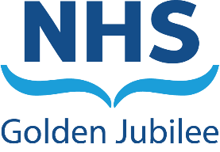
Subject: | University of Strathclyde Relationship Status
Recommendation: | Board Members are asked to:  Discuss and Note  Discuss and Approve  Note for Information only

Background

NHS Golden Jubilee has been exploring joint working with the University of Strathclyde for some time. In order to formalise this work, NHS Golden Jubilee has formally requested University Status from the University of Strathclyde.

The attached papers were submitted as evidence and included:

- University status request letter
- Shared Interests paper, and
- Developing the relationship paper.

Description

The attached papers provide an overview of the shared interest between NHS Golden Jubilee and the University of Strathclyde, our view of the priority areas (first phase) of joint working and plans for communicating the relationship.

This is to ensure clarity and allow discussions and projects with the University to move forward in a co-ordinated way with key leads responsible for their area of expertise.

The papers are currently going through the University of Strathclyde’s governance processes for approval. The current status is that the University Executive Team has approved University Status in December 2021, it has now been submitted to the University’s Senate for their meeting on 26 January 2022. Following that, the final stage will be to submit to the University Court.

Recommendation

Following Board approval of the submission, Board Members are asked to note the final submission papers and progress of requesting University Status.

Professor Jann Gardner
Chief Executive
19 January 2022
Sandie Scott, Director of Strategic Communications

