Meeting:  Date: | Board Meeting  27 January 2022
Subject: | Remobilisation Plan 4
Recommendation: | Board Members are asked to:  Discuss and Note  Discuss and Approve   Note for Information only

Background

NHS Boards were commissioned to produce their fourth iteration of their Remobilisation Plans in autumn 2021, with a submission date of 30th September. This Remobilisation Plan (RMP) is an update to RMP 3, particularly in terms of activity plan adjustment and covers the period October 2021-March 2022. The Remobilisation Plan (RMP) builds on NHS GJ Recovery Plans submitted to Scottish Government in April, May and August 2020, and March 2021.
At the time of preparing this plan and the activity projections within it, the NHS in Scotland remains on an emergency footing. There remains considerable uncertainty about when and how the nation and its health service will emerge from the pandemic and return to a state of relative stability.
We received approval of this RMP 4 from Scottish Government on 13 December and the sign off letter is supplied with these papers.
2. Our Planning Approach
All NHS Scotland boards have been asked to focus their Remobilisation Plans on a shared core set of key priorities that are aligned to the NHS Scotland Recovery Plan:
• Maintain our capacity to respond to the pandemic
• Focus on the whole system
• Quality, values and experience
• Services close to people’s homes
• Improved population health
• Services that promote equality
• Sustainability
• Value and support the workforce
The RMP includes updated clinical activity modelling assumptions and plans, updated wait list position across our specialities, and service activity projections for the six month period (October-March) for NHS GJ services. It also includes our Winter Preparedness Plans and reflects the requirements for services to continue to live with Covid.
3. Our Key Objectives
The key assumptions supporting delivery of RMP#4 are as follows:
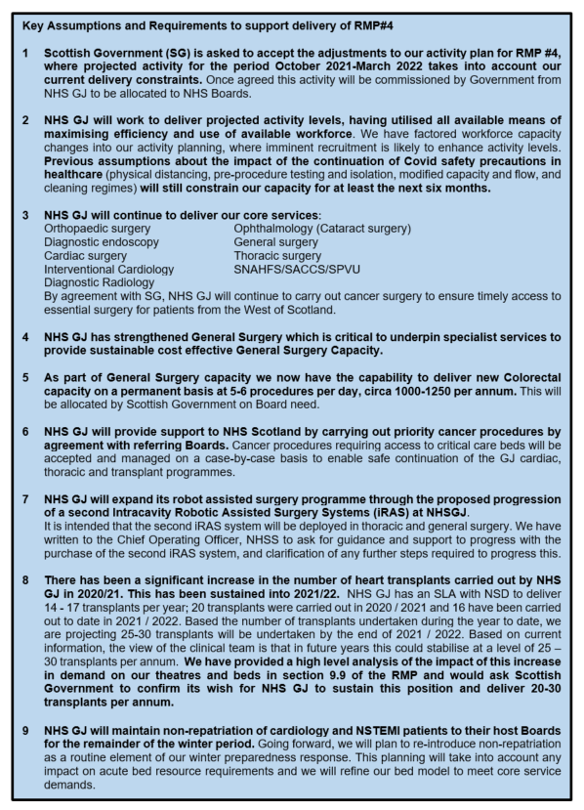

4. NHS GJ Wider Portfolio contribution to Remobilisation
RMP #4 describes the activity planned within all aspects of the NHS GJ portfolio, which are supporting NHS Scotland to Recover and Remobilise:
- Strategic Partnerships assisting remobilisation
- NHS Scotland Academy
- Centre for Sustainable Delivery (CfSD)
- Hotel & Conference Centre

4. Consultation

This plan was developed collaboratively with Divisional and Senior/Executive colleagues ensuring alignment with the commissioning checklist issued to Boards for the development of RMPs. The NHS GJ draft RMP was issued to the NHS GJ Board in early October. The RMP is now presented for formal discussion by the Finance and Performance Committee to enable approval by the NHS GJ Board at its January meeting.

Following approval of the RMP#4 by the Board, it will be published on the Board website along with the sign-off letter. Scottish Government has requested that this be completed by end January 2022.

5. Resource implication

The RMP is accompanied by a detailed financial plan and is aligned to the current Board draft workforce plan. The financial analysis templates are presented as part of this RMP submission.

6. Governance and Ongoing Reporting

Following submission and approval of the RMP, performance against the plan

will be regularly reviewed through Board governance and performance management arrangements. Specifically, Scottish Government will request quarterly progress updates against the key deliverables within our Delivery Planning Templates at the end of January 2022, covering Quarter Three, and the end of April 2022, for Quarter Four.

Three Year Operational Recovery Plans 2022-25

It is planned to move to a slightly longer-term period of three years, for future Operational Plans. This will enable a more strategic approach to planning and support programmes of service transformation, aligned with the NHS Recovery Plan and the Care and Wellbeing Portfolio. SG has intimated that these three-year plans will take the form of a Recovery Plan for the period of 2022-25 for our Board. They will encompass a relatively high level narrative setting out key priorities for recovery and transformation within this period, and how these contribute to our national priorities, underpinned by a spreadsheet-based Annual Delivery Plan (ADP).
This latter element, which will build on the format and content of the delivery planning template used for RMP4, will continue to form the basis for ongoing engagement as well as regular quarterly progress reports to Scottish Government, recognising the continuing fluidity in our operating context and supporting responsive changes to plans in-year. In recognition of the pressures that Boards are currently working under, and the high level of uncertainty and volatility that remains in the system, these three year plans will be scheduled for submission at the end of July 2022. Financial planning will also move back to a 3-year cycle, and SG will use the Quarter One review in 2022-23 as an opportunity for Boards to refresh their financial plans to align with the three-year operational plans.

7. Recommendation

The Finance and Performance Committee reviewed this RMP on 11 January 2022 and recommended its submission to the Board for approval. Board members are asked to approved this RMP to enable its publication and ongoing cascade.

Colin Neil
Finance Director
19 January 2022
Carole Anderson, Associate Director of Quality, Performance, Planning and Programmes

