|  |  |  |  |  |
| --- | --- | --- | --- | --- |
| Board meeting: | | 27 May 2021 |  | |
| Subject: | | Recovery Plan 2021/2022 – Weekly Performance Report – Week 6 |
| Recommendation: | | Board Members are asked to:  |  |  | | --- | --- | | Discuss and Note | x | | Discuss and Approve |  | | Note for Information only |  | | | |
|  | |  | | |

1. **Background**

NHS Golden Jubilee received approval to proceed with an initial Recovery Plan from Scottish Government in July 2020 which was monitored to the completion of its time frame which finished in March 2021.

A new plan, Remobilisation Plan 3, for the Financial year 2021/2022 was submitted in February 2021 and has received approval.

The Plan contains activity projections and accompanying financial assumptions and this report enables regular performance review of progress against the NHS GJ Recovery Plan.

The purpose of this report is to:

* Provide scrutiny by speciality of activity versus plan (based on agreed Recovery Plan);
* Provide assurance on effective use of theatre capacity through limiting cancellations, and understanding their classification (avoidable vs unavoidable);
* Provide assurance on theatre time used each week;
* Enable oversight of bed utilisation by speciality; and on a monthly basis
* To report a monthly reconciliation of activity and finance data – aligned to the financial plan.

1. **Preparation of this Performance Report**

This report is provided on a weekly basis and will be based on the most current data from NHS GJ systems. Activity against plan will be reported for the previous week running from the Monday to Sunday. Divisional Teams will be able to provide additional operational information to Silver Command during discussion of this report.

## **Performance against submitted Recovery Plan**

The following section outlines performance against the recovery plan submitted and agreed with the Scottish Government (SG).

The Recovery Plan, submitted to SG, provided monthly levels of expected activity, which commenced from April 2021.

For reference the latest activity plan, as submitted to SG, is supplied below:



Figure 1: Recovery plan, detailing activity by month, by specialty/subspecialty. Total for financial year 21/22 (Version: Appendix 2 NHS GJ activity plan 2021-22)

The Recovery plan was submitted based on expected levels of monthly activity however monitoring will be provided on a weekly basis. The plan commenced in April 2021.

The report currently provides a position for those specialties previously reported in 2020/2021. There have been some changes to the subspecialty breakdown which are represented in the table above.

To illustrate the recovery plan week by week, a plan is provided in Figure 2 below which is based on translating the monthly activity required into a weekly profile based on each month’s available working days with consideration to known CME days.

This provides an overview of the required levels of activity, on a cumulative basis, over the whole period of the recovery plan and is referred to as the ‘SG Target’. Against this, actual activity has been charted for completed weeks.

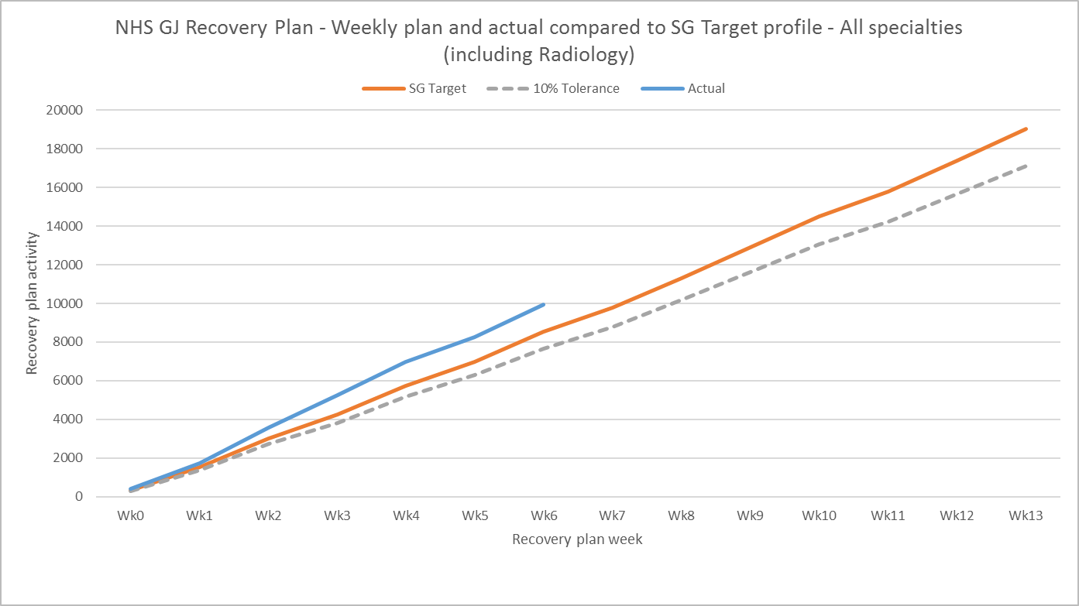

Figure 2: SG target profiled by week and actual activity. Weeks 0-13 covering to end June 2021. All specialties including Radiology.

The table below presents a view of the recovery plan for the last week of activity and the cumulative position against SG Target.

The table reports an actual position against plan consistent with Division activity reporting adjusted for complexity for NES specialties. A count of procedures (Actual Count) is also provided.



Figure 3: Activity against SG Target and adjusted activity for latest available week (10.05.21 – 16.05.21) and cumulative plan (01.04.21 – 16.05.21)

The chart below shows reported SG target and actual activity for Week 6 of the recovery plan, by specialty.

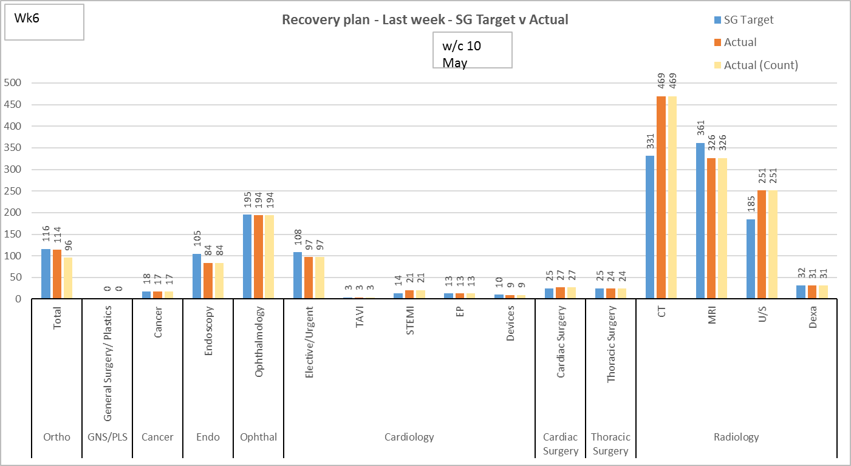

Figure 4: Activity against SG target and adjusted activity for latest available week (10.05.21 –16.05.21) by specialty

The chart below shows the cumulative activity, cumulative adjusted activity and SG target up to Week 6 of the recovery plan by specialty.

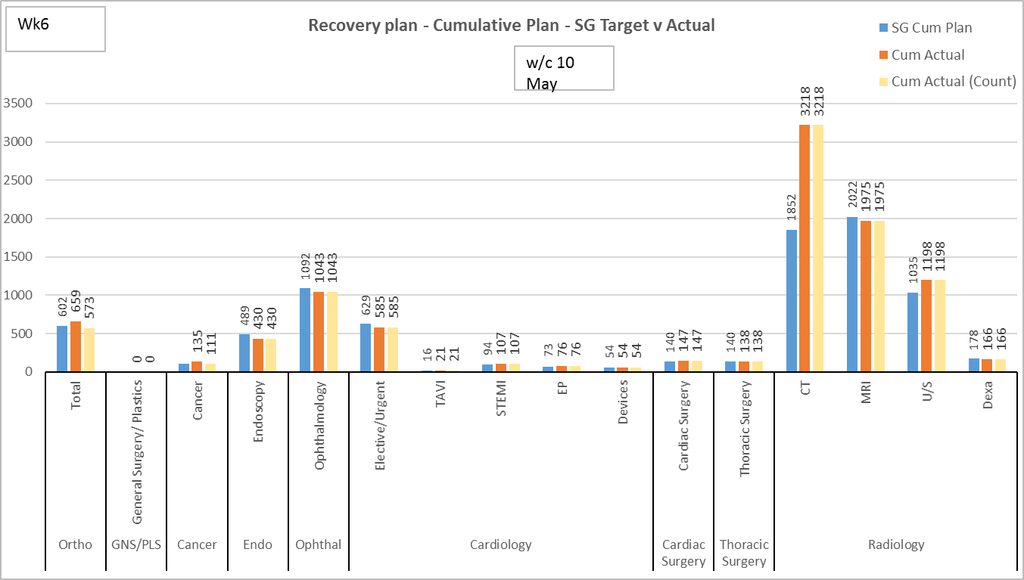

Figure 5: Chart of cumulative activity against plan (01.04.20 – 16.05.21) by specialty.

## **Theatre Utilisation**

The Weekly Recovery Report Theatre utilisation section now contains additional information on the physical usage of standard theatres, the Eye centre and the Cath Labs. This information has been provided with the assistance of the NES & HLD Divisions and is based upon:

* TAR – Theatre Availability Rota – a spreadsheet used for Theatre planning.
* A count of available theatre of half day sessions and their categorisation eg Planned, Backfilled, Available, Cancelled etc
* To give an overall percentage and count of usage.
* Where a session was identified as available but not used the Division are providing a narrative to describe the circumstances
* Note: The current report does not include the new Eye Theatre suites. Additional development is underway to incorporate this.

For week commencing 10 May there were:

Standard Theatres:

* 154 sessions available with 151 used (98.1%). This includes sessions run and staffed by NHS GGC.
* For the three sessions not used additional information is provided where identified:
  + Two sessions were not used as NHS GG&C did not have a surgeon available, and attempts to assign the sessions to another board were unsuccessful.
  + One session was assigned to a cardiac surgeon and no suitable patients were available for that surgeon. (A new consultant building up patients and portfolio).

Eye Centre:

* Ophthalmology Theatres – there were 30 (half day) sessions available with 30 sessions used (100%).

Cath Labs:

* Cath Labs 1,2,3,4 & 5 – there were 60 (half day) sessions available with 60 sessions used (100%)

The two charts below (Figure 6 and Figure 7) show the time spent in theatre, in hours, by week, separated by Division. The times have been calculated by adding together the OPERA timing data for each individual procedure from the time the patient entered the care of the anaesthetist to the time that they left theatre.

Different time periods have been used for HLD and NES Divisions due to the varying activity levels during the earlier stages of the Covid pandemic.

HLD theatre activity is provided from March 2020 with NES represented from April 2020.

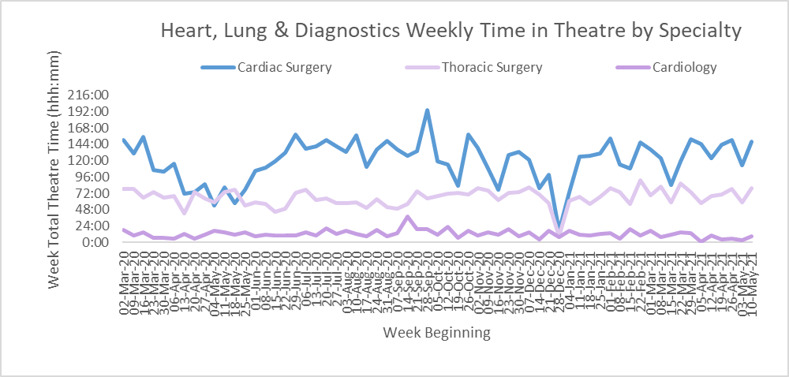

Figure 6: Time in theatre for Heart, Lung and Diagnostics specialties (for weeks beginning 02.03.20 to 10.05.21)

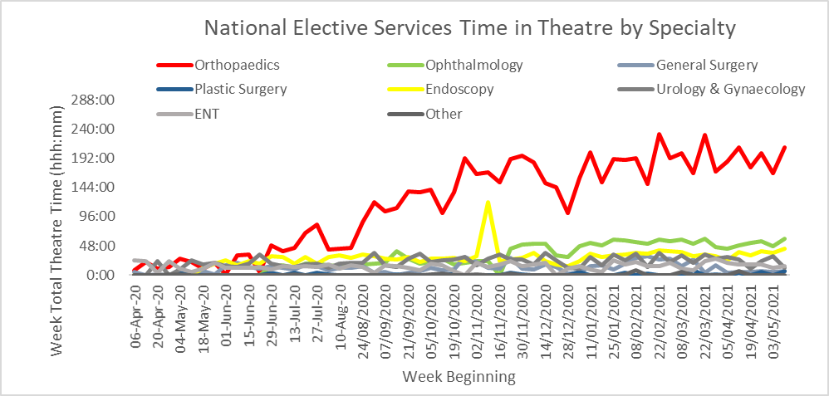

Figure 7: Time in theatre for National Elective Services specialties (for weeks beginning 06.04.20 to 10.05.21)

The table below provides information on all on the day theatre cancellations for the last week of activity. The table lists the specialty, theatre, priority, referring hospital and the reason for the cancellation. There were three cancellations classified as avoidable:

* One Cardiac cancellation due to lack of OR time (patient transferred to pre-op instead of theatre).
* One Gynaecology cancellation due to patient not prepared (further investigation required).
* One Gastroenterology cancellation due to patient not informed to stop medication.



Figure 8: On the day theatre cancellations (for week beginning 10.05.21)

The chart below shows the overall weekly cancellation rate for on the day theatre cancellations. The centre is calculated based on September 2019 to January 2020 data and so shows a pre-Covid mean cancellation rate. For week beginning 10.05.21 there were 28 cancellations against 473 scheduled procedures to give a rate of 5.9%.

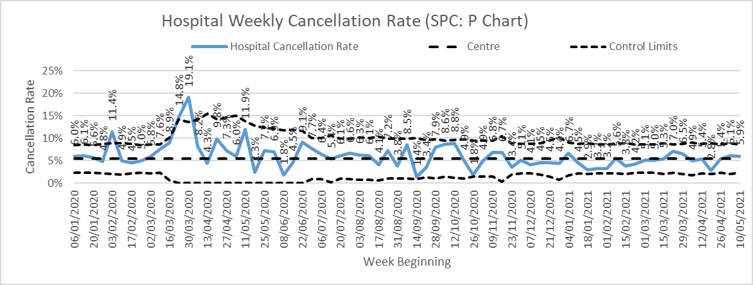

Figure 9: Weekly on the day theatre cancellation rate (for weeks beginning 09.03.20 to 10.05.21)

Figure 10 below shows the total number of on the day theatre cancellations in the hospital by week. The cancellations have all been categorised by reason. The classifications cover, but are not restricted to, the following reasons:

* Clinical reasons - patient not fit, not prepared or does not require surgery;
* Patient reasons - patient did not attend, could not attend or no longer wishes surgery;
* Capacity reasons - clinical prioritisation, lack of operating time, availability of beds (critical care or ward) and or staff availability;
* Equipment reasons - equipment required is not available, this includes catastrophic events such as flooding to theatres; and
* Other reasons - administrative errors or where no detail is provided in the reason for cancellation.



Figure 10: Weekly Hospital cancellation reasons (for weeks beginning 26.10.20 to 10.05.21)

**Lost slots**

The lost slots position for last week (w/c 10 May) was calculated as zero.

**Bed Occupancy**

Reported occupancy, using Trak care, for the week commencing 10 May was 74.9%.

Acute bed occupancy (excluding Critical care) was 77.6%.

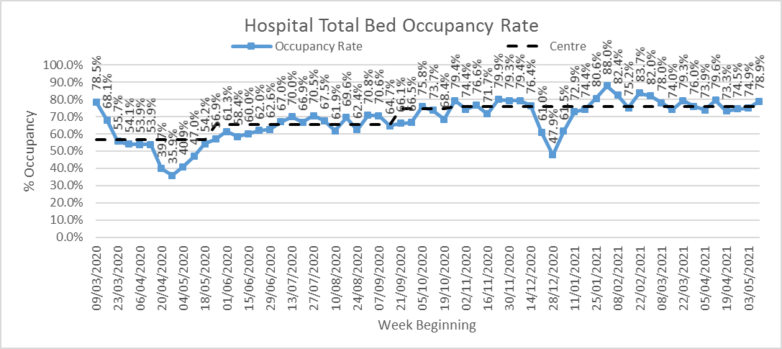

Figure 11: Weekly Hospital total bed occupancy rate (for weeks beginning 09.03.20 to 10.05.21)

The chart below shows the percentage occupancy in each ward within the hospital split down by specialty for the last week.

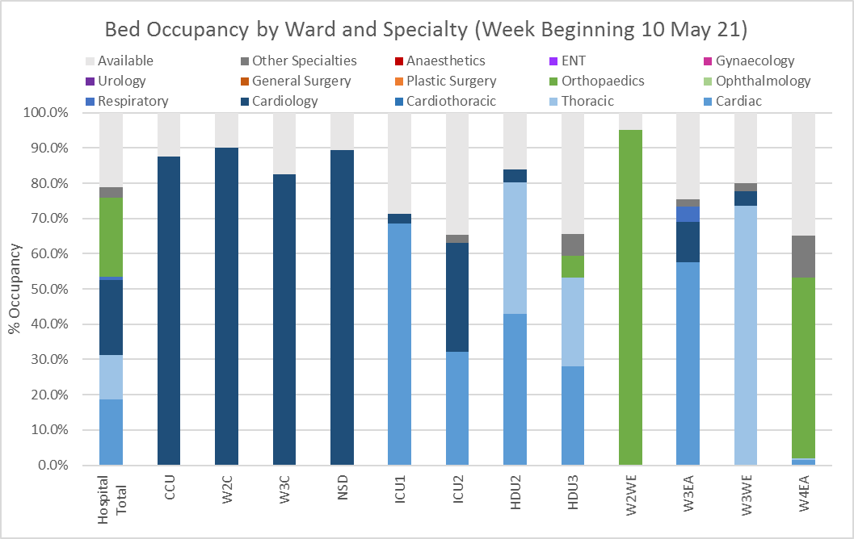

Figure 12: Bed occupancy by ward and specialty (week beginning 10.05.21)

**Colin Neil**

**Director of Finance**

**20 May 2021**