Meeting:  Date: | Board Meeting  23 September 2021
Subject: | Duty of Candour Annual Report
Recommendation: | Board Members are asked to:  Discuss and Note  Discuss and Approve  Note for Information only

- Introduction

As part of the Duty of Candour legislation we are required to publish an annual report. There has not been detailed guidance from Scottish Government in relation to the template to be used; we have therefore followed the previous template adding the table and detail requested.

This report provides information on those events that triggered the legal Duty of Candour. The appendix provides information of those events that were considered but decided not to trigger; this information is for interval review only and will not be published, nor will details of the individual events in case any are identifiable.

In line with our approach to Significant Adverse Events, regardless of the legal status we inform patients and families of a review and seek their input.

- Recommendation

The Clinical Governance Committee approved the Duty of Candour Annual Report for sharing with the Board prior to publication via the website.

Mark MacGregor
Medical director
June 2021

Laura Langan
Head of Risk & Clinical Governance

Duty of Candour Annual Report

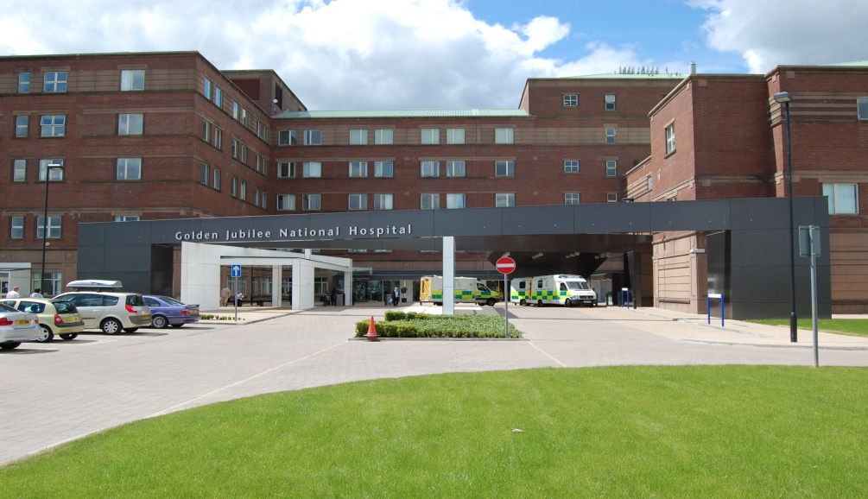

2020 – 2021

- Introduction

All health and social care services in Scotland have a Duty of Candour (DoC). This is a legal requirement which means that when unintended or unexpected events happen that result in death or harm as defined in the Act, the people affected understand what has happened, receive an apology, and that organisations learn how to improve for the future.

An important part of this duty is that we provide an annual report about how the DoC is implemented in our services. This report describes how we have operated the DoC during the time between 1 April 2020 and 31 March 2021.

- About Golden Jubilee National Hospital

NHS Golden Jubilee has always aimed to ensure that we support the delivery of NHS Scotland’s national health priorities. Our focus since our establishment has been to meet NHS Board demands and deliver equity of access to high quality healthcare for as many patients as possible so that they benefit from our clinical expertise and excellent facilities.

- COVID-19 Impact

During the COVID-19 pandemic, non-urgent services were paused in line with government guidelines. This had a significant impact on the activity within the hospital. All elective activity was paused and during this time clinical governance activity was temporarily paused until it was known what level of support was manageable taking into account clinician availability. Any open Significant Adverse Event Reviews (SAERs) were placed on hold and the patients/families were contacted and advised of this.

It was acknowledged that adverse events had the potential to still occur and this meant that normal processes for reporting adverse events were encouraged however a revised assessment process for Significant Adverse Event Reviews was implemented. This involved the development of a Brief Assessment Tool which was adapted from our SAER initial assessment tool and our SAER report template to support prompt review and investigation of any immediate issues and actions required. This tool also identified if any subsequent review was required when COVID restrictions were eased and business as usual (or as close to this) resumed.

During the reporting period the Brief Assessment Tool was used for four adverse events, with one progressing to an SAER investigation when appropriate to do so.

NHS Golden Jubilee have not triggered the Duty of Candour procedure for any events directly attributed to COVID-19.

During this period only one family requested to meet to discuss the findings of an SAER investigation. Although during COVID we were able to accommodate this meeting in a socially distanced environment.

From July 2020 we were able to revert back to our normal SAER processes within NHS Golden Jubilee as we were able to facilitate socially distanced meeting facilities that allowed us to continue in-person SAER review panels.

- Our Policies and Procedures

Each Adverse Event is reported and reviewed via the Datix system. The procedure for reviewing each level of incident is set out in the Adverse Events Management policy. The Adverse Events Management policy and supporting tools/ guidance have been updated to reflect the introduction of DoC.

The decision on DoC is built into the Significant Adverse Event Review (SAER) process. All severity 4 and 5 adverse events are automatically escalated as potential SAER. Legislation requires that a clinical person must make the final decision on Duty of Candour. The Initial Assessment Tool (IAT) that supports review of SAERs is completed by the Clinical Governance Lead and/ or Clinical Nurse Manager depending on the type of event. This includes a specific question relating to the Duty of Candour status. The completed assessment and recommendation of Duty of Candour is then approved by the Division Management Team (DMT) which includes an Associate Nurse and Medical Director. Any IATs that do not progress for review are discussed at the service Clinical Governance Forum with multi-disciplinary representation to ensure learning is captured and tis offers further opportunity for any challenge on the level of review and DoC status.

Each adverse event is reviewed with a focus on learning from what has happened, regardless of the level of harm. If there is potential to learn from an error this should be harnessed and taken forward. On completion of an adverse event review actions are identified and these are monitored to completion via the Clinical Governance reporting framework.

All staff receive training regarding adverse event reporting and the implementation of DoC at via the corporate induction e-learning package. More in depth training is delivered to those responsible for reviewing incidents on Datix and a programme of investigation training is being refreshed for staff who could potentially take part in a Significant Adverse Event investigation; this will take the form of blended learning utilising webinars, MS Teams sessions and in-person training where possible.

We know that being involved in a significant adverse event can be difficult for staff as well as those affected by the event. We have support available to staff in the form of the formal line management structure. In addition to this we have the Spiritual Care and Diversity Lead and the Occupational Health team who are available to provide staff support in different forms following significant adverse events, where required. Further to this, patients/families are offered the support of our Spiritual Care Lead and clinicians where required.

- Significant Adverse Event (SAE) Activity 2020-2021

Between 1 April 2020 and 31 March 2021, there were 29 SAE’s reported; this is a decrease of 15 events compared to the previous year and reflects the reduction in activity during the initial stages of the COVID-19 pandemic.

During this period 10 events triggered the organisational Duty of Candour; the table below shows the breakdown of these in relation to the outcome of the event, specific detail regarding the events is documented in appendix 2.

Nature of unexpected or unintended incident where Duty of Candour applies | Number
A person died | 2
A person suffered permanent lessening of bodily, sensory, motor, physiologic or intellectual functions
Harm which is not severe harm but results or could have resulted in:
An increase in the person’s treatment | 3
Changes to the structure of the person’s body
The shortening of the life expectancy of the person | 3
An impairment of the sensory, motor or intellectual functions of the person which has lasted, or is likely to last, for a continuous period of at least 28 days
The person experiencing pain or psychological harm which has been, or is likely to be, experienced by the person for a continuous period of at least 28 days.
The person required treatment by a registered health professional in order to prevent:
The person dying | 1
An injury to the person which, if left untreated, would lead to one or more of the outcomes mentioned above. | 1

Regardless of DoC status, when adverse events occur the appropriate clinician makes contact with patients and/or families to advise of an event and the investigation process.

- DoC Events

Of the 10 events that triggered the DoC, two reviews remain open at the time of reporting; one is still within timeframe for meeting the 90-day target, however, one has breached this timeframe. In all of the Doc cases, relevant parties were advised a review was taking place and they were also given a copy of the final report and an offer made to meet to discuss the content of the report.

Of the 8 reviews that have concluded, 4 fully met the DoC process requirements including meeting the 90-day timescale for completion of the review process.

Four of the reviews did not fully meet the DoC process requirements. Each of these were complex and sensitive cases. Three breached the timescales by 14 – 28 days however this was mainly due to arranging suitable panel dates when all panel members were available and also time taken to sign off the review reports. The remaining event significantly breached timescales with the main reason being the time taken to secure an appropriate panel date for the investigation, however it should be noted that the report production and sign off took longer than anticipated.

- Learning

Further to the review of the events that triggered the DoC various learning points were identified. Some of this learning currently being implemented includes:

- A process where medical staff meet with their mentor on a regular basis has been developed and implemented by the cardiac medical team
- A system is being developed to ensure a level of consistency for reviewing, acknowledging and acting upon radiology reports by the responsible clinician. This will also be a topic for a future Continuing Medical Education session.
- Various workstreams identified for improvement in MCS service including the referral pathway and processes, MDT decision making, surgical SOP content and record keeping in terms of actions and goals for MCS patients
- Policy/SOP being developed for Peri-operative Management of patients with implantable cardioverter defibrillators
- The post falls monitoring bundle is being reinstated, which includes the appropriate use of bedrails and the lowering of beds.

It is acknowledged that meeting the timescales for DoC has been challenging during this period. The Clinical Governance team work closely with the Divisional Management Teams to improve compliance with timeframes and will monitor this throughout the year making necessary amendments where indicated.

In relation to process learning; within this last year in addition to a verbal discussion with a clinician and patient/ relative we have implemented a step that ensures a formal letter out to all confirming the discussion that has taken place and remit of the review and an additional named contact within the Clinical Governance department. This is to ensure clarity on the review remit and allow a further opportunity for their input in respect of this.

- Conclusion

This is the third year of the DoC being in operation. The organisation continues to learn and refine processes to ensure adherence to the DoC process. We have demonstrated the ability to achieve the timescales (or very close to the timescale) however there are still improvements to be made with adhering to timescales.

This report will be disseminated via the Clinical Governance reporting structure for internal information and will also be published on our public website as per the DoC legislation. The Scottish Government will be made aware of the publication of this report and we are aware that they may, for the purposes of compliance with the DoC provision, request information regarding the content of this report.

Appendix 1 – DoC Criteria

Incident which activates the duty:

The DoC procedure must be carried out by the responsible person as soon as practicable after becoming aware that an individual who has received a health, social care or social work service has been the subject of an unintended or unexpected incident, and in the reasonable opinion of a registered health professional has resulted in or could result in:

- death of the person
- a permanent lessening of bodily, sensory, motor, physiologic or intellectual functions
- an increase in the person’s treatment
- changes to the structure of the person’s body
- the shortening of the life expectancy of the person
- an impairment of the sensory, motor or intellectual functions of the person which has lasted, or is likely to last, for a continuous period of at least 28 days
- the person experiencing pain or psychological harm which has been, or is likely to be, experienced by the person for a continuous period of at least 28 days
- the person requiring treatment by a registered health professional in order to prevent –

  - the death of the person, or
  - any injury to the person which, if left untreated, would lead to one or more of the outcomes mentioned above.

