NHS Golden Jubilee
Corporate Governance Annual Report
2020-2021

June 2021

NHS Golden Jubilee
Corporate Governance Annual Report 2020-21

- Background

  - The Blueprint for Good Governance (DL (2019) 02) was published in February 2019 and emphasises the importance of good corporate governance to maintain high standards of clinical, staff and financial governance. The Blueprint supports a consistent, effective and transparent governance approach across NHS Scotland.

  - NHS Golden Jubilee (GJ) has implemented a number of developments to its governance framework to ensure good corporate governance principles are embedded throughout the organisation and undertakes continuous review and improvement of the system.

  - This report outlines work conducted throughout 2020-21 to augment and develop the corporate governance arrangements across NHS GJ.

- Agile Governance and the Pandemic Response

  - Faced with the Covid-19 pandemic, the Board reviewed its governance arrangements to ensure a more flexible approach was in place to reduce unnecessary demands on the corporate management team and which protected the health and wellbeing of Board Members and staff involved in governance processes.

  - In March 2020 the Board approved the NHS Golden Jubilee (GJ) Agile Governance Model. These temporary arrangements ensured that flexible governance arrangements were in place to allow fast paced response to the changing national landscape.

  - A series of Agile Governance Group weekly meetings were convened during the initial pandemic response, frequency of the meetings reduced in line with requirements to monthly.

  - During this time the Board also adopted a Committee Light approach, whereby meetings were convened virtually for a maximum of 90 minutes where possible. Minimal papers were included and, where possible, questions were submitted in advance of meetings.

  - To support the NHS Scotland Board’s duty to protect public health, in March 2020 the Board agreed that, in light of the preventative measures put in place across the country, it was not appropriate to convene public meetings. Board papers continued to be published on the NHS GJ website. As new virtual meeting formats were implemented and embedded, these measures were maintained until April 2021; members of the public may now attend NHS GJ Board meetings virtually upon request.

  - The Board and Committees continued to meet as per the regular frequency across the pandemic and adopted a virtual format using MS Teams. The new format has been extremely successful and planning is underway to continue its use in a hybrid way across 2021/22, further detailed in Section 3 below.

  - Board’s approach to agile governance ensured:

- The organisation can effectively respond to Covid-19 and discharge its governance responsibilities.
- Agile Governance arrangements could move in a flexible way between phases if required.
- The organisation maximised the time available for management and operational staff to deal with the pandemic response and recovery.
- Optimal use of NHS Golden Jubilee Site
- Staff Safety and Wellbeing
- NHS GJ added support and value to NHS Scotland

- Board and Board Committees

  - The Board has a framework of Board Committees actively engaged in delivering the corporate governance system. These are:

- Audit and Risk Committee
- Clinical Governance Committee
- Staff Governance and Person Centred Committee
- Finance and Performance Committee
- Strategic Portfolio Governance Committee
- Remuneration Committee

  - Over the last year NHS GJ core work programme has seen significant change, work continues with the Recovery Plan, Hospital Expansion Programme and the Conference Hotel Strategy for the future. The wider NHS GJ portfolio also continues to expand with a number of strategic programmes underway and more in development. This currently includes development of the NHS Scotland Academy, the augmentation and implementation of the Centre for Sustainable Delivery (CfSD) and the programme of work associated with the development of the NHS Scotland National Innovation Accelerator.

As the NHS GJ portfolio grows there is a need for additional review of key strategic programme objectives and milestones. Therefore, the new Strategic Portfolio Governance Committee was established in January 2021.

With the establishment of this new committee the Finance, Performance and Planning Committee was updated with the new title of Finance and Performance Committee.

  - Board Committee membership was refreshed as part of this review, full membership including details of the Chair of each Committee are noted in Appendix 1.

  - The Board and Board Committees have continued to meet as per their regular bi-monthly cycle across 2020/21. With the exception of the May 2020 Committee meetings which were rescheduled to June 2020 to support the pandemic response. The same meeting frequency continues into 2021/22 as per the Board Business Programme detailed in Appendix 2.

- Non-Executive Directors and Board Development

Non-Executive Directors

  - NHSGJ Board currently includes four Executive Members and ten Non-Executive Members, including the Board Chair.

  - In 2020/21 NHSGJ welcomed a new Non-Executive Director and reappointed two Non-Executive Directors to serve a further term.
  - A further Non-Executive Director Whistleblowing Champion was appointed to the Board from 1 November 2021.

Board Development

  - In line with the Blueprint for Good Governance, NHSGJ recognises the place of the Board in achieving good governance. Securing high quality, effective and efficient organisational performance is dependent on the leadership skills of Board Members and the Executive Team.

  - Board Development is a key priority and to support this a number of Board Seminars have taken place across the year. These interactive sessions focused on developing elements of the Board Strategy and embedding Non-Executive Director development throughout the Board calendar.

The Seminars included forums on the NHS GJ Remobilisation Plan, Hospital Expansion Programme, Risk Management, Counter Fraud, Diversity and Inclusion, NHS Scotland Academy, and the Centre for Sustainable Delivery. Further Seminars are planned across 2021/22.

  - A programme of Executive and Non-Executive virtual departmental walk rounds has been embedded. The virtual sessions allow key interaction between the Board and operational delivery teams, sessions this year have included Laboratories, Critical Care, Intensivists and Anaesthesia, Theatres and the Patient Contact Centre. The further development of this engagement programme is a key part of the Board Development agenda going forward.

  - A Board Skills Matrix was recently developed and rolled out. This tool will assist in conducting self-assessments with Non-Executive Directors to inform Non-Executive Director recruitment, Board Development and Training and focus topics for Board Seminars and Workshops.

- Corporate Administration

  - To ensure effective provision is in place to facilitate the corporate governance agenda and support Executive and Non-Executive Directors an appropriate Corporate Administration function is required.

  - A review of the Corporate Administration function took place in 2020/21 resulting in the implementation of a re-structure to outline specific secretariat resource and corporate administration resource.

  - The new Deputy Head of Corporate Services commenced in post in February 2021 to augment the new structure and provide dedicated support to the Board and Committee framework.

  - Further Corporate Administration resource has also been agreed to support the expanding NHSGJ portfolio. This identifies designated administrative provision for the NHS Scotland Academy Team and CfSD Team.

  - Appendix 3 details the new Corporate Administration structure.

- Integrated Performance Report

  - During the Financial Year 2019/2020 the Integrated Performance Report (IPR) was commissioned as the key high level corporate performance report for the year.
  - The IPR brings together all elements of the Board family and providing balanced reporting of performance to support the Governance Committees: Clinical Governance, Staff Governance and Person Centred, Finance and Performance.

  - The annual review of the construction of the IPR was carried out in March 2021 and suggested amendments to measures within the IPR Performance Dashboard for 2021/2022 were presented to Board Committees in May 2021.

  - The proposals were reviewed and supported at the relevant Board Committees and subsequent Board Meeting in May 2021. Reporting under the revised format will commence from June 2021.

- Corporate Governance Framework

  - Blueprint for Good Governance

The Blueprint for Good Governance (DL (2019) 02) was published in February 2019. The Blueprint emphasises the importance of good corporate governance and describes how its adoption will help NHS Boards to improve their corporate governance system. It will deliver a consistent, effective and transparent governance approach across NHS Scotland.

Following publication, the Board undertook a baseline self-assessment against the Blueprint, the survey results suggested that corporate governance was, overall, considered to be in a good position. Areas for further focus were identified and an action plan agreed.

A number of improvement actions were implemented following the self-assessment including the appointment of the Head of Corporate Governance, review of the Board Committee Structure and meeting cycle and the establishment of the IPR.

In 2020-21, this work was further augmented by the restructure of the Corporate Administration Department and implementation of the Agile Governance arrangements.

The Board is now in a position to review performance against the Blueprint again to agree actions that will incorporated into the Corporate Governance Work Plan 2021-23.

  - Active Governance

An active approach to governance requires having the right mix of people and skills on the Board and the Standing Committees. Board Members have to focus on the right things, consider the right evidence and respond in the right way. Board Members must pay close attention to the delivery of the organisation’s purpose, aims, and values, and concentrate their efforts on achieving the Board’s longer term corporate aims and objectives. Board Members must also have an understanding of current and past delivery of services in order to hold the executive leadership to account for the performance of the organisation. Board Members always have to have regard to the wider strategic and policy context in which they operate.

To assist Board Members in anticipating and identifying the risks and opportunities which could have a significant impact on the delivery of their objectives, their relationships with their stakeholders and their reputation, NHS Boards need to operate within a governance system that ensures that the right issues are considered by the right people, the right information is reviewed in the right format at the right time, and the right level of scrutiny produces the right challenge and the right reaction.

The Board will actively consider what changes are required to the governance arrangements as we recover from the pandemic. For example, a structured approach to presenting information to the Board and Standing Committees that is considered best practice is expected to be adopted by all NHS Scotland Boards as part of the rollout of the active governance development programme.

  - Work Plan 2021-23

The Corporate Governance Work Plan 2021-23 should be seen as evolving and flexible as it will have to respond to any changes in the corporate governance arrangements for the Golden Jubilee and any decisions that come from NHS Scotland and Scottish Government.

Appendix 4 outlines the proposed Work Plan for 2021-23.

- Recommendations

Members are asked to note the Corporate Governance Annual Report 2020-21 and endorse the Work Plan for 2021-23

Susan Douglas-Scott Jann Gardner
Board Chair Chief Executive
July 2021 July 2021

Report prepared by: Nicki Hamer
Deputy Head of Corporate Services
July 2021

Appendix 1
Board Committee Membership

Table 1. Board Committee Membership
Non-Executive Director | BOARD COMMITTEES |  |  |  |  | ADDITIONAL COMMITTEE/GROUP  NON-EXECUTIVE MEMBERSHIP
 | Finance and Performance Committee | Person Centred and Staff Governance Committee | Clinical Governance Committee | Audit and Risk Committee | Strategic Portfolio Governance Committee | Endowments Sub-Committee | Volunteers Forum
Callum Blackburn | - | Member | Member | - | - | Member | -
Elaine Cameron | - | - | Member | Member | Vice Chair | - | -
Jane Christie-Flight | Member | Member | Member | Member | Member | - | Member
Karen Kelly | Member | - | - | Chair | - | - | -
Linda Semple | Member | - | Member | - | Chair | - | -
Marcella Boyle | - | Chair | - | - | - | Member | Chair
Morag Brown | - | - | Chair | Member | Member | - | -
Rob Moore | Vice Chair | Member | - | - | - | Chair | -
Stephen McAllister | Chair | - | - | Member | Member | - | -

Appendix 2 - Board Business Programme
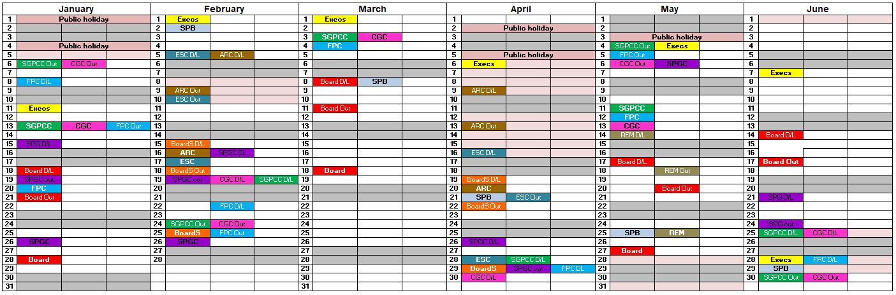
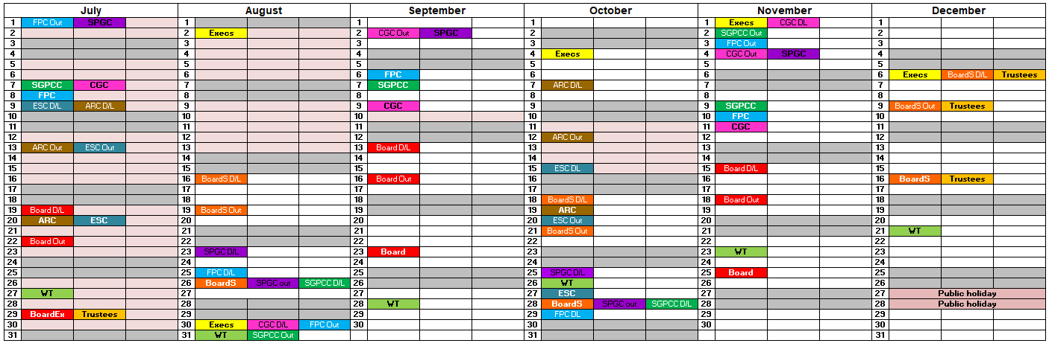
Appendix 3
Corporate Administration Structure
Head of Corporate Governance

Corporate Administrator
Secretariat
Corporate Administrator
DoF/NHSS Academy Director & Assistant DoF x 2
Corporate Administrator
Dir Quality, Inn & People / HRD / Employee Dir
Corporate Administrator
Medical Dir / Nurse Dir / Associate Med & Nurse Dirs
Corporate Administrator
CfSD
Personal Assistant
CfSD
Deputy Head of Corporate Services
Personal Assistant
Chief Exec /
Deputy CE
* Post TBC
Corporate Administrator
Secretariat

Appendix 4
Corporate Governance Work Plan 2021-23

Corporate Governance Function | Key Area | Agreed Action | Responsibility | Timescale
Holding to Account | Ensure all Members continue to have the opportunity to be involved and engaged in financial decision-making | Finance focussed Board Seminars to further understand Financial Management reports to the Board.  Finance & Performance Committee provides in-depth scrutiny. | Director of Finance | Ongoing
Assessing Risk | To discuss Risk Oversight:  - Where are we now  - Assurance  - Existing Corporate Risks  - Risk Oversight  - Risk Appetite | A session on Risk Management will be built into the Induction programme for all new Board members and will be offered to existing members as and when required. | Head of Corporate Governance | Ongoing
Engaging Stakeholders | Ensure all Members are kept up to date on Communication and Engagement plans to give assurance on the wider engagement processes. | Members will receive routine updates on our Communication and Engagement Plan that was agreed at the Board meeting on 26 September 2019. Members will receive advisory notification of any planned events, any special communications, copies of literature etc., as required. | Head of Corporate Governance | Ongoing
Influencing Culture | Significant focus has been given to organisational culture during 2020/21. | The Board welcomed a new Non-Executive Director as the Whistleblowing Champion.  Ongoing work undertaken to review the Whistleblowing Policy in line with national standards. | Director of Human Resources | Process implemented, ongoing monitoring
Enablers – Skills, experience and diversity | Board Development in relation to the quality of the induction and going development programme for Board Members has been identified as an area which would benefit from ongoing review and development. | Review of Board induction pack. Induction pack to include:  - Information on induction  - Scottish Government induction events  - Local and National Seminars  - ELearning and training events  - Access to attend any governance meeting to aid learning.  Ensure a robust appraisal process is in place for Members. | Head of Corporate Governance | Ongoing
Enablers – Skills, experience and diversity | To further strengthen the Membership Team by recruiting to skill gaps. | Implementation of Board Skills Matrix | Head of Corporate Governance | Ongoing
Enablers - Roles, Responsibilities & Accountabilities | To further strengthen the Board’s governance arrangements. | Present a paper to Board each time there is a change of Board Members on Committees, or annually if there are no changes. | Head of Corporate Governance | This now takes place routinely with the next scheduled update May 2021.
Enablers – Values, Relationships & Behaviours | Work will be undertaken with Board Members to reflect on what changes in approach and behaviours could be made, individually and collectively, to improve governance. | Further develop organisational awareness and information requirements of the Non-Executive Members of the Board to enable effective engagement. | Head of Corporate Governance | Ongoing
Supports of Good Governance | Assurance Information Systems | Regular review of the Code of Corporate Governance | Head of Corporate Governance | Ongoing
Supports of Good Governance | Administration arrangements: Improvement to Board Agenda and papers | Review of current Board templates to ensure fit for purpose. To ensure writers of papers are clear on key messages, using the SBAR approach as much as possible and ensure papers are of the highest quality and presented in a timely manner.  Consider the Board agenda structure to ensure the flow of the agenda gives the right time for discussion of topics, ensuring a focus on governance.  A review of all Board standing Committees in respect of Terms of Reference, agenda content, minutes and actions. | Head of Corporate Governance | This is evolving to deliver an informed and robust Annual Programme of work for Board meetings.  The Board Committee templates are under review.
Engaging Stakeholders | Ensure all Members are kept up to date on Communication and Engagement plans to give assurance on the wider engagement processes. | A new approach to delivering the Board’s Walk Round programme for 2020/21 has been created. These sessions include a virtual visit to each department across NHS Golden Jubilee wherein staff are asked to join the Seminar to answer any questions and to celebrate their successes to date. | Head of Corporate Governance / Head of Communications | Ongoing

