****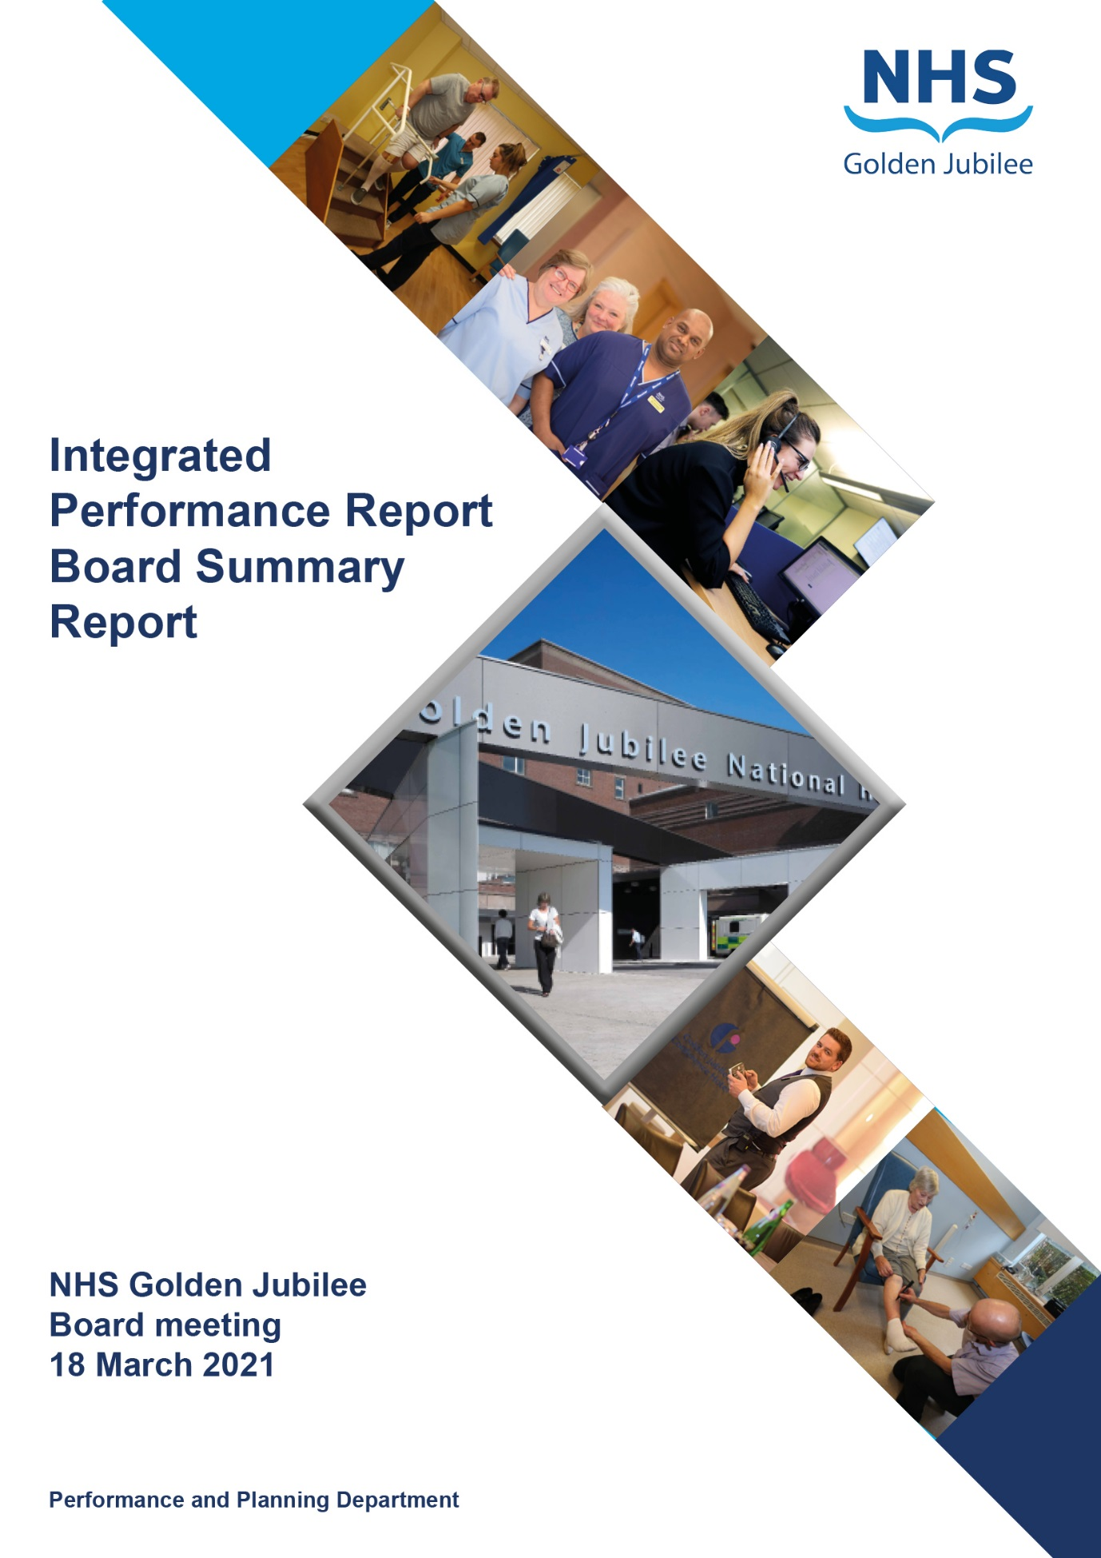

# Contents

**Introduction 2**

**Performance Summary Dashboard 4**

**Integrated Performance Report: Executive Summaries 7**

# Section A: Introduction

The purpose of the Integrated Performance Report (IPR) is to provide assurance on NHS Golden Jubilee’s performance relating to National Standards, local priorities and significant risks.

The IPR comprises four sections with each section being considered in detail by the appropriate Standing Committee:

* Section A Introduction
* Section B:1 Clinical Governance
* Section B:2 Staff Governance
* Section B:3 Finance, Performance & Planning

This Board Summary Report of the IPR is presented to the Board and contains the summaries from each section of the full IPR.

**Jann Gardner Colin Neil June Rogers**

**Chief Executive Director of Finance Deputy Chief Executive**

Performance Summary Dashboard – Guidance



Statistical Process Control – Guidance



Board Performance Dashboard – Part 1





Board Performance Dashboard – Part 2





At each meeting, the Standing Committees of NHS Golden Jubilee (NHSGJ) consider targets and standards specific to their area of remit using the Integrated Performance Report (IPR). There is a section of the IPR which provides a summary of performance Standards and targets identified as areas of note which is reproduced below. Topics are grouped under the heading of the Committee responsible for scrutiny of performance.

# Section B: 1 Clinical Governance

|  |  |  |
| --- | --- | --- |
| **Clinical Governance** | | |
| **KPI** | **RAG** | **Position:** |
| Total complaints (Stage 1 and 2) by volume |  | In January 2021 there were six complaints reported. |
| Stage 1 complaints response time |  | In January 2021 there was one Stage 1 complaint, which was responded to within the five day target (100%) |
| Stage 2 complaints response time |  | In December 2020 there were four Stage 2 complaints, zero of which were responded to within 20 days (0%). |
| Mortality |  | The mortality figure for January 2021 was reported as seven. There were eleven deaths in December 2020. |
| Significant adverse events |  | There was one significant adverse event review in January 2021. |
| MRSA/MSSA cases |  | There were three instances of Staphylococcus aureus Bacteraemia (SAB) reported in January 2021. Year to date the count is ten. |
| Clostridiodes Difficile |  | There were zero Clostridiodes Difficile Infections (CDI) reported in January 2021. Year to date the count is six. |
| Gram Negative Bacteraemia |  | There were zero reported instances of Gram Negative Bacteraemia in January 2021. Year to date the count is three. |
| Surgical Site Infections |  | There are four new Surgical Site Infection indicators which appear on the dashboard. These indicators were last measured in February 2020 with reporting paused due to Coronavirus. |

**Clinical Governance Executive Summary**

**Executive Summary February 2021**

January saw a similar level of complaints to the previous two months with five stage 2 and one stage 1.

The feedback levels are consistent with the previous year and when looked at as a percentage of activity is showing an increase in the last quarter which is beginning to level off. Waiting times is the highest category.

Stage 1 response times are at 100% for the last month; stage 2 continue to be a challenge.

The average response time for stage two complaints during quarter 3 Oct- Dec 2020 was 28.9 days.

There have been delays at investigation and sign off level that have impacted on the response times.

One shared complaint has been delayed whilst we await a response from the referring Board.

The delays in investigation from service level have been discussed with Division Management teams with weekly meetings in place to review progress and highlight where delays are occurring. Executive sign off process has also been reviewed. This will be closely monitored.

**Key Healthcare Associated Infection Headlines – (January 2021 data)**

* ***Staphylococcus aureus* Bacteraemia-** 10 cases in total since April 2020.

1. ***cases*** to report in January, source Dental, IABP and chest sepsis related.

5 of 11 cases to date are PVC related. Clinical Governance are working with the PCIT and have updated PVC bundles to reflect learning points. Updated bundles are currently out for printing.

* ***Clostridioides difficile* infection (previously known as *Clostridium difficile***)- 0 cases in Jan.

Oct-Dec 20 quarterly data indicates the CDI rate out with the national trajectory. Our low CDI rate, coupled with a reduction in total occupied beds days a resulted in an obvious rise in NHSGJ CDI rate. No patient crossover noted in any case.

* **Gram Negative/E.coli Bacteraemia (ECB)**- No cases to report.
* **Hand Hygiene**- The **bimonthly** report from January indicates an overall compliance of 100% with hand hygiene opportunity and technique. Medical staff compliance has increased from 86% in November.
* **Cleaning and the Healthcare Environment- Facilities Management Tool**

**Housekeeping Compliance:** 98.13% **Estates Compliance:**  98.27%

* **Surgical Site Infection**- As per CE Letter 25/03/2020 “Temporary changes to routine surveillance requirements”, SSI surveillance has been paused until further notice.

**Other HAI Related Activity**

* **Contact Tracing-** As community incidence of COVID 19 is increasing the team have been working with Occupational Health and clinical teams to ensure timeous contact tracing/ self-isolation.
* **ARHAI-** Ongoing support to ARHAI re national guidance through weekly update meetings and consultation of patient pathways management.

# Section B:2 Staff Governance

|  |  |  |
| --- | --- | --- |
| **Staff Governance** | | |
| Disciplinaries, Grievances and Bullying |  | There were zero cases reported in January 2021. |
| Local Sickness absence |  | Sickness absence in January 2021 was reported at 4.6%, an increase of 0.1%. Absence due to COVID-19 reasons was 3.8% in January (+1.7%) |
| Turnover |  | Turnover in January 2021 was reported as within control limits at 0.4% |
| Medical appraisal with completed interview and form 4 |  | January 2021 performance was reported as 22% (39/106). |
| TURAS Appraisal rates |  | The TURAS position for January 2021 reports the position at 53%, a 1% decrease on last month. |
| Job Planning: All hospital |  | The January 2021 performance reported as 37% (39/106). |

**Staff Governance Executive Summary**

**Executive Summary January 2021**

In January 2021 the Board’s sickness absence rate stood at 4.6%, up 0.1% on the previous month. Despite the increase sickness continues to be reported within the normal range with January’s position being below average.

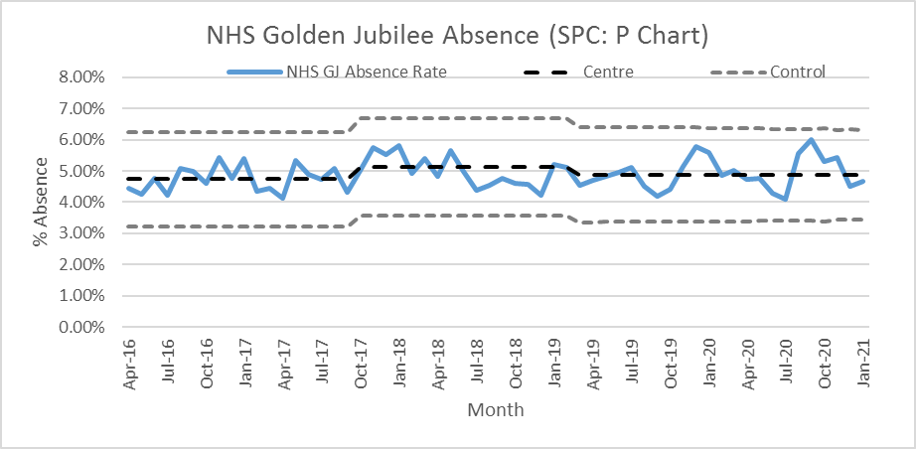

Across the Directorates absence was as follows:

* Corporate: 3.9%, up from 3.6% the previous month;
* Golden Jubilee Conference Hotel: 3.6%, up 0.7% on December;
* Heart, Lung and Diagnostic Services: 5.0%, up from 4.0% in the previous month; and
* National Elective Services: 5.0%, which was 1.4% lower than December.

As with previous months, a large proportion of sickness absence was due to “Anxiety/stress/ depression/other psychiatric illnesses”.  It accounted for 25.4% of the Board’s sickness absence, 2.4% less than in December.  It was the main cause of sickness absence for three of the four directorates:

* Corporate, 30.0%;
* Heart, Lung and Diagnostic Services, 21.8%; and
* National Elective Services, 29.2%.

In the Conference Hotel the main reason for sickness absence was “Unknown cause/not specified”, accounting for 68.1% of the Hotel’s sickness absence.

**COVID-19**

In January COVID-19 special leave accounted for 3.8% of all contracted hours, up from 1.7% the previous month. The Directorate breakdown was:

* Corporate: 2.5%;
* Golden Jubilee Conference Hotel: 2.9%;
* Heart, Lung and Diagnostic Services: 3.7%; and
* National Elective Services: 5.3%.

The large increase is mainly due to members of staff having to shield due to underlying health conditions, which was not the case in December.

We will continue to provide a monthly summary of COVID-19 absences until the end of the pandemic.

**Agenda for Change appraisal**

Within the year to 31 January 2021 53% of staff who come under the Agenda for Change terms and conditions completed their appraisal using TURAS, which is down 1% on the previous month.  The Directorate breakdown is as follows:

* Corporate:                                               36%, down 2%;
* Golden Jubilee Conference Hotel:    74%, up 3%;
* Heart, Lung and Diagnostic Services: 63%, up 1%; and
* National Elective Services:                   54%, down 3%.

# Section B:3 Finance, Performance and Resources

|  |  |  |
| --- | --- | --- |
| **Finance, Performance and Resources** | | |
| Finance – Manage within annual budget limit |  | As at month ten the position was reported as a surplus of 225k. |
| Finance – Efficiency savings |  | As at month ten efficiency savings of £1,835,00 were reported against a profile of £3,100,000. |
| Cancer 31 Day |  | In December 2020 performance was reported as 97% (32/33) |
| TTG: Number of patients who have breached the TTG |  | In January 2021 there were 123 patients who exceeded their twelve week treatment time guarantee. This included 2 cardiac surgery patients,10 coronary patients,45 electrophysiology patients,6 device patients,4 respiratory patients,11 orthopaedic patients,45 ophthalmology patients. |
| TTG: Percentage of patients admitted within 12 weeks |  | The percentage of patients who were admitted within their twelve week treatment time guarantee increased by 8.3% from 73.4% in December 2020 to 81.7% in January 2021. This reflects a decrease in the number of patients admitted over twelve weeks (-106). |
| Stage of Treatment Guarantee – Inpatient and DC cases (Heart & Lung only) |  | 73% of Heart and Lung patients were treated within 12 weeks in January 2021 (319/437 ) |
| DOSA rate: Cardiac Surgery |  | The Cardiac DoSA targets had been paused till January 2021. Confirmation of when DoSA cases will restart is to be confirmed. There were no DoSA cases in month. |
| DOSA rate: Thoracic Surgery |  | The Thoracic DoSA targets had been paused till January 2021. Confirmation of when DoSA cases will restart is to be confirmed. There were no DoSA cases in month. |
| DOSA rate: Orthopaedics |  | In January 2021 there were 187 Orthopaedic primary joint admissions, 86 (46%) of which were on the day of surgery. |
| Theatre Cancellation Rates |  | In January 2021 the overall hospital cancellation rate was 4.22%. There were 67 cancellations with 1586 procedures undertaken. |
| Hospital Bed Occupancy |  | Hospital wide bed occupancy was reported as 61.3% in January 2021. |
| Hotel KPIs |  | Hotel target thresholds for 2020/2021 are currently under review following the impact of Covid 19. For some KPIs reported positions will be provided but no assessment made. |
| R&I: New research projects approved |  | 4 projects were approved in Q3 2020. The target was 8 |
| R&I: Income |  | Year to date income is £1,084,239 compared to a target of £1,500,00 (-3.6%) |
| R&I: Motion Lab Income |  | No income was earned in Year 2020. |
| R&I: % Occupancy Clinical Skills Centre |  | Occupancy was 82% in Quarter 3 2020. (Target 75%) |
| R&I:% Occupancy Clinical Research Facility |  | Occupancy was 57% in Quarter 3 2020. (Target 80%) |
| National Comparison Table, Corporate Dashboard, Waiting list & Productivity table | | |
| NHSGJ nationally reported elective cancellation rate, in December 2020, was reported as 4.0%. This ranked GJNH as third out of 15. The Scotland rate was 7.5%. | | |
| NHSGJ comparative performance against the national 31 Day Cancer target is reported using the Information Services Division (ISD) nationally published position. For Quarter 3 2020 NHSGJ reported 100% of eligible patients treated within the target (Joint 1st) | | |
| Health Protection Scotland published figures for Quarter 3 2020 report a NHSGJ incidence rate (per 100,000 total occupied bed days) of 10 for CDiff incidence and 20 for SAB. The Scotland rates were 17.4 and 17.3 respectively. | | |
| Corporate sickness rates in January 2021 were 4.4%. Departments over the 4% threshold were: Catering, Estates, Finance, Research, Security, Business Services, Performance & Planning, Procurement and Housekeeping. | | |
| Referral numbers in January 2021 were significantly down on December 2020 with Orthopaedics and Ophthalmology both down on previous months.  The total outpatient waiting list decreased by 365 to 2913.  The total inpatient waiting list month end position decreased by 49 from 4618 to 4569.  For current inpatient waiters the number waiting between 12-26 decreased from 309 to 286 (-23)  The number of patients waiting over 26 weeks also decreased from 417 to 384 (-33). | | |

**NHS Golden Jubilee**

**Summary Finance Report**

**As at 31 January 2021 – Month 10**

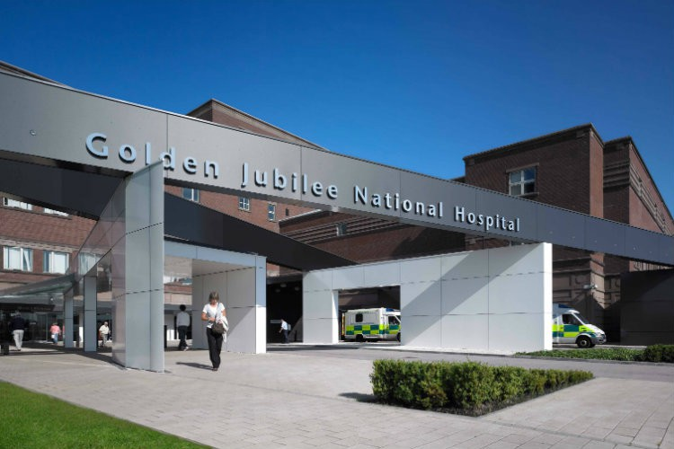

**Financial Position as at 31 January 2021, Month 10**

This Summary Finance Report provides an overview of the key points within the financial position as reported at Month 10, for the period ending 31 January 2021.

In line with previous communications reported with Scottish Government and final confirmation from Boards via the Month 9 Financial Performance returns the balance of Covid funding of £2.275m was received in January 2021 RRL allocation.

The focus is now on managing the final March 2020-21 year-end position, which based on detailed financial appraisal recognised that flexibility of up to £0.5m surplus may be realised and this financial assessment has therefore been reflected in the M10 FPR trajectory submitted to Scottish Government. There are a number of areas requiring final assessment, which may impact this position, including the implications of the level of increased annual leave balances and associated financial provision. This will be clearly understood for month 11 reporting as all services have been asked to return detailed templates to allow for the full and robust consideration of the carry forward leave implications as at March 2021.

In addition to the management of the March 2021 year-end out-turn there has been significant focus on the 2021/22 1 year remobilisation plan submission in addition to the supporting financial templates and recovery financial assessment as issued from Scottish Government, all of which are to be returned by 26 February 2021 deadline. The planned activity targets for 2021/22 in addition to the previously approved recovery workforce by NHSGJ Gold Command, provided a solid baseline to build this financial appraisal. This therefore reflects an additional funding ask for the remobilisation of c£17m with and a further separate funding need for the planned Endoscopy Unit of c£3.5m including rental, staffing and consumables.

Month 10 SLA monitoring summary reports on the top-slice SLA have been shared with both the Access Support Team and Other Boards SLA leads as at January 2021. The December 2020 RRL Allocation reflected the reduced SLA top slice funding of £12.266m agreed at that stage, the final adjustment on March 2021 SLA out-turn against the Boards £12.266m indicates a further £2m reduction in funding on the top slice based on activity forecast to March 2021. Discussions are in place with both Scottish Government and Boards around the detail behind this by Board and final adjustments by Board will be progressed for the March 2021 RRL allocations.

**Summary Financial Position as at 31 January 2021**

The tables below represent an extract of the summary financial position in line with reporting to the Scottish Government Health and Social Care Directorate as at month 10, 31January 2021.

The tables below clearly distinguish between the total NHSGJ and the GJCH position separately in order to define the financial performance and drivers for variances on income performance.





This clearly demonstrates that the GJCH income loss is the main driver for the overall NHSGJ income underperformance and that the Core hospital position reflects a small under-recovery against revised planning of (£17k).

**Summary Points**

**Core Income excl. GJCH (£0.017m) under-recovered** – As the SLA top slice reduced allocation has been actioned, the month 10 finance report now reflects the £8.178m movement within the Core RRL SLA line. Non-WoS activity account for a small (£0.055m) under recovery against original budget plan and mainly driven by;

* Cardiology services at January reporting for Mitraclip, TAVI and PFO procedures performing £0.146m positively against year to date plan. This is in the main due to TAVI and as a result in increased procedure numbers for transfemoral activity for the West region on the back of reduced Non-Transfemoral cases (from 15% to 7%) noted in the East Unit. This reduced level of Non T/F cases was predicted by the clinical team and NHSGJ Management are progressing a review of this and the 61 Pmp rate in collaboration with the West Regional planning lead and the National Planning Group. Approval has been received from the two Boards who are mainly impacted from the increased NHSGJ activity.
* Cardiac is behind year to date plan by (£0.151m) due to the ongoing and noted reduction in referral activity for Cardiac Surgery
* Thoracic performing behind year to date plan of (£0.051m) due to reduced activity throughput partly driven from 4 nations guidance implications

As Covid-19 is a significant driving factor for most of the above, re-aligning the budget in Non-WoS Income will take place in Month 11 to take cognisance of these issues.

Underperformance against Additional Cost of Teaching (ACT) of (£0.035m) is also noted, however this is due to non-progression of previous bids against additional ACT allocation and can be re-accessed as required in future years.

SPVU is also under performing by (£0.061m) – 14%, and the reduction in activity in the first quarter of the financial year remains the key factor to this position, the forecast is realigned to reflect current profile forecast for NSD services.

Other Income flows continue to reflect a small over recovery of £0.131m year to date which is offsetting some of the minor under-recoveries noted above.

**GJCH Income (£4.220m) under-recovered**

The element associated with the Hotel and Conference centre as previously reported has been incorporated and approved within our Local Mobilisation Plan (LMP) – net £3.651m performance loss and is all funded within the £7.108m formal allocations received in the September and January RRL allocations and has been fully allocated to GJCH expenditure. The £3.651m sits specifically against non-pays and this offsets the net year to date variance driven by the lost income opportunity to take the total hotel position to a small adverse position of £0.207m ytd. The adverse ytd position noted as at M10 is a phasing impact between budget and spend and the year-end position remains to be forecast at breakeven. The additional £2m regeneration funding allocation for the GJCH is released as bedroom work progresses up to March 2021.

**Core Expenditure excl. GJCH £0.449m underspend** – There is a continued notable trend in expenditure increase aligned with the recovery plan target seen from M7 reporting ongoing through to month 10 reporting, expenditure levels have maintained at month 7 increased levels of £1.3m to £1.6m in comparison to September 2020. This is specifically evident in Surgical Supplies areas and close monitoring of this increase is in place considering reduced activity levels. Cath Lab supplies has been a focussed area of review as although activity is down overall between 2020/21 and 2019/20, expenditure continues at a higher cost per case. This is now understood to be a combination of the increased TAVI activity (small number but high cpc), there are 8 products identified where costs have increased and this is being monitored closely with the operational team in addition there has been no review to the minimum and maximum stock levels held within the Cath Lab on the back of the reduced activity. These areas have active Action Plans which will be closed down for the financial year end.

In addition, some key pressure areas within medical staffing recruitment are presenting additional financial costs to manage the impact on service activity, specifically within Cardiac Junior Doctors and the additional backfill to support Transplant rota gaps. There is some improvement in this area noted due to appointment of a new Consultant. Anaesthetics is another high financial pressure area with high levels of waiting list initiatives to support vacant slots within the staffing budget and this is further compounded by some sickness / absence, including self-isolation as appropriate to government guidelines.

As in previous months there have been reductions in supplementary spend for some specialties and most notably within nursing and clinical workforce groups due to a combination of reduced service provision, particularly during quarter 1, together with some historical vacancies. Active recruitment to support achievement of the required workforce needed to align to the ambitions of our recovery and routine vacancies is ongoing with increased social media presence for adverts to aid improved appointments in collaboration with Divisions, Human Resources and the Communications Department.

The master recovery workforce control document approved by Gold Command is in a continual process of review and update for actual and planned start dates against these roles, as at the end of January forecast costs of posts with agreed start dates equates to £1.6m to March 2021, with £0.823m through to January 2021, with supplementary staffing and staff in the recruitment process stage equating to a further planned £1.0m at this point. There remain some high level assumptions to those recovery posts that do not yet have confirmed start dates, therefore the above cost information will be subject to some fluidity until commencement dates are clearly defined. However, it is recognised that current activity against remobilisation cancer activity against recovery target as at month 10 is 286 below planned and this is reflected in reduced workforce cost and associated income and funding support ask of Scottish Government.

**GJCH Expenditure £4.013m underspend**

The release of SG LMP funding element for the GJCH under performance is included within the Hotel non-pays budget and therefore is the main contributor to the significant underspend variance – directly offsetting the income loss as reported above.

|  |
| --- |
| **The Board are asked to**   * Note the financial position for Month 10, as at 31 January 2021 for the financial year 2020/21 * Note the key messages as highlighted below |
| **Key Messages**  Total surplus as at Month 10, January 2021 of £0.225m (includes core, non-core and income).  The Golden Jubilee’s January Revenue Resource Limit (RRL) allocation on the 5 February 2021 reflected a reduction on total funding allocations of (£4.748m), in the main this was associated with the non-core funding transfer (£7.302m) which is routinely progressed at this position in the financial year and partly offset by the £2.275m final Covid funding balance, £0.200m return for the National Boards Savings over deduction and £0.076m for distinction awards;  Therefore, the NHSGJ financial reporting as at January 2021 takes into consideration the remaining anticipated funding allocation from the original NHSGJ Annual Operating Plan (AOP) submission – including the following;   * Centre for Sustainability workforce resource and associated non-pay costs to be incurred during 2020/21 of £1.877m   COVID-19 Local Mobilisation Plans (LMP) balance of funding which is updated as part of the Quarter 2 return process – based on M6 reporting this reflected £4.617m (£15.550m LMP costs less both £6.1m and £4.833m received to date) including efficiency savings underachievement and broken down as below;   * Recovery Plan - £6.085m (Plus £2m Capital) * GJCH Income loss - £3.651m * GJCH regeneration - £2.000m * Equipment/IT - £0.136m * Deep cleans/vaccinations/other - £0.160m * Additional staff - £0.980m * Research Income - £0.543m * Underachieved efficiency - £1.995m   **Total of above - £15.550m**  Some movement in key lines from month 6 as previously reported reflects a reduced requirement of funding due to the following areas;   * Recovery Plan reduction - (£1.484m) * Efficiency savings improvement - (£0.668m) * Additional staff cost reduction - (£0.274m) * Addition of vaccination cost estimate - £0.084m * **Revised Total Funding need -£13.208m** * Funding received to date £13.208m * **Outstanding level of allocations £0m**   **Additional Areas to Note**  Capital Resource Limit (CRL) allocation. Expenditure programmes associated with CRL funding allocations are progressing well for this time of the financial year. The core Formula Capital Allocation of £2.691m is being increased by £530k which was included in the Annual Plan, and an additional £2m associated with our Recovery Plan.  The core capital allocation is progressing in line with plan and the forecast shows this being achieved by the year-end.  This will be increased further by the formal allocations for Phase I and Phase II expansion programmes. Formal approval is in place with Scottish Government colleagues for Phase II costs being enacted between April and December 2020, prior to final approval of the FBC assurance programme process.  We are working to agree the final accounts for Cath Lab 5 and Phase One of the expansion, both of these are complicated pieces of work with the aim to agree both final accounts by the end of the financial year.  The Board valuers have been on site to value Phase One and Cath Lab 5 works, to ensure any appropriate impairments are captured and accounted for. This valuation exercise cannot be finalised until the final account for Phase One is received.  As a result of the prioritised focus on the Boards Efficiency Savings agenda for 2020/21 through Divisional performance review robust savings appraisal there is a re-energised drive through monthly budget meetings and wider Divisional clinical and management leads meetings and this has continued to generate improvement in identifying savings already achieved and other future opportunities. It should be noted that this improvement is for non-recurring planned cash savings to support the wider financial performance agenda. As at month 10 reporting the Board has achieved £1.809m of efficiency savings, £0.891m of which are non-recurring in nature, with a current forecast target of £2.4m by March 2021. The current run rate is however capturing further non-recurring gains given the net underspend being reported. |

**Director of Finance**

**NHS Golden Jubilee**