Board Meeting: | 28 January 2021 | 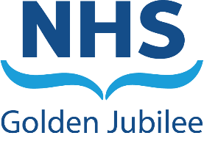
Subject: | EU Withdrawal
Recommendation: | Board members are asked to:
  Discuss and Note | ✓
  Discuss and Approve
  Note for Information only

- Purpose

The purpose of this paper is to update on any potential impact to the Board following EU Withdrawal on 31 December 2020.
- Background

As previously communicated key areas of focus are:

- Procurement (including medical equipment)
- Supply of medicines
- Workforce
- Finance
- R&D
- Regulatory (e.g. MHRA, Information Governance, legislation)

Contingencies that were previously in place remain and much of this is co-ordinated at a national level.

- Assessment
- The SLWG is ready to step up to consider updates from the key leads in relation to escalation of any areas of risk
- Leads for pharmacy, procurement and resilience are linked in to the key national network discussions.
- Procurement have undertaken some work to review any high risk suppliers locally and will advise of any issues.
- No key risks highlighted from key internal leads.
- Noted that there may be potential impact on construction supplies if borders become an issue.
The Board risk remains at a medium level.
- Current Control Measures in place

EU Withdrawal SLWG chaired by Executive Director of Nursing & AHPs, reporting to Gold and Board to provide assurance.

Preparedness assessment undertaken across all key areas and where required internal contingency plans and escalation process are in place.

Well established links to national (Scottish and UK) contingency arrangements as impact will be across NHS Scotland with a nationally co-ordinated response.

Element of financial provisions incorporated into Boards finance plan.

- Recommendation

Board members are asked to note this update.

Anne Marie Cavanagh
Executive Director of Nursing and AHP’s
20 January 2021

S12 EU Withdrawal
Current Risk Level  L2 x S2 = 12 (medium) | Target Risk Level  L2 x S2 = 4 (medium) | Risk Appetite:  Outwith for hotel  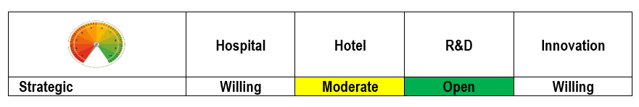
If we cannot adequately respond to the changes associated with the EU Withdrawal, it may impact on our ability to continue to deliver our core services  May impact on ability to deliver corporate objectives and on long term strategy.  Financial consequences possible in relation to funding and budget impact.  Impact as EU regs transferred; loss of access to MHRA; R&D impact of not being part of EU  .  Pharmaceutical and market impacts that may affect supplies of key items.  High risk workforce areas within medical staffing and hotel housekeeping identified. | Current control measures in place:  EU Withdrawal SLWG chaired by Executive Director of Nursing & AHPs.  Preparedness assessment undertaken across all key areas and where required internal contingency plans in place.  Links established to national (Scottish and UK) contingency arrangements as impact will be across NHS Scotland with co-ordinated response.  Element of financial provisions incorporated into Boards finance plan. | Assurance/ Monitoring:  Reports to Gold and Board as situation develops.  Post withdrawal assessments have not highlighted any areas of direct impact.
Additional Mitigations:
- SLWG in readiness to be reconvened to reassess preparedness / escalation across the key areas.
- Monitor updates from national networks.

