

Expansion Programme Risk Register Reporting

July 2020

Prepared by John Scott, Interim Director of Facilities & Capital Projects and Laura Langan, Head of Risk & Clinical Governance

1. Situation

Following the update to the Board in December 2019, discussion at the Audit & Risk Committee and given the recent changes in the Expansion team and governance structure it was agreed to develop a paper outlining the governance arrangement supporting review and reporting of risks for the programme.

2. Background

The Risk Register for Phase 2 of the programme was developed as part of the Initial Agreement (IA) submission following the same process as Phase 1. In following with arrangements in place for Phase 1 of the programme, the project team and Head of Risk & Clinical Governance meet monthly to review the risks, discussing progress with mitigations, any issues from the PSCP and agree updates that were required to the risk register and subsequently into the Programme Steering Group and programme update reports. The Programme Director met monthly with the PSCP to review the PSCP risks and would escalate any issues into that discussion. The PSCP also provides a separate report into the Programme Steering Group which includes an update on risk.
A Risk & Benefit workshop was held in April 2019 to review the risk register as part of the Outline Business Case (OBC) development. Over the next few months the risks were continually reviewed and updated by risk owners as the OBC progressed with the final revised version submitted as part of the final document. This was reviewed via the programme structure as part of the OBC approval process in September 2019.
Through this process one of the key emerging risks was in relation to the Consultant Microbiologist support to the programme which was escalated from the programme risk register to the Board risk register in July 2019. The potential impact of Brexit was also an area of concern with a risk generated and added to reflect this; this was also an issue under constant discussion with the PSCP who had also reflected within their risks the potential. The other key area that arose during this time was in relation to the CSPD equipment specification and fact that due to the procurement process this would not be finalised prior to OBC and then FBC submission. This was reflected in the OBC risk register position and continued to be the main areas of focus following that submission. Finally, a risk was generated to reflect the requirement from West Dunbartonshire Council for a full public consultation to be undertaken prior to the Planning application being submitted which had the potential to impact the programme.
In the absence of formal Programme Board the regular review of risks by the project team and Head of Risk & Clinical Governance continued. The Board were regularly updated on all of these issues via Programme Update reports to Senior Management Team meetings and updates at the formal Board and Board workshops. The work in relation to the Consultant Microbiologist support which was of high concern was also discussed regularly via the Clinical Governance Committee. The Board Risk Register is presented quarterly to the Board and the Expansion Programme overall as well as the specific risk relating to Microbiology are part of that.
With regard to project assurance, it was agreed with Alan Morrison at Scottish Government to review the hospital expansion programme as a Gateway Review 0 (i.e. a programme of projects). An initial Gateway 0 Review was carried out in January 2018 and this was outlined in the OBC. A second review was undertaken in October 2019 which found a Delivery Confidence Assessment of Amber/Green (Successful delivery appears probable. However, constant attention will be needed to ensure risks do not materialise into major issues threatening delivery).

The Review Team noted that the Jubilee Expansion Programme is being managed by an experienced and committed client team who are seen to be performing both individually and collectively in a highly effective manner. There is strong support and leadership for the Programme from a fully engaged Golden Jubilee Executive team and a highly competent community of healthcare professionals, clearly committed to delivery of a successful outcome. The team have built good working relationships with their chosen design and contractor team and have used lessons learned in earlier stages of the Programme to inform current activity to good effect.

3. Assessment

As outlined in the Full Business Case, the Project Management structure has changed since OBC with a change in role from Programme Manager to Clinical Programme Manager and the appointment of a Senior Project Manager. The overarching governance arrangements have also been revised; the Programme Steering Group has been replaced by a revised Senior User Group which has expanded membership and remit and reports directly to the Senior Management Team as outlined in the figure below.
The Programme Board continues to be chaired by Jann Gardner, Chief Executive (NHS GJ), supported by June Rogers, Director of Operations and Senior Responsible Officer and includes representatives of the NHS GJ senior management team, NHS GJ Chair, the Director of Regional Planning, the Programme Director of the National Elective Centres Programme, Strategic Director, West Dunbartonshire Council, and Vice Principal Operations, West College Scotland.
Figure 1 – Expansion Programme Governance Structure
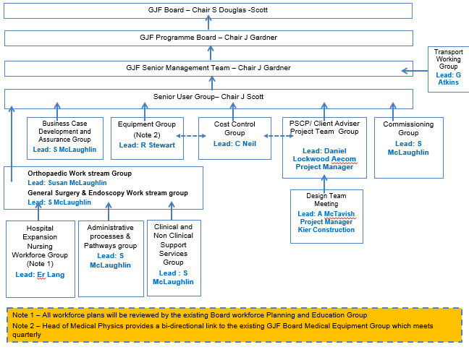
We have considered the risk reporting arrangements as part of this as follows:

- The Risk Register will be a standing item on the Senior User Group which meets monthly to allow for update/ escalation of any issues.
- The programme update report risk section has been revised and will include an overview of the risk profile for the programme and note any changes since the last report (nil report if none).
- The full risk register will be reviewed quarterly via a meeting of the project team and Head of Risk and Clinical Governance. This will also include the PSCP Project Manager to allow consideration of any shared risks and update on the PSCP risk profile. This will then form a formal risk update report to the Senior User Group and Programme Board.

4. Recommendation

Members are asked to note the update on management of Expansion Programme risk.

