Date | 25th May, 2020
Title | Clinical and Operational Governance of Service Changes due to COVID-19
Executive Lead | Mark MacGregor
Authors | Mark MacGregor, Anne-Marie Cavanagh, Laura Langan, Lynne Ayton, Claire MacArthur
Audience | Board
Situation
- As a consequence of the COVID-19 pandemic, some of our clinical services were reduced to provide emergency and urgent care only, and others stopped to ensure adequate capacity for the pandemic, and to minimise infection risk to patients.
- As we move towards a recovery phase we now need to upscale or restart our services, taking into account the additional risk presented by the COVID-19 era. Additionally, to meet NHS Scotland’s needs, we are rapidly implementing new services for urgent cancer surgery.
- Actions taken to ensure these services are delivered safely with mitigation of any risks are presented in this paper.

Background
COVID-19 is the disease caused by SARS-CoV2, a recently identified coronavirus. The disease was first reported on 31st December, 2019, and the fully sequenced viral genome was published on 10th January, 2020. The WHO declared a public health emergency on 30th January, 2020 and a pandemic on 11th March, 2020. The first identified case in Scotland was on 1st March, 2020. The number of patients peaked in Scottish intensive care units on 12th April, and in hospitals on 20th April. Concerns remain about a potential second or third wave later this year and next.

The GJNH response to the COVID-19 pandemic has had four main elements:
- Enhanced intensive care service. Capacity for an additional 16 ventilated patients was provided from 9th-20th April to support West of Scotland ICUs, while they were at 176-195% of baseline capacity. Fortunately, this was only required for a small number of patients. The additional capacity was closed on 12th May.
- Cardiology and cardiothoracic services. We restricted our cardiology and cardiothoracic activity to urgent patients, but expanded the catchment to most of the West of Scotland, and did not repatriate patients. This reduced bed pressures across the West of Scotland, while maintaining a high quality service. Elective cardiology and cardiothoracic surgery were stepped down to release capacity and because of potential risks of operating during a pandemic.
- Elective diagnostics and surgical services. We stood down our elective general surgery, ophthalmology and orthopaedic operating on 17th-18th March. This was done to provide additional capacity for the COVID-19 response, but also because of concerns about the safety of operations for conditions which could be safely deferred. Very small volumes of urgent surgery continued (predominantly revision arthroplasty patients from the West of Scotland). As of 21st May, we recommenced colonoscopy, but with patients selected by territorial boards because of urgency.
- Urgent elective cancer surgery. On 12th March, GJNH offered to provide facilities for urgent cancer operations to territorial boards, using the capacity released by discontinuing elective surgery. From 26th March, we have provided support for visiting surgeons to perform osteosarcoma resections, laryngectomies, hysterectomies, gastrectomies and nephrectomies.

Assessment
Risk Mitigation
In such a dynamic environment assessment of risks and their mitigations is crucial. All medical interventions carry a balance of risks. The benefits of an intervention have to be weighed against the harms, and the harms minimised. COVID-19 adds an additional layer of risks beyond those normally expected:
- Early reports suggest a substantially increased risk to elective surgery, if the patient is infected with COVID-19 at the time of operation or shortly afterwards, with mortality figures of 25% reported.
- Bringing patients to a healthcare environment may increase their risk of becoming infected.
- Performing procedures on potentially infected patients may increase the risk to staff.
- Finally, there is the risk of staff to staff transmission.
The various additional risks due to COVID-19 are displayed in the schematic diagram below (risks are not to scale), with the mitigations put in place. It is important to note that there is residual risk despite mitigation.

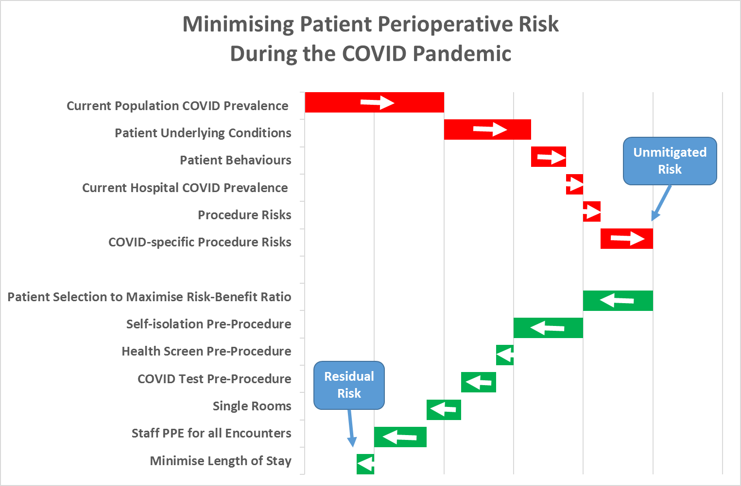

Policies and Procedures to Minimise Risk

Zoning policy and patient pathways. Healthcare acquired infection is always an important consideration when performing medical interventions, but became increasingly so, when dealing with a new pathogen and its attendant uncertainties. In the first phase of our response to the COVID-19 pandemic we expected to be dealing with primarily critical care patients. We therefore determined that our five critical care wards would be established Red, Amber and Green zones for patients with known, suspected or presumed negative COVID-19 status.

We are now moving into a different phase, expanding urgent cancer surgery, and planning towards restarting elective surgery. Based on increasing knowledge and our own experience, we have now redesigned our patient pathways to further minimise the risk of hospital acquired infections. A high level diagram of our current patient flows is shown below. The majority of our patients will be admitted electively after a period of self-isolation and so are unlikely to have COVID-19. They are admitted via the “Green” pathway. The main risk of exposure to COVID-19 for these patients is from staff (who will be wearing PPE at all times when interacting with patients). Uncommonly, if a patient develops severe post-operative complications they may require to be admitted to our Amber ICU, which has individual single rooms. We challenged our teams to design a pure “Green” pathway, but it was felt that this would compromise the quality of care that could be delivered for our most complex patients.

A number of our patients are admitted via an emergency pathway (predominantly interventional cardiology, cardiac surgery and national services). Their COVID-19 status is unknown, though the large majority will not have the virus. They are admitted predominantly to our Amber pathway. If identified as COVID-19 positive, they will continue to be managed in the most appropriate Amber ward (in single rooms, with a second adjacent single room used as a PPE donning/doffing station). There are a small number of emergency admission patients who require to be admitted to “Green” wards, because of their clinical needs. The combination of PPE and single rooms, should minimise the risks.

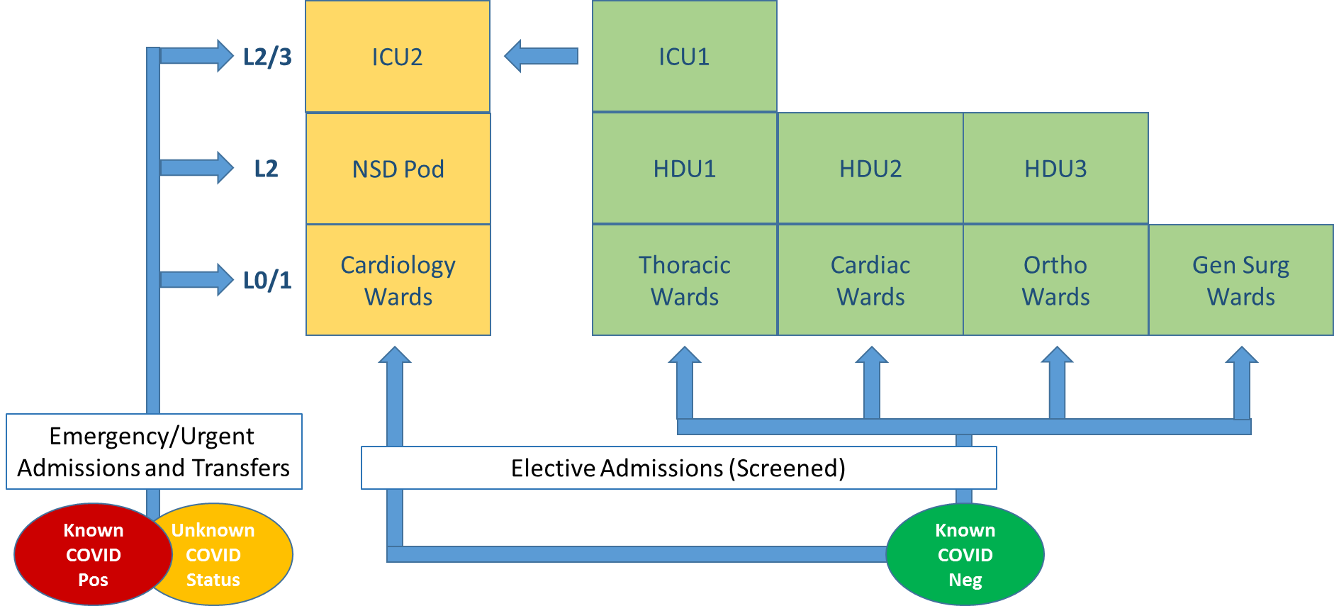

For each service, we are now drawing up similar diagrams at a more detailed level informed by physically walking the patient pathway, to ensure minimal cross-over between emergency and elective flow. These will continue to evolve as the evidence changes and our experience grows.

Standard operating procedures. Normally, when we implement a new surgical service it would be planned over a number of months giving multiple opportunities for oversight and consultation. In these challenging times, and given the urgency of these patients’ needs, we have had to commence services a matter of weeks after initial request. To mitigate the risks of such a rapid approach, we have developed a standard operating procedure template (appendix A), which has evolved with our growing experience. This allows us to ensure that all important issues have been discussed with each board and surgical team. This SOP template has been well received by other boards.

As examples, two key elements included in the template are selection of patients, and pre-operative preparation. In selecting patients at this time of additional risk, it is important that the clinical decision-making is done by a multi-disciplinary team, together with an informed consent process (see below). For most services, this element is performed by the referring board. Our current approach to pre-operative preparation includes self-isolation of the patient for 14 days before the procedure, a call at 48 hours before the procedure to confirm the patient remains asymptomatic and a pre-operative COVID-19 test 24-48 hours before the operation.

The completed template is then approved through Silver and Gold Command before the new service commences. In the future we will be moving to a process of approval via the clinical governance structure and then the operational team before executive approval.

Enhanced consent. The consent process is an intrinsic part of shared decision-making. However, the environment has changed, and the relative benefits and harms of procedures have changed. Clinicians are used to tailoring consent conversations to the individual circumstances of the patient. Nevertheless, to ensure a standard and complete approach, we are drafting a leaflet to describe the additional risks related to COVID-19, and the mitigations we have put in place to minimise them. A revised consent form will include space to document the version of COVID-19 leaflet the patient is given.

Other Precautions.
- Extensive work has been done on the use of personal protective equipment in line with national guidance, and on the implementation of physical distancing to minimise staff to staff transmission in non-clinical areas, but is not discussed further in this paper.
- A separate COVID-19 PCR Testing Guideline has also been created.

Recommendations
The Board are asked to note the actions taken to mitigate the consequences of the COVID-19 pandemic, while upscaling and restarting our previous services, and implementing new services:
- Zoning policy and patient pathways
- Standard operating procedure for procedures new to GJNH
- Enhanced consent process

