Board Meeting: 26 March 2020 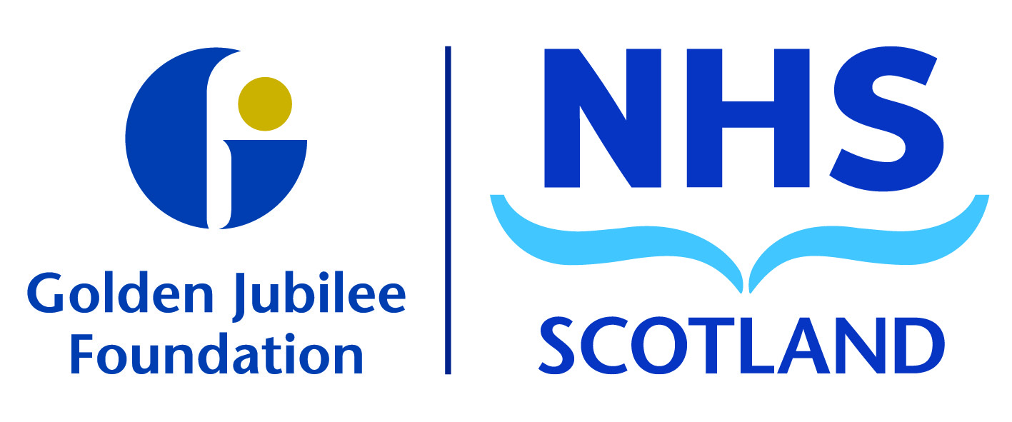
Item
Subject: Audit and Risk Committee Update
11 February 2020
Recommendation: Board members are asked to:
Discuss and Note | X

Discuss and Approve

Note for Information only

1 Background
The following key points were agreed at the meeting and have been split into the three high level quality ambitions of person centred, safe, and effective.

Person Centred
Mutually beneficial partnerships between patients, their families and those delivering healthcare services which respect individual needs and values and which demonstrate compassion, continuity, clear communication and shared decision-making.
- A presentation on the NHS Overview report was provided by Audit Scotland, the report highlights pressures and challenges across the system and gives a reflection of performance and good work going on in health care.
- Two Audit Scotland reports were presented to the committee for information:
- EU Withdrawal Report was noted by members and it was agreed that although the risk has reduced there is still uncertainty therefore the committee will consider key questions for public bodies and feedback to the next meeting.
- NHS Lothian Report regarding the delay to opening of Royal Hospital for Children was discussed by the committee discussed and they noted the importance of ensuring robust adherence to building standards during the Hospital Expansion Programme works and agreed that lessons learned will be taken from this report.
- An update on Prevention of Fraud was noted by the committee on work undertaken throughout the year and forthcoming activities planned.
- Shared Services/Regional Working Update – Director of Finance is a member of the National Board Collaborative Programme Board where regular discussions are held in regard to collaboration for Shared Services and there are no definitive strands of work to pursue at present and hence NHS GJ have not committed to any shared service model at this time.
- The committee were informed that Phase 1 of the Expansion Programme is on target to meet completion date and Phase 2 is progressing as planned with work commencing to develop refurbishment designs.

Safe
There will be no avoidable injury or harm to people from healthcare they receive, and an appropriate, clean and safe environment will be provided for the delivery of healthcare services at all times.
- A review of the Board Risk Register and Risk Appetite was undertaken and members were satisfied with recommendations. A key point noted was that all risks would be aligned to Board committees and this will be raised with relevant Chairs of governance committees.
- The committee were informed that a National Review of Standing Orders was undertaken and following internal discussions it was agreed that the Board will adopt the new national model with some important additions included from the current Standing Orders.
- The committee were informed that dialogue has taken place between NHS GG&C and NHS GJF regarding formalising a Service Level Agreement for investment of endowments which is anticipated will be completed in the new financial year. It is proposed to remain with current arrangements with NHS GG&C for remainder of this financial year.
- Members approved accounting policies which will be used for preparation of the Board’s annual accounts for 2019/20.
Effective
The most appropriate treatments, interventions, support and services will be provided at the right time to everyone who will benefit, and wasteful or harmful variation will be eradicated.
- Internal Audit Progress Report was presented with no recommended changes to the internal audit plan for 2019/20. Four reports will be submitted to the April committee meeting.
- Internal Audit Risk Management Report was presented and overall conclusion from the review was ‘Partial assurance with some improvement required’ with three low level and three medium recommendations made.
- Internal Audit Financial Controls Report was presented and overall conclusion from the review was ‘Significant assurance with some improvement required’ and three low level recommendations were made.
- The committee were informed of implementation of International Financial Reporting Standard (IFRS) 16 which is being adopted for accounting period commencing 1 April 2020. As part of the internal audit plan it was agreed that audit would undertake a review of internal work done in readiness of adoption of new financial standards for lease arrangements.
- Internal Audit Recommendations Follow up Report was noted by members with good progress reported to date in closing down actions.
- Planning is taking place on the Internal Audit Annual Plan for 2020/21 and this will be presented for consideration to the April committee meeting.
- External Audit Annual Plan for 2019/20 was presented and members indicated they were satisfied that the scope of audit provides assurance.
- Governance Statement Guidelines were presented and members were reminded that the committee’s role is to gain assurance from other governance committees on work undertaken throughout the year through their annual report which in turn informs the Governance Statement which is included in the annual accounts.
Concern was noted regarding time constraints for other governance committees to have their annual reports approved before submission the Audit and Risk Committee meeting on 14 April therefore draft reports will be submitted and timescales will be considered for future years.

- Blueprint for Good Governance includes a self-assessment survey which was completed for the Board, an update on work undertaken to date is included in the action plan presented to the committee which demonstrates that good progress has been made.
- Members supported extension to current internal audit contract for a further 2 years. A full tendering process will be undertaken for internal audit services when the next tenure expires in 2021/22

The next meeting is scheduled for: Tuesday 14 April 2020.

Karen Kelly
Chair, Audit and Risk Committee
18 February 2020
(Colin Neil, Director of Finance)

