Board Meeting: |  | 30 January 2020
 | Subject: | EU Withdrawal Update
 | Recommendation: | Members are asked to:
  Discuss and Note | ✓
  Discuss and Approve
  Note for Information only

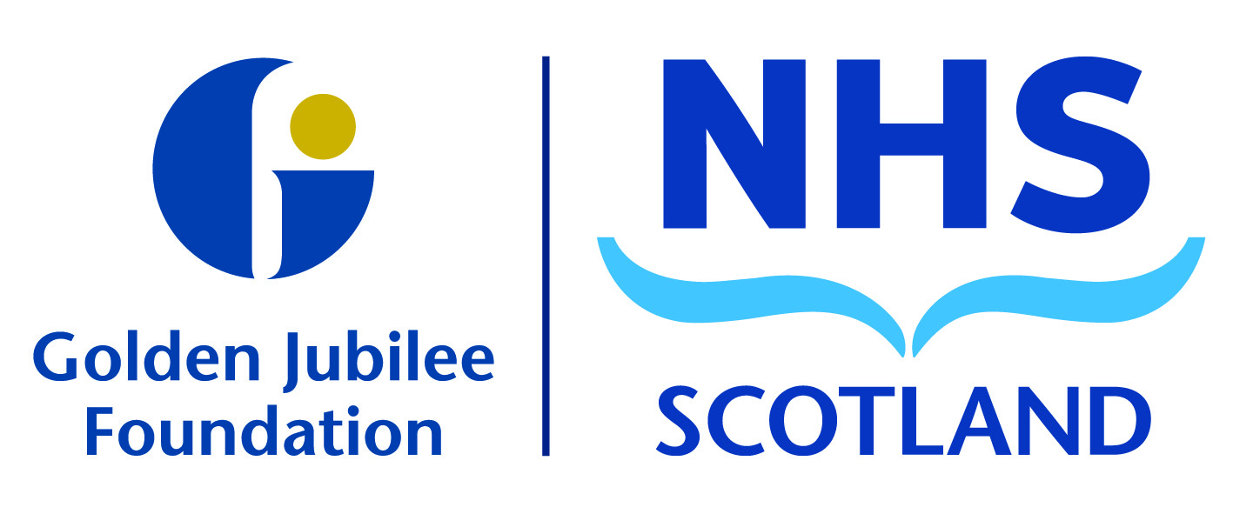
Background
Item 8.5

The planning for EU withdrawal continues to be a priority for Scottish and UK Governments. This paper covers the most recent updates we have received and continues to inform our preparedness for EU withdrawal.

- Situation

Update 1. The attached letter is an update from the national team at Scottish Government in relation to the recent General Election. A no deal scenario at the end of January 2020 is highly unlikely and this update gives the organisation more information around the potential impact of this.

Update 2. The NHS Confederation has established the Brexit Healthcare Alliance (BHA), bringing together representatives of those who use health services, healthcare commissioners and providers, educators, researchers and the health care industry. The intent is to ensure that those working to improve population health and wellbeing can have a strong, collective voice as the formal process of leaving the EU develops. A short teleconference meeting was convened on 18 December to consider the implications of the General Election results on the EU withdrawal from the perspective of health and the actions to be taken by BHA as a consequence.

- Conclusion/Recommendation

The Board are asked to discuss and note these updates and consider the implications for business continuity planning across the organisation.

Anne Marie Cavanagh
Executive Nurse Director
January 2020

