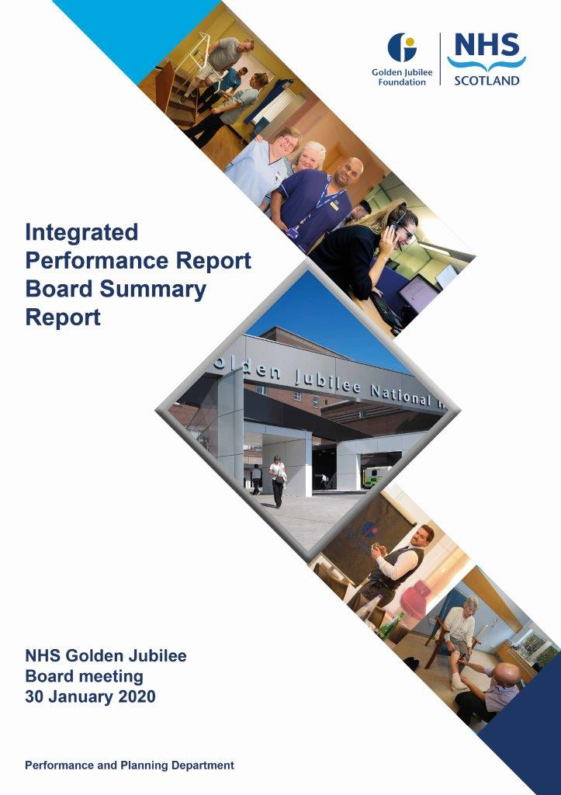

# Contents

**Introduction 2**

**Performance Summary Dashboard 4**

**Integrated Performance Report: Executive Summary 6**

# Section A: Introduction

The purpose of the Integrated Performance Report (IPR) is to provide assurance on NHS Golden Jubilee’s performance relating to National Standards, local priorities and significant risks.

The IPR comprises four section with each section being considered in detail by the appropriate Standing Committee:

* Section A Introduction
* Section B:1 Clinical Governance
* Section B:2 Staff Governance
* Section B:3 Finance, Performance & Planning

This Board Summary Report of the IPR is presented to the Board and contains the summaries from each section of the full IPR.

**Jann Gardner Colin Neil June Rogers**

**Chief Executive Director of Finance Deputy Chief Executive**

Performance Summary Dashboard – Guidance



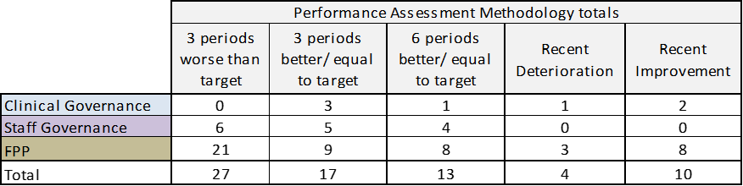

Board Performance Dashboard – Part 1



Board Performance Dashboard – Part 2



Note: This Board performance dashboard aggregates KPIs indicators for Bed Occupancy and Cancellation rates into Hospital level performance.

At each meeting, the Standing Committees of NHS Golden Jubilee consider targets and standards specific to their area of remit using the Integrated Performance Report (IPR). There is a section of the IPR which provides a summary of performance Standards and targets identified as areas of note which is reproduced below. Topics are grouped under the heading of the Committee responsible for scrutiny of performance.

# Section B: 1 Clinical Governance

|  |  |  |
| --- | --- | --- |
| **Clinical Governance** | | |
| **KPI** | **RAG** | **Position:** |
| Total complaints (Stage 1 and 2) as a percentage of activity. |  | Position improved from 0.11% in September 2019 to 0.09% in October 2019. The volume of complaints decreased by one to eight. |
| Stage 1 complaints response time |  | The target was not achieved in November 2019 with seven out of ten (70.0%) responses within the five day response threshold against a target of 75% |
| Stage 2 complaints response time |  | In October 2019 100% (4/4) Stage 2 complaints were responded to within 20 working days. |
| Mortality |  | The mortality figure for November 2019 was reported as ten. There were eleven deaths in October 2019. |
| Significant adverse events |  | There were three significant adverse event reviews in November 2019, one less than in October 2019 and within the set tolerance limit. |
| MRSA/MSSA cases |  | There were no instances of Staphylococcus aureus Bacteraemia (SAB) reported in November 2019. |
| Clostridiodes Difficile |  | There were zero Clostridiodes Difficile Infections (CDI) reported in November 2019. |

**Clinical Governance Executive Summary**

Within the Clinical Governance section of the IPR, we are maintaining the existing indicators from the corporate balance scorecard relating to complaints and infections, and also proposing that we add the number of Significant Adverse Events (SAE) and crude hospital mortality as further indicators of safety.  It must be stressed that neither indicator is necessarily suggestive of harm, as an SAE can be a low severity or near miss event, and not all deaths are preventable. However, both act as a prompt to review and consider learning and it is therefore felt useful to include and monitor the overall levels using statistical process charts.

With regards mortality; Hospital Standardised Mortality Rate (HSMR) data will be published on a quarterly basis and the intention is to include the national data when published. Recommendation from Healthcare Improvement Scotland is that Boards monitor crude mortality on a more regular basis.

The response times for stage two complaints remain under close monitoring and we are pleased to note the improvement in Octobers figures.  Clinical Governance Risk Management Group continues to monitor the actions to support process improvements and have agreed further revisions to the process which it is anticipated will support the response times and quality of responses also.  Clinical Governance Department are also undertaking a further deep dive across the various forms of feedback and benchmarking with external Boards.

Mortality remains within limits.  The latest HSMR publication data is shown below for noting; both the HSMR and crude mortality rates are shown.  GJNH remains within limits for HSMR and significantly below the national crude mortality rate with no issues to highlight:

**HSMR:**

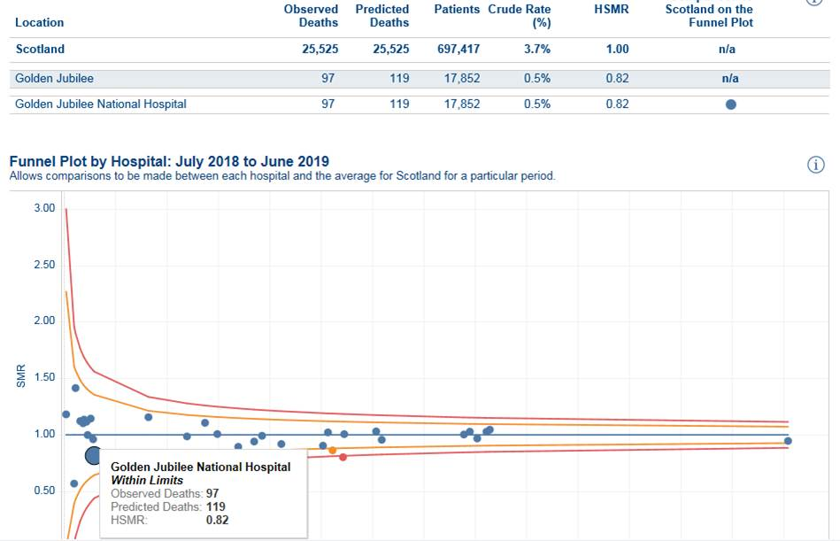

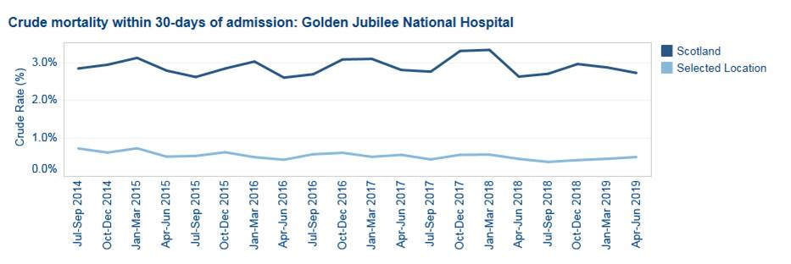

**Key Healthcare Associated Infection Headlines**

***Staphylococcus aureus* Bacteraemia**

No SAB to report in November 2019.

***Clostridioides difficile* infection (previously known as *Clostridium difficile)***

No CDI to report in November 2019

**Hand Hygiene**

The bimonthly report from November demonstrates an overall compliance of 99% with hand hygiene opportunity and technique. Medical staff compliance has increased from 95% to 98%.

**Cleaning and the Healthcare Environment- Facilities Management Tool**

Housekeeping Compliance: 98.7% Estates Compliance: 99.13%

**Surgical Site Infection (SSI)**

Hip replacement SSI rates within control limits.

Knee replacement SSI rates breached upper control limit in October (n=2 superficial infections) reduced to 1 case in November. Due to low numbers of infection upper control limits can be breached with only two cases. The PCIT will remain vigilant to further cases.

Cardiac and CABG SSI rates (within 30-day post-operative period) within control limits.

**Other HAI Related Activity**

• **Annual Operational Plan**

New HAI targets for 2020 and beyond have been released by Scottish Government. These continue to focus on SAB, CDI however these have also been supplemented with antibiotic use, Gram negative bacteraemia, compliance with HIS HAI Standards, DL (2015) 19 and SHTM 03-01, SHTM 04-01 and HAI SCRIBE.

• **Problem Assessment Groups (PAG).**

The PCIT worked closely with the clinical team in ICU 2 to determine a potential link in patients with the same isolate. Following a period of enhanced cleaning and application of control measures this incident has been closed. Incident report will be shared with relevant governance committees.

# Section B:2 Staff Governance

|  |  |  |
| --- | --- | --- |
| **Staff Governance** | | |
| Disciplinaries & Grievances |  | Both indicators were on target for November 2019. With zero disciplinary cases resulting in a warning and zero grievance cases reported. |
| Bullying and harassment |  | There was one bullying case reported in November 2019. This follows one case reported in October 2019. |
| Local Sickness absence |  | There was a 0.7% deterioration in sickness absence in November 2019 compared to October 2019, with sickness rising from 4.4% to 5.1%.  Corporate sickness rose by 1.9% from 2.3% to 4.2% |
| Medical appraisal with completed interview and form 4 |  | Reported position at end of November 2019 was 22.4% (28/125) against a target of 50%. |
| TURAS Appraisal rates |  | Increased by four percent to 78% in November 2019 but remained below the required threshold of 80%. The Hotel (86%) and Heart, Lung and Diagnostic (80%) Divisions achieved the threshold |
| Job Planning Surgical Specialties: Consultants |  | Surgical consultant job plans remain on target with 79.3%, (55/69), having an approved job plan. |
| Job Planning SAS & RNM Consultants |  | Position remains as 37.5% (3/8) of SAS doctors and 37.5% (6/16) of RNM consultants with approved job plans by the end of November 2019. |

**Staff Governance Executive Summary**

Within the Staff Governance section of the IPR we report on the following:

* sickness absence rates;
* appraisal rates for those under Agenda for Change and medical pay scales; and
* medical job planning.

**Sickness absence**

In November 2019 the Board’s sickness absence rate rose to 5.1%, up from 4.4% the previous month. This was accounted for by an increase in the rate of sickness absence across three of the directorates, most markedly in Corporate, which rose by 1.9% to 4.2%. Only Regional and National Medicine fell, from 5.3% to 4.9%, but this is still markedly higher than the average for the Directorate.

As with previous months, a large proportion of sickness absence was due to “Anxiety/stress/ depression/other psychiatric illnesses”, which accounted for 30.2% of the Board’s sickness absence. It was the main cause of sickness absence in all four directorates.

Information relating to directorate and departmental sickness absence rates continues to be circulated to Heads of Department on a monthly basis. Management, Occupational Health and the Human Resources Team continue to work together to support members of staff during their absences, and to work with staff members to reduce the number and length of sickness absences, assisting them to remain at work and return to work sooner. Occupational Health Physiotherapy offers rapid access to help alleviate musculoskeletal problems.

We undertook a mental health check survey from 2nd to 27th September 2019 in partnership with See Me, the national programme to end mental health stigma and discrimination. We received 490 responses from staff. 58% of respondents identified as having experienced a mental health problem within the organisation and or in a previous organisation. A meeting took place on Tuesday 26th November 2019 with See Me to discuss the findings within the report and identify the priorities for the Board in order to develop an action plan towards creating a mentally healthy workplace.

The report indicates that there are good areas of practice and staff do feel supported by managers and colleagues within the workplace. There are areas where we can make improvements and which are likely to have the most impact for us such as:

* commitment of senior leaders and managers;
* safe, effective and pertinent disclosure of mental health concerns;
* confident and informed line managers;
* understanding and adopting reasonable adjustments;
* increased mental health awareness and literacy;
* effective approaches to training including a wider range of resource tools, e-learning for all staff;
* stigma free culture and ethos; and
* effective communication of support available to current staff and potential/future staff.

Further work will be done to formulate an action plan which will be shared with the Staff Governance Sub Group.

**Agenda for Change appraisal**

Within the year to 30 November 2019 78% of staff who come under the Agenda for Change terms and conditions completed their appraisal using TURAS. Managers are provided with monthly TURAS progress reports, which helps them to identify those members of staff who have undertaken appraisal within the previous rolling 12 months, as well as those who did not, and most urgently need to participate in appraisal.

We are undertaking an analysis of the staff governance data to compare sickness absence rates and TURAS appraisal completion rates to identify any departments where further support may be required where both areas are out with targets. This information continues to be gathered in order that action plans can be developed to identify which areas require additional support to overcome any barriers or challenges they might be facing.

**Medical appraisal**

The appraisal year for medical staff runs from 1 April to 31 March. As at the end of November 129 medical staff were attached to NHS Golden Jubilee for appraisal and revalidation purposes. By 30 November a total of 28/129 (21.7%) doctors had completed the appraisal process and had been issued with a Form 4, or had participated in an ARCP in the current appraisal year.

**Medical job planning**

As of 30 November 64 out of 96 (66.7%) medical staff had signed off on their 2019/2020 job plan.

# Section B:3 Finance, Performance and Resources

|  |  |  |
| --- | --- | --- |
| **Finance, Performance and Resources** | | |
| Finance – Manage within annual budget limit |  | The month eight year to date results show a position of £309,000 above the annual budget target. This is an improvement on month seven (£70,000). |
| Finance – Deliver Board efficiency target |  | The month eight year to date results show an total cash releasing savings of £2.38m against a threshold of £2.69m. |
| Cancer 31 Day |  | In October 2019 100% (29/30) patients on a cancer treatment pathway were reported as being seen within 31 days. |
| TTG: Number of patients who have breached the TTG |  | In November 2019 there were 120 patients who exceeded their twelve week treatment time guarantee. This included 33 cardiac surgery patients,10 coronary patients,44 electrophysiology patients,21 device patients,2 lead extraction patients,1 TAVI patient,9 patients on the cardiology inpatient waiting list. |
| TTG: Percentage of patients admitted within 12 weeks |  | The percentage of patients who were admitted within their twelve week treatment time guarantee increased by 1.3% from 91.2% in October 2019 to 92.5% in November 2019. This reflects a decrease in the number of patients admitted over twelve weeks (-29). |
| Stage of Treatment Guarantee – Inpatient and DC cases (Heart & Lung only) |  | Position improved slightly from 77.7% in October 2019 to 78.9% in November 2019 but remained below the threshold of >=90%. The number of patients treated over 12 weeks decreased to 79 (-25) whilst the number of patients treated within 12 weeks also decreased 295 (-67). |
| DOSA rate: Cardiac Surgery |  | In November 2019 the Cardiac DoSA rate was 22.4% and met the target of 17.9% for the first time. The November position represented a 10.8% increase compared to October 2019. The number of patients admitted as DoSA was 19, the highest number since recording started. |
| DOSA rate: Orthopaedics |  | In November 2019 the Orthopaedic DoSA rate was 62.7% with a target of 75.0%. The October position represented a 2.5% decrease compared to October 2019 but represented the fifth consecutive month over 60%. |
| DOSA rate: Thoracic Surgery |  | In November 2019 the Thoracic DoSA rate was 28.4% with a target of 40.0%. The November position represented a 6.5% decrease compared to October 2019. The number of patients admitted as DoSA decreased by 5 compared to the previous month. |
| Theatre Cancellation Rates |  | In November 2019 the overall hospital cancellation rate was 5.3%. This represents a 0.32% deterioration compared to October 2019. The increase was mainly due to increased Cardiac Surgery cancellations at 28 (+7).There were 97 cancellations with 1820 procedures. |
| Hospital Bed Occupancy |  | Hospital wide bed occupancy was reported as 79.0% in November 2019 compared to 72.3% in October 2019. The calculated ‘green’ range, based on combining individual ward thresholds is between 83% to 88%. HDU and Ward 2D reported occupancies in the ‘red’ range |
| Hotel Overall Net profit |  | The November 2019 position was +3.0% compared to –3.2% in October 2019 and remained within the ‘green’ threshold. |
| Hotel Patient Bed Night Usage |  | Patient bed night usage remained below target with the position remaining at -17.1% in November 2019. |
| Hotel Not for profit percentage |  | The percentage in November 2019 increased to 54.1% and was above the minimum threshold of 44% |
| Research & Innovation |  | R&I KPIs will be updated for the February 2020 IPR |

|  |
| --- |
| National Comparison Table, Corporate Dashboard, Waiting list & Productivity table |
| The GJNH nationally reported elective cancellation rates increased from 5.0% in September 2019 to 5.1% in October. The GJNH had the lowest elective cancellation rate nationally. The Scotland rate was 8.5%. |
| Golden Jubilee performance against the national 31 Day Cancer target is reported using the Information Services Division (ISD) nationally published position. For Quarter 2 2019 GJNH remains jointly ranked 1st at 100%. |
| Corporate sickness rates deteriorated in November 2019 (+1.9% to 4.2%) with a number of departments over the 4% threshold: Business services, Clinical Governance, Communications, e-Health, Estates, Housekeeping, Human Resources, Occupational Health, Procurement and Security. |
| The total inpatient waiting list month end position increased by 30 from 3953 to 3983. The total outpatient waiting list decreased by 315 to 2231 with reductions seen in the Orthopaedic (1070, -78) and Ophthalmology (825, -159) waiting lists. |

**Business Performance Executive Summary**

**Background**

Patient activity is reported on a monthly basis, both by month and year to date. Data contained within the Performance Pack is primarily measured in episodes of care. However, data is also captured to reflect the number of procedures being carried out by Board, by specialty. This information is particularly relevant to referring Boards who are allocated activity and measure their activity/throughput at GJNH in numbers of procedures.

Appendix A to this document is provided for information purposes and reflects the number of patients treated against an annual plan of 18,314 (patients).

Appendix B to this document is adjusted to represent theatre slots used (as opposed to numbers of patients) in both orthopaedic surgery and plastic surgery. This allows us to more accurately reflect actual theatre utilisation and allows us to focus on maximising the theatre capacity that is available to us.

This paper is intended to monitor and report on the national waiting times activity allocated to Boards across Scotland. High level Regional Heart and Lung Centre activity is also provided for information purposes. This activity is reported in more detail on the Divisional Performance and Planning Reports which are then summarised for presentation to the Board.

Referring Boards receive a monthly monitoring document which provides a detailed breakdown of the number of patients referred, their complexity and the number of theatre slots used to treat them.

**Operational Governance**

**In Patient/Day Case/Diagnostic Imaging Activity Analysis November 2019**

Activity for inpatient/day case procedures measured against a projection of 18,314 (which excludes cardiothoracic/cardiology activity) was slightly behind plan by 1.1% for the month of November when activity is adjusted to reflect complexity (Appendix B) and 3.8% behind the year to date plan.

Measured against a total activity projection of 61,734, the combined inpatient/day case and imaging activity at the end of November was behind plan by 2.2% for the month of November when adjusted to reflect complexity (Appendix B) and 4.0% behind the year to date plan.

**Analysis of Performance Against Plan at End November 2019**

**Orthopaedic Surgery:**

The annual target for orthopaedic joint replacements for 2019/20 is based on 4003 primary joint replacements. This number is calculated on the basis of one patient to one theatre slot. Each session equals two primary joint theatre slots. However, based on experience over the recent years, we have made the assumption that the number of complex joint replacements likely to be referred for treatment would be approximately 9%. These procedures typically take the equivalent theatre space of 1.5 - 2 primary joint replacements.

In addition to the 4003 primary joint replacements, there are a target number of 931 orthopaedic non joint procedures and 550 foot and ankle procedures for the year. This equates to a total of 5484 orthopaedic theatre slots per annum (as documented in Appendix B).

At the end of November, orthopaedic joint activity was ahead of plan for the month by 8 joint replacements and behind plan by 46 ‘non joint’ procedures and 7 foot and ankle procedures. Overall, orthopaedic surgery in procedures/theatre slots is behind the year to date plan by 253.

**Ophthalmic Surgery**

Ophthalmology activity was ahead of the monthly plan by 22 procedures for the month of November and behind the year to date plan by 78 procedures.

**General Surgery**

General surgery performed behind by only 1 procedure for the month of November and is 90 behind the year to date plan.

**Plastic Surgery**

For reporting purposes Plastic Surgery has been split and will be monitored throughout 2019/20 as hand surgery and minor plastic surgery.

Hand surgery was behind plan for November by 8 procedures.

Minor plastic surgery was behind plan for November by 5 procedures.

**Endoscopy**

The endoscopy activity was ahead of the planned activity by 22 procedures and remains 39 behind year to date.

**Diagnostic Imaging**

Diagnostic imaging activity was behind the planned activity for November by 97 examinations and is 1,208 behind the year to date plan.

**Current Situation**

* Orthopaedic joint replacements exceeded the November planned activity by 8 procedures, orthopaedic non joint activity was behind by 46 procedures and foot and ankle surgery behind by 7 procedures. Overall, in November the service utilised 415 orthopaedic theatre slots against a plan of 459 and they are now behind the year to date plan by 253 procedures.
* The shortfall in orthopaedic activity has been due to a number of contributing factors including:
  + Consultant willingness to carry out waiting list initiative sessions when colleagues are on annual or sick leave.
  + One consultant reduced his job planned sessions. These sessions are being replaced by a new consultant. However, the new consultant will not take up these sessions until January resulting in a gap that cannot be utilised.
  + One consultant was on sick leave earlier in the year and has not yet resumed full operating.
  + A number of patients being referred to GJNH for surgery are ‘long waiters’ and the conversion to surgery rate has been much lower than we have typically experienced in the past.
  + Theatre staffing has been an issue since the summer, however, this situation is expected to improve in Q4.

The team are continually exploring opportunities to recover the shortfall in activity and they envisage some improvement from January to March.

* For the third consecutive month, Ophthalmology activity exceeded the monthly plan by 82 procedures. The Division remains focussed on recovering the year to date shortfall which has now reduced to 78 procedures. Every opportunity continues to be explored to minimise DNAs and late cancellations.
* Endoscopy procedures carried out in November were ahead of plan by 22 procedures. The service continues to work towards recovery of the year to date shortfall which has now reduced to 39 procedures.

* + There has been sustained improvement in Diagnostic Imaging in November although the service is behind the monthly plan by 97 examinations. The shortfall of 1208 examinations remains significant. However, there is some confidence that this shortfall will be recovered by the year end.

Although slightly behind the plan for November, activity carried out in November is 8.3% higher than in October. However, due to our dependency on visiting consultants and the willingness of consultants to carry out waiting list initiative sessions, recovering the year to date shortfall continues to be extremely challenging. The Recovery Group continue to meet on a weekly basis and remain focussed on identifying alternative solutions to challenges as they arise, addressing recruitment challenges and detailing a recovery plan for shortfalls by specialty.

**Finance, Performance and Resources Executive Summary**

**Financial Position as at Month 8, November 2019**

**Revenue Position**

The total surplus as at Month 8, November 2019 amounts to £309k. This comprises of an income under-recovery of (£131k), a core expenditure underspend of £441k and a non-core break-even position. This reported underspend position compares to an original Financial Plan Forecast of a break-even by the end of November 2019.

The forecast to the financial year-end at this point of the financial year remains to predict being within budget and now expects a level of surplus given recent results and run rate.

**Main Points to note**

* The YTD Budget across Expenditure headings amounts to c£97m, with the underspend above of £441k being split between pay, at £633k underspent, and non-pay, being (£192k) overspent. Whilst this overall position is favourable some ongoing pressures exist in Medical Pay lines due to excess costs to assist in meeting capacity demands, and within equipment repair and rental and thoracic supplies in non-pay, with these areas being subject of local reviews to define remedial actions. The income under-recovery is associated with some SLA activity being behind targeted plans at month 8, as previously reported.
* The Efficiency Savings target for the year amounts to £4.807m. At the end of November 2019, £4.534m of schemes have been identified, with £2.53m being recurring schemes and £2.004m non-recurring opportunities. At month 8 this reflects an in-year gap of £273k and a FYE gap of £1.277m, albeit further opportunities will be explored, and be of significant focus, via planned Performance Review Groups with the Divisions to source additional initiatives. Positively, £2.932m of cash releasing savings have been identified and achieved as at month 8, which is ahead of the planned YTD target of £2.69m.
* In addition to these savings schemes, there are cost avoidance and productivity schemes assisting the run rate and operational efficiencies, albeit these cannot be set against the target above. These schemes are under detailed scrutiny to assess the organisational benefits which can be recognised in year.
* The Clinical Waste contract and service contingency arrangements continue to be in transitional phase with the interim arrangements resulting in additional charges of c£14k per month from the contractor together with some internal costs to maintain service delivery. These costs have been factored into the Boards financial forecasts, recognising the full financial risk, with the changeover of services due at the beginning of the calendar year.
* The Hotel Expenditure position is £37k underspent following Pay Award funding, and forecasts a surplus for infrastructure reinvestment by the financial year-end. Hence the previously reported expectation of recovery is progressing well in the second half of the financial year.
* At a previous Annual Operating Plan Meeting with Scottish Government colleagues, confirmation of funding was provided for key Waiting Times Improvement Plan funding, which also included Independent Sector activity funds. Monthly monitoring reports will be issued to Scottish Government by Board, Supplier and Specialty to capture current and forecast positions and aid robust national reporting. These funds have been issued on a non-recurring basis and will re-appear in our finance plan for 20/21.

**Capital Position**

* Formula Capital of £2.691m and Capital Stimulus funding of £1.922m combine with a specific NSD allocation, a revenue to capital transfer of £1.2m and Elective Centre Capital to derive the overall allocation below of £19.856m of capital funding split across these 4 key allocation headings, which at month 8 has an expenditure profile of £8.59m.
* The revenue to capital transfer has been actioned following detailed review of capital spend, prioritisation of needs and discussion with Scottish Government to agree this value which has allowed the procurement of a CT Scanner to be incorporated within this financial year.

|  |  |  |
| --- | --- | --- |
|  | **Annual** | **Spend at** |
|  | **Budget** | **Month 8** |
| **Area of Spend** | **£000's** | **£000's** |
| Property | 1,703 | 451 |
| Medical Equipment | 3,554 | 1,192 |
| IM&T | 626 | 0 |
| Elective Centres | 13,973 | 6,947 |
| Total | 19,856 | 8,590 |

* Elective Centre Funding relating to phase one and phase two developments is received as a separate allocation. Phase one relates to the Ophthalmology expansion with funding of £10.473m included in the capital plan for the year. The in-year spend for phase one is £4.782m as at November 2019. Phase two relates to the creation of a new facility to increase Orthopaedic Surgery capacity, and an element has been allowed in the capital plan in year with regard to this, £3.5m. The Outline Business Case was approved and close communication with SG colleagues is in place given the scale and importance of this key development. The in-year expenditure related to appropriate enabling works for phase two at the end of month 8 is £2.165m, which is informed in detail at internal cost control meetings. Therefore, the total Elective Centre spend stands at £6.947m at the end of Month 8.
* The Board forecast to remain within the Capital Resource Limit for the financial year to meet the financial targets for 2019/20.