**NHS Golden Jubilee**

**Summary Finance Report**

**As at 31 May 2023 – Month 2**

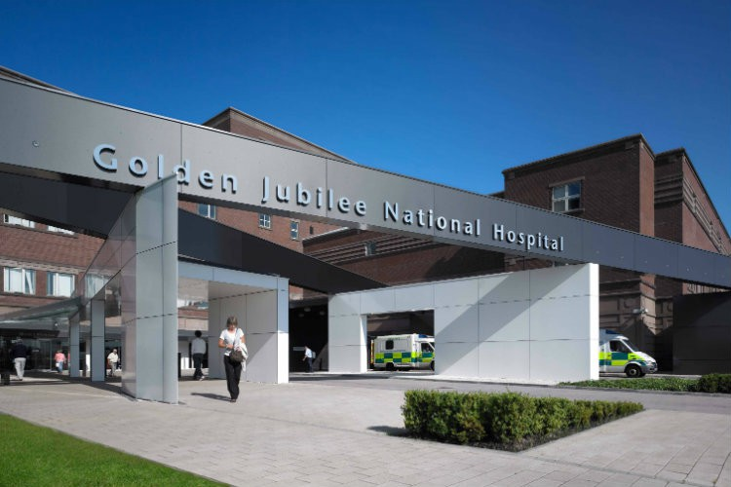

1. EXECUTIVE SUMMARY

|  |  |  |
| --- | --- | --- |
| **Finance Position as at 31 May 2023 – Month 2 Report** | | |
| **1.1** | **Delivery of**  **Financial**  **Plan** | The year to date (YTD) core revenue position as at the end of May 2023 is an adverse variance of (£0.392m). This mainly reflects the phasing of the financial gap of (£6.6m).  **This is an early draft position as at Month 2 with an exercise being completed as part of the Month 3 review to ensure a full analysis of all funding available is released into Divisional Budgets as well as ensuring the forecast level of non-recurrent savings in-year can be brought into the overall position.** |
| **1.2** | **Efficiency**  **Performance** | There is a (£6.6m) efficiency requirement within the Financial Plan to achieve the targeted break even position  for 2023/24.  A more structured programme management approach is being taken forward in the identification and delivery  of savings in 2023/24.  This approach is designed to achieve at least 3% on a recurring basis (as required by SG guidance).  The focus is now on the identification of recurring and sustainable savings in 2023/24 and  beyond. Finance continue to link with the National Financial Improvement Group (FIG) and the national Sustainability and Value programme. |
| **1.3** | **Capital income and Expenditure** | The formula core capital allocation for the Board is £2.691m. NHS Golden Jubilee submitted a 5 year capital expenditure programme in March 2023 with a total request of £6.134m for core capital and an estimate of £27.1m for Phase 2 and the Queens Quay District Heating system funding.  At Month 2 no capital funding has been confirmed by Scottish Government with the allocation letters expected to be finalised in July 2023. |
| **1.4** | **Income** | Income is £0.20m above the Financial Plan at Month 2. Hotel income is £0.10m ahead of the expected  positon and over-performance of £0.16m relating to Scottish National Radiology Reporting Service (SNRRS).  All other income sources are recording an under performance of (£0.06m). |
| **1.5** | **Expenditure** | Expenditure is (£0.592m) overspent at Month 2. Pay costs are underspent by £526k with Non-Pay costs overspent by (£1,119m). In terms of Non-Pay, the largest pressure reported is within CS&R&S of (£1.361m). (£1.111m) of this total relates to the phasing at Month 2 of the (£6.6m) efficiency gap. |
| **1.6** | **Annual Delivery Plan**  **2022/23 to 2024/25** | The Financial Plan will be updated to reflect any final changes identified from the final version of the ADP  due to be submitted to Scottish Government at the end of June 2023. |
| **1.7** | **Recovery Workforce**  **Budget, in post and**  **Release review** | This work continues with the HLD Management Team to agree an appropriate ‘exit strategy’ related to posts  funded non-recurrently from recovery monies in 2020-21 and 2021-22. |
| **1.8** | **Agreement of final outstanding allocations**  **from SG** | Scottish Government have yet to issue the allocations letters for 2023/24. |
| **1.9** | **2023/24 to 2025/26**  **Financial Plan and**  **Annual Delivery Plan** | The Board approved the three year Financial Plan for 2023/24 to 2025/26 at their meeting in March 2023.  This three year plan identified that to continue to achieve a break even position significant levels of recurring financial savings would be required over the life time of this plan. As noted above, the break-even position  agreed for 2023/24 requires NHS Golden Jubilee to deliver (£6.6m) of savings in-year through a combination  of recurring and non-recurring measures.  Further analysis and work with Divisional colleagues is required to finalise the programme of Sustainability  And Value projects required to reduce the current 2023/24 financial gap. |

**Core Revenue Financial Performance as at 31 May 2023 (Month 2)**

The Core Revenue position for May 2023 reflects an adverse variance of (£0.392m).

**Table 1: - Summary Core position as at Month 2**



**Key Points**

* Increasing use of Agency Medical Staff to cover service gaps and recover levels of activity:-
  + HL&D - Radiology Consultants (£19k) and Cardiac Registrars (£50k)
  + NES – Ophthalmology Consultants (£52k) - Gen Anaesthetics Registrar (£20k) – Orthopaedic (£5k) – General Surgery (£10k).
* The continuing pressures within Medical staff in both divisions is mainly due to recruitment challenges and sickness absence – this has resulted in the increased use of Agency staff and WLI costs resulting in a (£0.359m) variance.
* The position for Medical Staff is offset by the underspend within Nursing, Clinical and Support staff. Again, due to the continuing challenges in recruiting to vacancies resulting in a YTD surplus variance of £0.655m. Further a pay pressure budget release of £0.208m has been included in Month 2 figures.
* Non-Pay costs at Month 2 are (£1.119m) over. Three Non-Pay categories are showing adverse variances being Pharmacy Supplies, PPE and CS&R&S.

Total cumulative variance of (£1.569m).The largest adverse variance within CS&R&S relates mainly to the Month 2 phasing of the expenditure efficiency gap of c.(£6.6m). Surgical Supplies, Labs/Radiology supplies and FM are recording cumulative underspends at Month 2 of £0.450m

**Total Income Performance as at 31 May 2023**

Table 2 below shows the summary financial position against Core Income. This comprises the Revenue Resource Limit (RRL) and other Core income (mainly SLA income from Heart & Lung and National Services) as at Month 2.

**Table 2 – Total Core Funding and Income as at Month 2**



**Key Points:**

* Cardiology activity has over performed by £74k owing to an increase of two additional Transcatheter Aortic Valve Implantation (TAVI)

procedures over the YTD implants target agreed with the Boards.

* Cardiac is under performed by (£107k) due to no Non WoS activity and reduction of the Medical training posts due to recruitment

difficulties.

* Thoracic is also under performing (£18k) due to no Non WoS activity.
* The GJCH income performance is higher than expected by £0.103m.

**Total Expenditure Performance as at 31 May 2023**

Table 3 provides an overview of key expenditure variances based on the Board reporting categories.

**Table 3 – Total Expenditure as at Month 2**



**Key Points**

* Medical staff costs are ahead of expected budget due to both short and long term sickness absence which has required Agency staff and WLIs to cover service gaps.
* All other Staff cost categories are recording underspends against the expected position at Month 2.
* £208k has been released into the budget from the central pay pressures budget to reflect the Medical Staff cost position.
* Surgical Supplies, Lab/Radiology Supplies and FM categories are underspent at Month 2 resulting in a cumulative underspend of £450k
* Pharmacy Supplies is recording a small overspend of (£3k). PPE is overspent by (£204k). The largest category overspend is (£1.361m) within

CS&R&S with the majority of the figure (£1.111m) relating to the phasing at Month 2 of the (£6.6m) efficiency gap

**Annual Delivery Plan and Finance Plan 2023/24 to 2024/25**

The Financial Plan has been updated to reflect the final changes identified from the version of the ADP submitted to Scottish Government at the end of June 2023. Discussions are on-going with SG to finalise funding arrangements relating to the staffing requirements for Phase 2.

**Efficiency Savings and Financial Improvement Performance**

NHS GJ is represented within the Scottish Government Financial Improvement meetings and meets with SG regularly to review progress against efficiency performance.

The Financial Plan assumes c.(£6.6m) of budget savings / in-year efficiency savings. Work is currently on-going on the identification of budget savings on a non-recurring basis e.g. estimation of vacancy turnover factors.

Additional staffing resources have now agreed across Finance, Procurement, Programme Management, Quality Improvement and Services to drive forward our Sustainability and Value Programme

The Key areas of focus during 2023/24 (starting July 2023)

* + Digital transformation initiatives e.g. PECOS
  + NHS Golden Jubilee Conference Hotel
  + Other Trading income – Dining, Vending and Shop
  + HLD Division (including NSD services)
  + Research Institute

**Non-Core Performance**

The main elements of non-core funding that are included within Non-Core funding;

* Depreciation for core capital items – this is an annual transfer from core RRL each year with the budget based on a detailed depreciation budget prepared annually in line with our approved capital plan and existing capital items. This reflects a breakeven position for the year to date.
* Depreciation for donated capital items – this is an annual budget forms part of exchequer funding; this relates to items that have been purchased using donated funds.
* AME Provisions – this is part of Annually Managed Expenditure and is managed and funded centrally. The original £40k estimate in 2022/23 will fluctuate throughout the year with the final amount being identified by year-end. As this is based on movement in claims and estimates from the CLO this number changes on a monthly basis in addition the Board element of its share of the CNORIS pot is only identified at year-end and will be cost neutral. At the end of Month 2 the Board the Board specific the provision for AME decreased by £64k, our share of the pot was £740k which has been incorporated into the Month 2 numbers. The new movement in provisions at Month 2 is an increase of £676k. Non-core movements in balance sheet provisions and have no impact on the RRL
* AME – Debtor – as required by accounting standards this is the corresponding debtor for the AME provisions recognising that the Board will receive income upon settlement of claims.
* Impairment – this also is part of Annually Managed Expenditure and is managed and funded centrally based upon an annual expected spend on building projects. There has been no budget included for this in 2022/23, as it is not anticipated that there will be any impairment funding required from SG. Any in year impairment will be managed via the revaluation reserve.

**Capital Income and Expenditure**

The formula core capital allocation for the Board is £2.691m. NHS Golden Jubilee submitted a 5 year capital expenditure programme in March 2023 with a total request of £6.134m for core capital and an estimate of £27.1m for Phase 2 and the Queens Quay District Heating system funding.

At Month 2 no capital funding has been confirmed by Scottish Government.

**IFRS16**

The entries are not yet in e-financials, however the numbers we are reporting are from pro-lease, the new national system purchased for recording IFRS 16. The account codes for this have now been entered into e-financials therefore from Month 3 onwards the information will be recorded in the finance system. IFRS16 has no financial effect on NHS Golden Jubilee with allocations being received from Scottish Government to net off the recorded expenditure.

**RRL Allocations April 2023- March 2024**

Scottish Government have yet to issue the allocations letters for 2023/24.

|  |
| --- |
| **Decision–NHS Golden Jubilee Board are asked**    **(1) Approve the Summary Financial Report as at 31 May 2023 (Month 2)** |

**Michael Breen**

**Director of Finance**

**NHS Golden Jubilee**